

IT342-G5
System Integration and Architecture

System Design Document (SDD)

Project Title: StreamStack
Prepared By: Esdrelon, Mary Kaitlin Claire A.

Version: 1.0
Date: February 27, 2026
Status: Draft

REVISION HISTORY TABLE
Version | Date | Author | Changes Made | Status
0.1 | February 27, 2026 | Esdrelon, Mary Kaitlin Claire A. | Initial draft | Draft
0.2 | [Date] | [Your Name] | Added API specifications | Review
0.3 | [Date] | [Your Name] | Updated database design | Review
0.4 | [Date] | [Your Name] | Added UI/UX designs | Review
0.5 | [Date] | [Your Name] | Incorporated feedback | Revised
0.6 | [Date] | [Your Name] | Final review and corrections | Final
1 | [Date] | [Your Name] | Baseline version for development | Approved

TABLE OF CONTENTS
Contents
EXECUTIVE SUMMARY 4
1.0 INTRODUCTION 5
2.0 FUNCTIONAL REQUIREMENTS SPECIFICATION 5
3.0 NON-FUNCTIONAL REQUIREMENTS 8
4.0 SYSTEM ARCHITECTURE 9
5.0 API CONTRACT & COMMUNICATION 10
Authentication Endpoints 11
User Registration 11
User Login 11
6.0 DATABASE DESIGN 13
7.0 UI/UX DESIGN 14
8.0 PLAN 17

EXECUTIVE SUMMARY
1.1 Project Overview
StreamStack is a personalized media management system designed to help users organize their movie-watching journeys. It serves as a private repository where users can search for films, manage a "To-Watch" queue, and track their viewing history. The system synchronizes comprehensive film data from external metadata providers and contextualizes it within a secure, authenticated environment.
1.2 Objectives
- Centralized Tracking: Provide a single digital environment for hobbyist collectors and casual viewers to archive their viewing habits
- Cross-Platform Integration: Deliver a seamless experience across a React web application and a Kotlin-based Android mobile app
- Real-time Data Sync: Utilize Spring Boot RESTful APIs to ensure watchlists and history are updated instantly across all devices
- Data Persistence: Implement a robust MySQL relational schema to store user profiles, movie metadata, and transactional history
1.3 Scope
Included Features:
- User registration and authentication (email/password)
- Movie discovery with search functionality integrated with a third-party API.
- Watchlist management (add, remove, and update movie status).
- Transactional "Mark as Seen" process with immediate history archiving.
- User Profile displaying a "Total Watched" counter and personal stats.
- Responsive web interface for desktop and mobile browsers.
- Native Android mobile application built with Kotlin.
- MySQL database with relational schema for data persistence

Excluded Features:
- Native video streaming or playback.
- Social media login or sharing (Community features)
- Public product/movie reviews and ratings system.
- Advanced analytics dashboard.
- Push notifications for new releases.
- Email notification system

1.0 INTRODUCTION
1.1 Purpose
This document serves as the comprehensive design specification for the StreamStack system. It provides detailed requirements, architectural decisions, API contracts, database design, and diagrams to guide development and ensure all components—Spring Boot, React , and Kotlin—integrate seamlessly.

2.0 FUNCTIONAL REQUIREMENTS SPECIFICATION
2.1 Project Overview
Project Name: StreamStack
Domain: Media Management/ Personal Productivity
Primary Users:
- Casual Viewers
- Movie Lovers
Problem Statement: Users need a simple, private way to track films across different streaming platforms without complex interfaces.
Solution: A minimalist movie tracker focusing on personal watchlists and history with a consistent experience across web and mobile.
2.2 Core User Journeys
Journey 1: First-time Discovery and Watchlist Entry
- User visits web/mobile app and creates an account.
- User types a movie title into the search box.
- System displays results from the external third-party API.
- User views movie descriptions and posters.
- User clicks "Add" to put the movie into their "To-Watch" list.
Journey 2: Completing a Movie (Transactional Update)
- User logs in and searches for their specific saved movie.
- User updates the movie status by clicking "Mark as Seen".
- The system moves the entry to history and clears it from the watchlist.
- User receives immediate confirmation via the updated "Total Watched" counter.
Journey 3: Administrator Data Management
- Admin logs in with admin credentials.
- Navigates to the user management section.
- Admin monitors active user accounts and system health.
2.3 Feature List (MoSCoW)
MUST HAVE
- User authentication (register, login, logout).
- Movie Catalog search via 3rd-party API.
- Watchlist management (add, delete, view).
- Transactional "Mark as Seen" history archiving.
- Admin panel (User moderation).
SHOULD HAVE
- Viewing history for users.
- Basic Profile stats (Total Watched counter).
- Responsive design for all screen sizes.
- Error handling for API downtime.

COULD HAVE
- Genre-based filtering for the Watchlist
- Personal notes/ratings for movies in History.
WON'T HAVE
- Social login or sharing.
- Email/Push notifications.
- Real-time streaming integration.
- Payment processing.
2.4 Detailed Feature Specifications
Feature: User Authentication
- Screens: Registration, Login, Forgot Password
- Fields: Email, Password, Confirm Password
- Validation: Email format, password strength, uniqueness
- API Endpoints: POST /auth/register, POST /auth/login, POST /auth/logout
- Security: JWT tokens, password hashing with bcrypt
Feature: Movie Search (3rd-Party API Integration)
- Screens: Movie Listing, Movie Detail
- Display: Grid layout, posters, movie names, genres
- Search: By movie title
- API Endpoints: GET /movies, GET /movies/{id}, GET /movies/search
- Admin Functions: POST /movies, PUT /movies/{id}, DELETE /movies/{id}
Feature: Watchlist Management
- Screens: Watchlist View
- Functions: Add movie, remove movie, mark as seen
- Persistence: MySQL database storage per user
- API Endpoints: GET /wacthlist, GET/ history/{id}
Feature: Admin Panel
- Screens: User Management, Global Movie List
- Data Collected: Add/edit/delete movie entries, view/moderate users
- Access Control: Admin role required.
- API Endpoints: Admin-prefixed endpoints with role validation.
2.5 Acceptance Criteria
AC-1: Successful User Registration
- Given I am a new user
- When I enter valid email and strong password
- And confirm password matches
- And click "Create Account"
- Then my account should be created
- And I should be automatically logged in
- And redirected to the homepage
AC-2: Product Purchase Flow
- Given I am logged in as a user
- When I add a movie to my watchlist
- And click "Mark as Seen"
- And confirm the action
- Then I should see the movie in my History list
- And it should be removed from my Watchlist
- And my profile "Total Watched" counter should increase by 1

AC-3: Admin Product Management
- Given I am logged in as an administrator
- When I add a new movie with valid details
- And save the entry
- Then the movie should appear in the public movie listing
- And be available for users to add to their watchlists

3.0 NON-FUNCTIONAL REQUIREMENTS
3.1 Performance Requirements
- API response time: ≤ 2 seconds for 95% of requests.
- Database queries: Complete within 500ms.
- Concurrent Users: Support 100 concurrent users.
3.2 Security Requirements
- HTTPS for all communications.
- JWT token authentication.
- Password hashing with bcrypt (salt rounds = 12).
- Admin endpoints require role verification.
3.3 Compatibility Requirements
- Web Browsers: Chrome, Firefox, Safari, Edge (latest 2 versions)
- Android: API Level 24+ (Android 7.0+)
- Screen Sizes: Mobile (360px+), Tablet (768px+), Desktop (1024px+)
- Operating Systems: Windows 10+, macOS 10.15+, Linux Ubuntu 20.04+
3.4 Usability Requirements
- Complete first purchase within 5 minutes for new users
- WCAG 2.1 Level AA compliance for web
- Consistent navigation across all pages
- Clear error messages with recovery options
- Touch targets minimum 44x44px on mobile
- Keyboard navigation support

4.0 SYSTEM ARCHITECTURE
4.1 Component Diagram
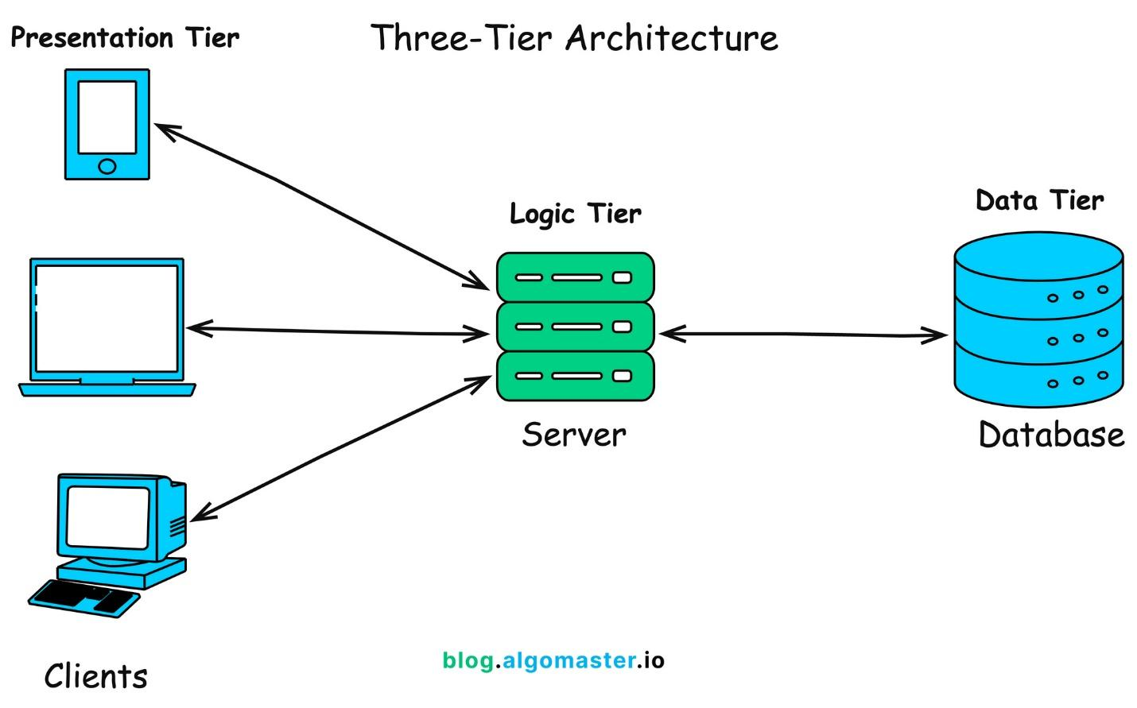
Technology Stack:
- Backend: Java 17, Spring Boot 3.x, Spring Security, Spring Data JPA
- Database: PostgreSQL 14+
- Web Frontend: React 18, TypeScript, Tailwind CSS, Axios
- Mobile: Kotlin DSL
- Build Tools: Maven (Backend), npm/yarn (Web), Gradle (Android)
- Deployment: Vercel/Netlify (Web), APK (Mobile)

5.0 API CONTRACT & COMMUNICATION
5.1 API Standards
Base URL | https://[server_hostname]:[port]/api/v1
Format | JSON for all requests/responses
Authentication | Bearer token (JWT) in Authorization header
Response Structure | {  "success": boolean,  "data": object|null,  "error": {  "code": string,  "message": string,  "details": object|null  },  "timestamp": string  }

5.2 Endpoint Specifications

Authentication Endpoints

User Registration
Description | Creates a new user account in tblUSER
API URL | /auth/register
HTTP Request Method | POST
Format | JSON for all requests/responses
Authentication | None
Request Payload | { "email": "<email>", "password": "<password>", "firstname": "<firstname>", "lastname": "<lastname>">, "username": "<username>" }
Response Structure | {  "success": true,  "data": {  "user": {  "email": "user@example.com",  "firstname": "John",  "lastname": "Doe"  "username": "j.doe"  },  "accessToken": "<jwt_token>",  "refreshToken": "<refresh_token>"  },  "timestamp": "2026-02-28T10:30:00Z"  }

User Login
Description | User Login
API URL | /auth/login
HTTP Method | POST
Format | JSON for all requests/responses
Authentication | None
Request Payload | {  “email”: <email>,  “password”: <password>,  }
Response Structure | {  "success": true,  "data": {  "user": {  "email": "user@example.com",  "firstname": "John",  "lastname": "Doe",  "username": "j.doe",  "role": "USER"  },  "accessToken": "<jwt_token>",  "refreshToken": "<refresh_token>"  },  "timestamp": "2026-02-28T10:35:00Z"  }

5.3 Error Handling
HTTP Status Codes
- 200 OK: Successful request.
- 201 Created: Resource successfully created.
- 400 Bad Request: Invalid input/Validation failed.
- 401 Unauthorized: Authentication required/failed.
- 403 Forbidden: Insufficient permissions.
- 404 Not Found: Resource doesn't exist.
- 409 Conflict: Duplicate resource (e.g., email exists).
- 500 Internal Server Error: Server-side error.
Error Code Examples

Example 1 | json  {  "success": false,  "data": null,  "error": {  "code": "AUTH-001",  "message": "Invalid credentials",  "details": "Email or password is incorrect"  },  "timestamp": "2024-01-28T10:30:00Z"  }
Example 2 | {  "success": false,  "data": null,  "error": {  "code": "VALID-001",  "message": "Validation failed",  "details": {  "email": "Email is required",  "password": "Must be at least 8 characters"  }  },  "timestamp": "2024-01-28T10:30:00Z"  }

Common Error Codes
- AUTH-001: Invalid credentials
- AUTH-002: Token expired
- VALID-001: Validation failed
- DB-001: Resource not found
- DB-002: Duplicate entry
- SYSTEM-001: Internal server error

6.0 DATABASE DESIGN
6.1 Entity Relationship Diagram
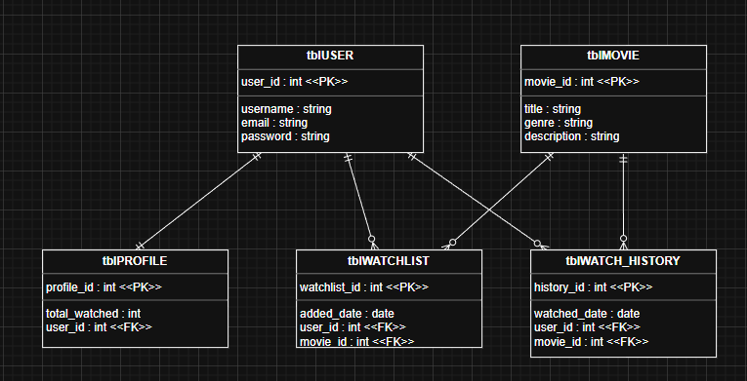

7.0 UI/UX DESIGN
7.1 Web Application Wireframes
Login Register
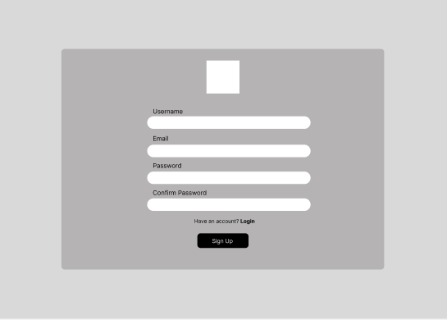
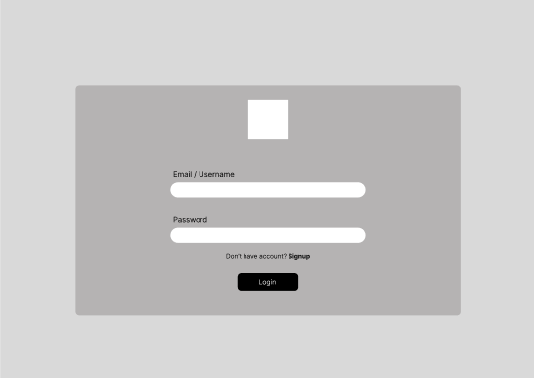

Dashboard Profile

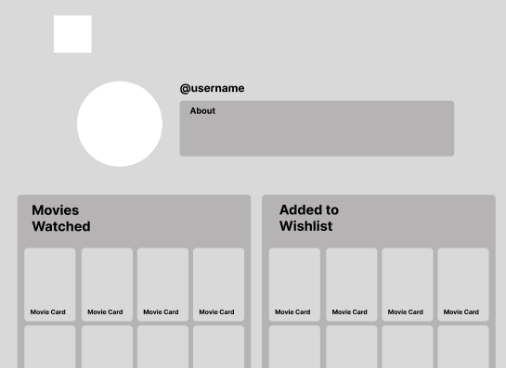
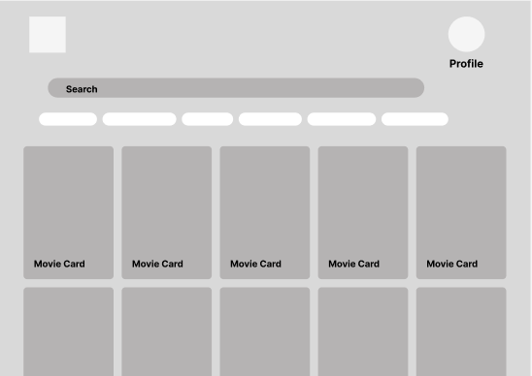

Movie Description
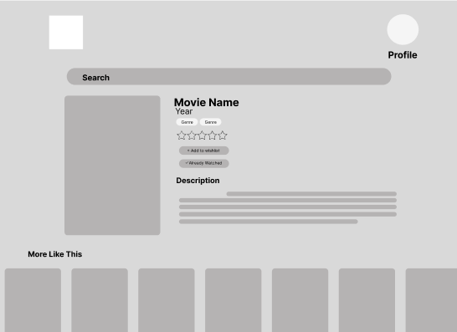

7.2 Mobile Application Wireframes
Login Register
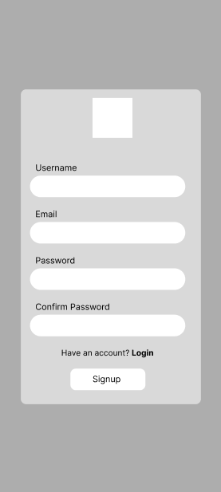
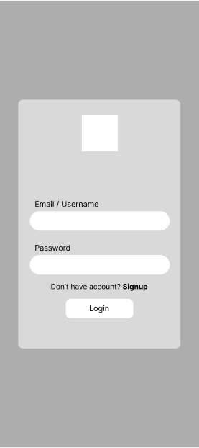

Dashboard Profile
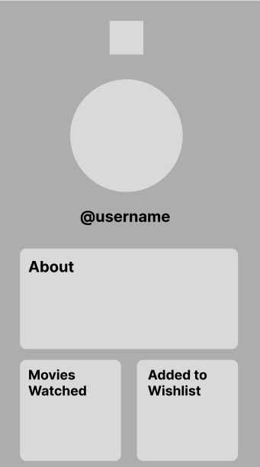
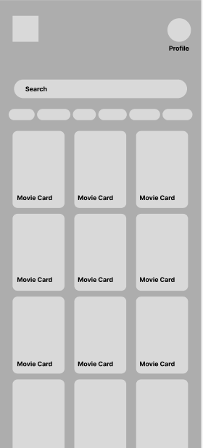

Movies Watched Added to Wishlist
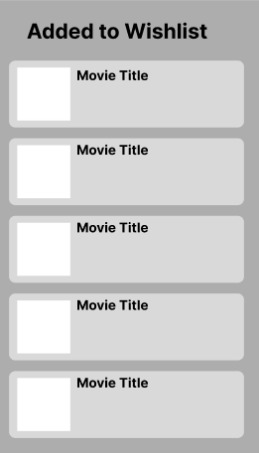
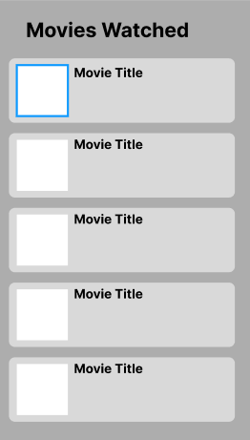

Movie Description
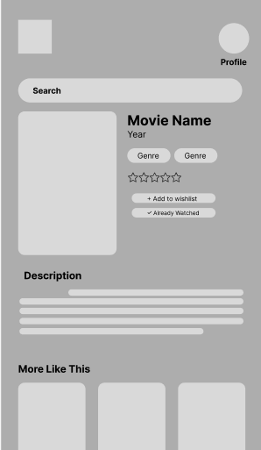

Mobile-Specific Features:
- Touch-optimized buttons (min 44x44px)
- Gesture support (swipe, pull-to-refresh)
- Offline caching for product images
- Bottom navigation for main actions
- Simplified forms for mobile input
Design System:
- Colors: Primary (#2563EB), Secondary (#7C3AED), Success (#10B981), Error (#EF4444)
- Typography: Inter font family, responsive sizing
- Spacing: 8px grid system
- Components: Consistent buttons, inputs, cards, modals
- Responsive: Mobile-first approach, breakpoints at 640px, 768px, 1024px

8.0 PLAN
8.1 Project Timeline
Phase 1: Planning & Design (Week 1-2)
Week 1: Requirements & Architecture
Day 1-2: Project setup and documentation.
Day 3-4: Complete FRS and NFR.
Day 5-7: System architecture design (3-Tier).
Week 2: Detailed Design
Day 1-2: API specification for Search and Watchlist.
• Day 3-4: Database design (PostgreSQL tbl schemas).
Day 5-6: UI/UX wireframes for Mobile and Web.
• Day 7: Implementation plan finalization.

Phase 2: Backend Development (Week 3-4)
Week 3: Foundation
• Day 1: Spring Boot setup with dependencies.
•Day 2: Database configuration and tbl entities.
•Day 3: JWT authentication implementation.
•Day 4: User management endpoints.
•Day 5: Movie metadata caching operations.
Week 4: Core Features
• Day 1: Watchlist "Add/Remove" functionality.
• Day 2: "Mark as Seen" transactional logic.
• Day 3: Search and filtering API.
• Day 4: Error handling and validation.
• Day 5: API documentation and testing.
Phase 3: Web Application (Week 5-6)
• Day 1: React setup with TypeScript.
• Day 2: Authentication pages (login, register).
• Day 3: Movie discovery listing page.
• Day 4: Movie detail page.
• Day 5: Watchlist implementation.
Week 6: Complete Web Features
• Day 1: History/Seen flow.
• Day 2: Profile dashboard and statistics.
Day 3: Admin management dashboard.
• Day 4: Responsive design polish.
• Day 5: API integration and testing.
Phase 4: Mobile Application (Week 7-8)
Week 7: Android Foundation
• Day 1: Android Studio setup and project structure.
• Day 2: Authentication screens (Kotlin).
• Day 3: Movie browsing and search.
• Day 4: Watchlist management.
• Day 5: API service layer (Retrofit).
Week 8: Complete Mobile App
Day 1: "Mark as Seen" flow.
Day 2: Room database for offline caching.
Day 3: UI polish and animations.
Day 4: Testing on emulator/device.
Day 5: APK generation and documentation.
Phase 5: Integration & Deployment (Week 9-10)
Week 9: Integration Testing
Day 1: End-to-end testing across platforms.
• Day 2: Bug fixes and optimization.
• Day 3: Security review (Spring Security).
• Day 4: Performance testing.
• Day 5: Documentation updates.
Week 10: Deployment
Day 1: Backend deployment (Railway/Heroku).
• Day 2: Web app deployment (Vercel/Netlify).
• Day 3: Mobile APK distribution.
• Day 4: Final testing.
• Day 5: Project submission.

Milestones:
- M1 (End Week 2): All design documents and UML diagrams complete.
- M2 (End Week 4): Backend API fully functional with PostgreSQL.
- M3 (End Week 6): Web application complete and responsive.
- M4 (End Week 8): Mobile application complete with offline support.
- M5 (End Week 10): Full system deployed and integrated.
Critical Path:
- Authentication system (Week 3).
- Movie Watchlist API (Week 3-4).
- Transactional "Mark as Seen" functionality (Week 4).
- Cross-platform integration testing (Week 9).
Risk Mitigation:
- Start with simplest working version of each feature: Focus on the core "Add to Watchlist" and "Already Added" check before adding complex filters.
- Test integration points early and often: Ensure the Kotlin app and React web frontend connect to the Spring Boot API as soon as endpoints are ready.
- Keep backup of working versions: Maintain stable code branches in Git before implementing advanced features like Room offline caching.
- Focus on core functionality before enhancements: Complete the Login/Register flow and tblWATCHLIST updates before adding UI animations.

