
IT342-G5
SYSTEMS INTEGRATION AND ARCHITECTURE 1

FUNCTIONAL REQUIREMENTS SPECIFICATION (FRS)

Project Title: CineTracker
Prepared By: Mary Kaitlin Claire A. Esdrelon
Date of Submission: February 6, 2026
Version: 1.2

Table of Contents
1. Introduction 3
1.1. Purpose 3
1.2. Scope 3
1.3. Definitions, Acronyms, and Abbreviations 3
2. Overall Description 3
2.1. System Perspective 3
2.2. User Classes and Characteristics 3
2.3. Operating Environment 3
2.4. Assumptions and Dependencies 3
3. System Features and Functional Requirements 3
3.1. Feature 1: 3
3.2. Feature 2: 3
4. Non-Functional Requirements 3
5. System Models (Diagrams) 4
5.1. ERD 4
5.2. Use Case Diagram 4
5.3. Activity Diagram 4
5.4. Class Diagram 4
5.5. Sequence Diagram 4
6. Appendices 4

Introduction

Purpose
The purpose of this document is to provide a detailed overview of CineTrack, a personalized media management system. This document serves as a roadmap by defining core features, technical constraints, and the operating context to ensure alignment between the development team and project stakeholders.

Scope
CineTrack is a web and mobile-based application designed to help users organize their movie-watching journeys. The system will allow users to search for films, manage a digital "To-Watch" queue, and track their viewing history. It acts as a private repository for personal viewing habits.

Definitions, Acronyms, and Abbreviations
- UI: User Interface.
- UX: User Experience.
- CRUD: Create, Read, Update, Delete (The four basic functions of persistent storage).
- Transactional Update: An operation that ensures database changes are processed reliably and reflected in the UI instantly.
- Watchlist: A list of movies the user intends to watch in the future.

Overall Description

System Perspective
CineTrack, an operating independent media organizer, synchronizes comprehensive film data—including posters, synopses, and release schedules—from external metadata providers. This data is then contextualized within the user's private environment, where a dedicated backend manages secure authentication and personalized tracking history.

User Classes and Characteristics
The Hobbyist Collector: Users who want a granular archive of every film they’ve ever seen.
The Casual Viewer: Users who simply want to remember what they need to watch next across multiple streaming platforms.
System Administrator: A background role responsible for managing user accounts and monitoring system health.

Operating Environment
Hardware: Compatible with modern smartphones, tablets, and desktop computers.
Software: Accessible via any modern web browser (Chrome, Firefox, Safari, Edge).
Development Tools: Likely built using a stack such as React/Next.js for the frontend and Node.js or Python/Django for the backend.

Assumptions and Dependencies
API Availability: The system assumes the external movie database of API remains operational.
Internet Connectivity: Users must be online to search for movies and sync their data across devices.
Data Integrity: It is assumed users will provide valid email addresses for registration.
.

System Features and Functional Requirements

Feature 1: User Login and Registration
Description: A simple way for users to create an account so their movie lists are saved only to them.
Functional Requirements:
-Users can create a new account with a username and password.
-Users can log in to see their personal saved movies.
-The system shows a simple "Profile" page with the user's name and how many movies they have watched.

Feature 2: Search and Add Movies
Description: A search bar where users type a movie name, see results from an external source, and click a button to save it.
Functional Requirements:
-Users can type a movie title into a search box.
-The system displays a list of matching movies with their titles and years.
-Users can click an "Add" button to put a movie into their "To-Watch" list.

Feature 3: The "To-Watch" List (Watchlist)
Description: A simple list of view where users can see everything they have saved to watch later.
Functional Requirements:
-The system displays all movies the user has added that are not yet "Seen."
-Users can click a "Delete" button to remove a movie if they change their mind.
-The list updates automatically when a movie is added or removed.

Feature 4: Transactional "Mark as Seen" Status
Description: A one-tap toggle that updates the movie's status and moves it from the Watchlist to the History archive.
Functional Requirements:
-Each movie in the "To-Watch" list has a "Mark as Seen" button.
-When clicked, the movie disappears from the "To-Watch" list and appears in the -"History/Seen" list.
-The "Total Watched" counter on the user's profile goes up by 1 immediately.

Non-Functional Requirements
Usability: The app should be easy to navigate with clear buttons (Add, Delete, Seen).
Response Time: When a user clicks "Seen," the movie should move to the other list without a long delay.
Device Support: The app should look okay on both a laptop screen and a phone screen (Responsive).

System Models (Diagrams)
Insert the necessary diagrams for the system:

ERD
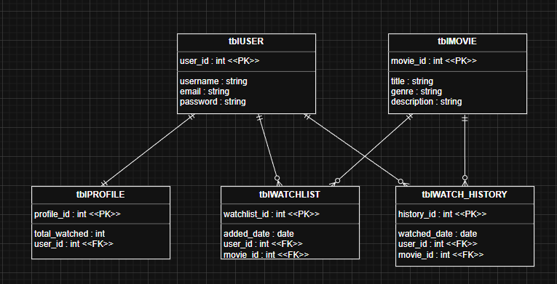

Use Case Diagram
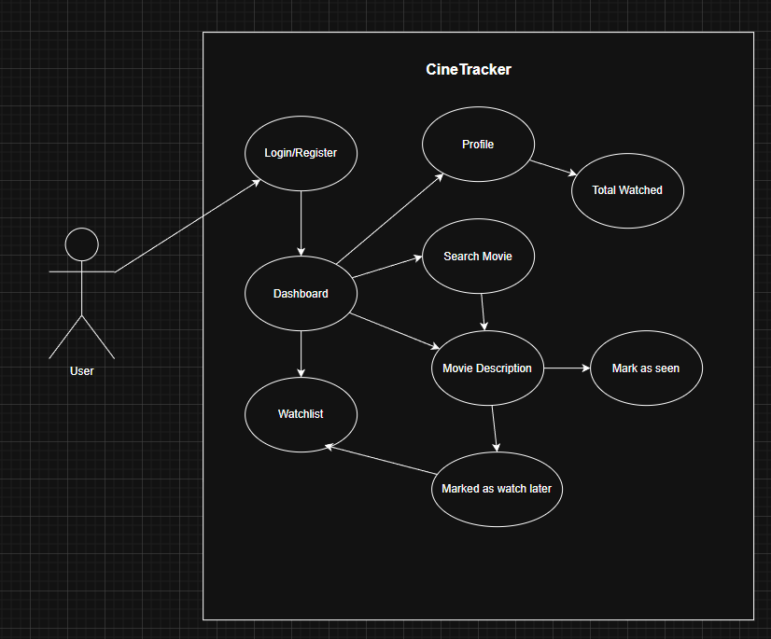

Activity Diagram
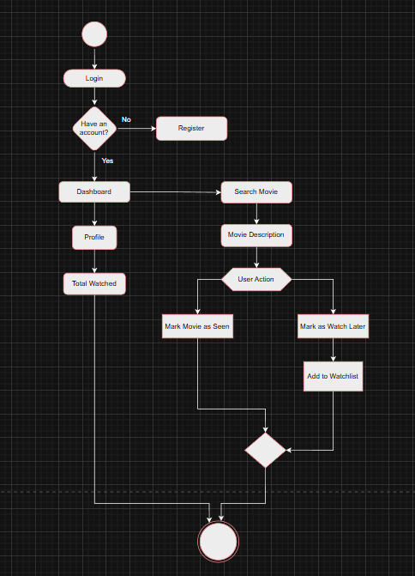

Class Diagram
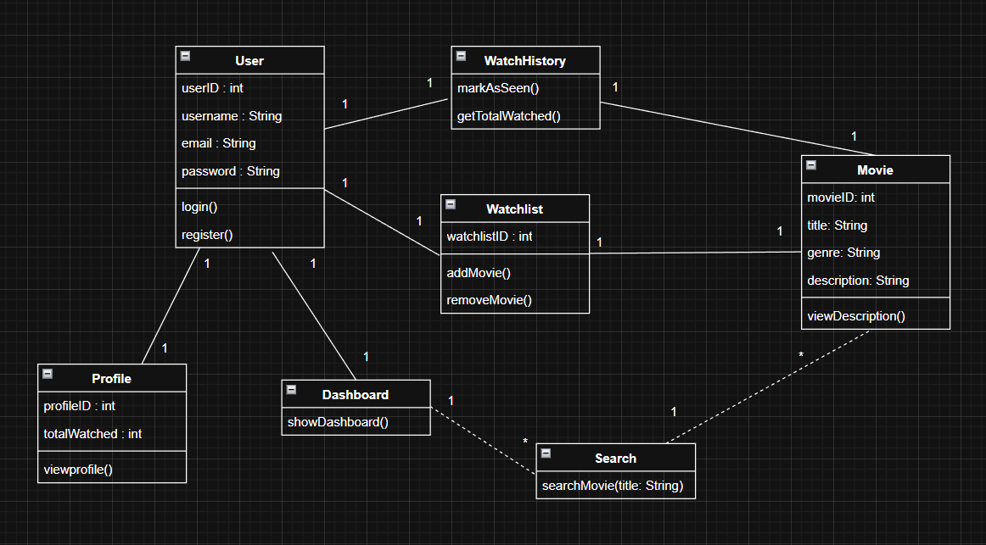

Sequence Diagram
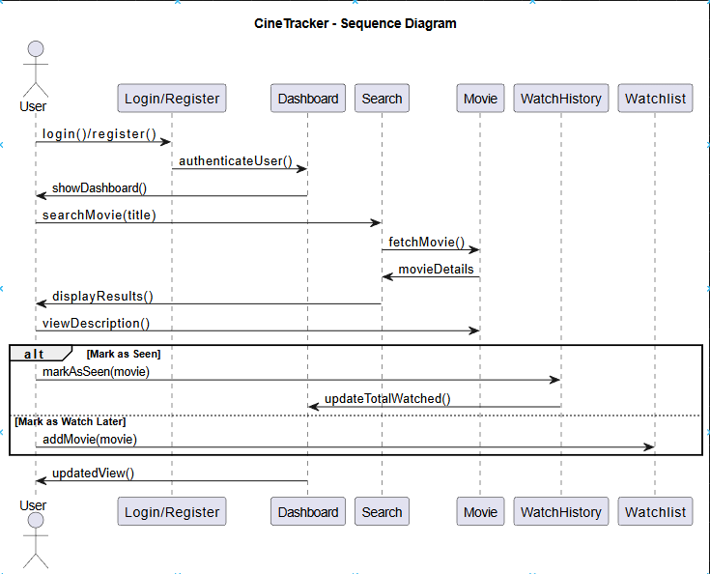s

Appendices
Include any additional information, references, or support materials.

Documentation
Login and Register Page

Dashboard and Logout button

