Secure Application Programming
Project Template

Student Name: Adriana Armstrong
Student Number:22388133
Module: Secure Application Programming
Date:

Revisions

Version | Primary Author | Description of Version | Date Completed
V1.0 | Adriana Armstrong

Table of Contents

Table of Contents
Software Development Lifecycle Methodology 2
Introduction 2
Software Requirement Specification: 3
General Description: 3
Requirements : 3
Functional Requirements: 3
Non-Functional Requirements: 3
Data Classification: 4
Entity Relation Diagram (ERD): 4
Technical Specification: 5
High-Level Architectural Diagram 5
Wireframes: 5
Use-Case Diagram: 7
Use-Case Description: 8
Class Diagram: 12
Sequence Diagram: 12
Testing Plan 13
Discussion on the Insecure Code: 13
Discussion on the Secure Code: 13
Ethics Question: 13
Appendix A Breakdown of Marks 14
Appendix B 14

Software Development Lifecycle Methodology
I chose to talk about Agile vs Waterfall (I plan to use an Agile method). A Waterfall model is a linear approach where you have to complete a phase before moving onto the next. Waterfalls typically move downward in a flow. Phases go from requirements, design, implementation, testing, deployment to maintenance. Changes can be hard to implement and costly once a phase is completed, this methodology is also documentation heavy at each phase, most of these projects require clearly defined expectations upfront. I chose to go with an Agile approach as this is more focused on the rapid delivery of my code not in a particular order. It has more flexibility. The phases of an Agile approach usually consist of a smaller time frame that include planning, requirements, analysis (existing code), design, coding and testing(existing code). Agile is easier to accept changing code/requirements. It focuses on the end user throughout the process and the measure of the progress is based on the software rather then heavy documentation.
FEATURE | WATERFALL | AGILE
Requirements | Fixed and well defined before development/ difficult to change | Requirements can evolve/ changes welcomed throught development
Delivery | Single delivery at the end of a project | Frequent deliveries(sprints)
Flexibility | Low- as change can be costly once moved on from that phase | High- continuous collaboration throughout a project
Customer involvement | Low- interaction at the beginning for requirements | High- continuous collaboration throughout
Risk Management | Risks are defined and addressed upfront | Risks can be identified throughout and mitigated continuously

Justification - as this [project requires me to have a secure and insecure branch Agile can support this allowing my development of the basic functionality in my insecure branch and then applying my security mitigation in my secure branch with testing and proper logging in. I can test my secure branch in each phase rather then all at the end which can mak it easier to change my requirements and code. This project does require extensive testing (DAST with ZAP) as Agile focuses on frequent testing showing my development vulnerabilities they can be identified quickly and usually easier to fix.

Introduction

This project will document the development of my web TO-DO-LIST application. The core objective will demonstrate and evaluate my key secure programming. My application is developed with python (FLASK) and an SQLite3 database. I will have two distinct implementation Insecure and Secure, the insecure branch will contain critical vulnerabilities, specifically in my SQL injection, Cross site scripting (XSS) and sensitive data exposure. The secure branch will rectify the flaws and incorporate industry standard security functions/features like logging and monitoring. The report should showcase my documentation outlining my design, implementation and testing used throughout this project.

Software Requirement Specification:

General Description:
My web application is a simple to do list manager designed to allow a user to register an account log in and manage personal notes or tasks. This is to firstly provide a platform successfully demonstrating and exploit common security vulnerabilities including my SQL injection, XSS vulnerabilities and sensitive data exposure in my insecure branch. Secondly to showcase the necessary security mitigations like proper logging and monitoring, session management and CSRF protection in the secure branch to improve overall security of the system.

Principle of least privilege – the user should have the minimum set of permissions necessary to perform the required task. My standard authenticated user will only have permission to view edit and delete their own to do notes. They will be prevented from accessing and modifying other user notes. If I had an administrative user role they would be allowed to monitor and modify any user notes.

Principle of secure defaults – unless configured otherwise by a user the application settings need to be as secure as possible. I will incorporate password hashing for the configuration of a stronger password (bcrypt) with a salt instead of an insecure method like plaintext. I will also include session management using secure flags that have a short expiration time to limit session hijacking.

Principle of fail securely – when a system fails it should default to a state that will deny access and preserve its confidentiality rather than exposing data or functionality. Bypassing this I will include authentication upon login, with a login failure (wrong credentials) my application should generate a error message instead of distinguishing between what credential is invalid, this will prevent user enumeration. If a database error occurs my application should display a generic error page to the user, logging detailed errors internally preventing the exposure of sensitive data.

Principle of separation of duties - critical tasks should be separated among different individuals or components to prevent single point failure. Using application layers it will follow an architectural pattern that will separate the model, view and controller. The separation will ensure that my database logic is confined to the model layer and not directly handled by the view.
Principle of defense in dept - using multiple layers of security can allow the fail of one while the rest stay in place to protect the system. In my secure branch I will use multiple overlapping protections against a threat like XSS, the application will use both output encoding and input sanitisation. Against SQL injection my application will used parameterised queries at the database layer and input validation checking at the application layer.

Requirements :
Define your web application. Describe what you are building. Set out the product scope by detailing what it can and cannot do.

Functional Requirements:
ID | REQUIREMENT
FR1 | The web application should allow all users to create an account ( register)
FR2 | Application will allow a user to log in by providing valid credentials
FR3 | The web application will authenticate a user and grant access to their notes
FR4 | An authenticated user should be able to create a new note
FR5 | An authenticated user should be able to view their notes
FR6 | An authenticated user should be allowed to edit ones notes
FR7 | An authenticated user should be able to delete their own notes
FR8 | The web application if an administrator role is implemented should be allowed to delete any users notes
FR9 | The user is able to log out

Non-Functional Requirements:
ID | REQUIREMNT | SMART REQUIREMNT
NFR1 | Security (injection) | Use of parameterised queries to prevent SQL injection attacks
NFR2 | Security (XSS) | Input sanitisation and output encoding to mitigate all XSS vulnerabilities
NFR3 | Security (data) | Use of strong password hashing and prevention of sensitive data exposure of credentials
NFR4 | Performance | Primary pages should reach a lighthouse performance level of 90 or higher when tested
NFR5 | Reliability | Application should maintain secure server side session management
NFR6 | Usability | If encountering an operational error the system should display a generic error message and log details internally.

Data Classification:
Type Of Data | Basis for collection | Security features to protect
Username / email (PII) | Account creation and user authentication | Invalid input; generic error message on login failure stored as a unique index
Password (sensitive) | Access control, user authentication | Strong, salted hashing. Not stored in plaintext
Session ID/ token | Maintain authenticated state between requests | Session management, stored in a secure session store.
To do notes | Core application functionality | Input santitisation to remove dangerous scripts, output encoding before rendering
User ID/ note ID | Maintain data integrity and establishing ownership | Stored as integers, use of parameterised queries to prevent SQL injection
Log entry data | Auditing user activity and monitoring application security | Log files stored securely and rotated. Encryption at rest if containing sensitive PII

This is to prevent sensitive data exposure. Hashing the passwords so they are not stored in a reversible format, using bcrypt will increase the difficulty for an attacker to crack a password even if the database is compromised. Session management when storing the session ID in a HttpOnly cookie it will prevent client-side scripts from accessing and stealing a session token. Input sanitisation and output encoding will ensure the integrity of my data stored in my database hopefully preventing XSS attacks when data is rendered top the users browser.

Entity Relation Diagram (ERD):

ENTITY | ATTRIBUTE | DATA TYPE | DECRIPTION | ROLE

USER | user-id | Integer | Unique identifier for a user | Primary key
 | username | Text(unique) | Username used for login | Unique index
 | password-hash | Text | Salted and hashed password
 | create-at | DateTime | Timestamp of account creation

NOTE | note-id | Integer | Unique identifier for the note | Primary key
 | user-id | Integer | Links the note to the user creating it | Forging key
 | title | Text | The title of a to do note
 | content | Text | Main body of the note
 | created-at | DateTime | Timestamp note is created
 | is-completed | Integer | Status of note

The relationship between these entities need to be clearly defined to support my applications logic ( a user can only manage their own notes) the type of relationship is ; one to many, one user can create many notes, but each note can only belong to one user. This is essential for implementing the principle of least privilege all database queries require a WHERE user_id=?

Technical Specification:
My technical specification should outline the core components and structural design of my web application, this will define the technology stack, the database structure and the client-server architecture. By following a layered architectural model like a model-view-controller pattern the project enforces a clear separation of concerns, which is critical for implementing security principles needed in this project.

High-Level Architectural Diagram

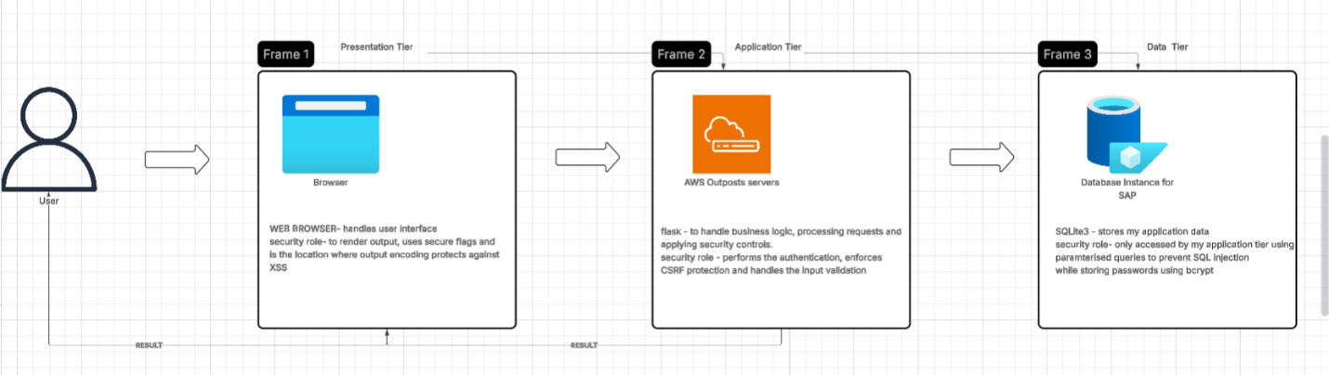
My system will use a three tier architectural diagram to achieve the separation of duties. The Presentation Tier handled by the browser will manage the user interface and is the location where output encoding takes place to mitigate XSS vulnerabilities. The Application Tier is powered by Flask containing my applications business logic this tier is crucial for security as it performs the authentication, input validation and enforces controls like CSRF protection. The Data Tier using SQLite3 stores all application data. The security in this tier is maintained by limiting access to rhe application tier using parameterised queries to prevent SQL injection, all passwords are stored using bcrypt for protection against sensitive data exposure.

Wireframes:
Provide a wireframe of each page in your application this will help you when you come to fill out your Use-Case Description.

Page 1
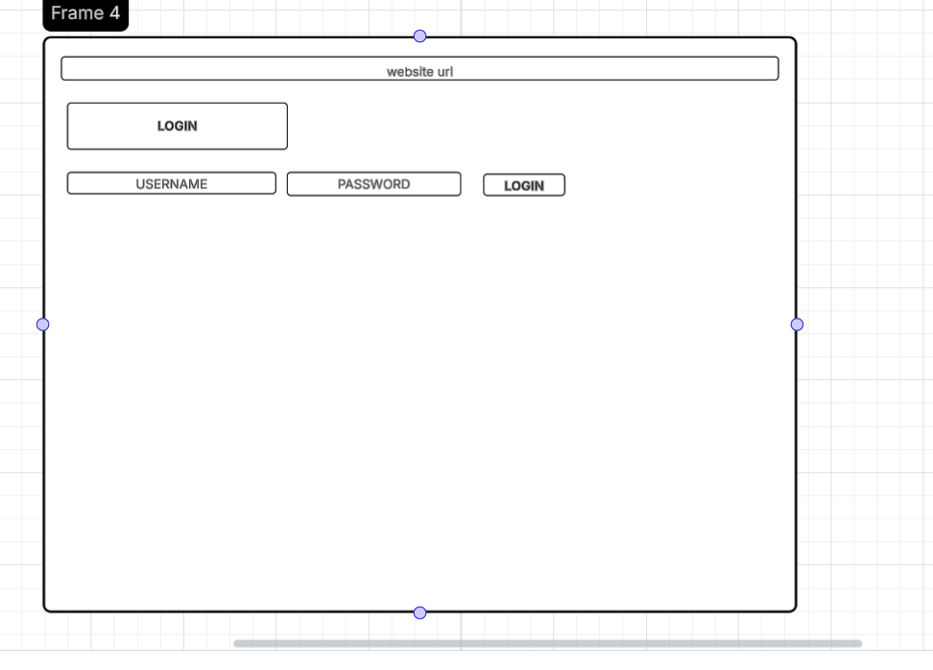

Page 2
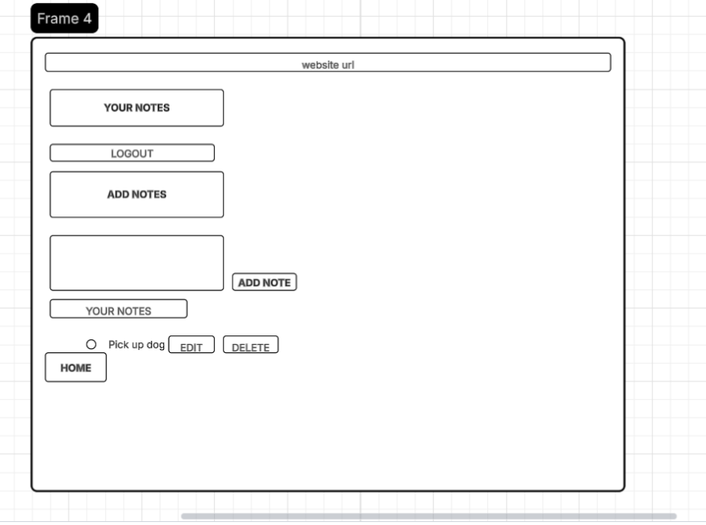

Page 3
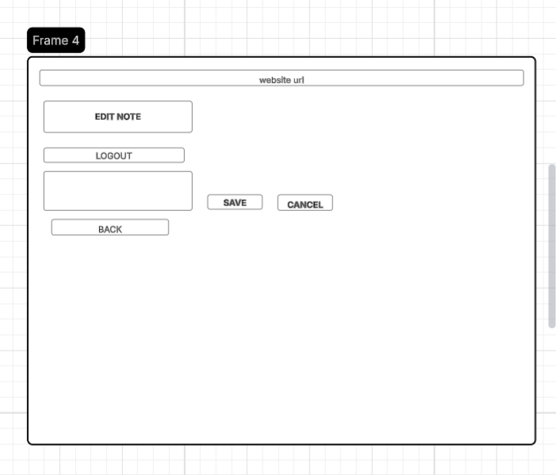

Page 4
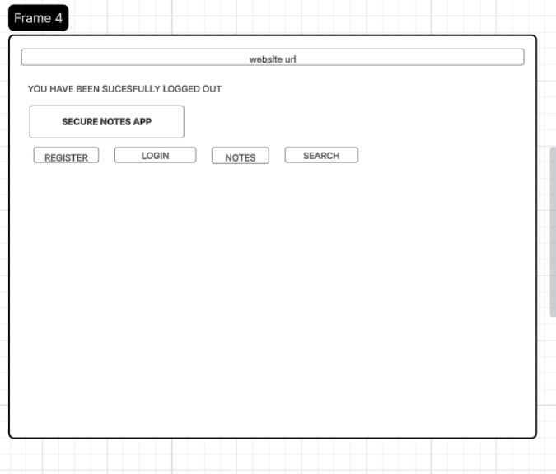

Use-Case Diagram:

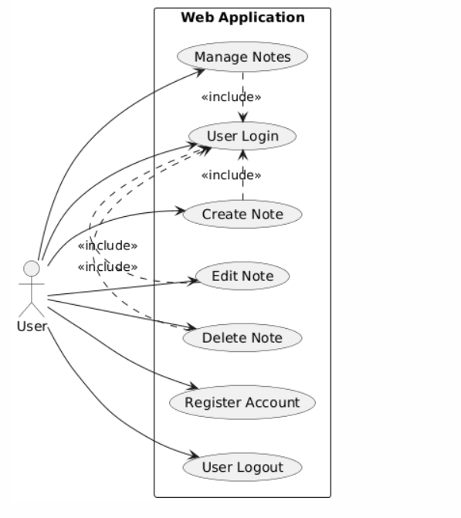

Use-case | Use-Case Name | Description
UC-1 | User authentication | Where a user registers account/ login into the web application
UC-2 | Manage notes | Allows an authenticated user to view edit delete and create notes.
UC-3 | Edit note | Allows an authenticated user to modify any of their notes
UC-4 | Logout | Successfully logs out a user in a session and successfully terminating session token.

Use-Case Description:

Use Case ID: | UC-1
Use Case Name: | User authentication
Created By: | Adriana Armstrong | Last Updated By:
Date Created | 1/12/2025 | Last Updated Date
Description: | The process where the new user registers an account and existing user logs into the TO-Do List web application
Actors:  Primary  Secondary | Primary actor – user  Secondary actor - system
Triggers: | User clicks ‘login’ button or the ‘register’ button on the landing page
Pre-conditions: | Users’ browser is open in the applications URL
Post-Conditions: | Successful login; user is authenticated and redirected to the notes management page. Session ID is created and stored successfully. Successful registration; new user account created, password is hashed and user is directed to login page.
Normal Flow: | 1; user provides credentials-user enters username/password.  2; system check- the application validates the inputs  3; database query – a parameterised query will run against the data tier to check if user does exist and if hashed passwords match  4; authentication – if successful the system will generate a token and grants access  5; the user is redirected to the notes management page.
Alternate Flows: | Registration; if the user is new they will select the ‘register’ option, provide their credentials and the password will be hashed and salted using bcrypt and a new record is created in the USER entity
Exceptions: | Login failure; invalid credentials provided. System action- displays generic error message (invalid username or password) to prevent user enumeration. Detailed errors are logged internally
Includes:

Extends:

Priority: | High
Special Conditions: | Use of bcrypt strong password hashing and secure session management.
Assumptions: | Flask is operational
Notes and Issues: | Password hashing implementation needs to be robust against sensitive data.

Use Case ID: | UC-2
Use Case Name: | Manage Notes
Created By: | Adriana Armstrong | Last Updated By:
Date Created | 1/12/2025 | Last Updated Date
Description: | Allows authenticated user to view, create, edit and delete their own notes within the application
Actors:  Primary  Secondary | Primary actor – user  Secondary actor – system
Triggers: | User clicks ‘add notes’ button, ‘edit’ button, ‘delete’ button or navigates to the note page after login
Pre-conditions: | The user is successfully authenticated and has an active secure session
Post-Conditions: | Successful creation/edit; note data is saved in the database and notes list is updated. Successful deletion; the note is permanently deleted from database. Logout; user session is terminated and user is directed to main or login page.
Normal Flow: | 1; view notes- system will retrieve notes associated with user ID, note content is output encoded before rendering to the user browser.  2; create note -user enters a note and clicks ’add note’, system performs the input validation on the content, so a new record is created in the NOTE entity linked to the user-id.  3; edit/delete – user selects ‘edit’ or ‘delete’ the system will verify the note belongs to that user before executing the action.
Alternate Flows: | Logout; user clicks ‘logout’ and the system will terminate the user session and redirects them to the main page.
Exceptions: | Unauthorised access; user attempts to access modify another users notes. System action; access should be denied displaying an error message. Database error; application will display a generic error page logging details internally
Includes:

Extends:

Priority: | High
Special Conditions: | Defense in dept applied by using input sanitation and output encoding to protect note content against XSS. All database queries are parameterised.
Assumptions: | Database connection is active and the user is logged in
Notes and Issues: | Implementation must enforce the one to many relationship for security.

Use Case ID: | UC-3
Use Case Name: | Edit Note
Created By: | Adriana Armstrong | Last Updated By:
Date Created | 1/12/2025 | Last Updated Date
Description: | Allow an authenticated user to modify the content of a note existing to their user-id
Actors:  Primary  Secondary | Primary actor – user  Secondary actor - system
Triggers: | User clicks ‘edit’ button next to a note on the note management page
Pre-conditions: | User is successfully authenticated and has an active session. The note a user wants to edit is existing in the database.
Post-Conditions: | Selected note is updated in the NOTE entity. User is redirected back to note management page with updated list.
Normal Flow: | 1; user selects note- clicks the ‘edit’ button next to a note  2; system verification – the application verifies the note-id belons to the user-id  3; display edit – system presents the edit form pre-populated with existing notes.  4; user makes change – user will modify note  5; system process – upon edit submission the system will perform input sanitisation on new content.  6; database update – the parameterised query is used to update the NOTE record including note-id and user-id in the WHERE clause.  7; success – user is redirected to note management page showing updated note.
Alternate Flows: | Save failure; if validation fails the user is prompted with an error message, update is aborted
Exceptions:

Includes:

Extends:

Priority: | High
Special Conditions: | System must used parameterised queries and input sanitisation to mitigate SQL injection and XSS vulnerabilities during the update process
Assumptions: | The note editing is functional and includes ‘save’ and ‘cancel’ functions
Notes and Issues: | The system must display the existing note content using output encoding to prevent XSS during initial display of the edit form.

Use Case ID: | UC-4
Use Case Name: | User Logout
Created By: | Adriana Armstrong | Last Updated By:
Date Created | 1/12/2025 | Last Updated Date
Description: | Allows an authenticated user to successfully terminate a session and return to main page where a confirmation message is displayed.
Actors:  Primary  Secondary | Primary actor – user  Secondary actor - system
Triggers: | User clicks ‘logout’ button on the notes management page
Pre-conditions: | The user is currently authenticated and has an active session
Post-Conditions: | The user session is securely terminated on the server. The user is then directed to the main page where a display message shows they have been successfully logged out.
Normal Flow: | 1; user requests logout – user clicks ‘logout’ button  2; application process – the application tier (flask) handles the request and performs a session termination.  3; the system will delete the session token from the secure session store (data tier) and removes session cookie from users’ browser.  4; redirection – system will redirect user to main page.  5; confirmation – a display message will appear on main page
Alternate Flows: | No alternative
Exceptions: | if a session is already expired before ‘logout’ the system will redirect to main/ login page without an error as the post condition is already met.
Includes:

Extends:

Priority: | High
Special Conditions: | Session management should use secure flags and have a short expiration time to limit session hijacking. A user must completely logged out on the server side.
Assumptions: | Flask is operational
Notes and Issues: | Proper logging out should capture timestamp and user id of the successful logout event.

Class Diagram:
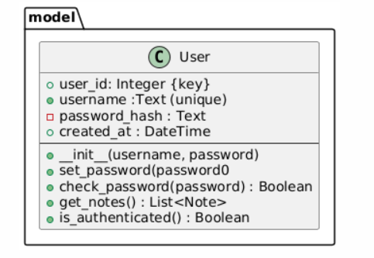

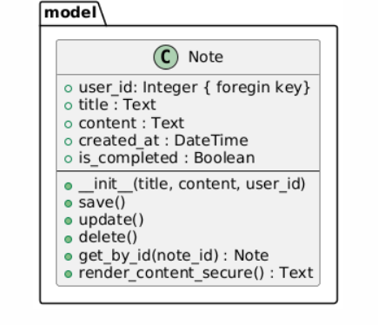

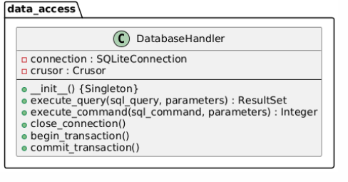
Design principles/patterns - I incorporate the Singleton pattern where this is incorporated in the DatabaseHandler and SecurityLogger classes. With making my constructor of the DatabaseHandler private providing a static method to access a single instance I can ensure this throughout my application. Only one database connection and one logging instance exits, this is crucial for my resource management to avoid connection overload and security auditing meaning they are al written into a single file.
Layered architecture – my application separates the presentation tier, application tier and data tier. My classes are organised into packages like model, service and data_access. The user in my model class handles the business logic like password checking while the DatabaseHandler handles the SQL execution. This fulfils the principle of separation of duties.

Solid principles- single responsibility – each class only has one reason to change, the user class is responsible for user data and business logic related to a user it does not handle the HTTP request or SQL. DatabaseHandler class is for connecting to the database and executing generic parameterised SQL queries, it does not contain any user specific logic. The SessionManager class is responsible for managing the secure state of tokens for the user session. Open/closed principle – my classes are open for extension but not modifications. If I decide to change my SQLite3 to a different SQL I should be able to create new classes without having to modify my logic. This should allow for easy maintenance or future technology mitigation.

Dry principle – this focuses on redundancy in my code. My password hashing and checking logic is implemented only once in my user class, any part of my application that needs to verify these credentials will call these methods instead of duplicating the hashing algorithm. All of my database interactions flow through my DatabaseHandler, this will prevent the other classes from having to manage its own connection.

Sequence Diagram:
Describe the sequence of messages outlined in the sequence diagram.
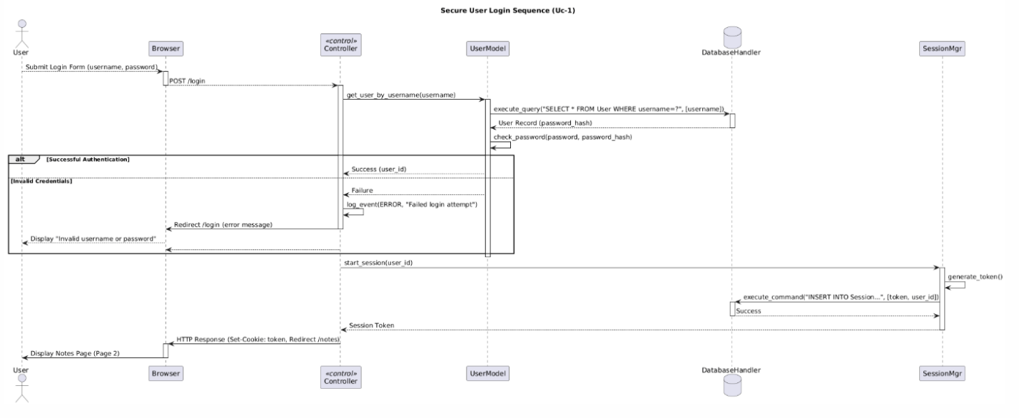

Initiation request handling – 1. User -> Browser View, the user submits the login form containing their username and password. 2. Browser -> Controller, the browser sends the credentials to the application tier via POST /login request. 3. Controller -> UserModel, the controller delegates the responsibility of verifying the user’s existence to the business logic.
Database access and authentication – 4. UserModel -> DatabaseHandler, the usermodel uses the DatabaseHandler to securely call my query. This enforces the NFR1 to prevent SQL injection. 5. DatabaseHandler -> UserModel, the database returns the user record which includes the hashed password.
6. UserModel -> UserModel, this then internally calls my method to check the hash password, it receives the plaintext password and compaires it against my stored hashed fulfilling the principle of secure defaults.
Alternative outcomes – 7. Alt(successful) if the check passes the UserModel sends a success message back to the controller. 8. Alt(invalid) if the check fails the UserModel sends a failure message, Controller -> Controller the controller will log the failure event. Controller -> Browser the controller then sends a redirect command with a generic error message. Browser -> User the browser will display a message of invalid username or password to prevent user enumeration.
Session creation and redirection – 9. Controller -> SessionMgr, upon a successful authentication the controller calls start_session(user_id). 10. SessionMgr -> SessionMgr this then generates a session token. 11. SessionMgr -> DatabaseHandler the SessionManger calls execute_command(“INSERT INTO Session…”,[token, user\_id] to securely store the active session state in the database. 12. SessionMgr -> Controller, the session maner returns the secure token. 13. Controller -> Browser, the controller sends the final HTTP response including the secure cookie and redirects the /notes command. 14. Browser -> User the user is finally directed to the main notes page.

Testing Plan
Create a testing plan is based on the normal, Alternate and Exceptional flows in each Use Case Description.

Provide details of the results of this plan.

Use Selenium or Playwright to create tests of your application.

Test the Non-Function requirements of your App using the Chrome developer tools.

Carry out DAST testing on both the Secure and Insecure Branches of your Code using ZAP.
Highlight any Vulnerabilities raised by the tool.

Discussion on the Insecure Code:
Explain the following vulnerabilities and illustrate how you implemented them in your application. Reference the OWASP Top 10 in your answer.
- SQL Injection.
- XSS.
- Sensitive Data Exposure.

Why are they so dangerous?
How a hacker could exploit these vulnerabilities
Provide screen shots of the code.
Provide a screen shot of these vulnerabilities in action in your application.

Discussion on the Secure Code:
Explain how you secured your application from the SQL injection XSS vulnerability and how use mitigated the Sensitive Data Exposure. Reference the OWASP Cheat sheets as to the available options to secure the application.

Discuss how you incorporated proper logging and monitoring. Make a reference to the
What security headers were added and explain why they improved the security.

Ethics Question:
You are working as a contractor in a large software development company you like the work and the organisation and any future work will depend on how you get on with the lead developer. During the final stage of the project, you are tasked with alpha testing and performing a code review where you discover a major vulnerability that would seriously affect the confidentiality integrity and availability of sensitive data held by the organisation. This discovery was only possible because of a penetration test that you had performed for a different client but as part of that test, you signed a letter of engagement which included a non-disclosure clause. You advised the lead developer of your findings and because of a lack of time to fix that problem, he does not want to do anything about it.
Consider three of the Software Engineering Code of Ethics principles and describe what you are going to do about the ethical issues raised by this scenario.

Answer
Principle: Public (the paramount consideration)
The software engineers should act consistently with public interest. Ethical issues, the vulnerability will jeopardises the confidentiality, integrity and availability of CIA of sensitive data held by the organization. The sensitive data likely belongs to customers, employees or partners meaning the security failure has consequences to the public not just the company. The lead developer’s refusal to act on this is against the public’s right to security and privacy.
Action- I can try to raise the concern by formally reporting details of the vulnerability and the lead developer’s refusal to a higher authority like the project manager or chief information officer or head of the department. I can also document everything from the initial report to the lead developer with the date and response. I will also document the steps and consequences of the vulnerability by showing the paper trail to ensure the issue is formally addressed.

Principle: Client and Employer
The software engineers should act in manner that is in the best interests of their client and employer with the interest of the public. Ethical issues, the developer’s decision to not act on the issue is not in the best interest of his employer, not fixing the issue can lead to a huge financial loss and legal issues or reputational damage. My personal interest (future work) conflicts with the professional duty of protecting the employer from risk.
Action – when reporting the issue, I should maintain my professionalism focusing on the technical risks and potential damage to the company. I will not report on my lead developer’s decisions. I will show that I am acting upon my employer’s best interest with proposing a mitigation plan that could address the immediate threat while allowing the team to meet the deadline that is scheduled.

Principle: Judgment
The software engineers should ensure that the professional judgment is not compromised by conflict of interest. Ethical issues, the NDA from the previous client can create a potential conflict meaning I cant reveal the source or methodology of the discovery of the penetration test. My judgement is being suppressed by my lead developers decision due to schedule pressure.
Action – I have to adhere to the NDA I won’t mention the previous client, penetration test and letter of engagement, but I can state that I have discovered the vulnerability during the current project code review/ test. I have to also back myself confidently showing I think this is a major risk. If the issue cannot be resolved I may need to ethically refuse the sign off on the testing phase until the risk is formally accepted by the CICO.

Appendix A Breakdown of Marks
Section | Description | % mark
1 | Software Development Lifecycle justification | 10%
2 | Software Requirement Specification | 20%
3 | The Use of GitHub for code and project planning | 5%
4 | Discussion of Insecure code implementation | 20%
5 | Discussion of Secure code implementation | 20%
6 | Testing Documentation and results | 10%
7 | Short video demonstrating your project | 5%
8 | Ethics | 10%

Appendix B
Link to GitHub:

Link to Video Demonstration:

