Bootstrap Homework

Bootstrap is an open-source Javascript framework developed by the team at Twitter. It is a combination of HTML, CSS, and Javascript code designed to help build user interface components. Bootstrap was also programmed to support both HTML5 and CSS3.

Also it is called Front-end-framework.

Bootstrap is a free collection of tools for creating a websites and web applications.

It contains HTML and CSS-based design templates for typography, forms, buttons, navigation and other interface components, as well as optional JavaScript extensions.

Some Reasons for programmers preferred Bootstrap Framework

1. Easy to get started
2. Great grid system
3. Base styling for most HTML elements(Typography,Code,Tables,Forms,Buttons,Images,Icons)
4. Extensive list of components
5. Bundled Javascript plugins

Reference:

* <http://getbootstrap.com/getting-started>
* <https://www.youtube.com/watch?v=YXVoqJEwqoQ> (watch this video)

***Note: The last step says to push to github. I want you instead to push to your github.io site. Don’t push all your past homework out via your github.io site just yet***. Only do your vanity page, and a link to this assignment. I will show you more on branching this upcoming week and how to create gh-pages for your assignments. You will be restructuring your github.io page next week.

## Requirements

Minimal requirements:

* Create at least 3 pages of content with a consistent style (see below)
* Create the general page layout on each page using Bootstrap's grid layout features.
* Use a single Bootstrap navigation component on all pages to allow visitors to browse among the 3 pages.
* Customize at least 3 Bootstrap components on each page (choose any you like)
* Post the code on github using a published github pages on a github.io page. Post your like to blackboard.

These are designs only… it’s a rough idea of what it should look like. You have full liberty to mess with this. Include any navigation you like.

Page 1 layout:

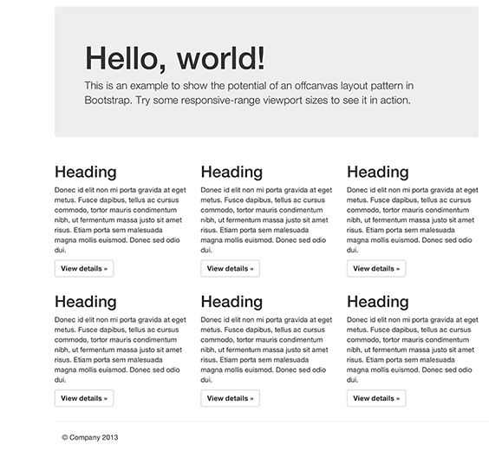

Page 2 layout:  
 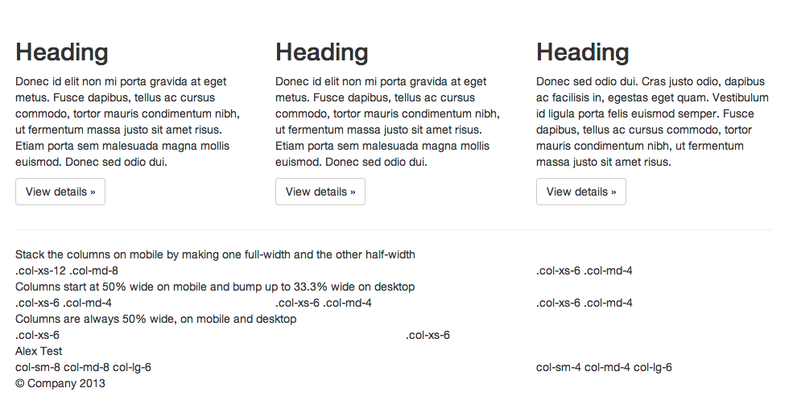

Page 3 Form

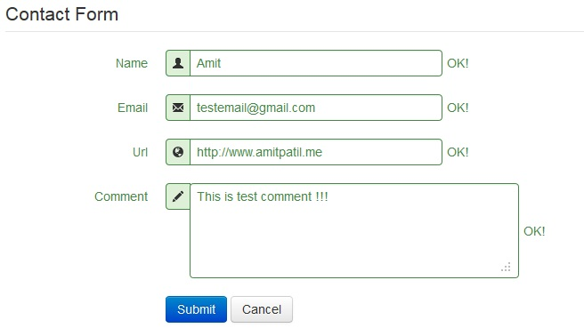

Less Homework

**Less** (also known as **LESS**) is a dynamic stylesheet language that can be compiled into Cascading Style Sheets (**CSS**), or can run on the client-side and server-side. Designed by Alexis Sellier, **Less** is influenced by Sass and has influenced the newer "SCSS" syntax of Sass, which adapted its **CSS**-like block formatting syntax.

References:

* <http://codeumbra.eu/less-101-learn-to-use-the-less-css-preprocessor> (read this tutorial)
* <https://www.youtube.com/watch?v=oh7_iZWvIyU> (watch this video)

I promised you easier homework this week. So all I want you to do is read the article above and watch the video. ***Make sure you do this.*** I’ve been known to give a pop quiz on the easier homeworks where you only have to read/watch something. Make sure you can answer what a mixin is and what does nesting mean (with less).