**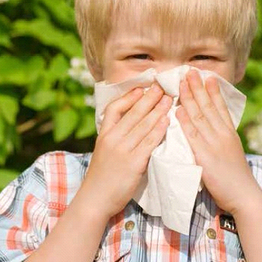

***www.hud.gov/healthyhomes***

***Everyone Deserves a***

Safe and

Healthy Home

***A stakeholder guide for protecting the health of children and all other family members***

*Lead Poisoning*

*Mold and Moisture*

*Asthma and Allergies*

*Radon*

*Carbon Monoxide*

*Indoor Air Quality*

*Unsafe Drinking Water*

*Household Chemicals*

*Pests*

*Home Safety*

*Home Comfort*

*Asbestos*

