Meeting #6

Date: Monday, 5 March 2018, 7 pm to 8:30 pm

Location: Cline Library, Room 143

Minute Taker: Savannah Fischer

Facilitator: Clayton Williams

In Attendance: Kaitlyn Lee, Savannah Fischer, Adam Goins, Brandon Horner, Clayton Williams

* Briefly discussed “D3 – Analysis” assignment and created Google Doc.
* Unanimous agreement to keep meeting relatively short for preparation of CS 386 Midterm
* Discussion of software design and analysis of similar web applications
  + Modularization and GitHub as a means of code collaboration

**Website Ideas**

**First time view homepage:**

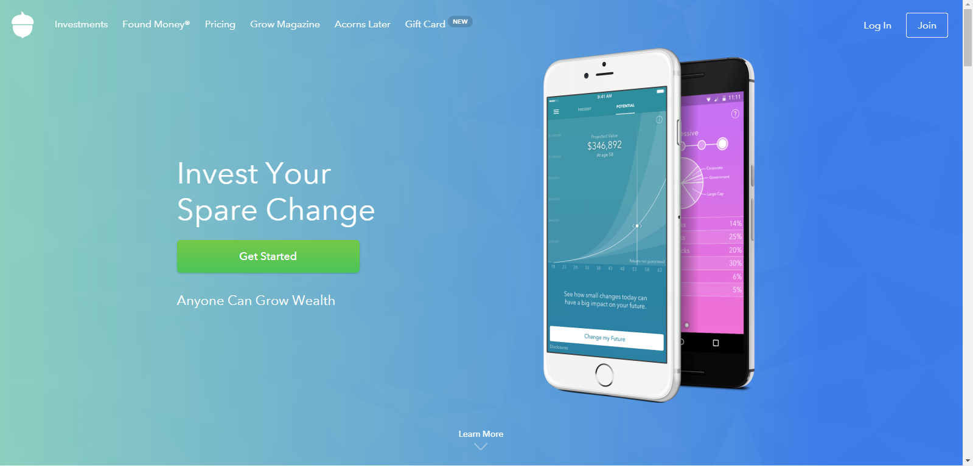

**Live stock watch:**

This appears in multiple stock analysis sites and seems to be something worth considering. Allows for an interactive stock analysis experience. Real time updates.

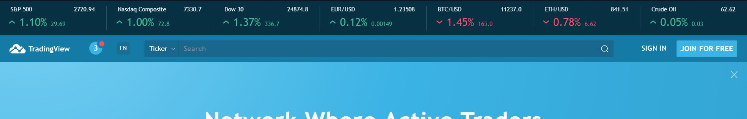

**Link header bar (Preferably collapsing on scroll):**



**“Trending news” format and ad placement:**

Not as busy as some of the other sites, but we may want to tone this blueprint down if we are going to be using something similar. The trending bar is especially encouraging. Add placement (Tradestation on the bottom right) is nice and appears to be a good size. It doesn’t interrupt important information or news stories, only articles on financial advice unrelated to trading.

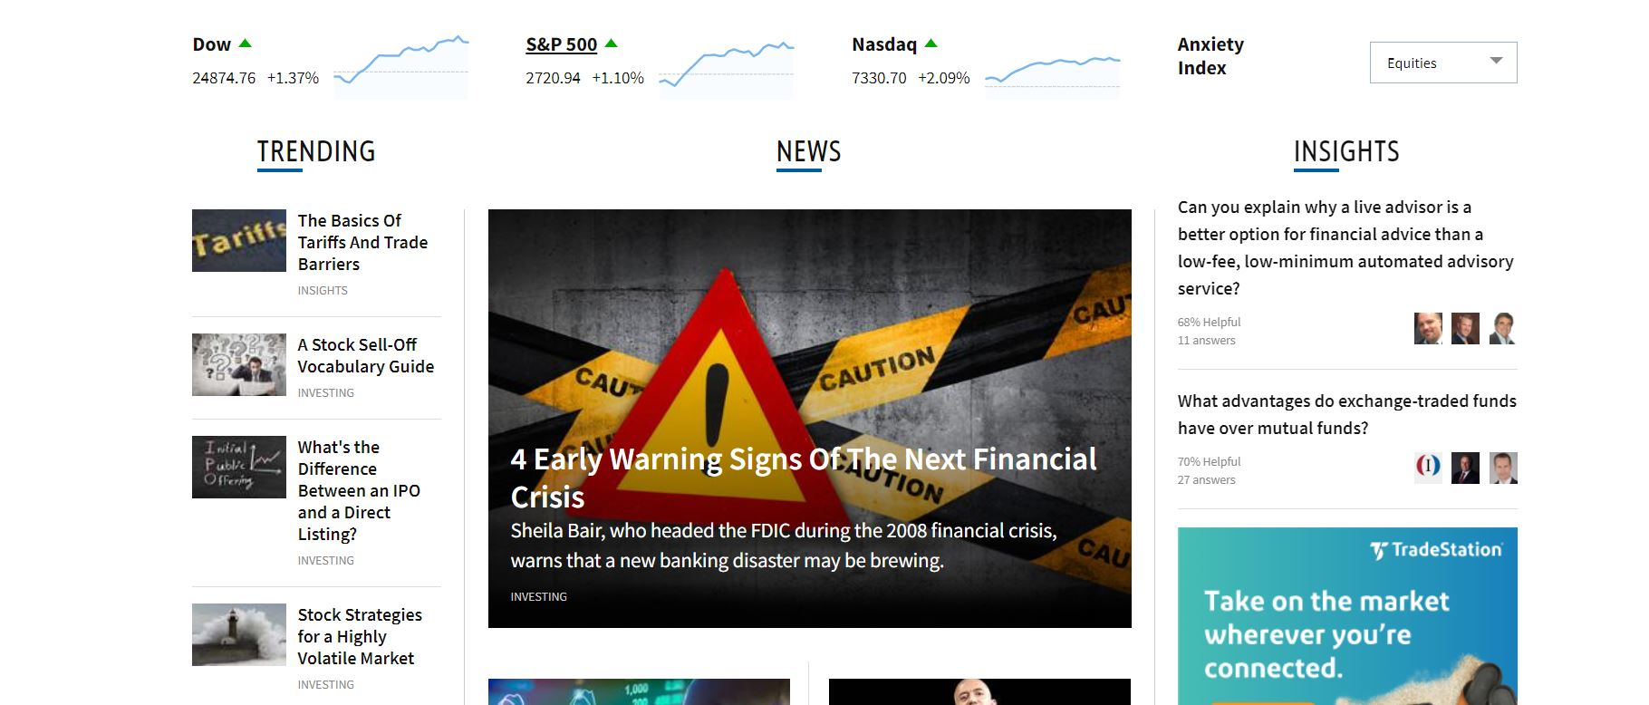

**A way to search for a company’s symbol:**

Maybe include a way to list all symbols in abc order. The idea of being able to search without knowing the full name of the company is a nice feature.

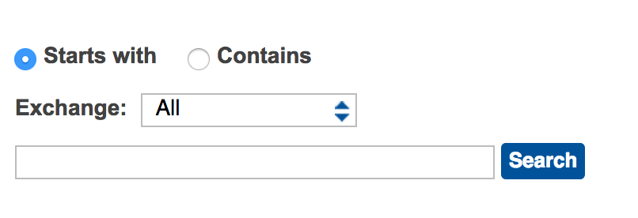

**Watchlist Solo Element: Dashboard:**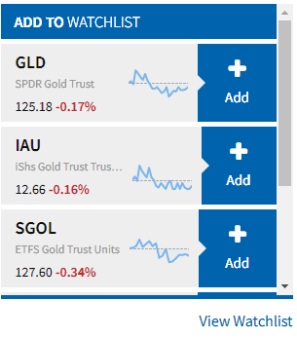

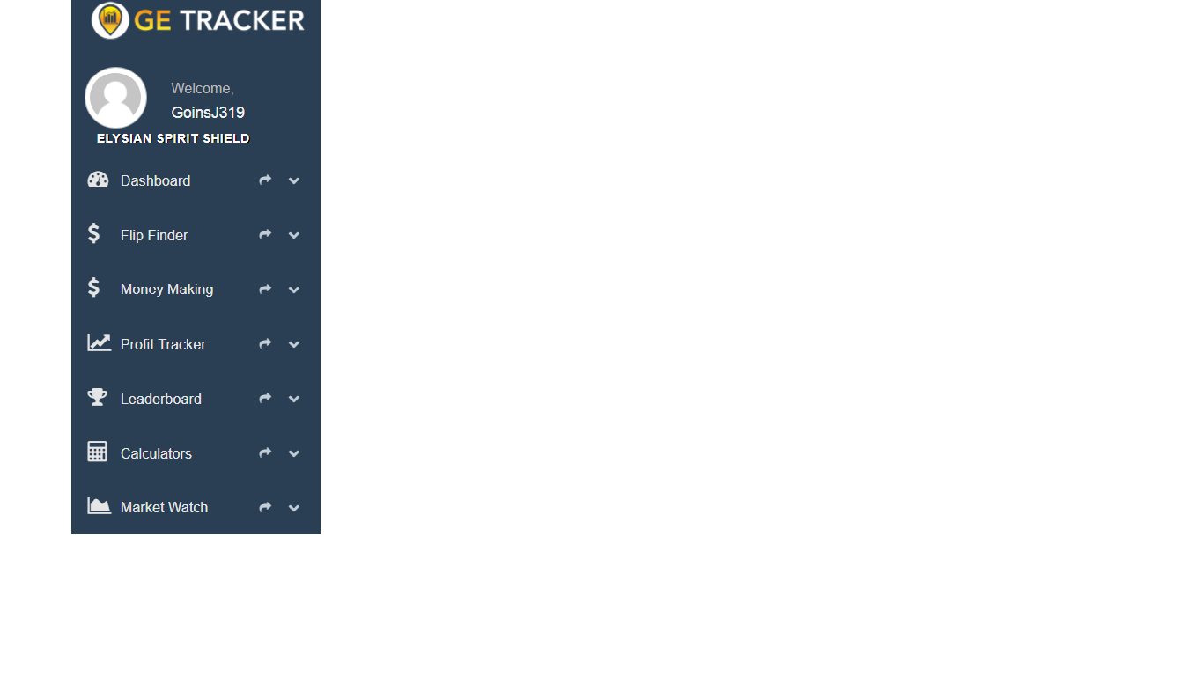

**Default stock watcher of the hottest stocks:**

Could be cool to have something similar alongside the user’s own personal “stock watch”

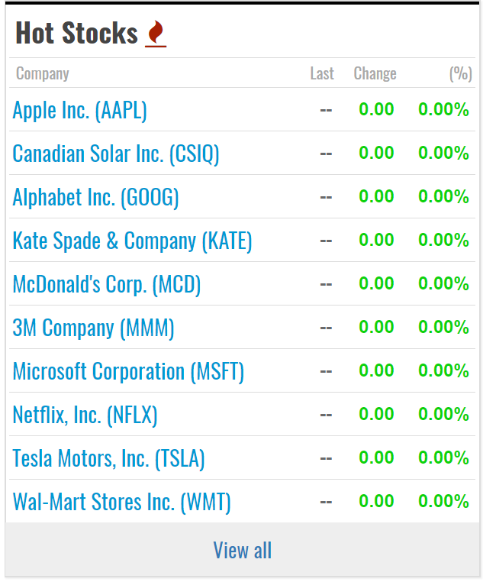

**Glossary:**

Features trending terms, commonly looked up terms, and a search function by category

<http://www.investorguide.com/glossary/>

**Live feed of up to the minute news:**

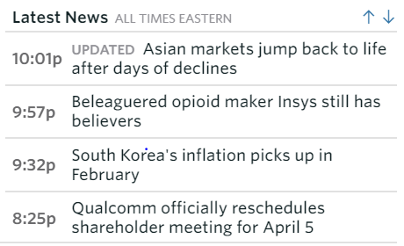

**Potential Main Page idea; Watch List unavailable for those not signed in**

We talked about having news information in the central portion of the main page and a watch list off to the side. Yahoo! Finance utilizes this idea, as well; this could serve as a blueprint.

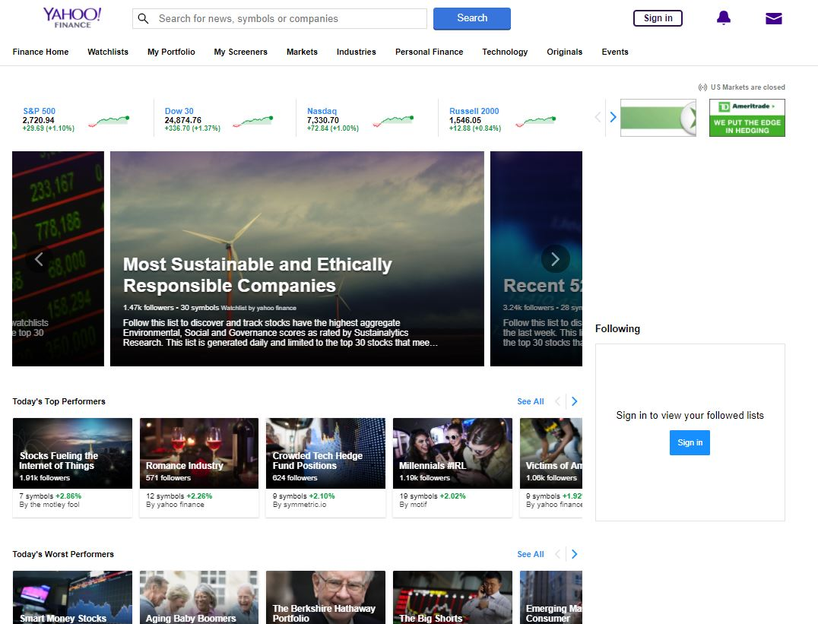

**Next Steps:**

* Next Facilitator = Savannah Fischer
* Next Note Taker = Adam Goins
* Discuss and Work on D3 - Analysis
* Talk about GitHub Workflow and start familiarization process
* Finish first section of Angular 5 online course.
  + Attempt to get ¼ of the way through the 2nd section