SQL Queries- Pizza Sales 25

KPI’s
Total Revenue
Select SUM(total_price) AS Total_Revenue from [pizza_sales]
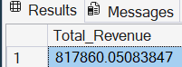

Average Order Price
SELECT (SUM(total_price) / COUNT(DISTINCT order_id)) AS Avg_order_Value FROM pizza_sales
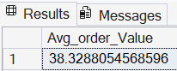

Total Pizzas Sold
SELECT SUM(quantity) AS Total_pizza_sold FROM pizza_sales
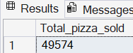
Total Orders
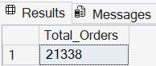
SELECT COUNT(DISTINCT order_id) AS Total_Orders FROM pizza_sales

Average # Pizzas Sold Per Order
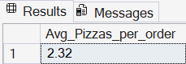
SELECT CAST(CAST(SUM(quantity) AS DECIMAL(10,2)) / CAST(COUNT(DISTINCT order_id) AS DECIMAL(10,2)) AS DECIMAL(10,2)) AS Avg_Pizzas_per_order FROM pizza_sales

Trends
Hourly Trends
SELECT DATEPART(HOUR, order_time) as order_hours, COUNT(DISTINCT order_id) as total_orders from pizza_sales

group by DATEPART(HOUR, order_time)

order by DATEPART(HOUR, order_time)
Daily Trends
SELECT DATENAME(DW, order_date) AS order_day, COUNT(DISTINCT order_id) AS total_orders FROM pizza_sales

GROUP BY DATENAME(DW, order_date)

ORDER BY COUNT(DISTINCT order_id) DESC;
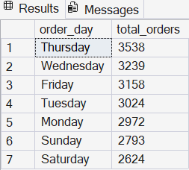
% of Sales by Pizza Type
SELECT pizza_category, CAST(SUM(total_price) AS DECIMAL(10,2)) as total_revenue,
CAST(SUM(total_price) * 100 / (SELECT SUM(total_price) from pizza_sales) AS DECIMAL(10,2)) AS PCT FROM pizza_sales

GROUP BY pizza_category

ORDER BY total_revenue DESC;
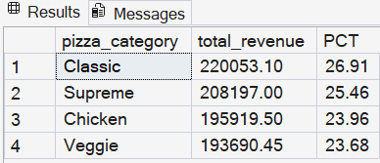
% of Sales by Pizza Size
SELECT pizza_size, CAST(SUM(total_price) AS DECIMAL(10,2)) as total_revenue,
CAST(SUM(total_price) * 100 / (SELECT SUM(total_price) from pizza_sales) AS DECIMAL(10,2)) AS PCT FROM pizza_sales

GROUP BY pizza_size

ORDER BY pizza_size
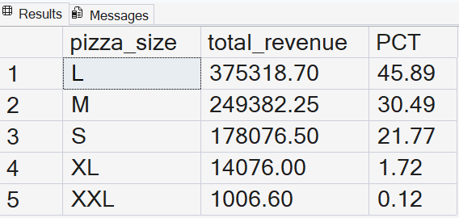
Most to Least Sold Flavors
SELECT pizza_name, SUM(quantity) AS Total_Pizza_Sold FROM pizza_sales

GROUP BY pizza_name

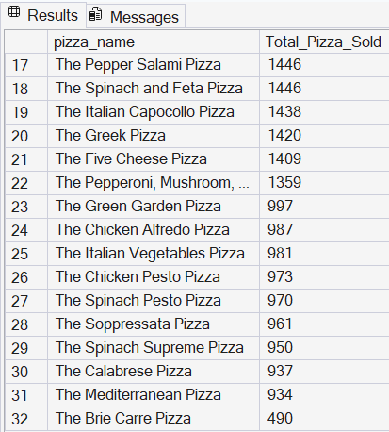
ORDER BY Total_Pizza_Sold DESC;
