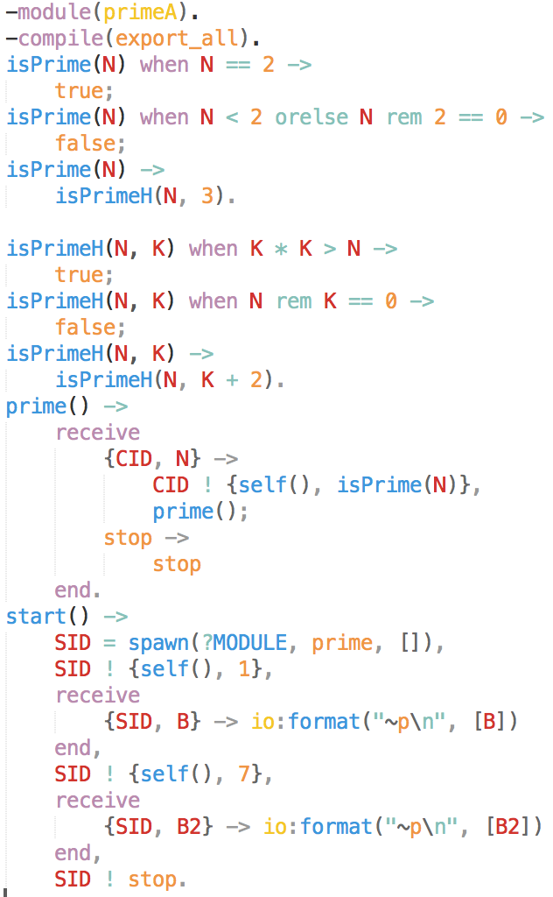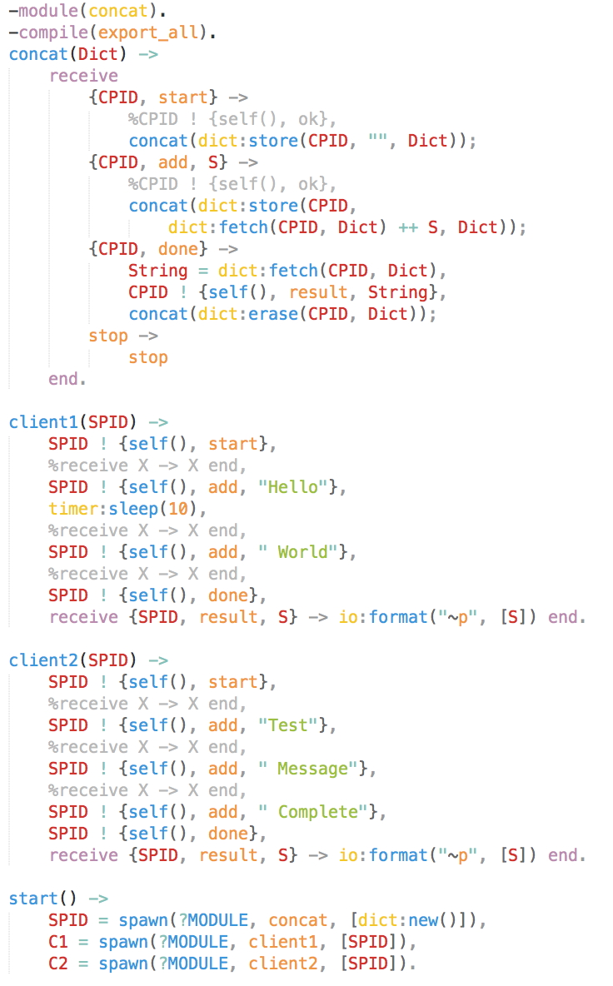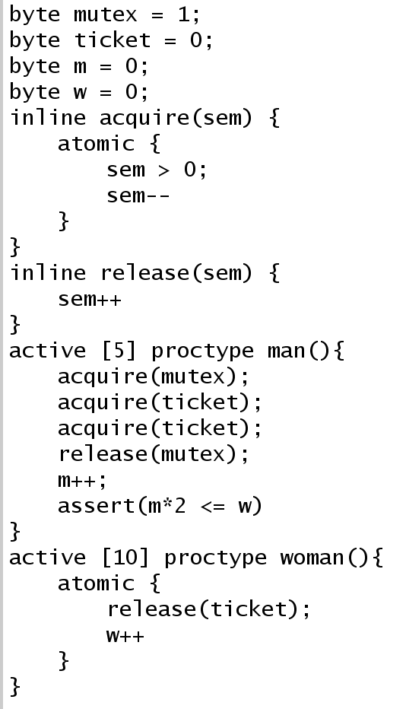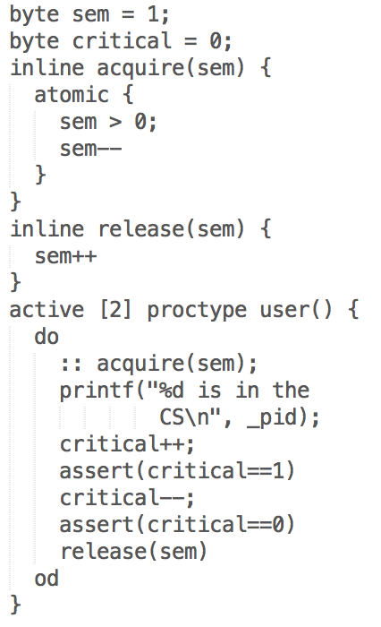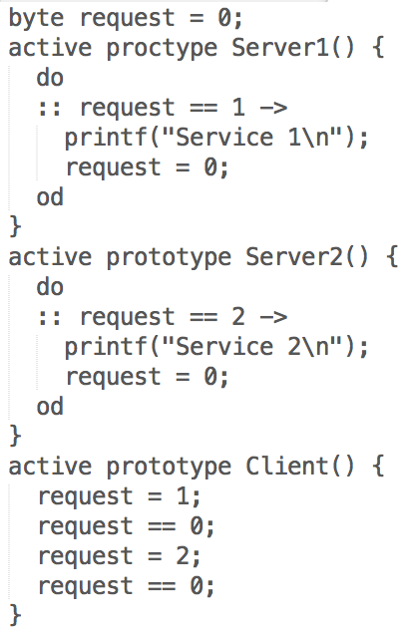

semaphores

concat

Restroom Problem

byte men = 0;

byte women = 0;

byte mutexH = 1;

byte mutexM = 1;

byte mutexHM = 1;

byte toilet = 10;

inline acquire(sem) {

atomic {

sem>0;

sem--

}

}

inline release(sem) {

sem++

}

active [4] proctype menThread() {

/\* Complete \*/

acquire(mutexHM);

acquire(mutexH);

men++;

if

:: men == 1 -> acquire(mutexM)

:: else -> skip

fi;

release(mutexH);

release(mutexHM);

acquire(toilet);

assert(women == 0 && men <= 10);

release(toilet);

acquire(mutexH);

men--;

if

:: men == 0 -> release(mutexM);

:: else -> skip;

fi;

release(mutexH);

}

active [4] proctype womanThread() {

/\* complete \*/

acquire(mutexHM);

acquire(mutexM);

women++;

if

:: women == 1 -> acquire(mutexH);

:: else -> skip;

fi;

release(mutexM);

release(mutexHM);

acquire(toilet);

assert(men == 0 && women <= 10);

release(toilet);

acquire(mutexM);

women--;

if

:: women == 0 -> release(mutexH);

:: else -> skip;

fi;

release(mutexM);

}

Prime numbers

Server

bar

endstate

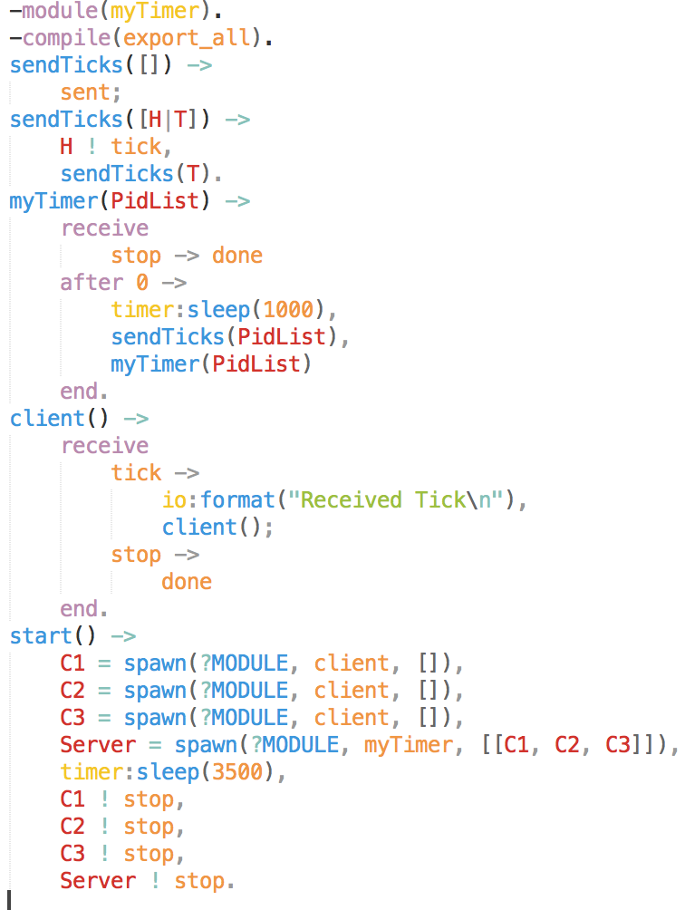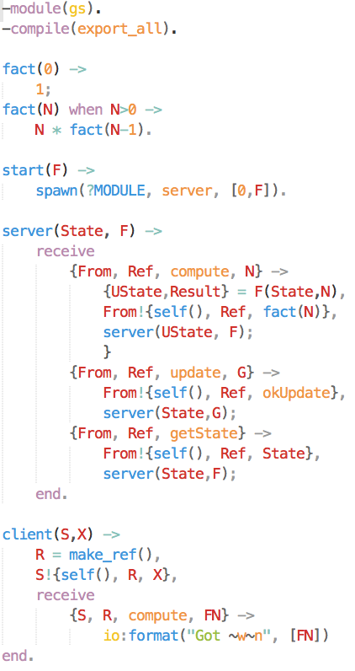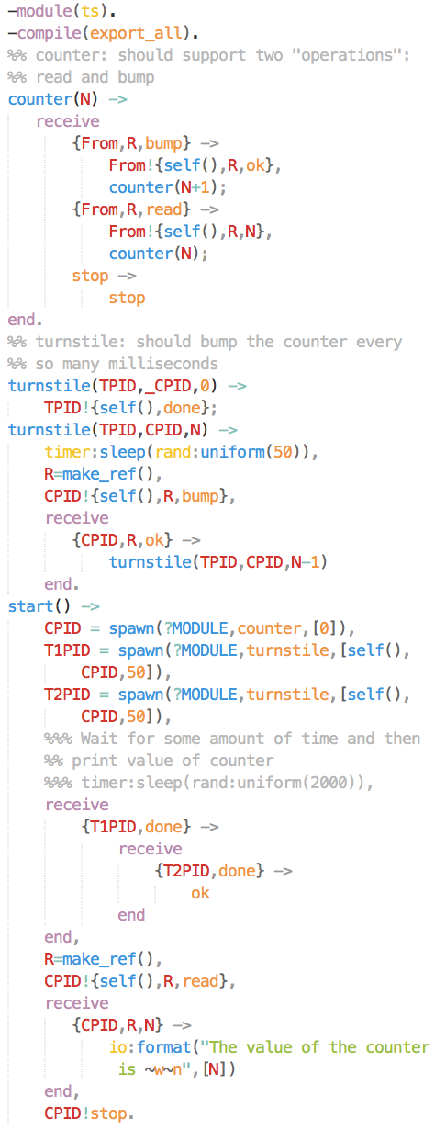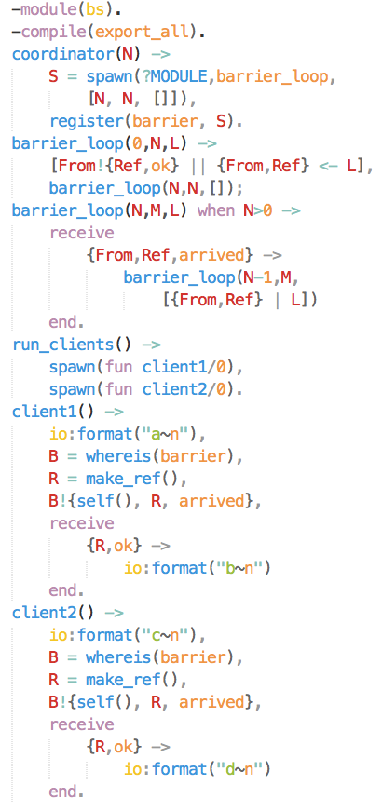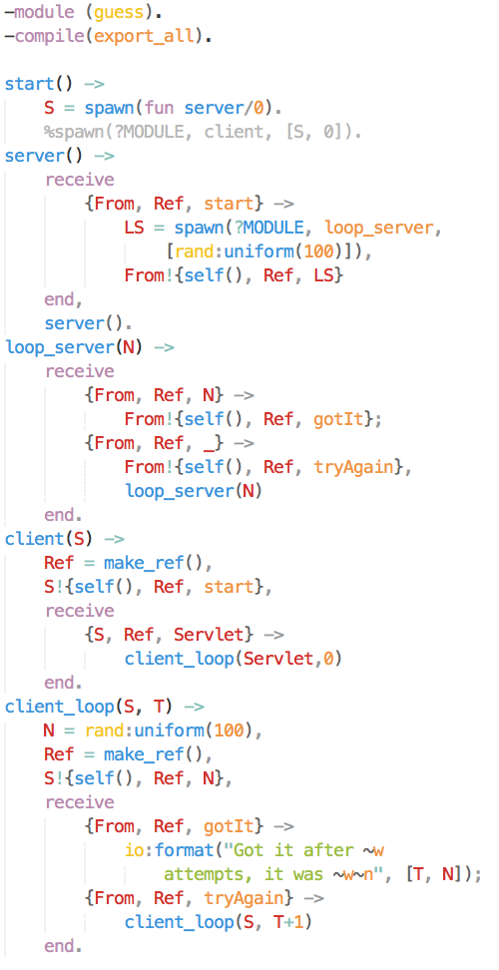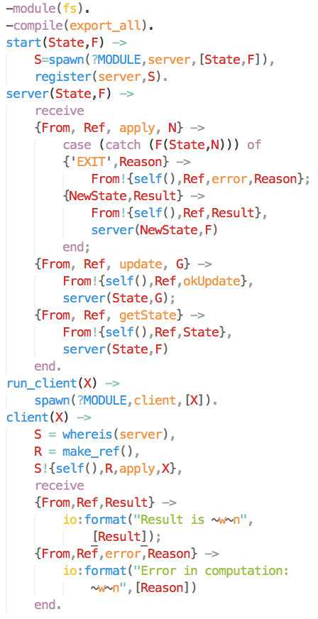

Factorial server

<-

timer

General server

<-

Barriers

turnstiles

Guess the number

<-