**Topic 1: Transition Systems, Interleavings, Paths**

MEP

* Mutual Exclusion: At any point in time, there is at most 1 thread in its critical section.
* Absence of Deadlock: If multiple threads try to access their critical section, at lease one will be successful.
* Free from Starvation: A thread trying to enter its critical section will eventually be successful.
* Critical Section: Part of program that accesses shared memory—should be executed atomically.
* MEP: Problem of ensuring 2 threads don’t execute critical section simultaneously.

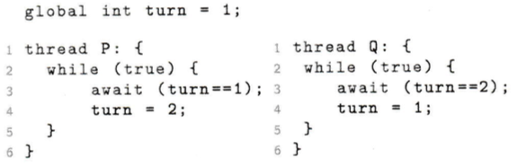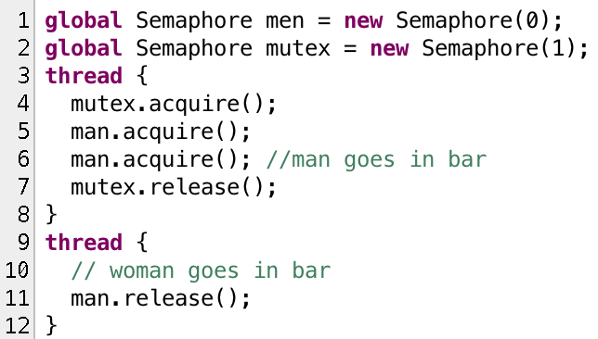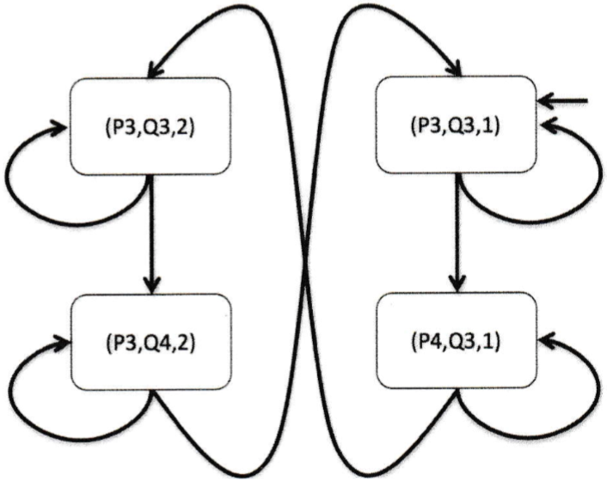**Topic 2: Semaphores**

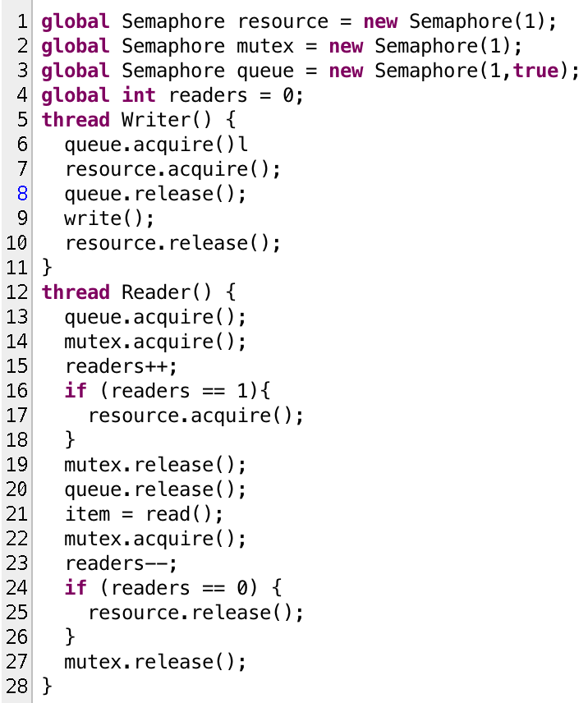

Bar Ratio

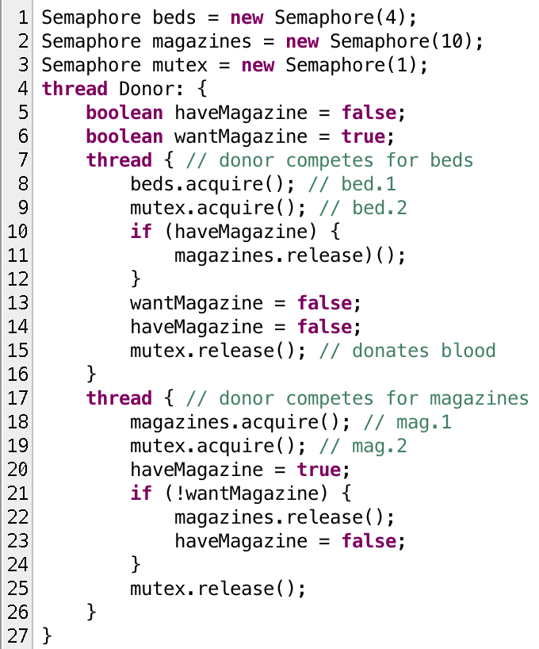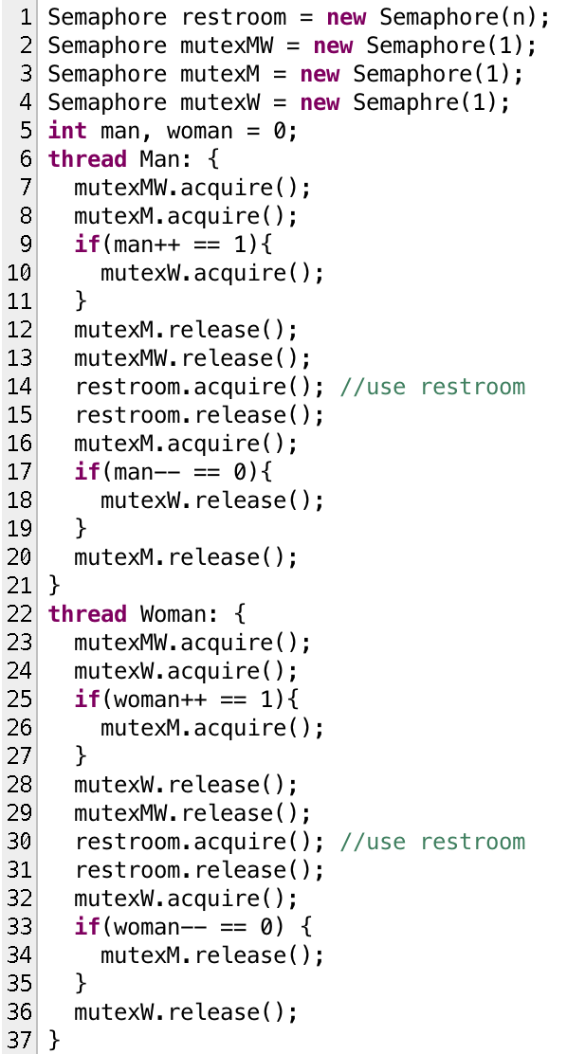

Blood Donors ->

and magazines

Unisex restroom

only used by one

gender at a time

Semaphores: acquire and release

Monitors: wait, signal, empty

<- Reader/Writer

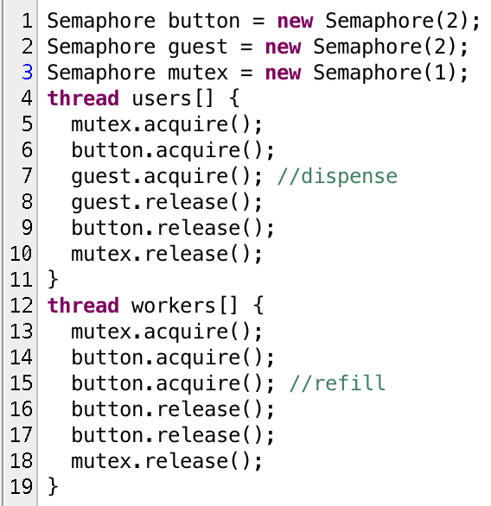**Topic 3: Monitors**

<- Semaphore

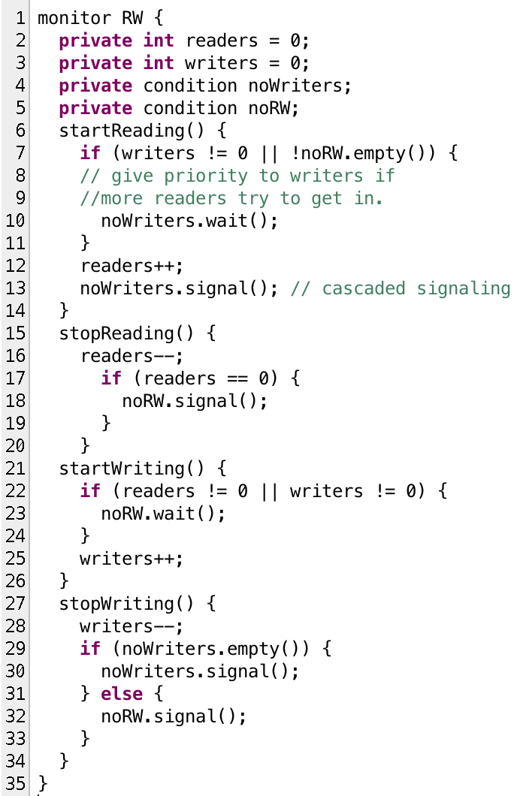

Reader/writer

monitor

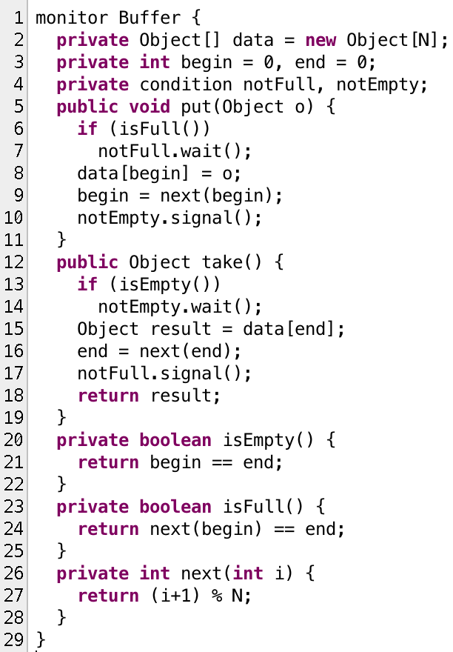

<- Buffer

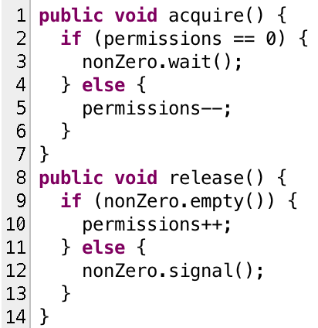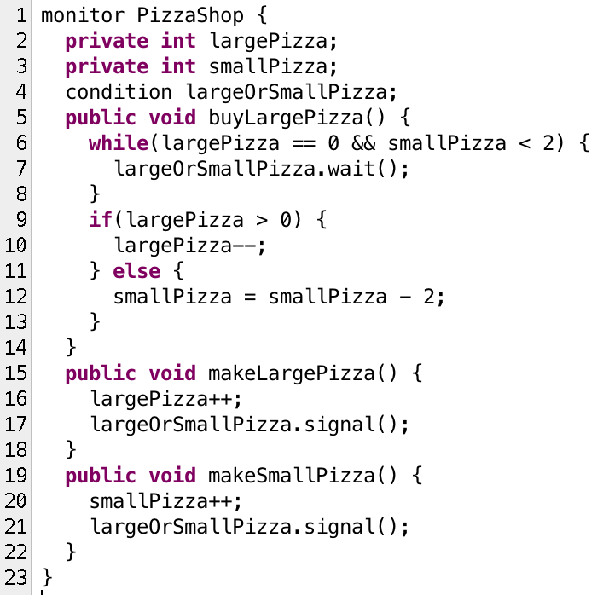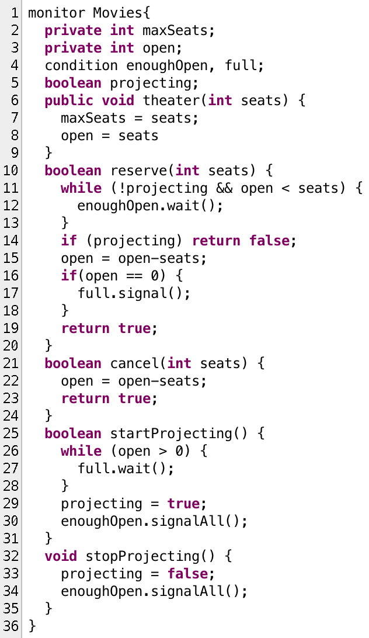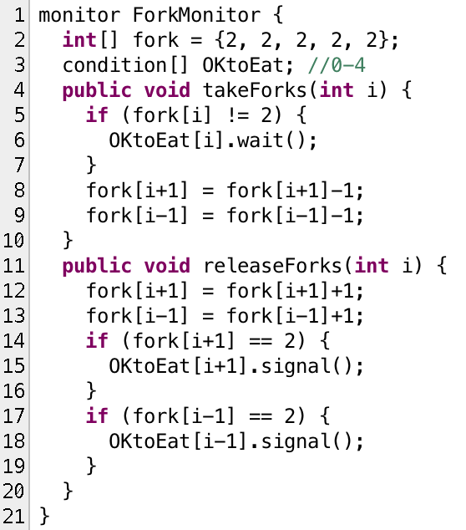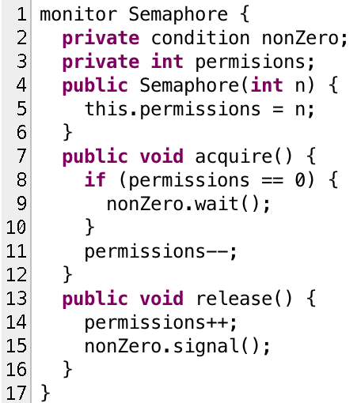

Trace Syntax:

(IP_P, IP_Q, np, nq, shared)

^ Dining philosophers

<- Pizza shop

<- Movie

theater

^ Semaphore

as a monitor ∨