Overview:

Create a tool to help Alphabet Soup select the applicants for funding with the best chance of success. The goal is to create a binary classifier that can predict whether applicants will be successful if funded by Alphabet Soup based on information from past organizations that Alphabet Soup has funded over the years.

* Data Preprocessing
  + What variable(s) are the target(s) for your model?
    - 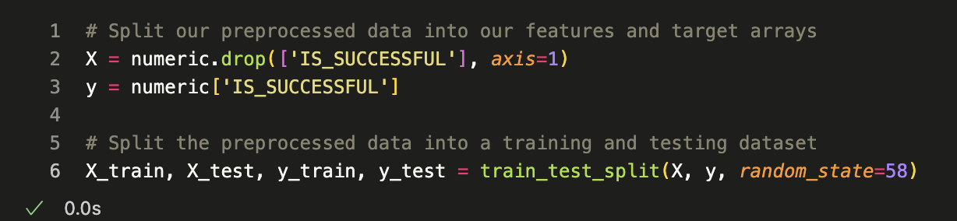The target variable is 'IS_SUCCESSFUL'
  + What variable(s) are the features for your model?
    - **APPLICATION_TYPE**—Alphabet Soup application type
    - **CLASSIFICATION**—Government organization classification
  + What variable(s) should be removed from the input data because they are neither targets nor features?
    - A screen shot of a computer

      Description automatically generatedBoth 'EIN' and 'NAME' columns were dropped/removed, because they were neither targets nor features for the dataset.
* Compiling, Training, and Evaluating the Model
  + How many neurons, layers, and activation functions did you select for your neural network model, and why?
  + Were you able to achieve the target model performance?
  + What steps did you take in your attempts to increase model performance?
    - I initially looked at application type and classification for binning, evaluated two layers with 10 epochs, which resulted in an accuracy of 67.3%.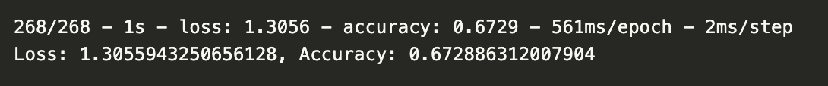 In the optimization model, looked at name and classification for binning, added two layers and increased to 50 epochs. This increased the accuracy to 75%.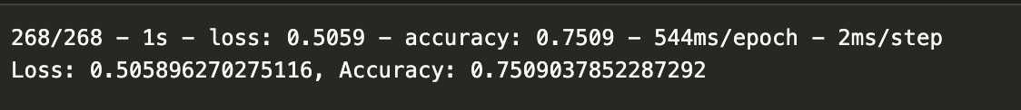

1. **Summary**: Binning by name instead of application type significantly increased the accuracy. An additional model could have additional layers and epochs to evaluate and generate more data.