Alumni Data Case Study
Kaitlyn Straight
BANA 7052: Applied Linear Regression

Executive Summary
Primary Driver: Student-Faculty Ratio is the only statistically significant predictor of alumni giving in the primary sample ($p<0.01$).The “Scale” Effect: While Private status and Class Size appeared non-significant initially, a simulation of $N=500$ reveals they are influential factors previously masked by low statistical power.Recommendation: Universities seeking to increase endowments should prioritize lowering the Student-Faculty Ratio to foster deeper alumni engagement.
In a case study of 48 U.S. universities, the student-faculty ratio was the only significant driver of alumni donation rates. For every 1-unit decrease in the student-faculty ratio (i.e. more faculty per student), the donation rate increases by approximately 1.4%. The goal of our analysis is to identify characteristics that drive alumni donations and develop a regression model for interpretation of insights. The dataset used is from user bgreenwell on GitHub, provided by BANA 7052 course instructor.
The response variable Y is the Alumni Giving Rate (%)—the rate of alumni donations. Predictors included X₁: “Small Classes”—Percentage of classes with fewer than 20 students, X₂: “Faculty Ratio”—Student-faculty ratio, and X₃: “Private”—Private/Public institution indicator.
Exploratory data analysis, multiple linear regression, and diagnostic testing were conducted to evaluate model fit. Lower Student-Faculty Ratio was the strongest and only statistically significant predictor of increased Alumni Giving Rate. Small Classes and Private status were not significant predictors in the original sample, but became significant when simulated with n = 500. The original model fit well, required no transformations, and influential observations did not meaningfully alter results. Understanding alumni giving is critical to universities’ finances as donations support scholarships, research, and infrastructure. T
Decision Support: These findings suggest that to increase long-term endowment growth, universities should prioritize faculty recruitment over infrastructure projects focused on class size.

Exploratory Data Analysis
Histograms show that all variables are reasonably symmetric with mild skew. Private institutions generally exhibit higher giving rates, and there is initial evidence that Faculty Ratio has a negative relationship with Giving Rate. A summary of descriptive statistics for key variables follows:
Variable | Mean | SD | Median | Min | Max
Giving Rate (%) | 29.27 | 13.44 | 29.0 | 7 | 67
Small Classes (%) | 55.73 | 13.19 | 59.5 | 29 | 77
Faculty Ratio | 11.54 | 4.85 | 10.5 | 3 | 23
# Prepare data for correlation viz
corr_df <- alumni %>%
dplyr::select(Giving_Rate, Small_Classes, Faculty_Ratio, private) %>%
mutate(private = as.numeric(private))
corr_mat <- cor(corr_df)
# Heatmap viz
ggcorrplot(corr_mat,
hc.order = TRUE,
type = "lower",
lab = TRUE,
colors = c("sienna", "white", "navy"),
title = "Predictor Correlation: Analyzing Multicollinearity",
ggtheme = theme_minimal())
## Warning: `aes_string()` was deprecated in ggplot2 3.0.0.
## ℹ Please use tidy evaluation idioms with `aes()`.
## ℹ See also `vignette("ggplot2-in-packages")` for more information.
## ℹ The deprecated feature was likely used in the ggcorrplot package.
## Please report the issue at <https://github.com/kassambara/ggcorrplot/issues>.
## This warning is displayed once every 8 hours.
## Call `lifecycle::last_lifecycle_warnings()` to see where this warning was
## generated.
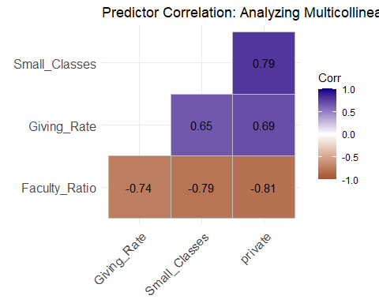
The pairwise matrix indicated moderate correlation among predictors, suggesting multicollinearity between key variables. Statistically significant correlation coefficients R² assert that 64.6% and 74.2% of the variation in Giving Rate is explained by Small Classes and the Student-Faculty Ratio, respectively.
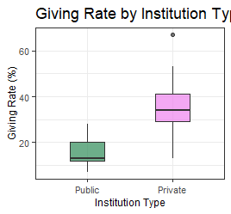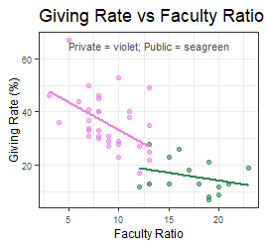
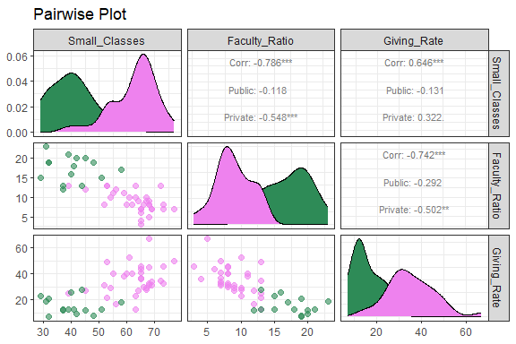

Data Description
The data is structured in csv format, consisting of 48 observations on 5 variables: (“school”, “percent_of_classes_under_20”, “student_faculty_ratio”, “alumni_giving_rate”, “private”). These variables capture information from a sample of U.S. universities, including measures of teaching environment and institutional type.
For preliminary analyses, we used a combination of histograms, scatterplots, boxplots, and pairwise plots to visualize trends and assess distributions and possible relationships between our variables. Our plots also highlight differences between private and public universities.
Results showed generally normal distributions across variables, with a higher giving rate at Private schools. We observed a _fairly even spread of Residuals, with approximately normal distribution and slight right skew, a normally distributed Q-Q plot, and slight heteroskedasticity in our Scale-Location plot.
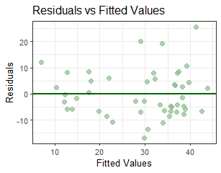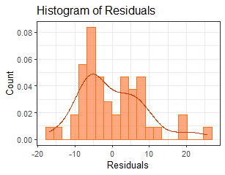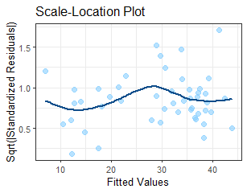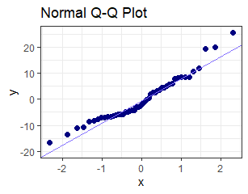

Methods
Through our initial multiple linear regression model, we found an estimated prediction equation given by: $\hat{Y}=36.784+0.077X1​-1.398X2​+6.285X3+ϵ$.
Model Diagnostics & Evaluation: We used the following diagnostic tools:
- Residual vs. Fitted Plot: Check linearity and homoscedasticity
- Q-Q Plot & Histogram of Residuals: Assess normality of errors
- Scale-Location Plot: Evaluate variance consistency across fitted values
- Cook’s Distance: Identify potentially influential observations (21, 33, 37)
- Variance Inflation Factors (VIF): Check for multicollinearity among predictors
- Box-Cox Transformation Analysis: Explore whether a transformation of the response variable could improve model fit or stabilize variance
- Simulation: Explore whether a larger sample size reveals more statistically significant results
Model Selection
Based on Box Cox results, we determined that a transformation was not necessary. While the optimal 𝜆 was 0.8, the 95% confidence interval included 1.0, allowing us to keep the data in its original scale for better interpretability. We We compared the original model to an alternate model in which we removed the most influential points (21, 33, 37), but found no meaningful differences, suggesting our original model is well-fit. Selection was guided by AIC, adjusted R², and diagnostic performance, and the original model was retained.
Variance Inflation Factor (VIF) were approximately 3.18 for Small Classes, 3.51 for Faculty Ratio, and 3.60 for Private/Public. All predictors’ values fall below the threshold of 5, indicating no serious multicollinearity between variables. Note that elevated values for Faculty Ratio and Private Institution suggest some overlap — possibly because private universities tend to have smaller class sizes and lower student-faculty ratios.
Diagnostics and Transformation
To evaluate the appropriateness of the linear regression model, we examined several diagnostic plots and conducted a Box-Cox transformation analysis.
- Residuals vs. Fitted Values: Fitted residuals were centered around zero with slight heteroskedasticity indicating the linearity assumption is reasonably met.
- Residual Histogram & Q-Q Plot: The residuals were approximately normal with a slight right skew and small upper-tail deviations. Normality assumptions are reasonably satisfied.
- Scale-Location Plot: A slight wavy pattern suggests minor changes in variance, but is unlikely to bias coefficient estimates.
- Cook’s Distance: Observations 21, 33, and 37 showed moderate influence but did not meaningfully affect the model.
- Box-Cox Transformation: Suggested optimal λ = 0.8, with a 95% confidence interval including λ = 1, indicating _that the _raw Giving Rate provides an adequate fit and that a transformation of the response variable is not required.__no transformation is needed._
Conclusion
Diagnostic results and the Box-Cox test confirm that the linear model assumptions are adequately met, so the Giving Rate is retained on its original scale for interpretability.

Simulation Study
To address the limitations of the small sample size (n = 48), I conducted a simulation study to determine whether “Private Status” and “Small Classes” were truly insignificant or simply masked by low statistical power. I generated a simulated dataset of n = 1000 observations, fit a multiple linear regression model, and compared distributions with the original data.
Predictor | Original Est. (p-val) | Simulated Est. | Significance
Intercept | 36.78 (0.010) | 42.59 (<0.001) | –
Small_Classes | 0.077 (0.668) | 0.096 (<0.001) | Became Significant
Faculty_Ratio | -1.398 (0.009) | -1.39 (<0.001) | Still Significant
Private | 6.285 (0.247) | -6.86 (<0.001) | Became Significant
Estimate Std. Error t value Pr(>|t|)
(Intercept) 42.59408 1.38006 30.864 < 2e-16 Small_Classes 0.09624 0.02037 4.724 2.65e-06 Faculty_Ratio -1.39049 0.05823 -23.880 < 2e-16 privatePublic -6.85874 0.56079 -12.230 < 2e-16
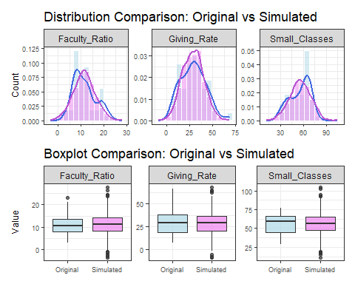
In the simulated dataset (n = 500), both Small Classes and Private/Public predictors became statistically significant. This illustrated that increasing the sample size can reveal effects that were not detectable in a smaller sample. We also observe a more normal distribution for all predictor variables.

Discussion
The simulated dataset produced regression estimates and distributions similar to the original data, suggesting that our findings generalize to larger samples. While class size and private status were positively associated with alumni giving, only student-faculty ratio was statistically significant, with lower ratios corresponding to higher donation rates.__ Model diagnostics indicated minor deviations from normality and mild heteroskedasticity, but not at a level requiring transformation or model manipulation. VIF values suggested only slight multicollinearity, but no single observation greatly influenced results.
Limitations include the small sample size (n = 48), possible omitted variables such as tuition, school rank, and endowment, and a simplified private/public indicator. Future analyses could incorporate additional predictors, cross-validation, and interactions between private status and faculty ratio.

References
- Greenwell, B. (n.d.). Alumni giving data. Retrieved from https://bgreenwell.github.io/uc-bana7052/data/alumni.csv

