**Kaitlyn Zahn**

***Assignment 2 Report***

**February 18, 2021**

**__**

**CS 4610 Computer Graphics 1**

**__**

**Ye Duan**

**_______________________________________**

**Link to YouTube Video**

https://youtu.be/EnbP9yn39f4

**Part A**: Understanding Events (3 points)

*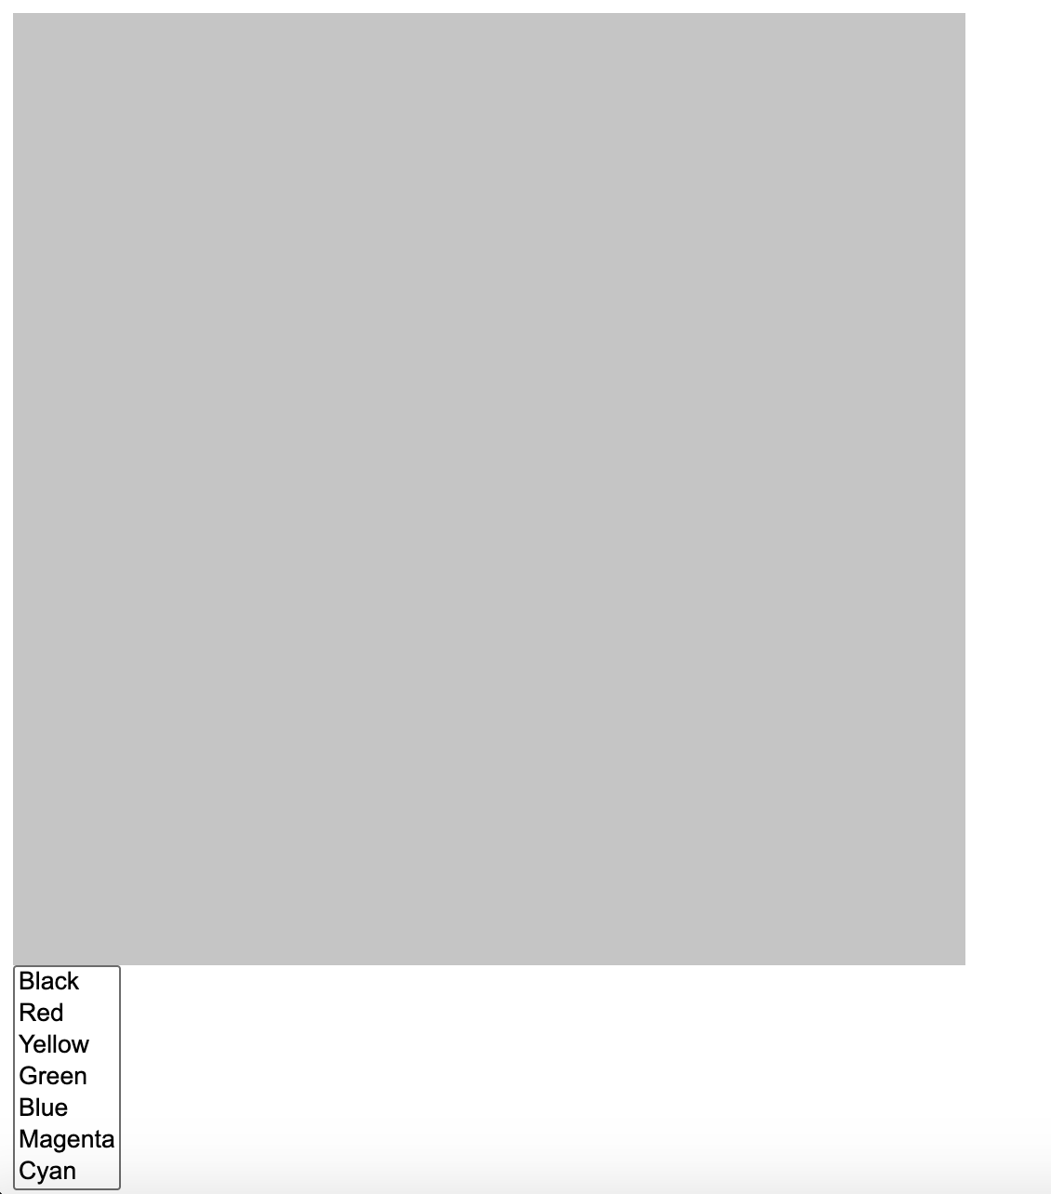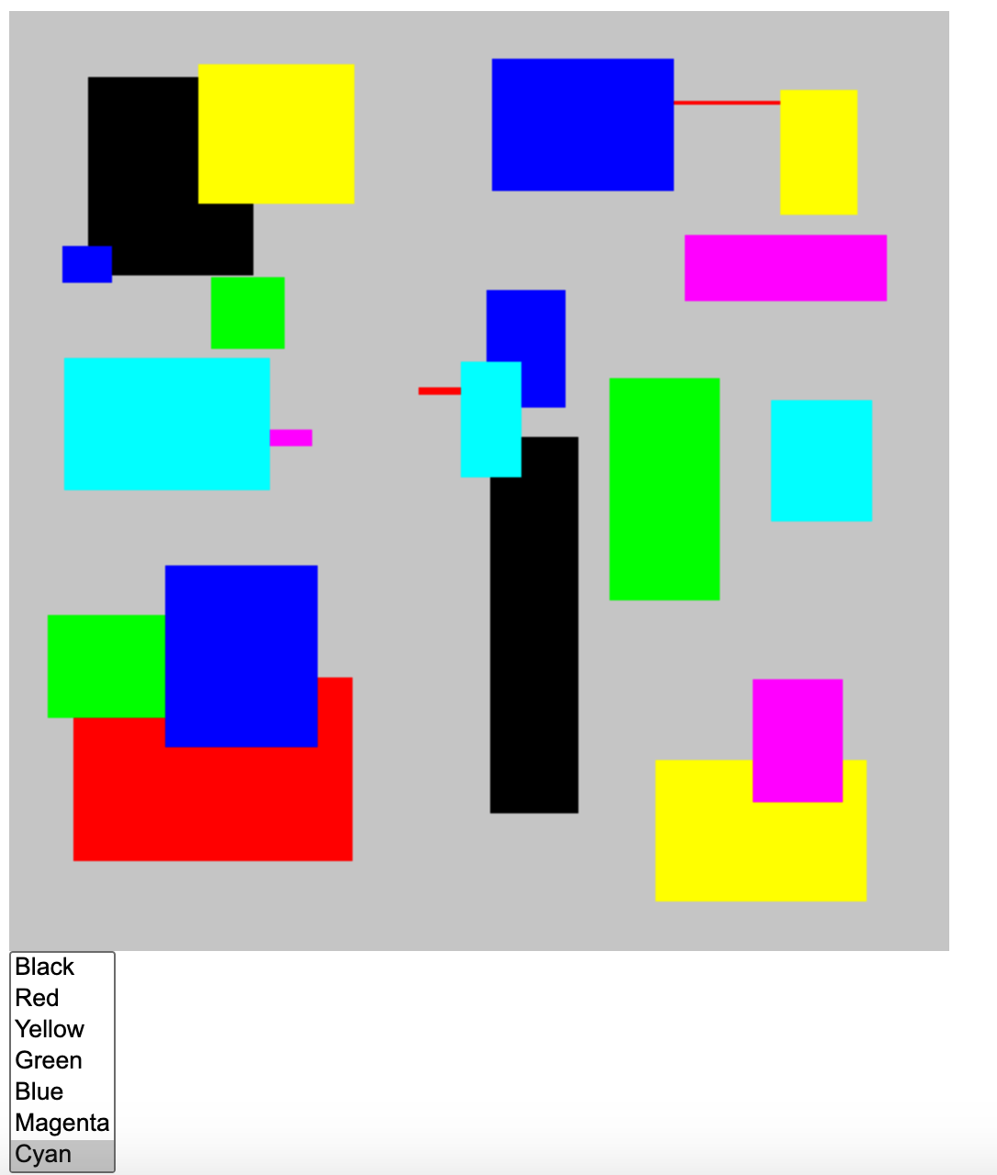Download and run the program Cad1*

Figure A.1.2 Cad1 Drawn

Figure A.1.1 Cad1 Original

*Download and run the program Cad2*

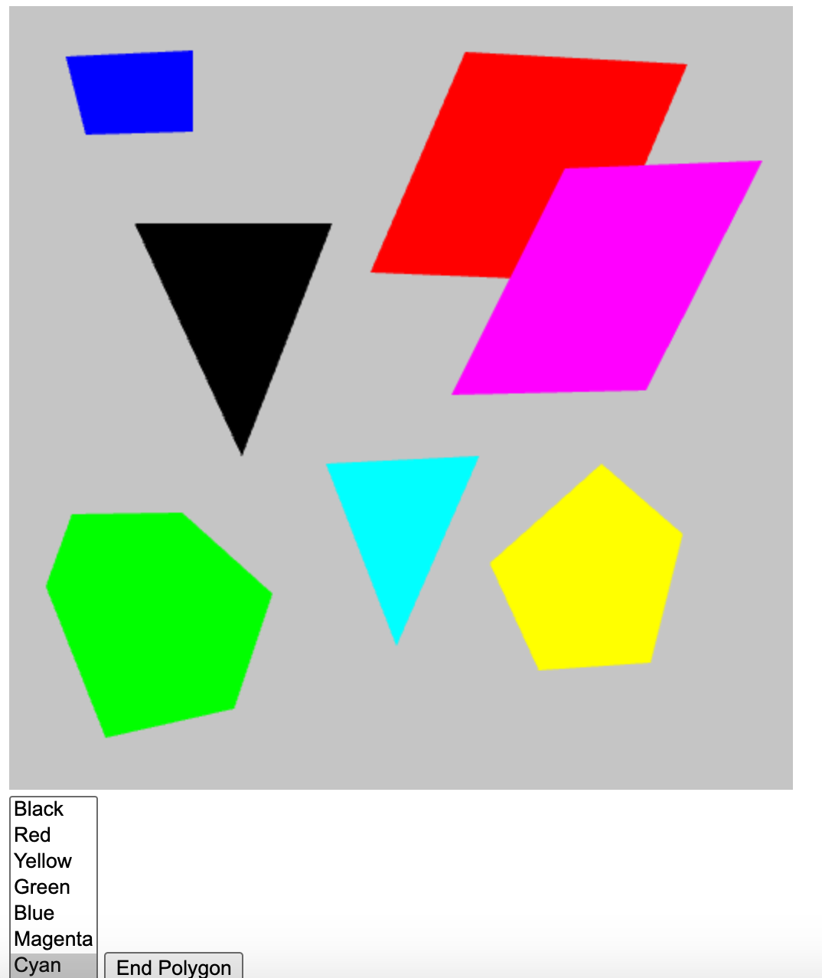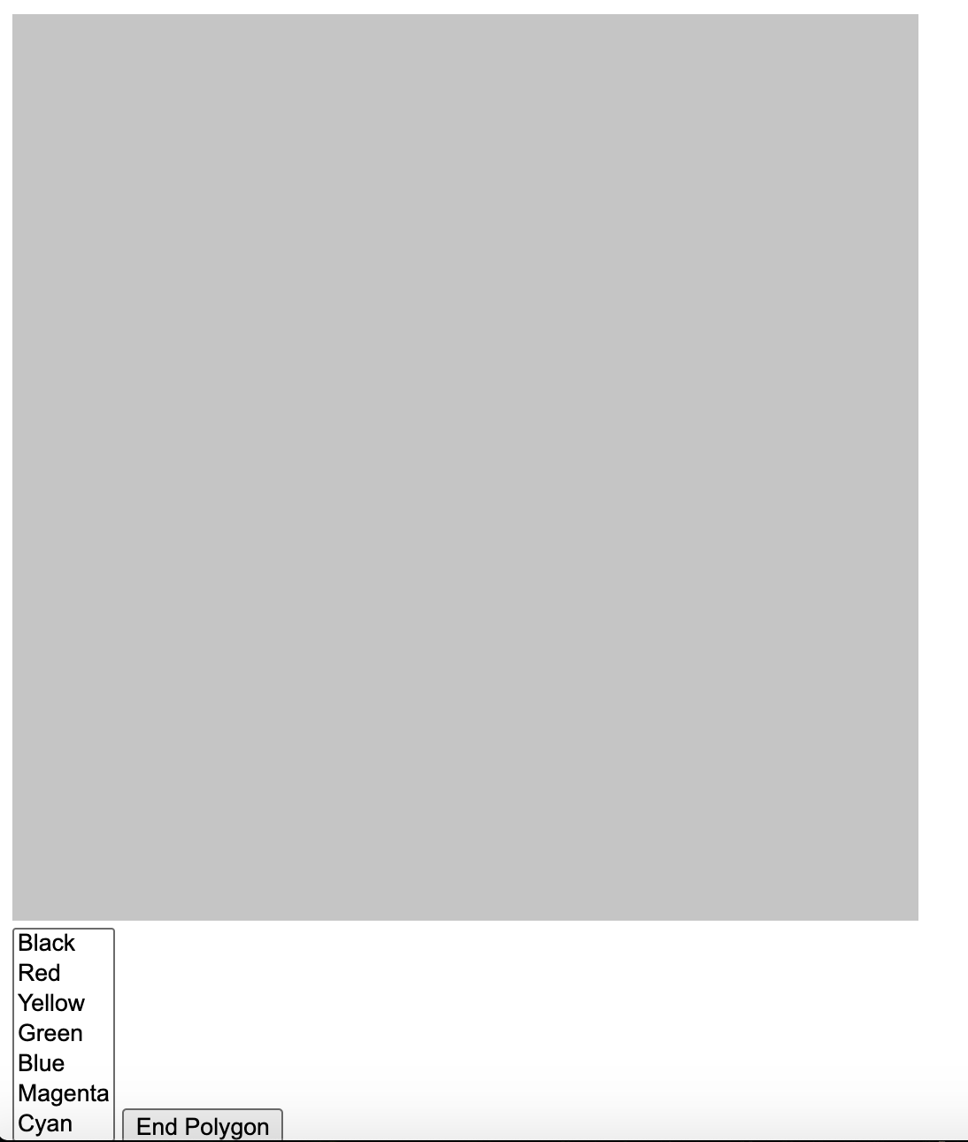

Figure A.2.1 Cad2 Original

Figure A.2.2 Cad2 Drawn

**Part B**: Implementing Mouse and Keyboard Events (7 points)

*Download the program DrawCube that will Render a 3D cube in WebGL.*

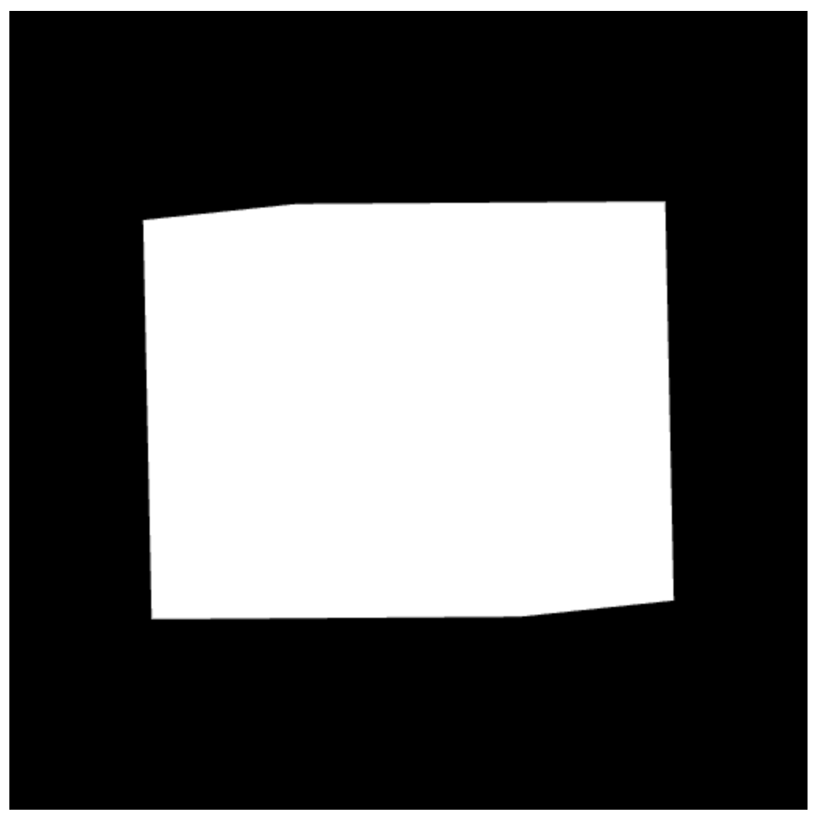

Figure B.1.2 DrawCube Original 2

Figure B.1.1 DrawCube Original 1

*Press any key to make the cube a random color*

Original Code

/*index.html line 50-56*/

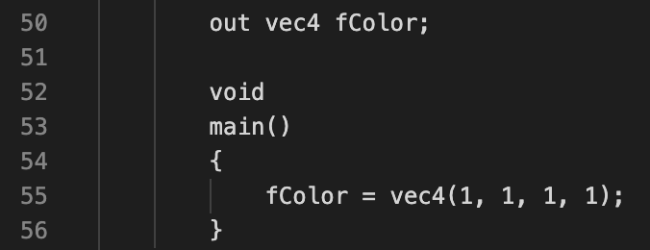

Modified Code

This code gets the location of the uniform from the GPU, uses the uniform to send a new color to the shader program, and uses an event listener to detect a keyboard click. If the keyboard click is random, display a random RGB value.

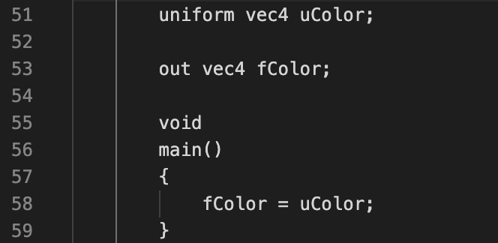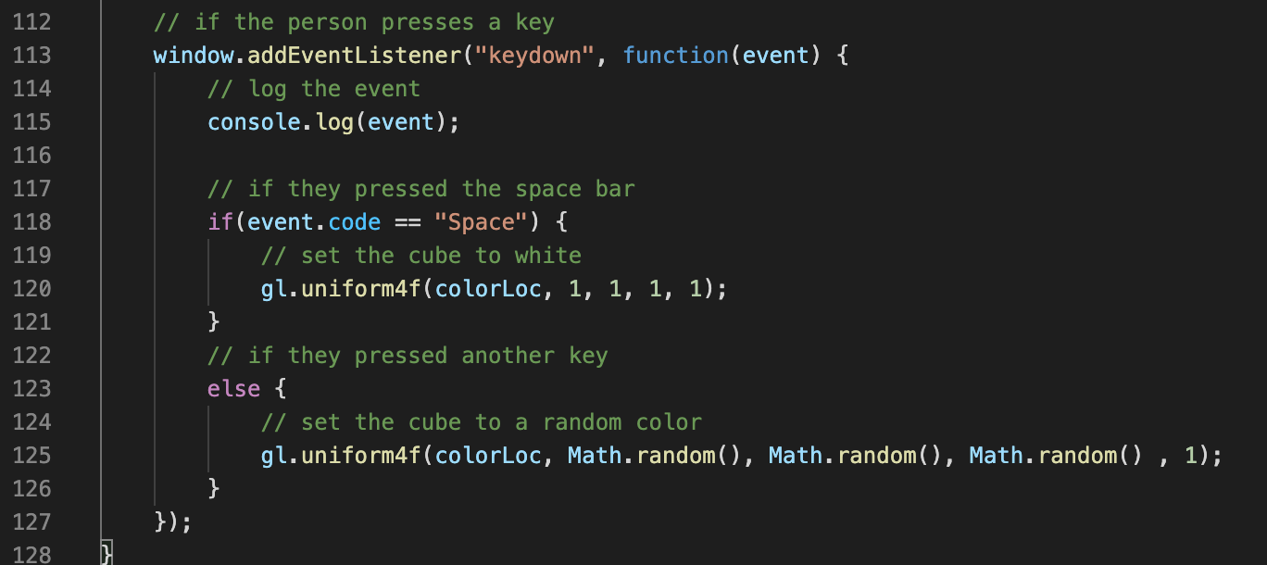/*index.js lines 112-128*/ /*index.html lines 51-59*/

/*index.js line 77-78*/

**

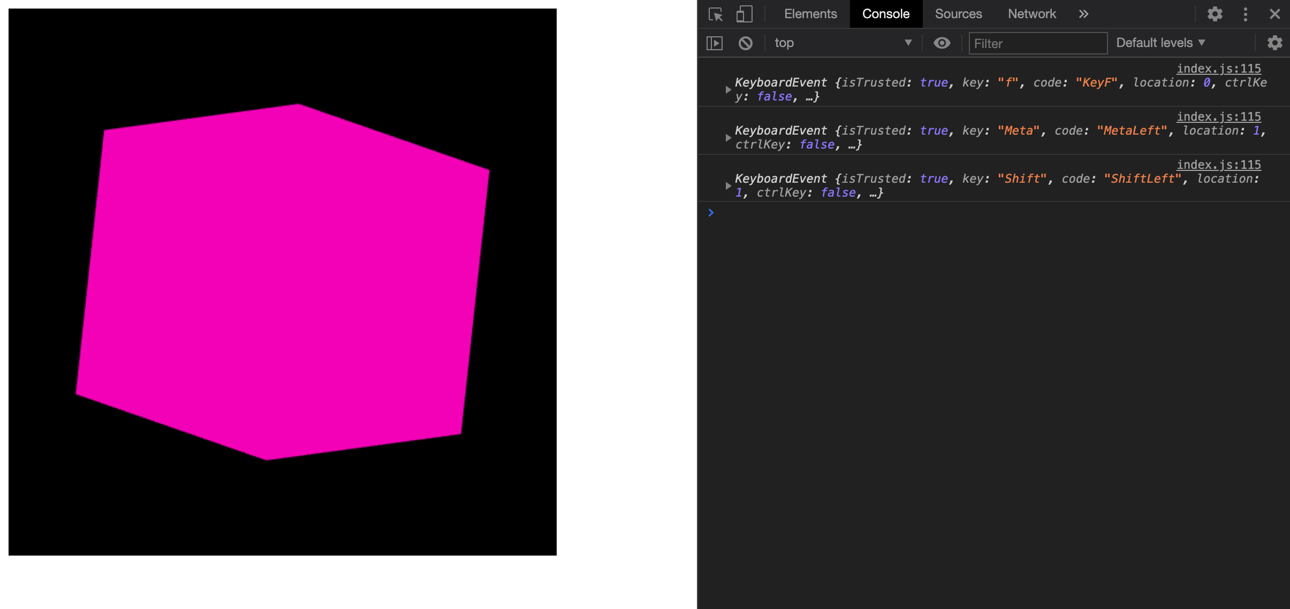

Figure B.2.1 DrawCube Random 1

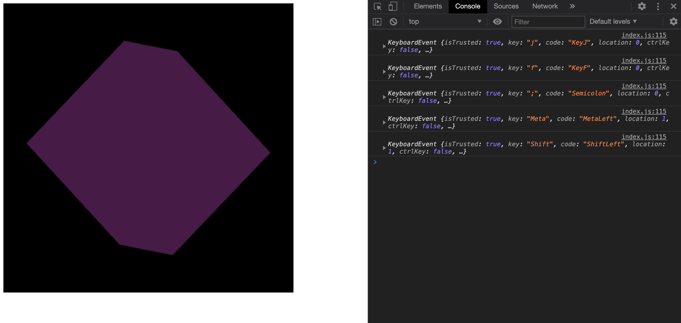

Figure B.2.2 DrawCube Random 2

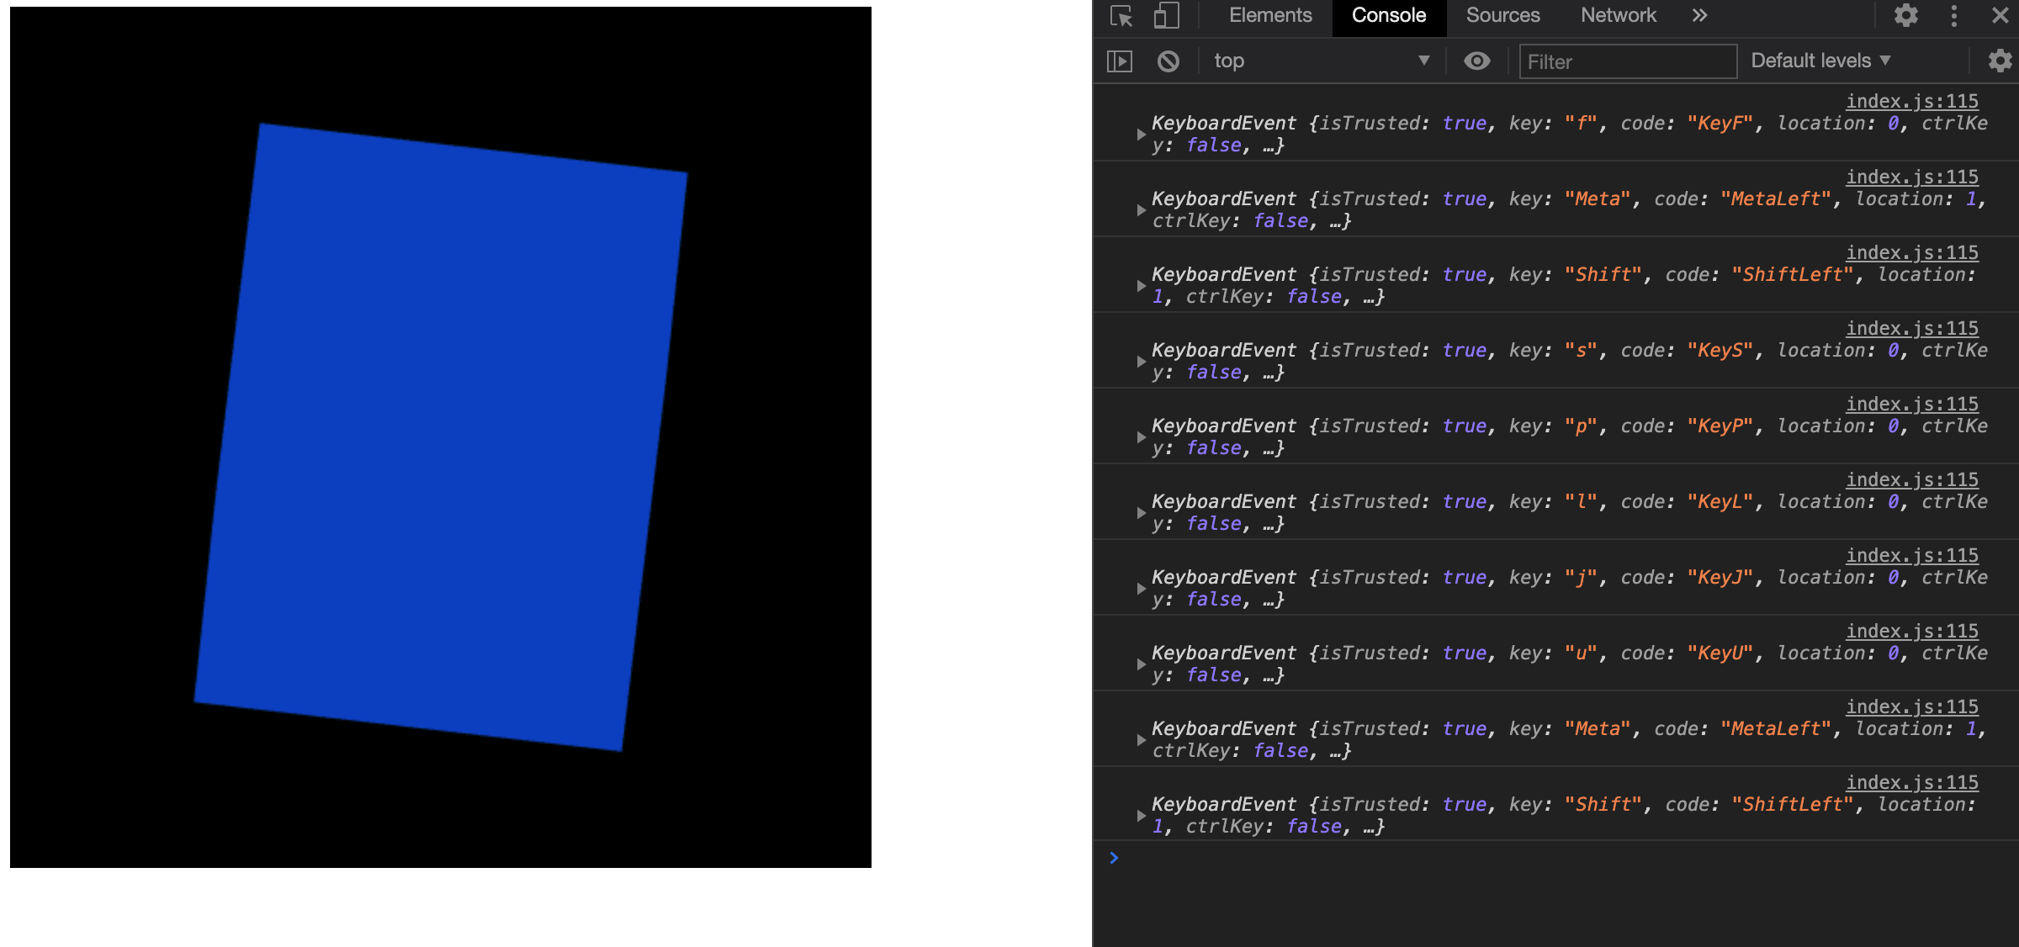

Figure B.2.3 DrawCube Random 3

*Press the spacebar key to return the cube back to white*

Original & Modified Code

See the code on page 3

Figure B.3.1 DrawCube Space Bar

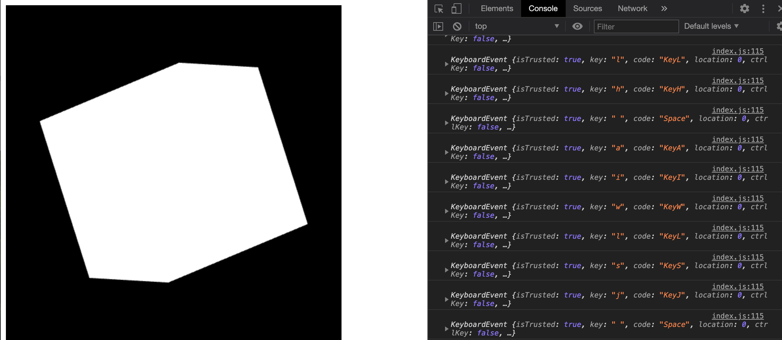

*Click on the canvas and change the color of the cube based on the click position*

Original Code

See original code on page 3

Modified Code

This code identifies when the user clicks on the mouse, calculates the x and y values using offset and the height/width of the canvas and then changes the cube color based on the click location.

/*index.js lines 98-110*/

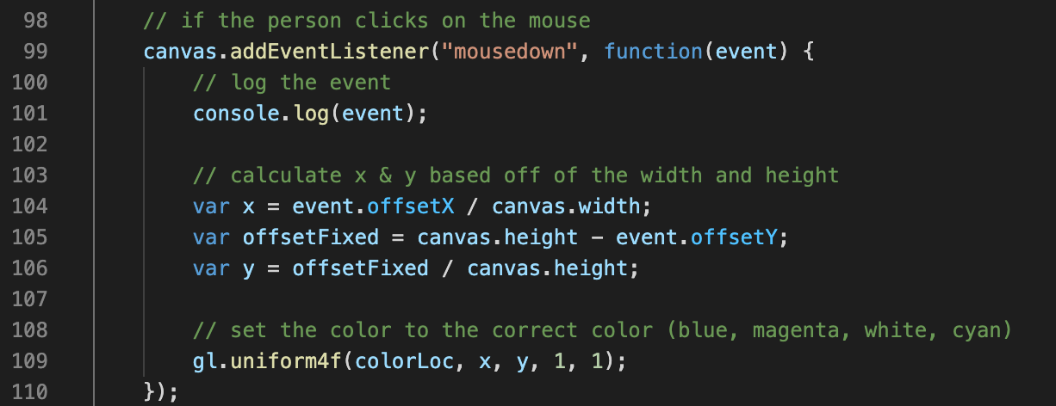

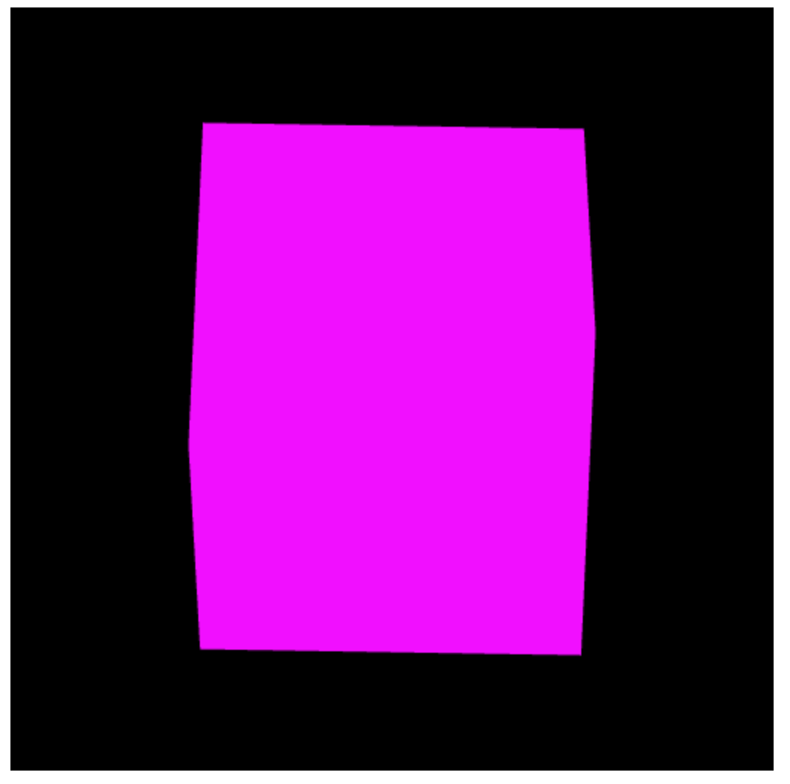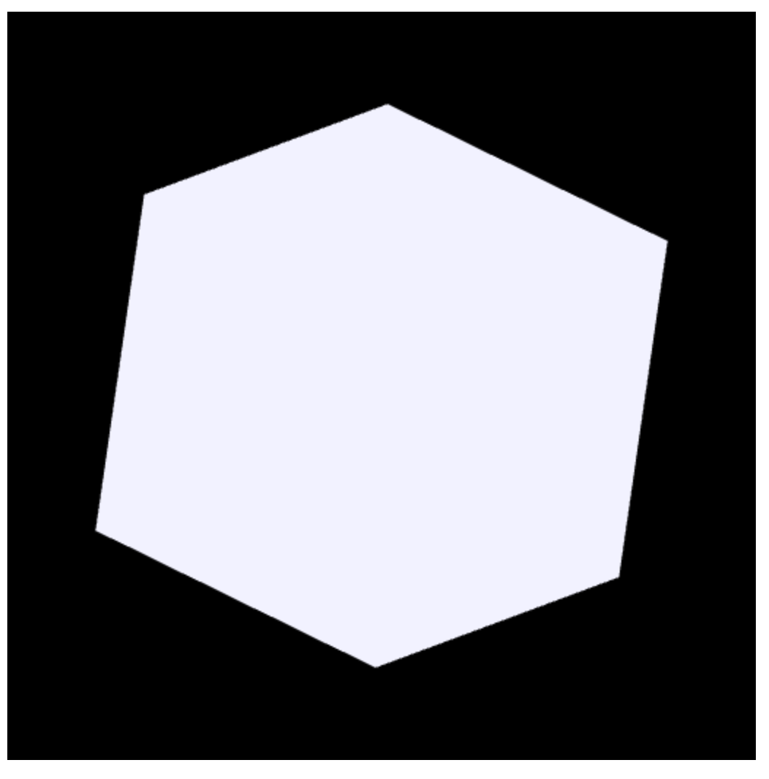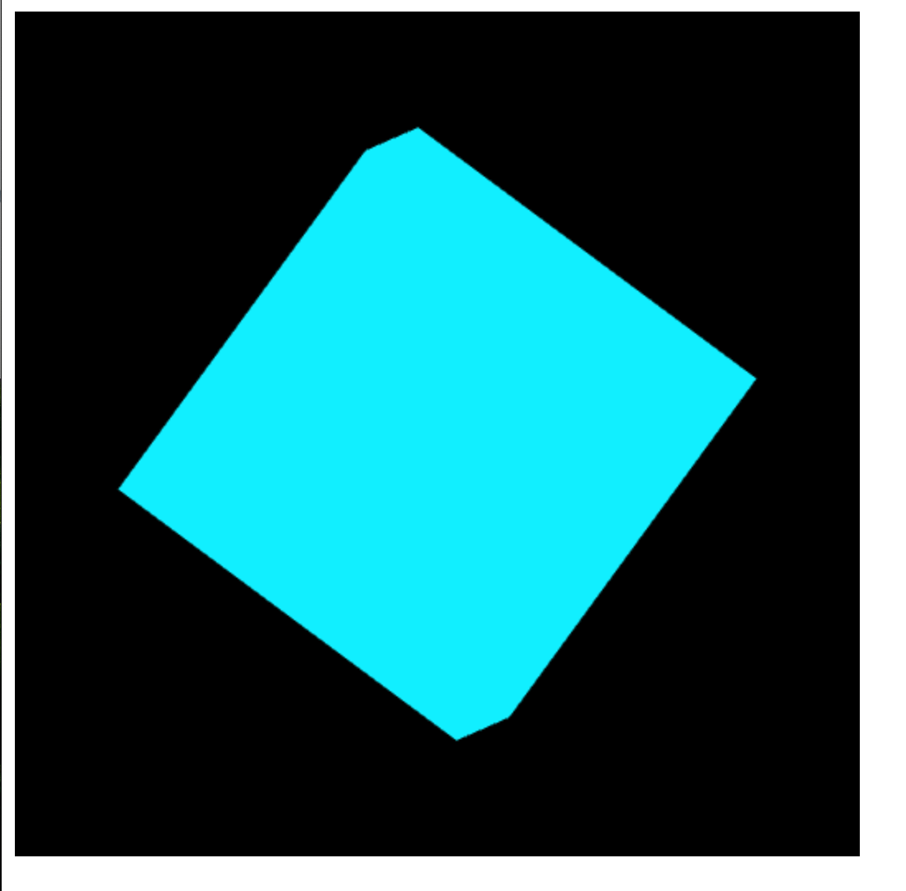

Figure B.4.1 DrawCube Click Cyan

Figure B.4.3 DrawCube Click Magenta

Figure B.4.2 DrawCube Click White

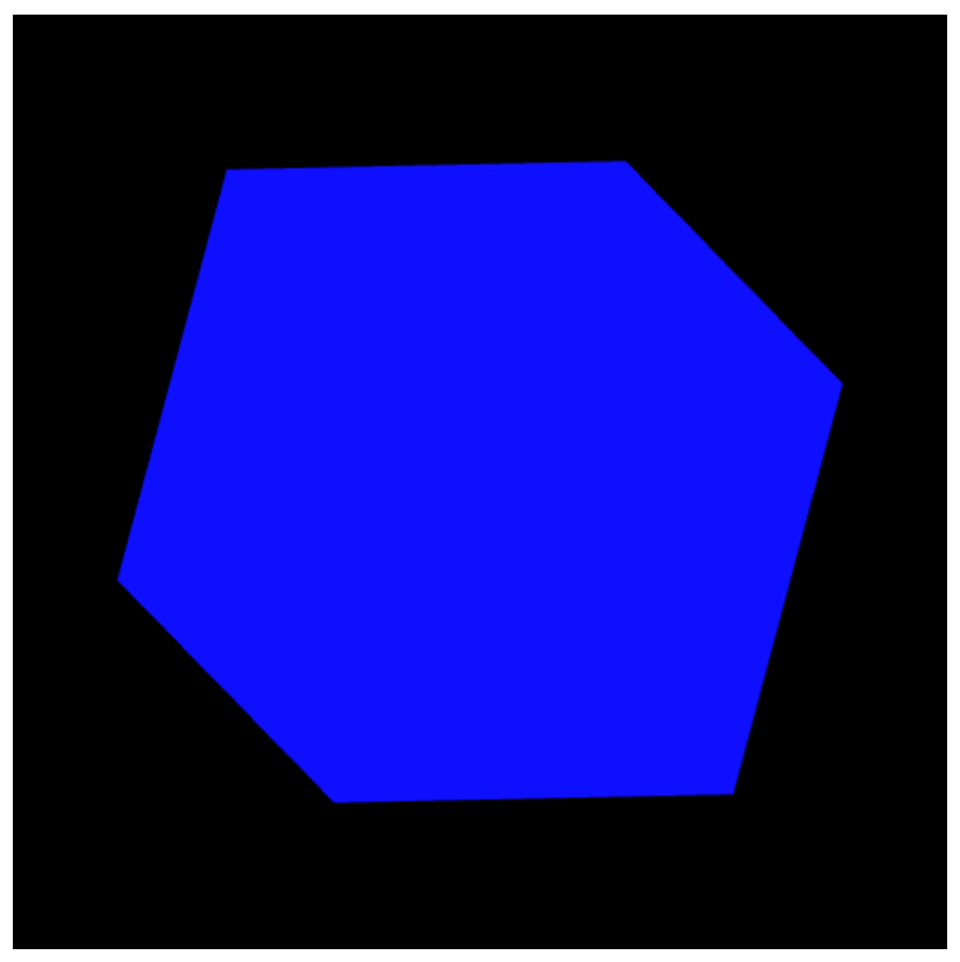

Figure B.4.4 DrawCube Click Blue