**Kaitlyn Zahn**

***Assignment 5 Report***

**April 8, 2021**

**__**

**CS 4610 Computer Graphics 1**

**__**

**Ye Duan**

**_______________________________________**

**Link to YouTube Video:**

<https://youtu.be/_CV6z71Wvz0>

**Part A: Illumination and Shading**

*Implement per-fragment Phong lighting shader  
- The shader code is already included, but you will have to send some uniforms to the vertex and fragment shaders*

This code calculates the lightPosition, ambientProduct, diffuseProduct, specularProduct, and shininess and then sends them to the shaders.

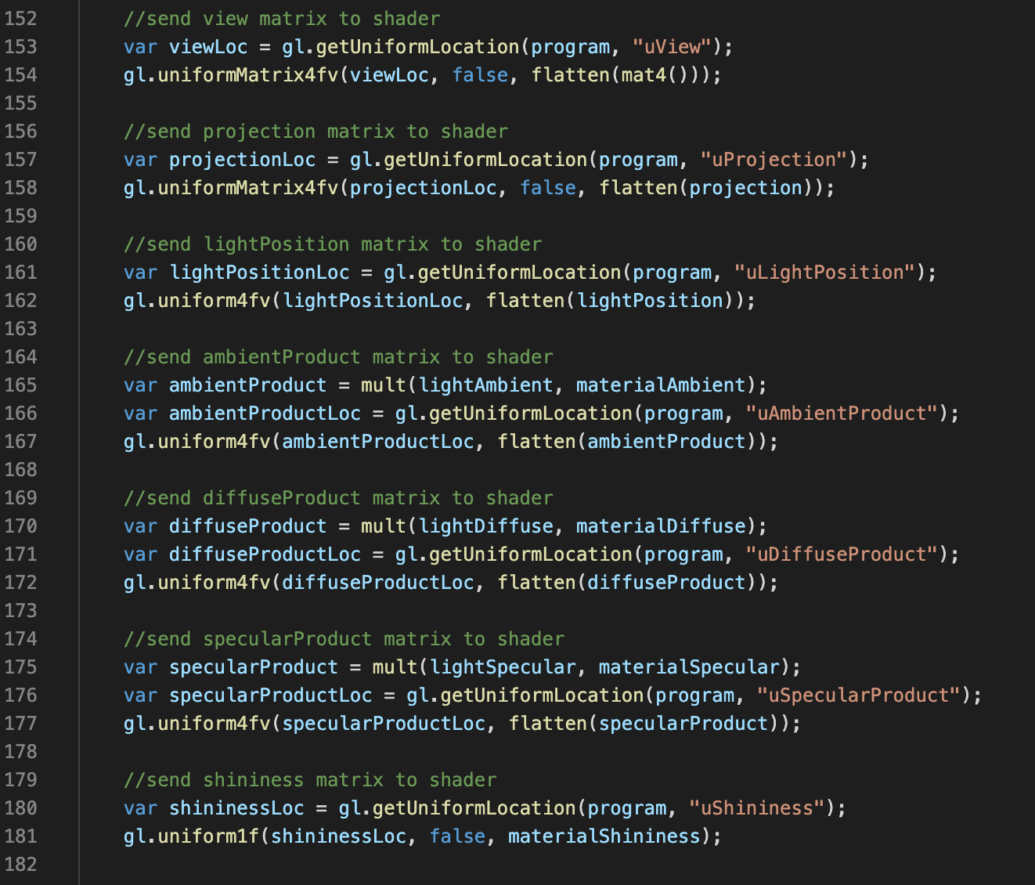

*Support flat and smooth shading by calculating normals  
- You can have two separate projects or one with a boolean at the top to switch between flat and smooth normals  
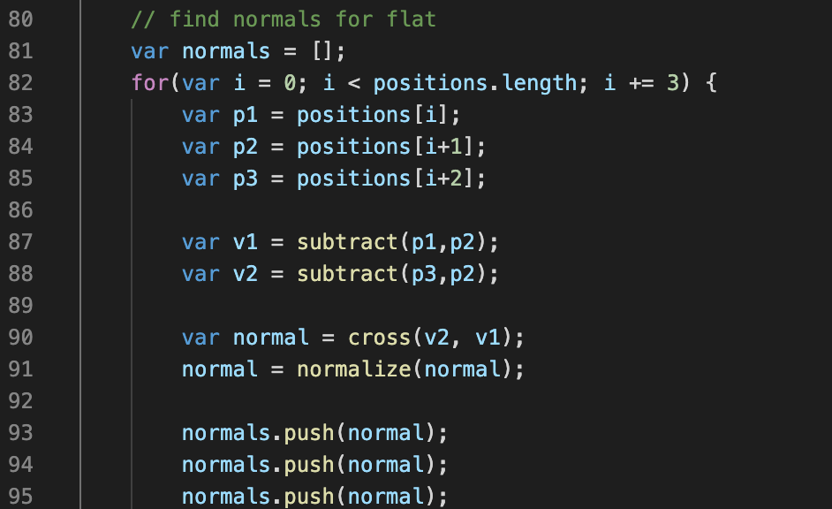*

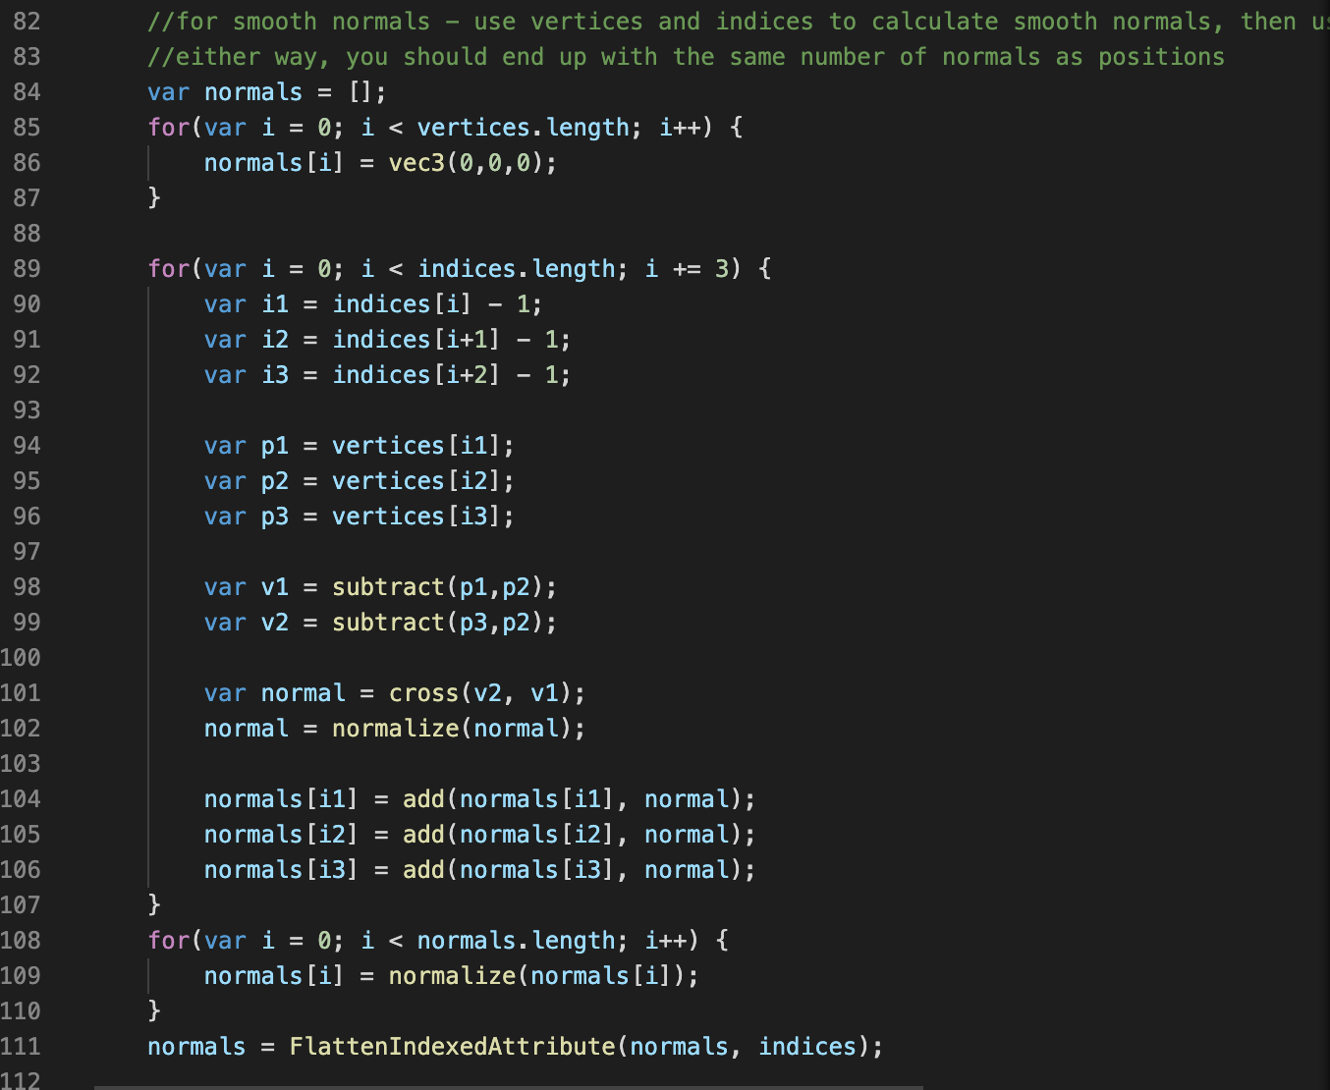

*Use sliders to change the values of the materialDiffuse, materialSpecular, and materialShininess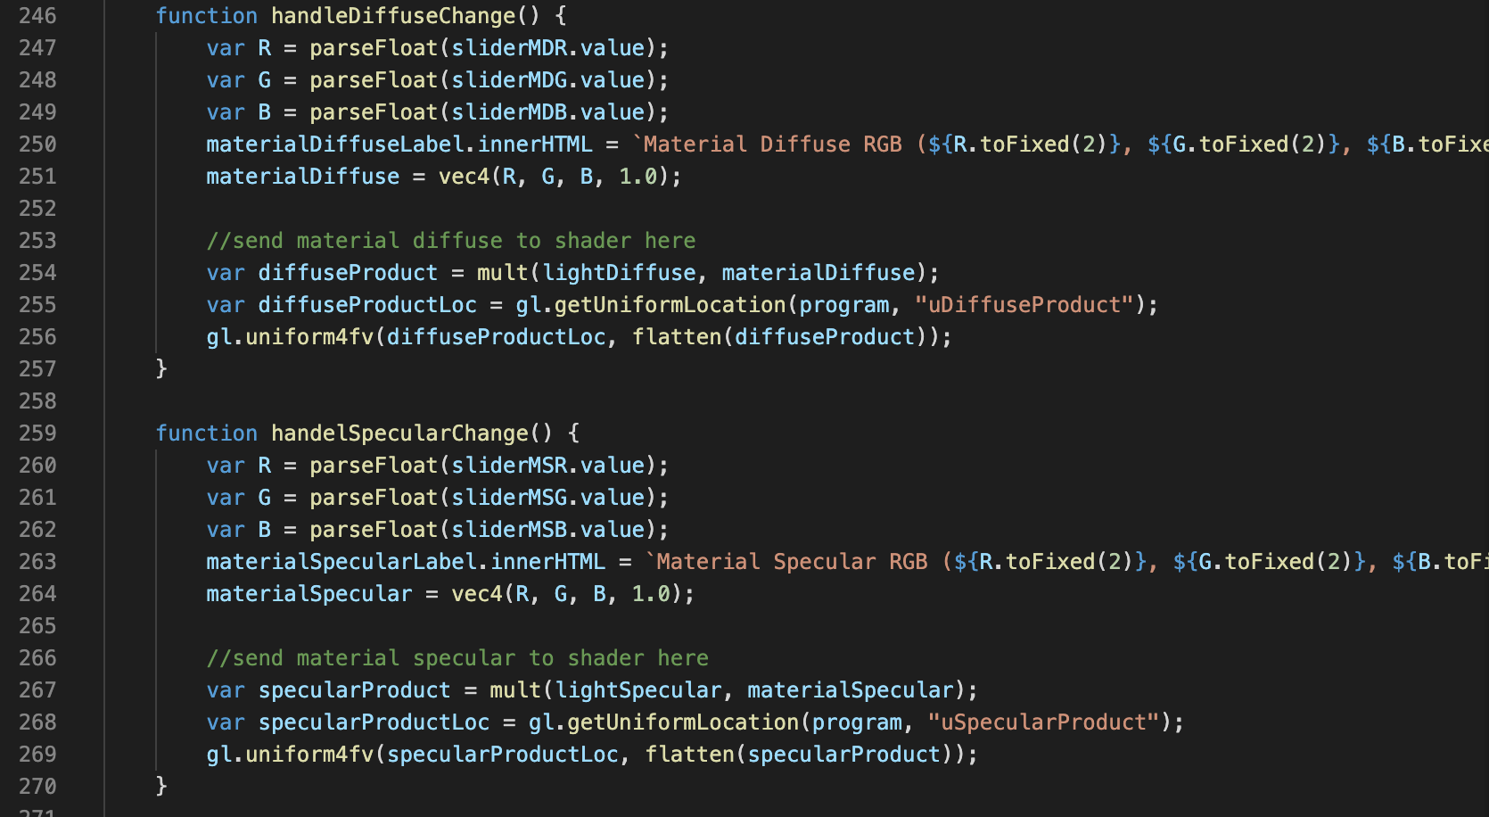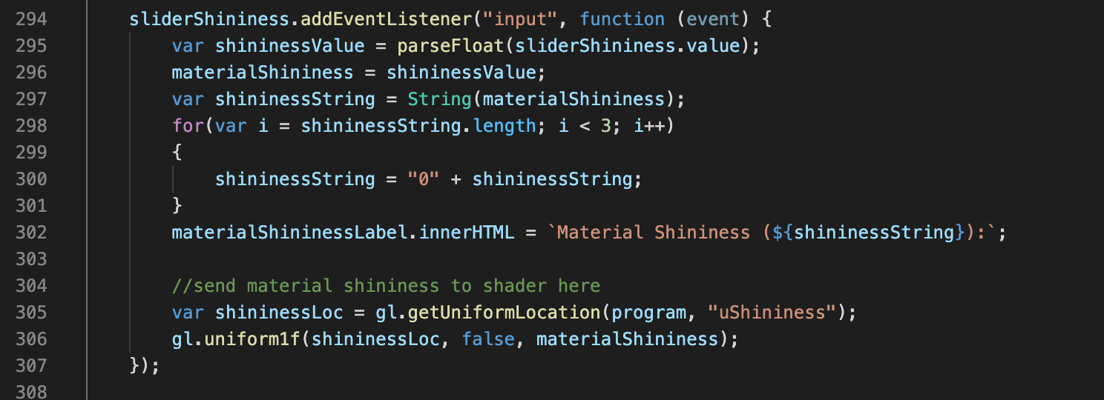  
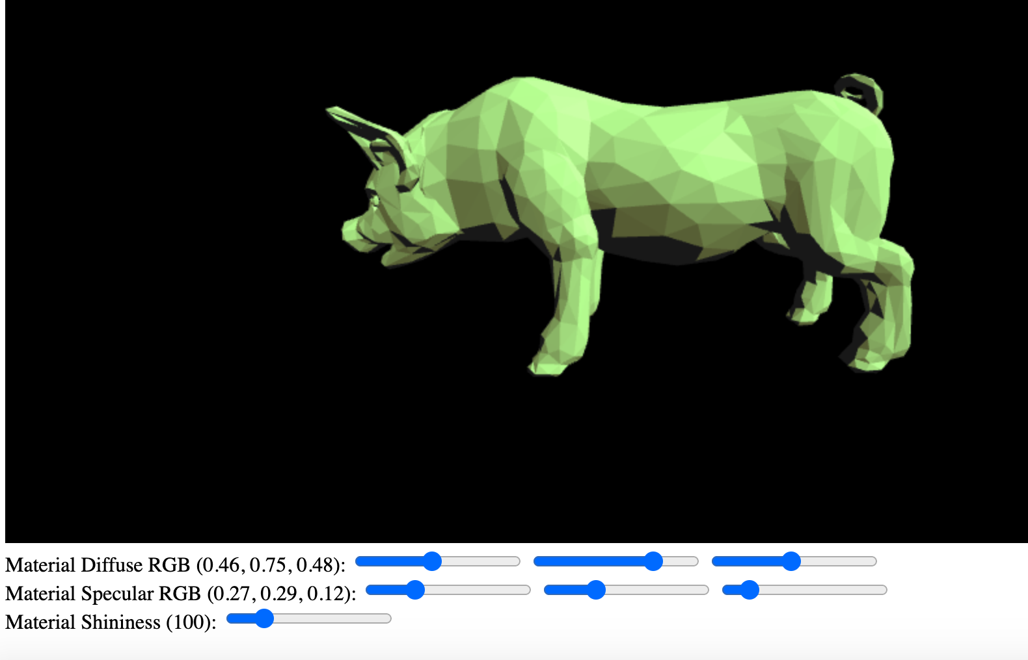*

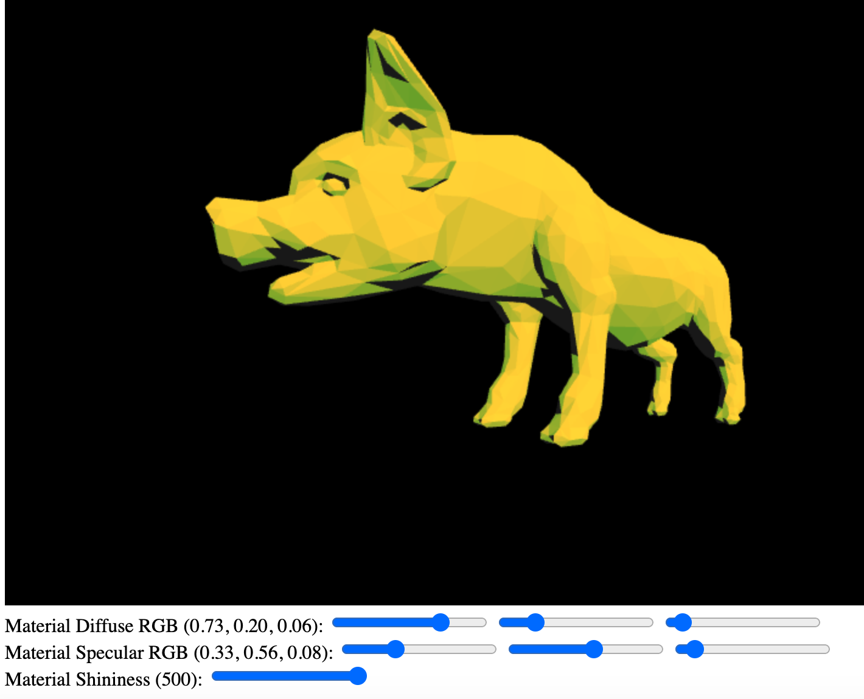

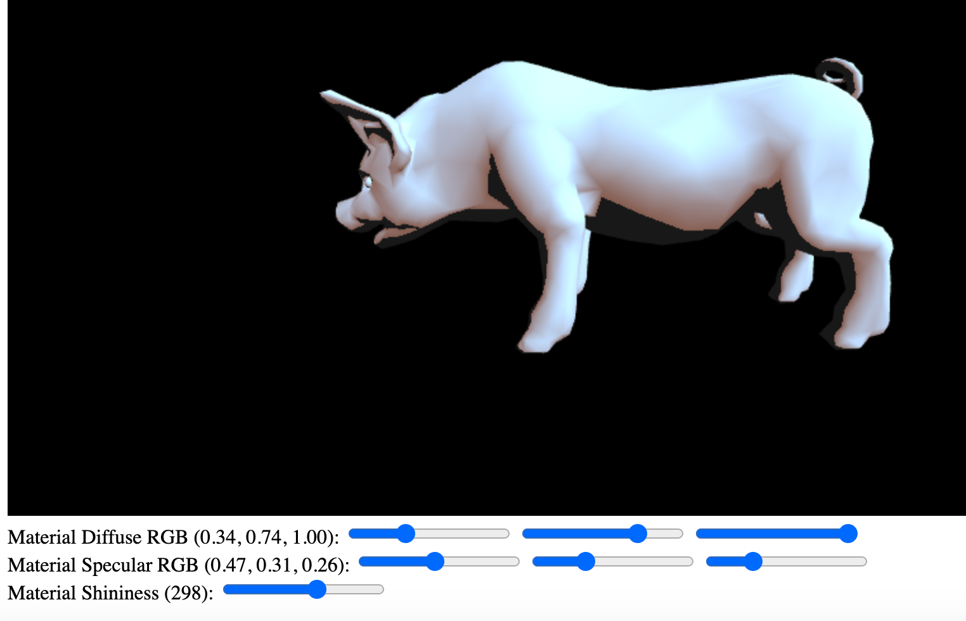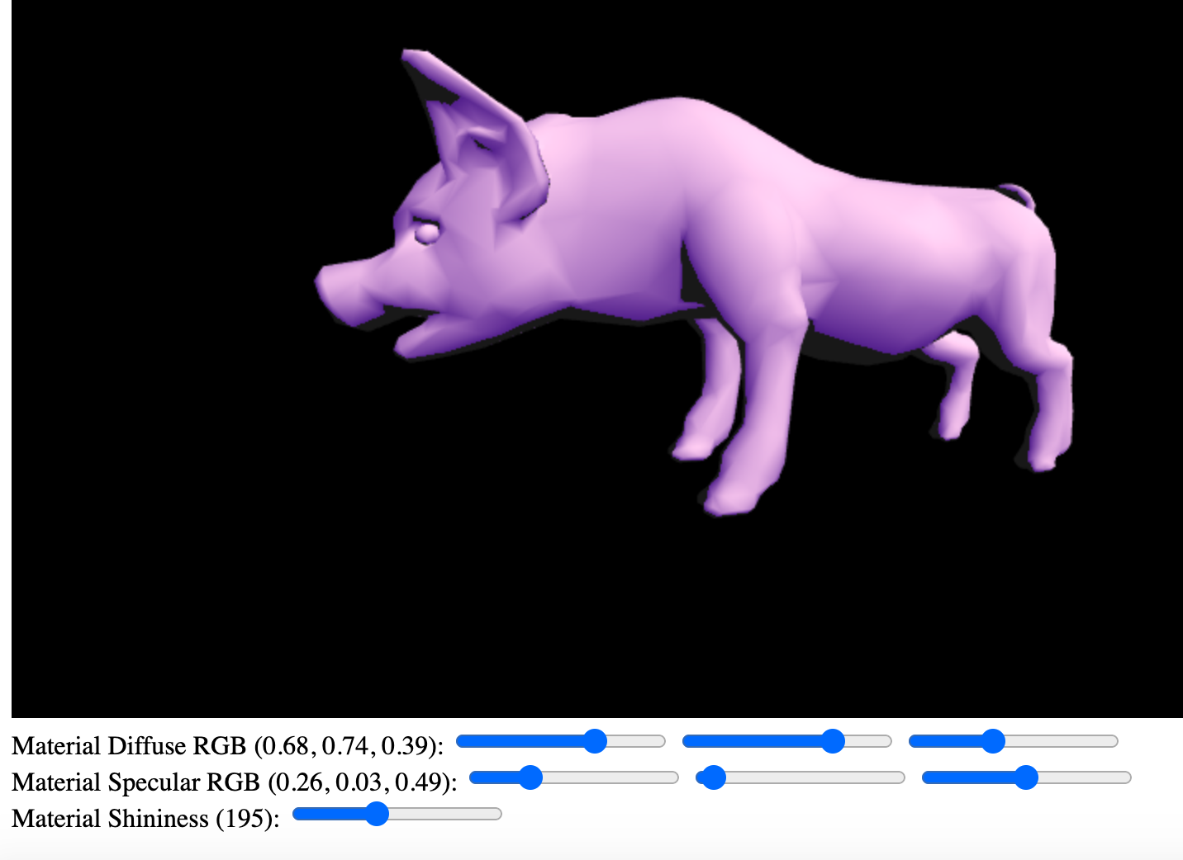

**Part B: Texture Mapping**

*Add texture coordinates to the quad*

This code creates coordinates in an array for the texture and binds it. 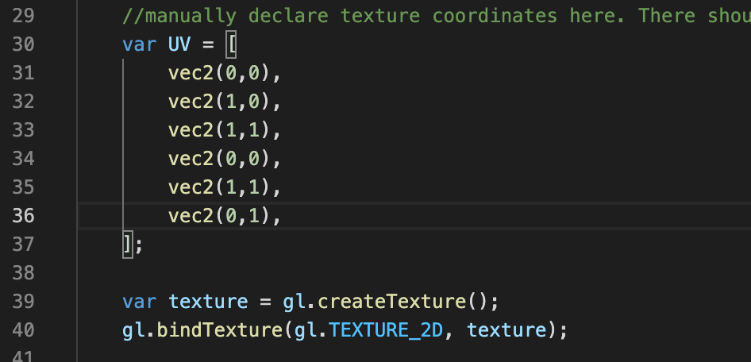

*Edit the shader to support a texture*

This code changes the shader to allow for the texture and in the try block, it loads the image

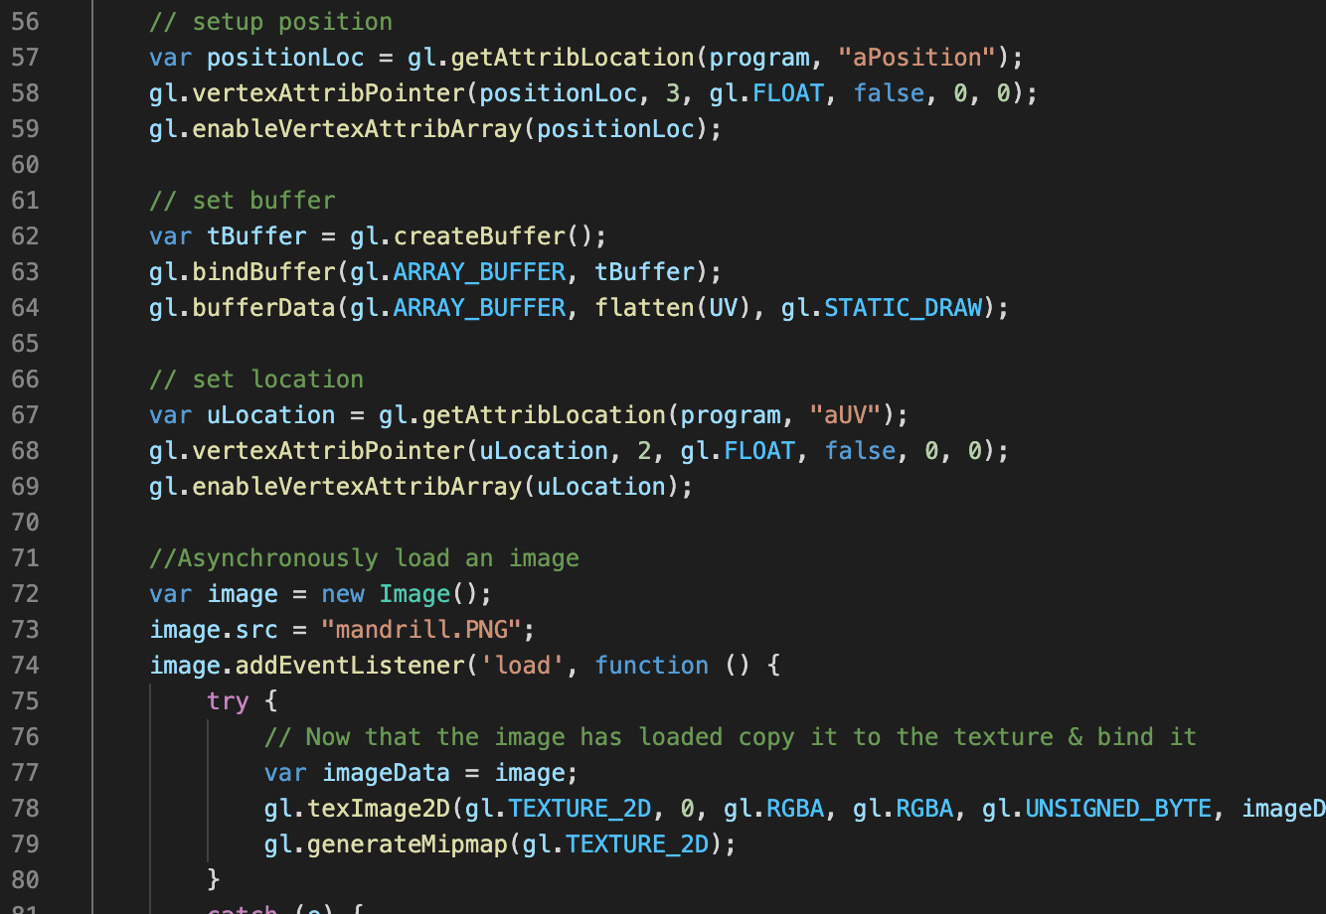

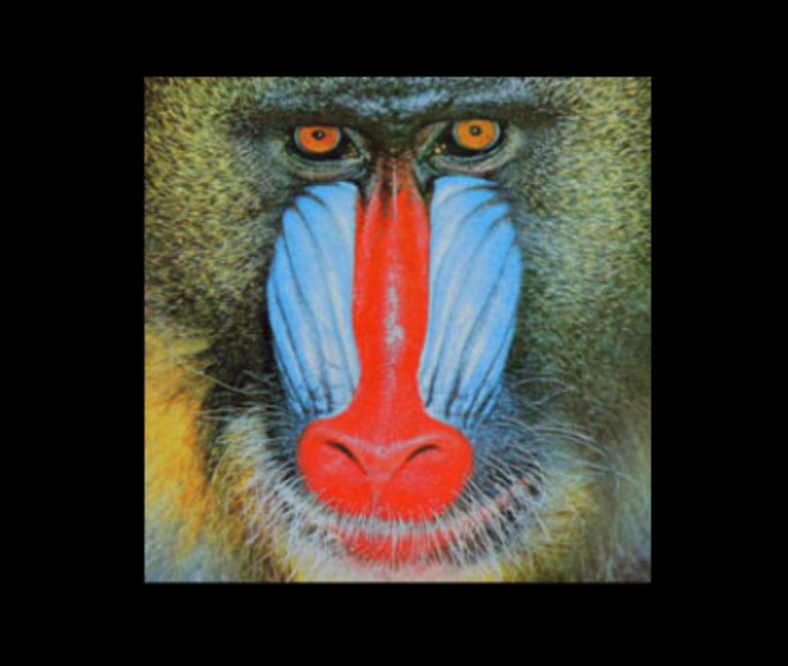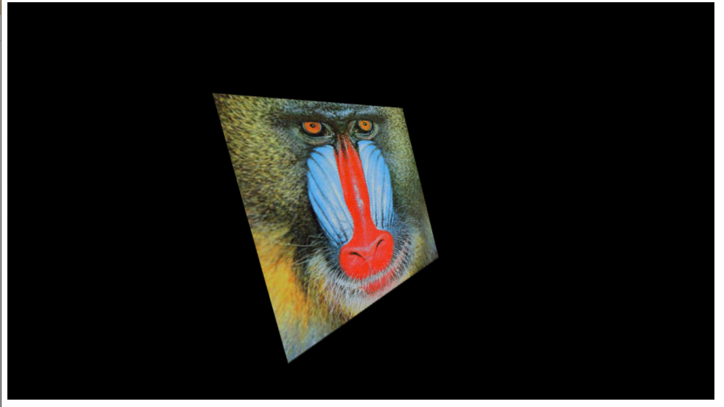

**Issues I Faced:**

When finding my normals, I was originally creating “var normals = []” inside of my for loop. I didn’t realize that’s where I declared it, so I was getting weird results because it was creating a new normals array every time.

For a long time I was confused on why my code to find the normals was seemingly correct, but my image wasn’t displaying correctly. Finally, I realized that I was sending “positions” into the normal buffer instead of “normals”.