RDRealty User Manual
Comprehensive Guide to the RDRealty Property Management System

1. Introduction
RDRealty is a comprehensive property management system designed to streamline the tracking of real estate assets, tax records, and title movements. This manual guides users through the core functionalities of the application.

2. Getting Started

2.1 Login
To access the system, users must authenticate using their secure credentials. The login screen provides a secure entry point to the application.

Figure 1: Login Screen

3. Dashboard
Upon logging in, users are greeted with the Dashboard. This central hub provides an immediate overview of key metrics, including total properties, active titles, and recent activities.
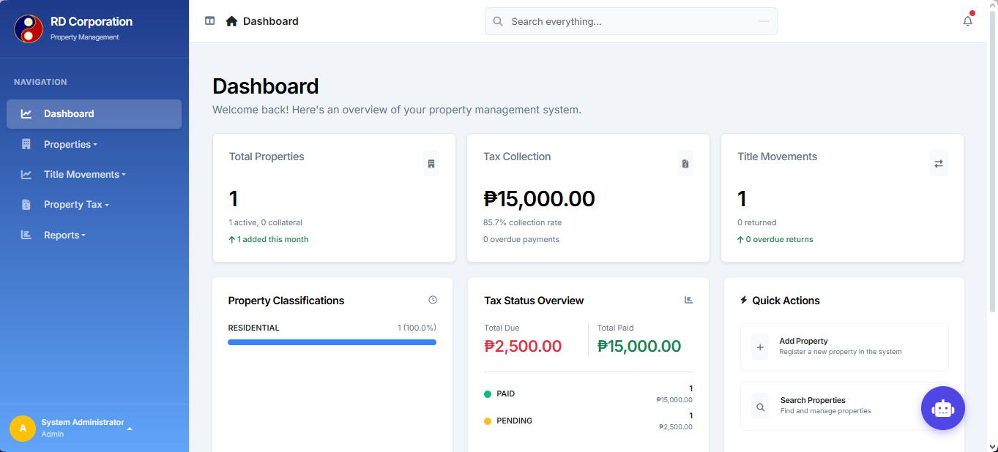
Figure 2: System Dashboard

4. Property Management

4.1 Property List
The Property List view displays all registered properties. Users can search, filter, and sort properties by various criteria such as Title Number, Lot Number, or Status.
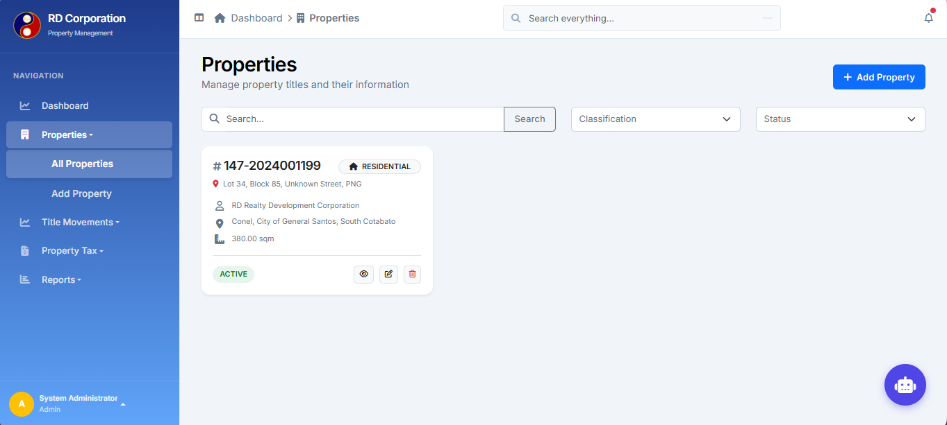
Figure 3: Property List View

4.2 Adding a Property
To add a new property, navigate to the "Add Property" section. Fill in the required details including Title Number, Lot Number, Area, and Classification.
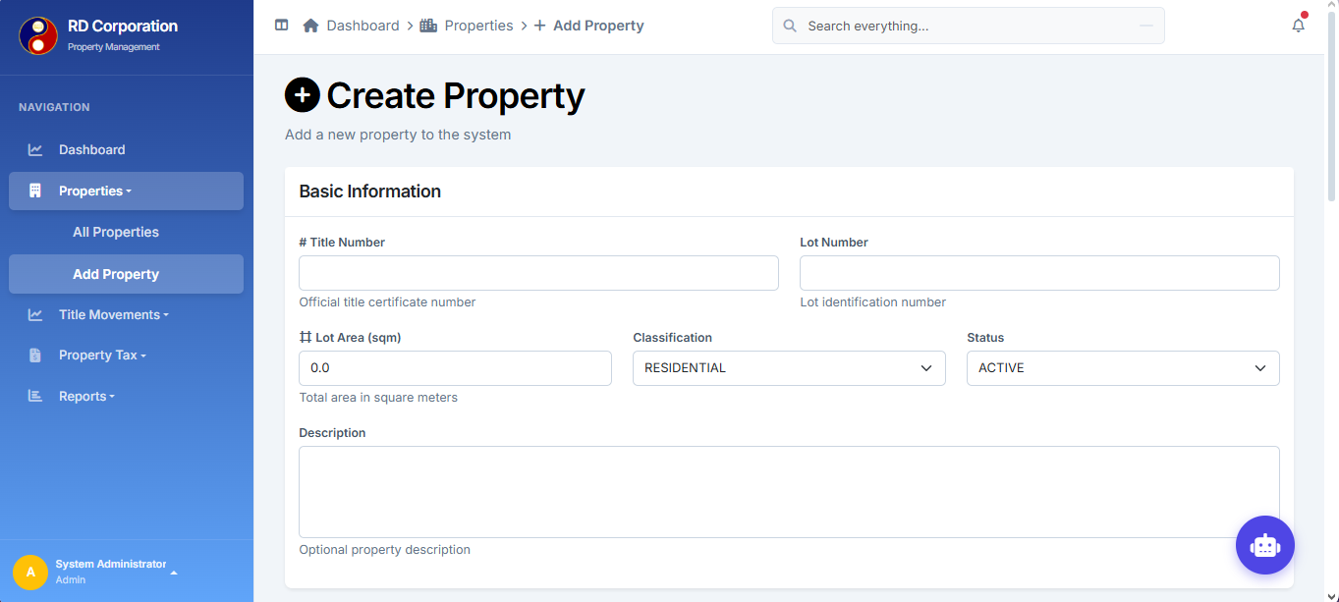
Figure 4: Add Property Form

4.3 Property Details
Clicking on a property reveals its detailed information. This page includes specific tabs for Tax Records and Title Movements.
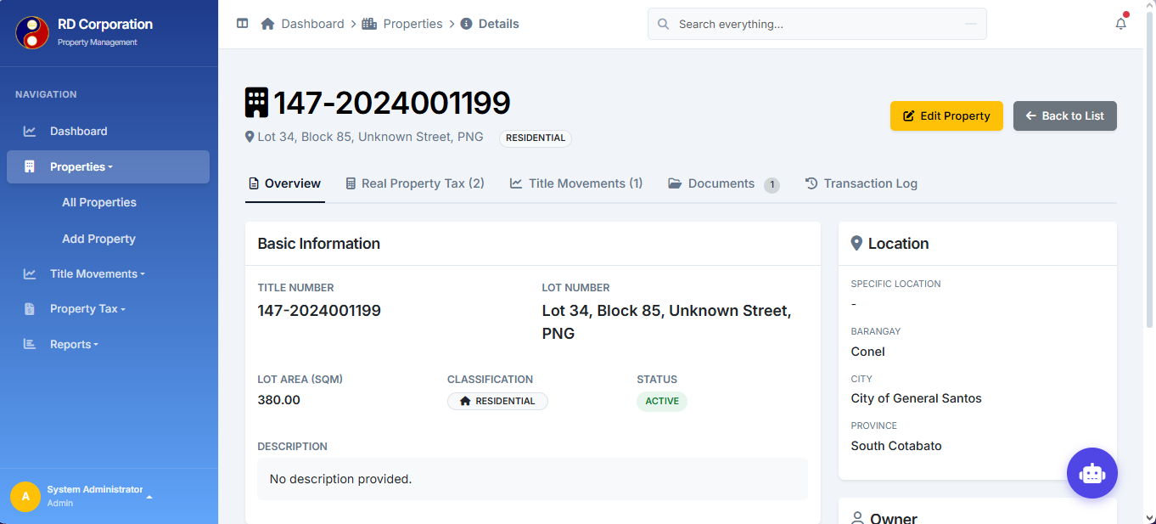
Figure 5: Property Details Page

5. Tax Management
RDRealty allows for detailed tracking of property tax records. Users can view payment history, status (Paid, Pending, Overdue), and add new tax records directly from the property detail view.
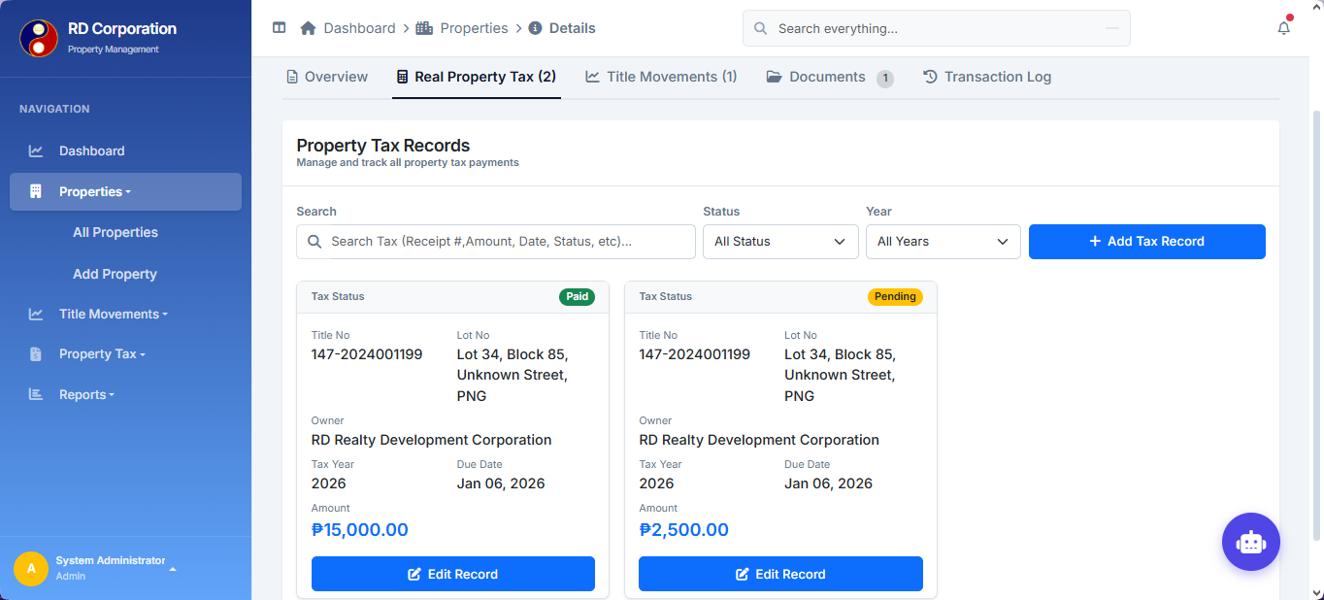
Figure 6: Tax Records Card Layout

6. Title Movements
Track the physical movement of titles with the Title Movement feature. Generate transmittal numbers and monitor the status of title transfers.
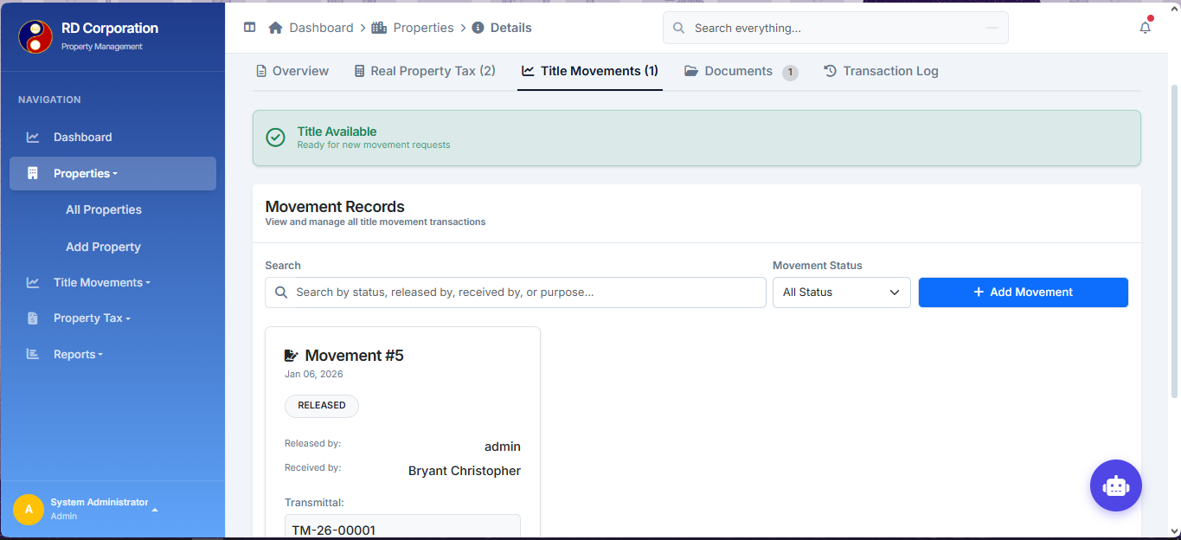
Figure 7: Title Movement Tracking

7. User Management
Administrators can manage system access by creating, editing, and deactivating user accounts. This ensures that only authorized personnel have access to sensitive property data.
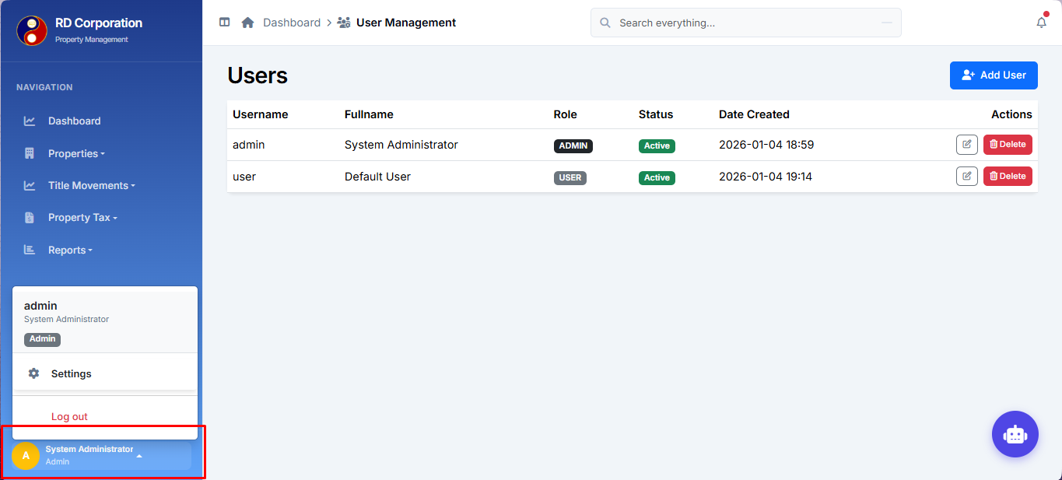
Figure 8: User Management Console

7. Reports
The Property & Tax Movement Report is a centralized tool for monitoring the status of your real estate portfolio, tracking tax compliance, and overseeing the progress of title transfers (movements).
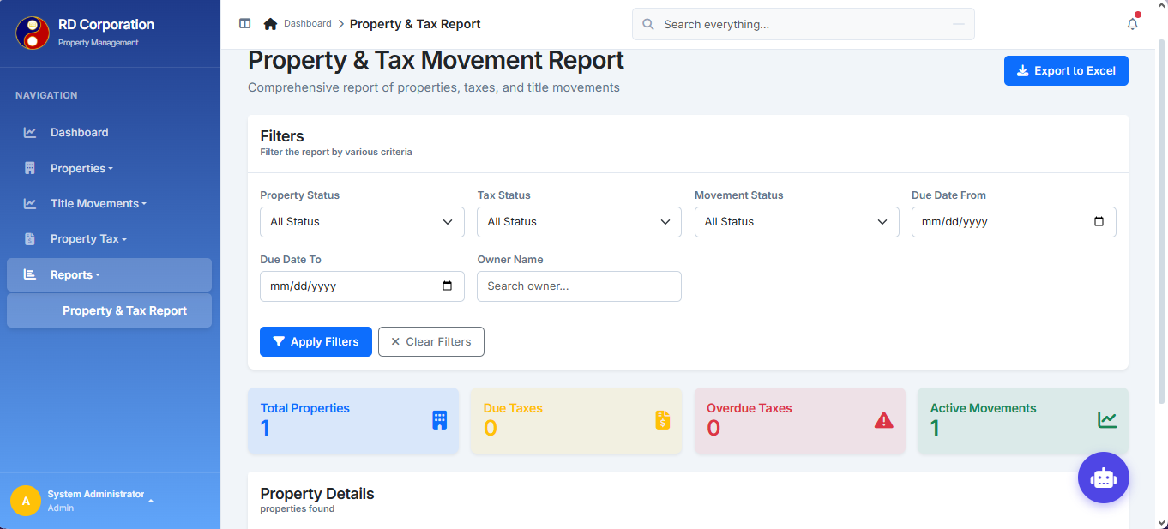
Figure 9: Property Tax Report

