RDRealty Technical Documentation
System Architecture, Debugging, and Enhancement Guide

1. System Overview
RDRealty is a web-based property management application built using the Django framework (Python) and MySQL database. It follows the Model-View-Template (MVT) architectural pattern.

1.1 Architecture Diagram
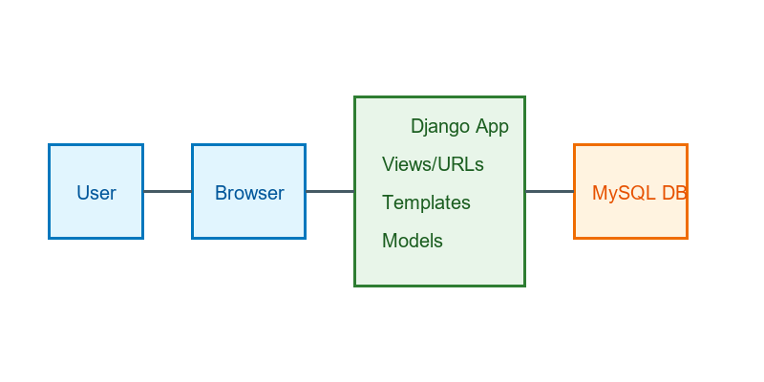

1.2 Technology Stack
• Backend: Python 3.x, Django 5.x/6.x
• Database: MySQL 8.0+
• Frontend: HTML5, CSS3, Bootstrap 5, JavaScript (jQuery)
• Deployment: WSGI (Waitress/Gunicorn), WhiteNoise for static files

2. Project Structure
RDRealty/
├── RDRealty/ # Project configuration (settings, urls, wsgi)
├── RDRealty_App/ # Main application logic
│ ├── migrations/ # Database migrations
│ ├── static/ # App-specific static files (JS, JSON data)
│ ├── templates/ # HTML templates
│ ├── models.py # Database schema definitions
│ ├── views.py # Business logic and request handling
│ ├── urls.py # App-specific URL routing
│ ├── forms.py # Django forms for input validation
├── static/ # Global static files (images, CSS)
├── manage.py # Django management script
├── requirements.txt # Python dependencies
└── .env # Environment variables (DB credentials, secrets)

3. Setup and Configuration
The system relies on environment variables for configuration. These are stored in a .env file in the project root.
Key settings in .env:
SECRET_KEY=...
DEBUG=True/False
DB_NAME=rdc_realty_db
DB_USER=root
DB_PASSWORD=...
DB_HOST=localhost
DB_PORT=1213

4. Debugging Guide

4.1 Common Issues
1. Database Connection Errors: Check .env credentials and ensure MySQL service is running on the specified port.
2. Static Files Not Loading: Ensure `python manage.py collectstatic` has been run if DEBUG=False. Check console for 404 errors.
3. Migration Errors: If database schema is out of sync, run `python manage.py migrate --fake` carefully or inspect migration files.

4.2 Debugging Tools
• Django Debug Mode: Set `DEBUG=True` in .env for detailed error pages during development. NEVER use in production.
• Browser Console: Press F12 to check for JavaScript errors or network failures.
• Server Logs: Check the terminal output where `runserver` is running for Python stack traces.

5. Maintenance and Fixes

5.1 Database Maintenance
To reset or update the database schema:
python manage.py makemigrations
python manage.py migrate

5.2 Fixing 500 Errors
1. Check `RDRealty/settings.py` for ALLOWED_HOSTS configuration.
2. Verify that all template tags used in HTML are loaded (e.g., `{% load humanize %}`).
3. Ensure all required Python packages are installed: `pip install -r requirements.txt`.

6. System Enhancement Guide
Follow these steps to add new features to the system.

Step 1: Update Models
Modify `RDRealty_App/models.py` to add new fields or tables. Always run migrations afterwards.
class NewFeature(models.Model):
name = models.CharField(max_length=100)
...

Step 2: Create Views
Add logic in `RDRealty_App/views.py`. Use Class-Based Views (CBVs) for standard CRUD operations or function-based views for custom logic.

Step 3: Define URLs
Register the new view in `RDRealty_App/urls.py` (or project urls.py if applicable).
path('new-feature/', NewFeatureView.as_view(), name='new_feature'),

Step 4: Create Templates
Create HTML files in `RDRealty_App/templates/`. Extend `base.html` to maintain layout consistency.
{% extends 'base.html' %}
{% block content %}
<h1>New Feature</h1>
{% endblock %}

Step 5: Update Navigation
Add links to the new feature in `RDRealty_App/templates/base.html` or the sidebar include file.

7. Deployment Checklist
• Set DEBUG=False
• Configure ALLOWED_HOSTS
• Set up a production WSGI server (e.g., Waitress on Windows, Gunicorn on Linux)
• Use a production-ready database (not SQLite)
• Run `python manage.py collectstatic`

