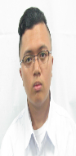**CERVANTES, Lioric Amiel C.**

Blk. 2 Lot 3 Natividad Comp.

Greenland Road Ampid I

San Mateo Rizal

Email: lioriccervantes@gmail.com

Mobile Number: 09163914677

**CAREER OBJECTIVES**

* Develop IT skills with collaboratiton with others in achieving organization’s goals;
* Work independently and be a part of a team;
* Organize, prioritize, manage time, and apply skills in software development.

**SYSTEM DEVELOPMENT EXPERIENCE**

* Designed a mini flight reservation system (case study in CS 121) using java;
* Designed a mini compiler (case study in CS211 ) using java;
* Implemented database design using IBM DB2 Express-C 9.0;
* Knowledgeable in Object-oriented Analysis and Design (OOAD) as implemented in java, HTML and CSS languages;
* Assigned as tester of Customer Management System (case study in CS 221)
* Adept in using MS Office products (Powerpoint, Word, Access, Excel).

**EDUCATION**

**BS in Computer Science**

June 2014 - present

          New  Era  University

**PERSONAL  INFORMATION**

Place of Birth : San Mateo Rizal

Civil Status :  Single

Citizenship :  Filipino

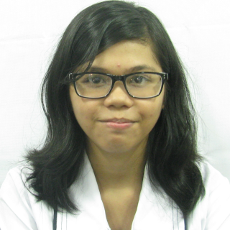**DILAO, Jerimin O.**

B-5-D U.P. Employees Village

Diliman, Quezon City

Email: dilaojerimin@yahoo.com

Mobile Number: 09162294364

**CAREER OBJECTIVES**

* Design, develop, and modify application software to measure consequences of design.
* Inspect user needs and software requirements to regulate usefulness of design.

**SYSTEM DEVELOPMENT EXPERIENCE**

* Designed mini compiler for case study in CS211 using java.
* Developed a game for Game Jolt using game making software (RPG Maker VX) implemented a scripting/object-oriented programming language, Ruby.
* Computer literate (Adobe Photoshop and Microsoft Office Application).

**EDUCATION**

**BS in Computer Science**

June 2014- present

           New Era  University

**PERSONAL  INFORMATION**

Place of Birth : Pasay City, Manila

Citizenship :  Filipino

Civil Status : Single

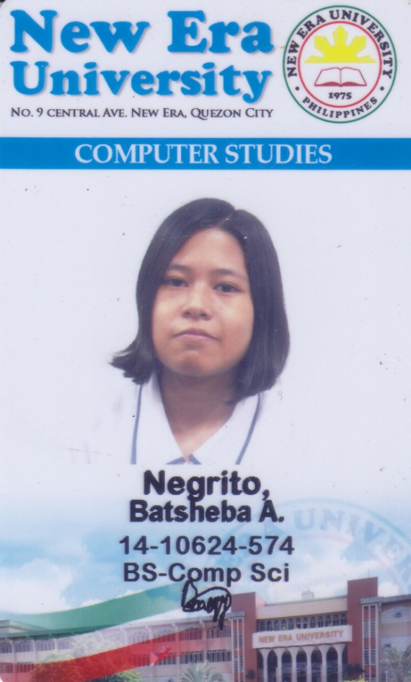**NEGRITO, Batsheba A.**

Mabuhay Homes 2000 Paliparan II

Dasmariñas City, Cavite

Email: [batsheba_negrito@yahoo.com](mailto:batsheba_negrito@yahoo.com)

Mobile Number: 09272957420

**CAREER OBJECTIVES**

* Developing and improving IT skills in every team’s goals and objectives;
* Work with cooperation and participation in the team;
* Application of skills in software development with correct management, organize work and prioritizing the project.

**SYSTEM DEVELOPMENT EXPERIENCE**

* Designed mini compiler (case study in CS 211) using java;
* Application of knowledge in database design using IBM DB2 Express-C 9.0;
* Application of Object-Oriented Programming and Design (OOAD) as implemented in Java;
* Documented case studies by using Lucidchart diagramming tool for flowcharts, entity-relationship diagrams (ERD), use-case diagrams, system sequence diagrams, sequence diagrams, and class diagrams using;
* Adept in using MS Office products (Powerpoint, Word, Access, Excel);Adobe Photoshop.

**EDUCATION**

**BS in Computer Science**

August 2014 - present

New  Era  University

**PERSONAL  INFORMATION**

Place of Birth : Biñan, Laguna

Civil Status :  Single

Citizenship :  Filipino

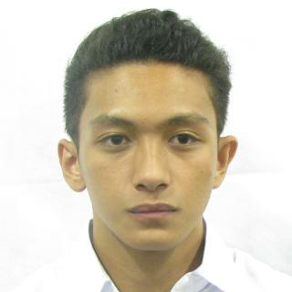**JOHN PHILIP D. PEREZ**

Blk2 Lot 21 Area 7 Luzon Avenue

Old Balara Quezon City

Email: perezjohnphilip@gmail.com

Mobile Number: 09758981794

**CAREER OBJECTIVES**

* To pursue great career in a professional organization enable obtaining company’s objectives of development, customer satisfaction and service;
* Seeking a good opportunity in a good company that enables me to improve my skills, increase my practical experience, fulfill my personal ambitions and expand my knowledge;
* Work as a team and don’t blame any members if they commit a mistake;
* To utilize my knowledge and abilities for the implementation of organizational objectives;
* Have a passion in all aspects of tasks and always open in any ideas coming from any people;
* Organize, prioritize, manage time, and apply skills in software development.

**SYSTEM DEVELOPMENT EXPERIENCE**

* Designed a mini program with my members that reads from the input file that has 5 candidates and determined the corresponding percentage in mayoral election in our 1st year (1st semester) case study;
* Create a mini compiler using java with my members that convert the source code into lexemes, identify if it’s syntactically correct, if it’s semantically correct and convert it to low level language;
* Develop a system with my members that reads textfile and word file and organize it to its appropriate file folders;
* Have knowledge in using Microsoft Office Software (Word, PowerPoint, Excel and Project).

**EDUCATION**

**BS in Computer Science (Third Year)**

June 2014- present

New Era University

**PERSONAL INFORMATION**

Place of Birth : Pasay City, Manila

Citizenship :  Filipino

Civil Status : Single