**Online Restaurant Reservation System**

**Introduction**

In today’s life, having a reservation on a restaurant is very convenient in all restaurants because it makes the customer effortlessly find or search available seats in the restaurant. The customer may want a specific view or position in the restaurant. In this restaurant reservation, the customer can choose the specific date and time such as dinner and lunch time.

**Objectives of the Research**

General Objective

This proposal aims to propose an online restaurant reservation system.

Specific Objectives

* To book a reservation on the fine dining restaurant through web browsing.
* To broaden the proponents knowledge concerning software engineering and implement the disciplines of software engineering.
* To help our society to effortlessly visit the restaurant without thinking or searching seats to eat.

**Scope and limitations**

This system proposal focuses on the online reservation and time management. The customer after he/she book a reservation, the system will get the information about the customers i.e. (name, address, phone number, date and time of reservation so on and so forth.) The customer can choose their desire view or position in the restaurant.

The limitation of this system is the reservation can only avail within 3 days only.

Use-case Diagram

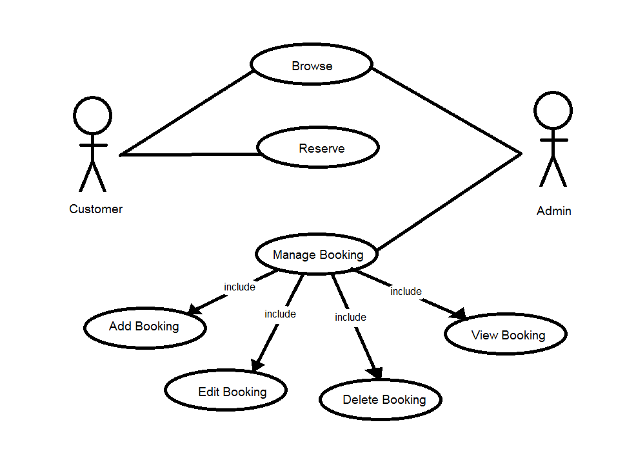

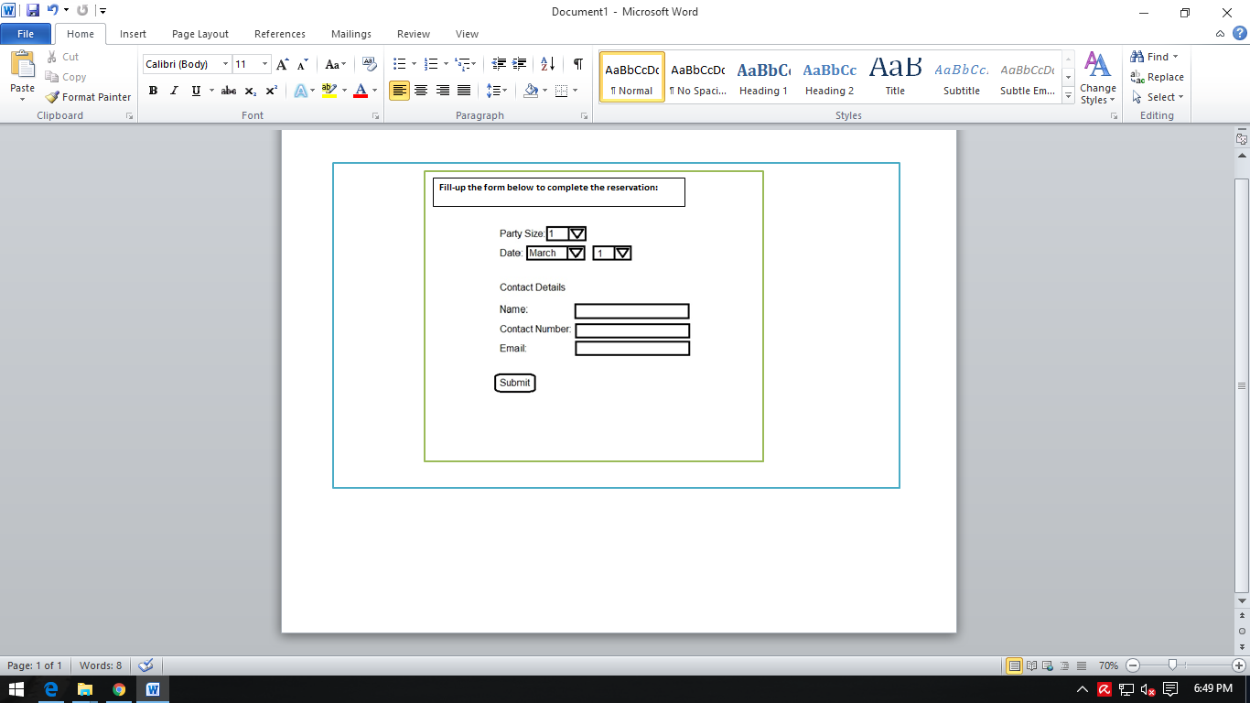UI Design Draft

This portion is the main interface of this study where you can make the reservation and conduct the reservation. This panel is compose of details such as contact details, time of the reservation, and number of accommodating persons.

User Requirements

* The user must provide some personal information such as name, phone number or email etc. to make reservation.

System Requirements

* The system will generate a proof of reservation receipt to be present by the customer to the restaurant.
* The system will provide some information about the restaurant such as the location, mechanics of reservation, and the validity of reservation.