Overview
This document contains the necessary information to build the Interact Switch, a large customizable switch with a low activation force.
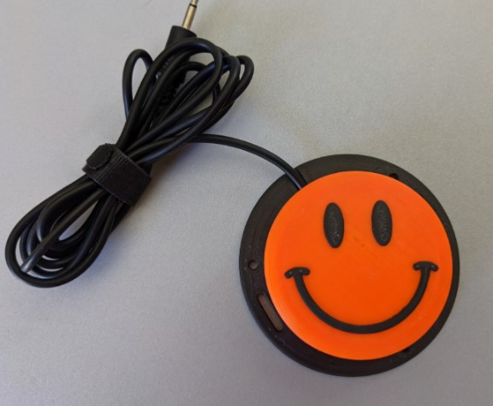

Contents
Overview 1
Maker Checklist 3
Maker To Do List 3
Items to Give to User 3
Attribution 3
Tool List 4
Tools / Equipment 4
Supplies 4
Personal Protective Equipment (PPE) 4
Customization Guide 5
3D Printing Guide 7
3D Printing Summary 7
3D Printing Settings 7
Post-Processing 8
Examples of Quality Prints 8
Building the Interact Switch 9
Required Components 9
Required Tools and Supplies 9
Required Personal Protective Equipment (PPE) 9
Assembly Steps 10
Testing 14
Troubleshooting 14

Maker Checklist
This list provides an overview of the steps required to build and deliver the Interact Switch.

Maker To Do List
- Read through the Maker Guide to become familiar with required components, tools, supplies, safety gear, and overall assembly steps.
- Talk to the User about customization options
  - What colour(s) would they like the topper and/or topper pattern to be printed in?
  - Which topper would they like to have? There are a variety of toppers available with different patterns and textures.
  - How would they like to receive the “User Guide”? (PDF or physical copy)
- Order hardware components
- Gather tools, supplies, and safety equipment.
- Assemble the device
- Test the Interact Switch

Items to Give to User
- Interact Switch
- User Guide

Attribution
The Interact Switch design by Mike Turvey is used under CC-BY 4.0. Instructions adapted from Original Interact Switch Assembly Instructions by Mike Turvey, used under CC-BY 4.0.
Due to changes made to make the switch compatible with the #4 sheet metal screws, the Base and Switch holder are no longer compatible with the original parts.

Tool List

Tools / Equipment
Tool ID | Description | Required / Recommended | Notes
T01 | Wire Strippers | Required | Stripping insulation from the cable
T02 | Soldering Iron | Required | Soldering the Cable to the switch
T03 | Phillips Screwdriver | Required | Attaching the base to the top

Supplies
Supplies ID | Description | Quantity |  | Notes
S01 | Solder | Roughly 1 inch | To attach the mono cable to the button

Personal Protective Equipment (PPE)
PPE ID | Description | Notes
P01 | Safety Glasses | To keep flying debris out of your eyes

Customization Guide
The device can be printed in the user’s desired colour.
There are over 12 different button caps available in the GitHub repository, and some projects such as the Open Playback Recorder have custom Interact Switch caps that match buttons on the device.
When printing the textured button caps, a filament change can be done to print the textured part of the cap in a different colour from the main body, increasing contrast. This can also be done automatically on printers that support multi-material printing.
The plain, ‘default’ button topper can be seen below, and the other options included in the Interact Switch Repository are listed in the table below.
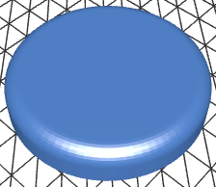

Arrow | Circle | Dome
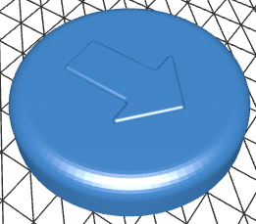 | 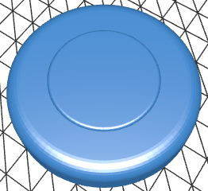 | 
Dots Circles | Dots Wide | Lines
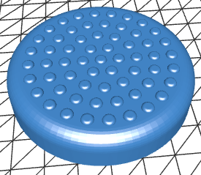 | 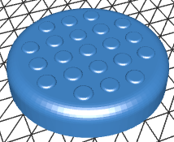 | 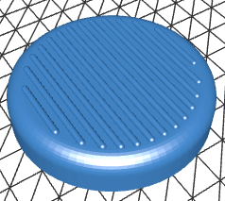
Lines Very Wide | Lines Wide | Octagon
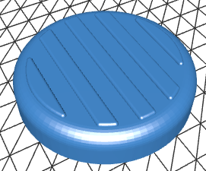 | 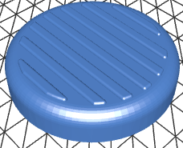 | 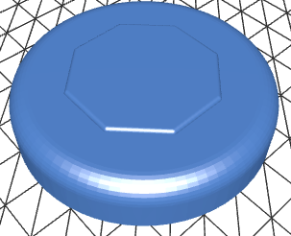
Rings | Rings Wide | Smile
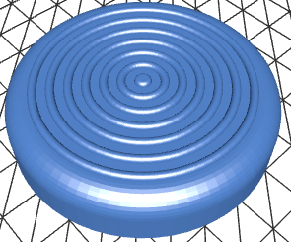 | 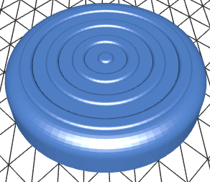 | 

3D Printing Guide
The device was originally printed on a Bambu P1S using Bambu Studio using the default profile.

3D Printing Summary
Metrics | Single Unit
Total Print Time (hour min) | 1h8min
Total Number of Components | 4
Typical Total Mass (g) | 35
Typical Number of Print Setups | 3

3D Printing Settings
Note that the 3D printing material should be assumed to be PLA unless otherwise noted in the table below.
Print File Name | Qty | Total Print Time (hr:min) | Mass (g) | Infill (%) | Suppor  (Y/N) | Layer Height/ Nozzle Diameter(mm) | Notes
Interact_Switch_Base.stl | 1 | 0:32 | 17 | 20 | N | 0.2/0.4
Interact_Switch_Cap_Plain.stl | 1 | 0:25 | 14 | 20 | N | 0.2/0.4 | Default cap; others are available
Interact_Switch_Holder.stl | 1 | 0:09 | 3 | 20 | N | 0.2/0.4
Interact_Switch_Insert_0.6mm.stl | 1 | 0:02 | 1 | 20 | N | 0.1/0.4 | Print with 0.1 mm layer height if printing an odd numbered insert (i.e. a 0.5 mm or 0.9 mm)
Interact_Switch_Solder_Jig.stl | 1 | 0:25 | 12 | 20 | N | 0.2/0.4 | Optional

Depending on the tolerances of your printer, you may have to print a different switch insert than the 0.6mm insert. The insert is the part that makes the cap press the switch in the base, and depending on the tolerances of your printer, this distance might be too close or too far for the 0.6mm insert. The repository includes inserts from 0.2 to 1.5mm and it may take a few tries to find the right one that works for your printer.

Post-Processing
Inspect the 3D printed parts for any printing defects, sharp edges, or burrs. Sharp edges and burrs can be removed with sanding or deburring tools.

Examples of Quality Prints
Compare your 3D prints to the images here. If there are significant differences, you may need to reprint the part.
Interact Switch
Interact_Switch_Base.stl | Interact_Switch_Cap_Plain.stl | Interact_Switch_Holder.stl
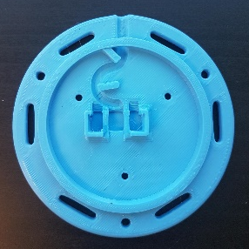 | 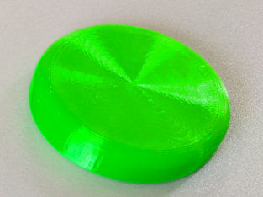 | 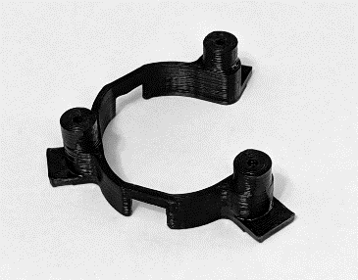
Interact_Switch_Insert_0.6mm.stl | Interact_Switch_Solder_Jig.stl
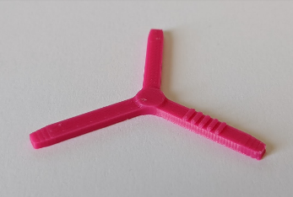 | 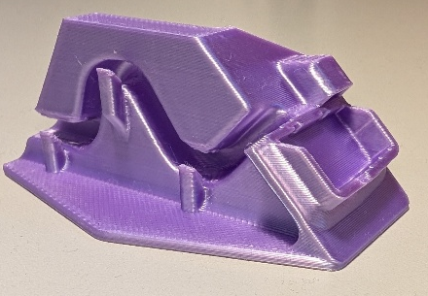

Building the Interact Switch

Required Components
Interact Switch
A01 |  | Switch Base |  | QTY: 1 | A02 |  | Button Cap Holder |  | QTY: 1 | A03 |  | Button Cap Insert |  | QTY: 1
A04 | Button Cap |  | QTY: 1 |  | A05 | Limit Switch |  | QTY: 1 |  | A06 | Mono Cable |  | QTY: 1
 |  |  |  |  | 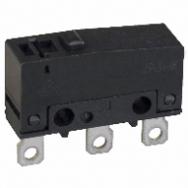 |  |  |  |  | 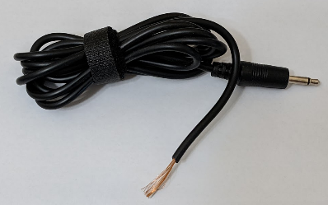
A07 | #4 Sheet Metal Screw |  | QTY: 3
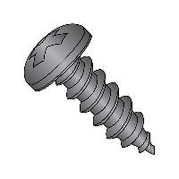

Required Tools and Supplies
- Wire Strippers
- Soldering Iron
- Screwdriver

Required Personal Protective Equipment (PPE)
- Safety Glasses

Assembly Steps

Step 1: Prep Cable
Cut off and discard one of the plugs from the mono audio cable.
Use the wire strippers to carefully remove about 15 mm of the outer insulation from the end.
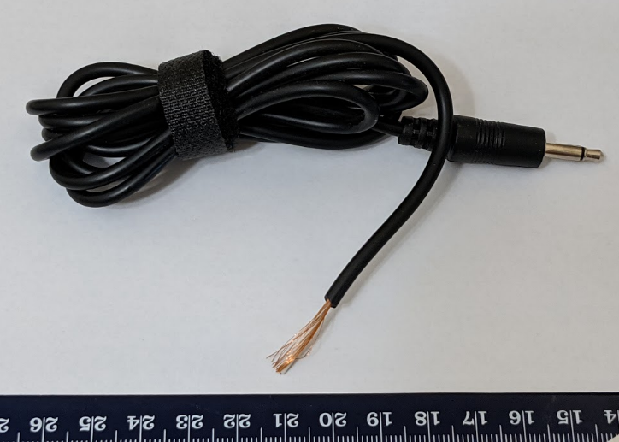

Step 2: Prep Cable Wires
Twist the copper strands together into a single wire.
Use the wire strippers to remove roughly 5 mm of insulation from the other wire.
(Note: Your cable may differ. If there are two wires with insulation, strip 5 mm from the end of each wire.)
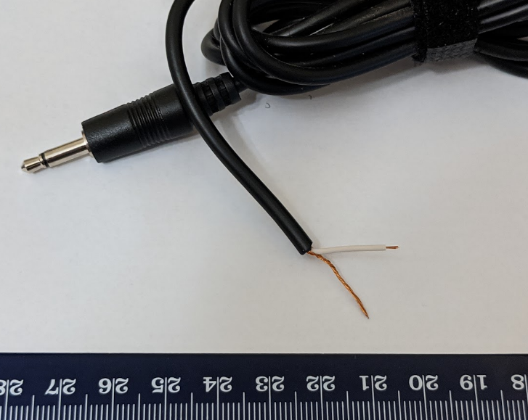

Step 3: Thread Cable into Switch Base
Thread the cable through the hole in the Switch Base. You will not be able to do this after you solder the limit switch onto the wire.
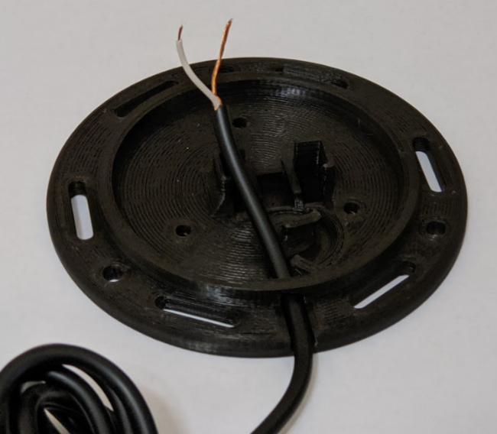

Step 4: Solder Wires to Switch
Solder the wires into the switch in the position shown below. The optional soldering jig can be used to hold the cable and switch in place, and to isolate the correct terminals to solder to.
Note: Solder the two leads closest to the button on the switch.
Test: plug your switch into a switch activated device and push the button on the limit switch
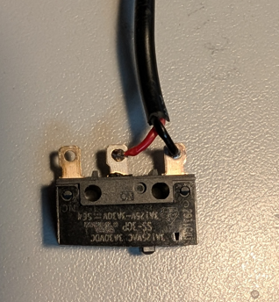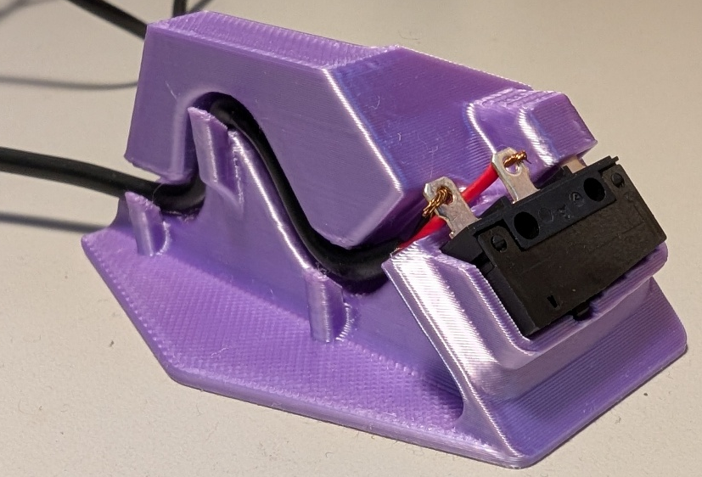

Step 5: Position Switch in Base
Place the limit switch into the Switch Base as shown.
For the orientation of the switch, when the cable is coming towards you, the button on the limit switch should be offset to the left. Make sure that no wires are stuck underneath, preventing the limit switch from going all the way down.
Push the cable in the slot as shown in the picture.
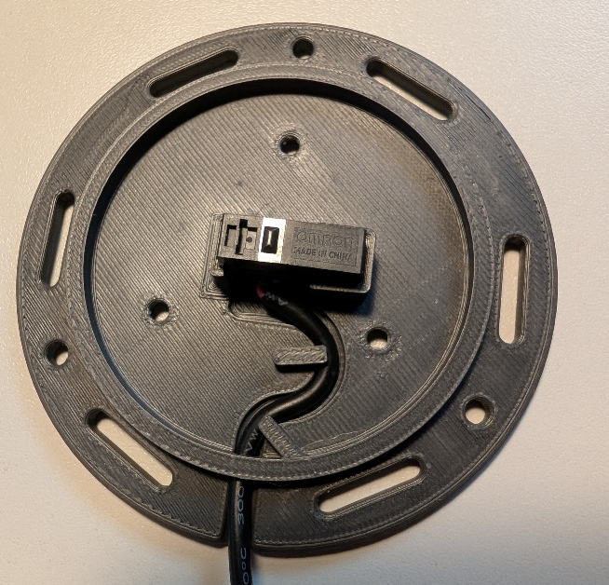

Step 6: Assemble Button Cap
Turn the Button Cap over and insert the Button Cap Insert. If you’re unsure which size to use, try starting with 0.6 mm. The lines on the button insert should be facing up, with the print surface facing down towards the cap. The raised section where all three legs on the insert join should be visible.
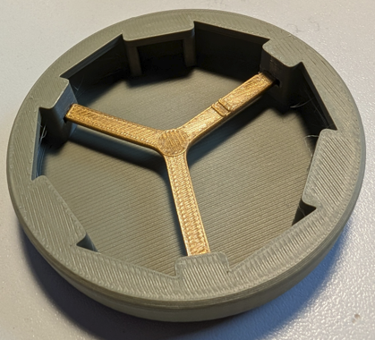
Lines facing up

Step 7: Finalize Button Cap Assembly
Insert the Button Cap Holder into the Button Cap Assembly. The orientation of the “open” side doesn’t matter.
Note: for smoother switch action, sand the edges of the Button Cap Holder where it rubs on the switch.
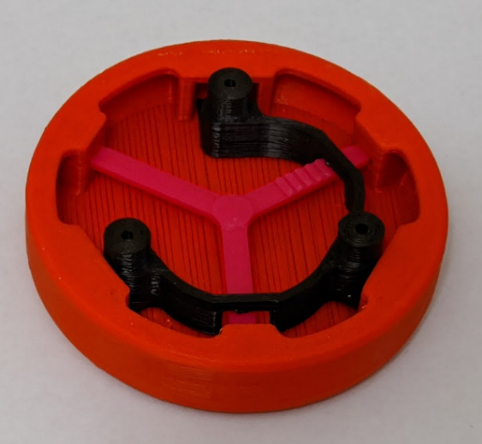

Step 8: Assemble Switch
Align the three posts of the Switch Cap Holder to the three holes in the Switch Base. Secure the Switch Cap Holder to the Switch Base using three screws. Tighten them until the Switch Cap holder is firmly against the base.
Note: Be careful not to over tighten the screws. Tighten them until you notice the resistance increases and the Switch Cap Holder is firmly against the Switch Base.
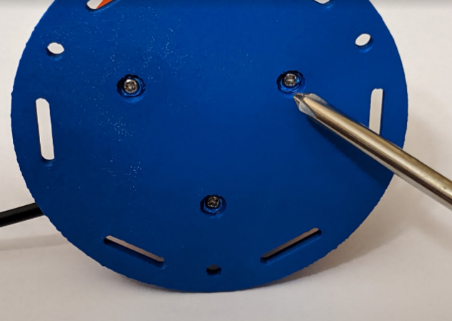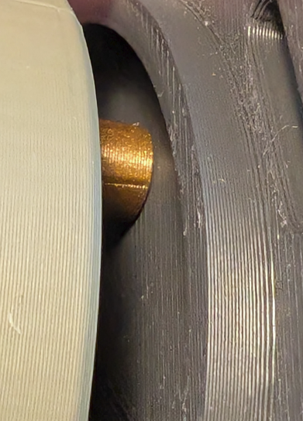

Testing
The last thing to do is test your switch. If this is your first switch, you’ll likely need to test it out and figure out the best size of Switch Cap Insert to use.
The first thing to do to test a switch is to push it a lot. Tap it everywhere, repeatedly. Every time you push it, you should hear it click down and click as it goes back up. It should never stick. If you wiggle the top, it should move some, but it shouldn’t feel like it’s rattling around. Next, plug the switch into a switch activated device and make sure that it works.

Troubleshooting
Problem | Solution
The switch cap is too loose and rattles around easily. | Use a larger/ thicker Switch Cap Insert.
Switch doesn’t make any noise when pushed. | Use a smaller/ thinner Switch Cap Insert. An insert that is too big can cause the limit switch to be always depressed. When this is the case, you’ll often hear the limit switch “click” closed when you’re screwing everything together, but it won’t ever click open.
Switch sticks/ doesn’t always go back up. | Use a smaller/ thinner Switch Cap Insert. You may likely need just one size thinner.
Switch makes clicking noise, but the switch activated device isn’t activating | - Test the switch activated device with a switch known to work, just to make sure it’s working fine.  - Check that the plug is firmly plugged into the device  - The solder connection may be bad and need to be re-soldered.  - There may be an internal break in the wire, and you will need to replace it. This is a particularly common failure point for an older switch.

