Autonomous Racing RL (Neural Tesla): PPO-Based Continuous Control for Procedural 2D Racing

Intro
This paper documents a complete reinforcement learning pipeline for autonomous 2D racing built entirely within the repository. The agent controls steering and throttle in continuous space and is trained with Proximal Policy Optimization (PPO). Observations are compact but intentionally structured to capture range sensing and core kinematics, which keeps learning stable and fast. The environment is procedural, so each episode is a different track configuration, which reduces overfitting to a single layout. All claims and results here are grounded in the code and the experiment CSVs in the provided bundle. | Return: G_t = sum_{k=0..T} gamma^k r_{t+k}

The design emphasizes reproducible metrics: reward, episode length, crash rate, and curriculum difficulty are logged per episode into CSV, and all ablation results are aggregated across three seeds. Figures in this paper are generated from the provided SVGs and are referenced directly in the Training Results section. The goal is to tie system behavior back to concrete implementation choices in the environment, policy, and PPO trainer. | crash_free = 1 - crash_rate (training_loop.py)

System Overview
The runtime system is composed of a single-environment simulator (CarEnv), a multiprocessing VectorEnv wrapper, and a PPO trainer that updates policy and value networks. The training loop orchestrates sampling, logging, curriculum updates, and checkpointing. The entry point main.py dispatches train, evaluate, and tune modes, ensuring the same code paths are used for both headless training and visualization evaluation. This architecture is explicitly implemented in rl_car_rl/main.py, rl_car_rl/training/training_loop.py, and rl_car_rl/training/trainer.py. | main.py: --mode {train,evaluate,tune}

Training configuration is loaded from configs/hyperparameters.yaml, including learning rate, gamma, clip epsilon, K epochs, update timestep, and number of environments. These parameters are consumed in training_loop.py to configure the PPO trainer and sampling cadence. This keeps the training pipeline declarative and ensures that experiment artifacts can be linked back to an explicit configuration. | hyperparameters.yaml: lr=3e-4, gamma=0.99, k_epochs=4, eps_clip=0.2

Environment Code Explanation
CarEnv creates a Car, Track, PhysicsEngine, and SensorSystem. Reset regenerates a track based on difficulty parameters, initializes the car at the track start pose, and returns a 9D observation. The environment tracks episode steps and terminates on crash or when max steps is reached (1000). This structure is defined in rl_car_rl/env/environment.py and is the primary interface used by the trainer. | done = crashed or current_step >= max_steps

The observation vector combines five normalized sensor distances with four normalized kinematic features: velocity, heading angle, angular velocity, and distance from a fixed center point. Velocity is normalized by max_speed, heading is normalized by pi, and angular velocity by a constant scale. This normalization stabilizes the neural network inputs and keeps observation magnitudes bounded. Observation assembly is implemented in rl_car_rl/env/environment.py and uses SensorSystem in rl_car_rl/env/sensors.py. | obs = [s1..s5, v/max_v, heading/pi, omega/2, center_dist]

Reward computation is delegated to training/reward_function.py and is based on forward velocity, progress along the track, and a crash penalty. The environment computes progress by measuring the nearest point along the track centerline and handling wrap-around for closed loops. Crash detection checks if any car corner falls outside the outer boundary or inside the inner boundary. This design provides smooth learning signals while strongly penalizing collisions. | reward = 0.01*v + 50*progress_diff - 0.01 - 10*crashed

Physics uses a bicycle model with bounded steering, bounded throttle, friction, and max speed. Angular velocity is derived from speed and steering geometry, and heading is normalized to [-pi, pi]. Position is updated with a fixed time step, which makes dynamics deterministic given the action sequence. This is implemented in rl_car_rl/env/physics.py and used in CarEnv.step. | omega = (v / L) * tan(delta)

Sensor rays are cast against both inner and outer track boundaries using segment intersection tests. Each ray returns the minimum intersection distance up to max_range and is normalized to [0,1]. This raycasting design provides local obstacle geometry without exposing full map information, keeping the task partially observed but tractable. Sensor implementation is in rl_car_rl/env/sensors.py. | d_norm = min(d_intersect, d_max) / d_max

Neural Network Implementation
Both policy and value networks are built from the same DriveNetwork MLP: Linear(9->256)->ReLU->Linear(256->256)->ReLU->Linear(256->128)->ReLU->Linear(128->out). The policy outputs a 2D mean for steering and throttle, while the value network outputs a scalar value estimate. This architecture balances capacity and stability for PPO in continuous control. The definitions are in rl_car_rl/agent/neural_network.py and rl_car_rl/agent/policy.py. | MLP: 9 -> 256 -> 256 -> 128 -> out

The policy maintains a learnable log standard deviation parameter for the action distribution. During training, actions are sampled from a Normal distribution, and log-probabilities are summed across action dimensions. For evaluation, deterministic actions use the mean directly. Action clamping ensures consistency with the environment’s steering and throttle bounds. This behavior is implemented in rl_car_rl/agent/policy.py. | log_prob = sum_i log N(a_i; mu_i, sigma_i)

PPO Training Pipeline
The PPO trainer computes discounted rewards for each environment independently and then flattens them to a single batch. Rewards are normalized before advantage calculation to reduce scale variance. Advantages are computed as normalized returns minus value predictions. This entire process is implemented in rl_car_rl/training/trainer.py. | A_t = (R_t - mean(R)) / std(R) - V(s_t)

The PPO objective uses a clipped surrogate ratio to avoid large policy updates: the policy loss is the negative minimum of unclipped and clipped advantages, plus an entropy bonus. The value loss is MSE between predicted values and normalized returns. The optimizer updates policy and value parameters jointly each epoch. This is explicitly coded in trainer.update. | L = -min(r*A, clip(r,1-eps,1+eps)*A) + 0.5*MSE

The training loop coordinates sampling from VectorEnv, handles episode termination per environment, and logs reward/length/crash rate/difficulty per completed episode. Checkpoints are saved on improved reward and periodically every 50 episodes. Curriculum updates are triggered at 2x update_timestep using recent mean reward, and update_timestep is read from hyperparameters.yaml. This control flow is in rl_car_rl/training/training_loop.py. | if time_step % update_timestep == 0: update PPO

Vectorized Environments Implementation
VectorEnv creates multiple worker processes, each hosting a CarEnv instance. The manager sends step and reset commands via pipes and aggregates the results into batched arrays. Terminal observations are returned in the info dict for value estimation. This implementation provides efficient, parallel rollouts without requiring a gym dependency. Code is in rl_car_rl/env/vector_env.py. | obs_batch = stack(obs_i), rewards = stack(r_i)

The step method also normalizes input action shapes to ensure correct batching in single-env and multi-env cases. This keeps the training loop consistent when num_envs varies via config overrides. The same VectorEnv is used for both curriculum and no-curriculum ablations, enabling controlled comparisons. The implementation is in rl_car_rl/env/vector_env.py and rl_car_rl/training/training_loop.py. | actions.ndim==1 -> expand_dims(actions,0)

Procedural Track Generation Code
Tracks are generated by sampling random radii at evenly spaced angles, centered at a fixed world origin. A Catmull-Rom spline interpolates these control points to form a smooth closed loop. The environment then computes inner and outer boundaries by offsetting along averaged tangents, which reduces corner artifacts. Track generation and boundary creation are in rl_car_rl/env/track.py. | Catmull-Rom: p(t) = sum_i f_i(t) * p_i

Track progress is computed by finding the nearest centerline point and returning its normalized index, which yields a value in [0,1). This allows the reward function to compute incremental progress by subtracting the previous index and handling wrap-around. The track also provides collision checks via point-in-polygon tests, using both outer and inner boundaries to ensure the car remains within the drivable lane. All logic is in rl_car_rl/env/track.py. | progress = argmin_i ||p_i - x|| / N

Curriculum Learning Logic
CurriculumManager defines easy and hard parameter sets and linearly interpolates between them based on a difficulty level. Each time mean reward exceeds a threshold, level increases by a fixed rate and the threshold is increased, making advancement progressively harder. This ensures that the environment only becomes more complex when the agent demonstrates sufficient performance. The logic is in rl_car_rl/training/curriculum.py. | params = easy + level * (hard - easy)

The training loop uses a global_step counter to trigger curriculum updates at fixed intervals (2x update_timestep), then sets new difficulty parameters across all vectorized environments. This ensures that the curriculum is applied consistently across parallel workers and that difficulty changes are synchronized with PPO optimization windows. This coupling is implemented in rl_car_rl/training/training_loop.py and rl_car_rl/env/vector_env.py. | if global_step % (2*update_timestep)==0: update curriculum

Training Results
All ablations were run for 1000 episodes with three seeds per variant. The aggregate curves and summary statistics are in experiments/20260311_230833/*.csv. The reward trajectories (mean ± std) are shown in Figure 1, comparing curriculum vs no-curriculum and single-env vs vectorized settings. These curves are computed from aggregate_curves.csv. | 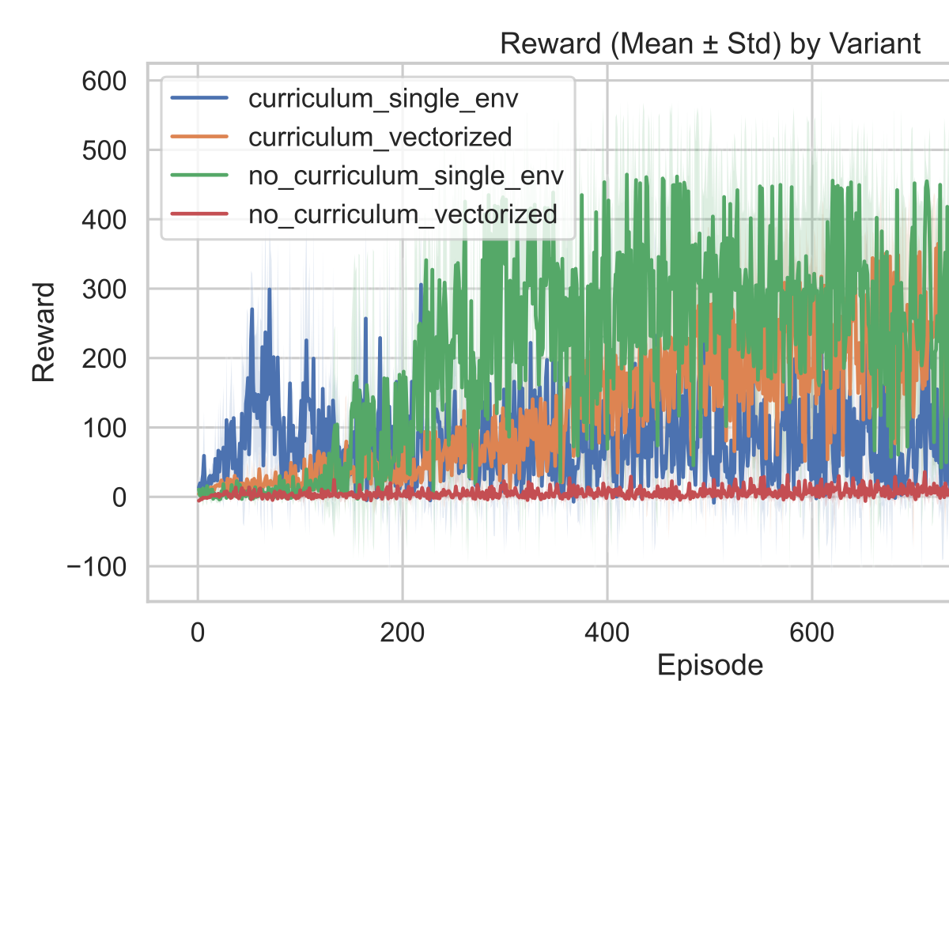

Episode length trends are shown in Figure 2 and reflect the interaction between control stability and track difficulty. Longer episodes generally indicate sustained control without crashes, but must be interpreted in conjunction with crash-free rate. Length curves are aggregated across seeds from aggregate_curves.csv. Figure 2 corresponds to figures/ablations_20260312_080245_episode_length_mean_std_1.svg. | 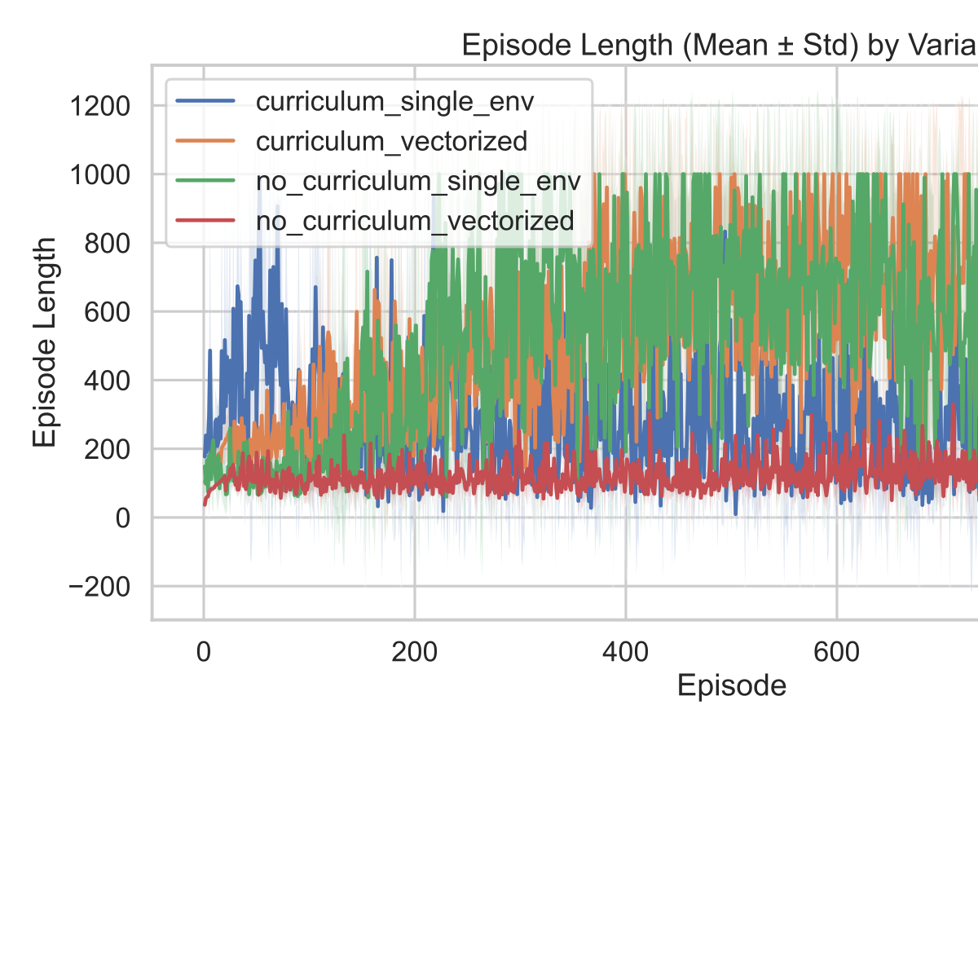

Crash-free rate over time is shown in Figure 3 and is computed as 1 - crash_rate from the training loop logs. This metric provides a direct stability signal and is aggregated across seeds for each variant. Figure 3 uses figures/ablations_20260312_080245_crash_free_rate_mean_std_1.svg and is derived from aggregate_curves.csv. | 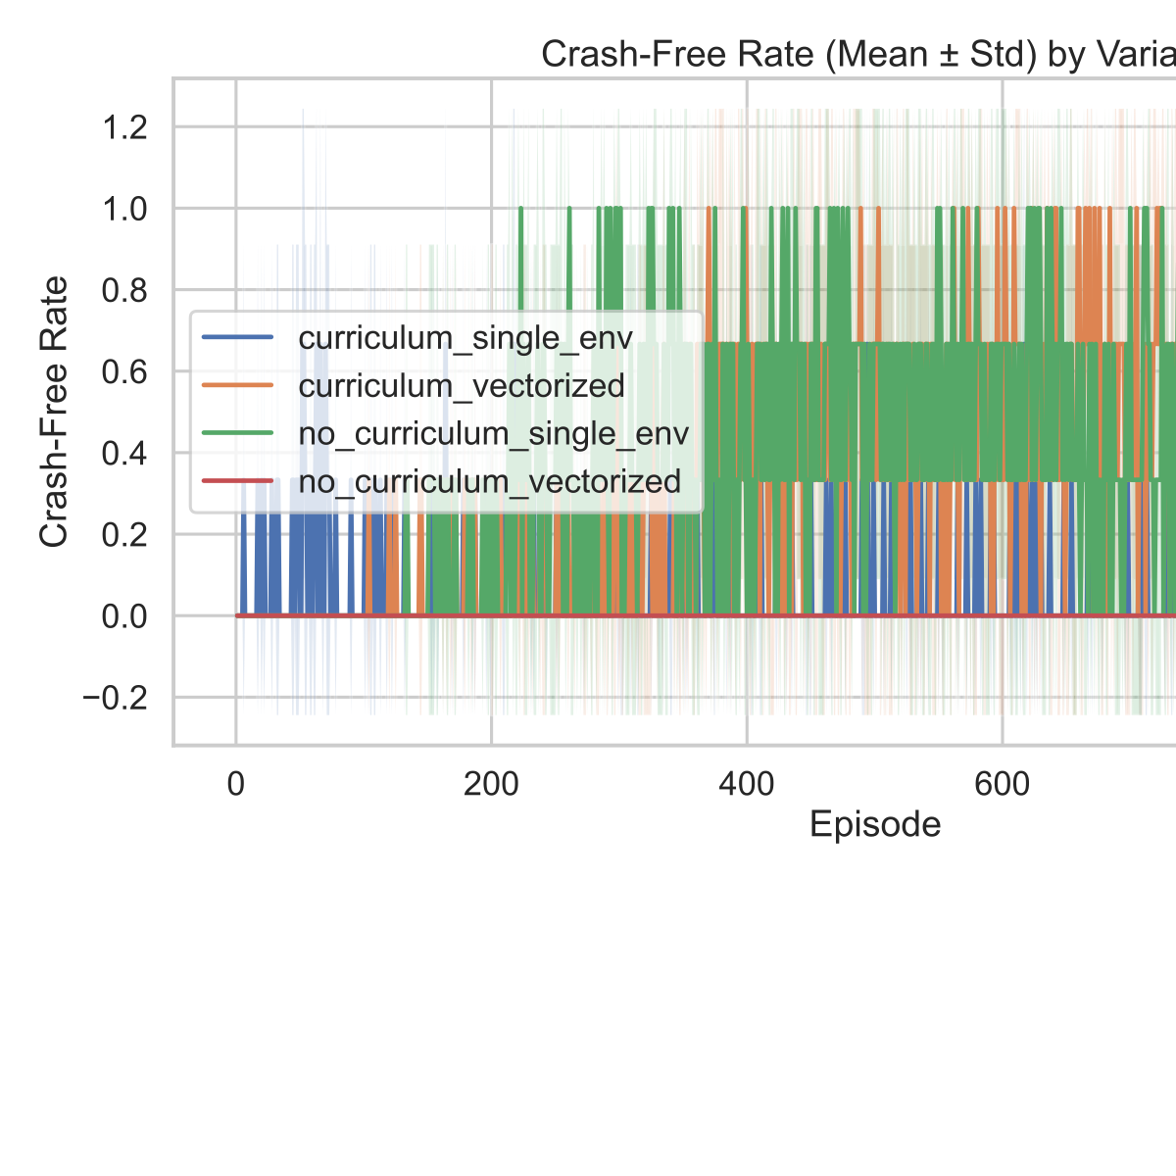

Curriculum difficulty progression is shown in Figure 4. Curriculum single-env reaches higher difficulty earlier on average, while curriculum vectorized progresses more gradually and does not reach the maximum level in these runs. Threshold-hit statistics (0.2/0.4/0.6/0.8/1.0) are reported in curriculum_thresholds_summary.csv. Figure 4 uses figures/ablations_20260312_080245_curriculum_difficulty_mean_std_1.svg. | 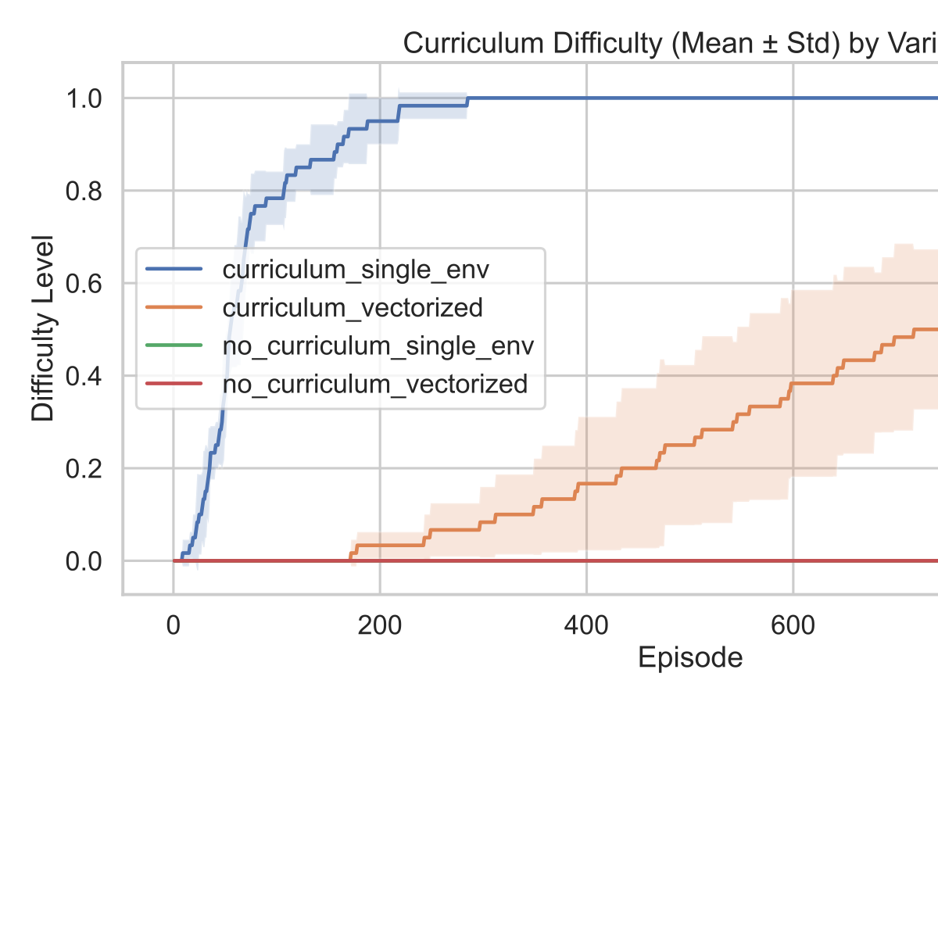

Final 10-episode mean ± std across seeds: curriculum single-env reward 59.809±16.407, length 221.800±54.853, crash-free 0.033±0.058, final difficulty 1.000±0.000. Curriculum vectorized reward 162.174±122.743, length 439.433±298.265, crash-free 0.267±0.379, final difficulty 0.683±0.076. No-curriculum single-env reward 382.178±43.329, length 890.467±79.940, crash-free 0.700±0.100. No-curriculum vectorized reward 19.385±15.580, length 189.300±77.946, crash-free 0.000±0.000. | See experiments/20260311_230833/variant_summary.csv

Curriculum threshold hit episodes (mean ± std across seeds): vectorized reaches 0.2 at 449.7±167.5, 0.4 at 600.7±159.7, 0.6 at 778.0±149.1. single-env reaches 0.2 at 31.7±7.5, 0.4 at 50.0±3.6, 0.6 at 60.7±8.1, 0.8 at 95.3±23.7, and 1.0 at 224.3±57.8. | See experiments/20260311_230833/curriculum_thresholds_summary.csv

GitHub repo link
https://github.com/kaivalya-cyber/car_neural_diff_learning | Repository with code and experiment artifacts

