Autonomous Racing RL (Neural Tesla): PPO-Based Continuous Control for Procedural 2D Racing

Intro
This paper documents a complete reinforcement learning pipeline for autonomous 2D racing built entirely within the repository. The agent controls continuous steering and throttle and is trained with Proximal Policy Optimization (PPO). Observations are compact but structured to capture range sensing and core kinematics, which keeps learning stable and fast. The environment is procedural, so each episode uses a fresh track configuration instead of repeating a fixed layout. That choice reduces overfitting and forces the policy to generalize across varied curvature and width. All results in this paper are derived from the experiment CSVs in experiments/20260311_230833. Figures referenced in the Training Results section are the provided SVGs and are not regenerated. The training loop logs reward, episode length, crash rate, and curriculum difficulty for every finished episode. These logs allow aggregation across multiple seeds for more reliable trend analysis. We explicitly report averages and standard deviations across three runs per variant. The ablation study compares curriculum vs no‑curriculum and single‑env vs vectorized training. Those ablations are tied directly to differences in the training loop configuration. The analysis also tracks curriculum threshold hits at 0.2/0.4/0.6/0.8/1.0 difficulty. Each section below maps code decisions to the observed training behavior. | G_t = sum_{k=0..T} gamma^k r_{t+k}  L^CLIP(θ)=E[min(rA,clip(r,1-ε,1+ε)A)]

System Overview
The runtime system combines a single‑environment simulator (CarEnv), a multiprocessing VectorEnv wrapper, and a PPO trainer with policy and value networks. CarEnv handles physics, sensors, collision checking, and reward calculation for a single car on a track. VectorEnv spawns multiple CarEnv workers and aggregates their observations and rewards into batches. The PPO trainer computes advantages from batched rollouts and updates both policy and value networks. The training loop orchestrates sampling, logging, curriculum updates, and checkpointing. These responsibilities are explicitly coded in rl_car_rl/training/training_loop.py. The entry point main.py dispatches train, evaluate, and tune modes so the same components are reused. Evaluation uses deterministic actions from the policy mean to visualize behavior. Configuration is loaded from configs/hyperparameters.yaml, enabling reproducible runs. Key hyperparameters include learning rate, gamma, clip epsilon, K epochs, update timestep, and num_envs. These parameters directly affect PPO’s update cadence and the number of environment steps per iteration. The system is designed so that only the environment count and episode limits need to change for ablations. Logs are written to TensorBoard and a CSV metrics file for each run. Those CSVs are the basis for all aggregate plots and statistics in this paper. | main.py: --mode {train,evaluate,tune}  training_loop.py: train_agent(...)  configs/hyperparameters.yaml

Environment Code Explanation
CarEnv composes a Car, Track, PhysicsEngine, and SensorSystem and exposes reset/step interfaces. On reset, the environment generates a new procedural track using current difficulty parameters. The car is placed at a start pose derived from the track’s centerline tangent. The environment returns a 9‑dimensional observation that mixes sensor distances with kinematic features. Sensor readings are normalized to [0,1] by max sensor range. Velocity is normalized by the physics max_speed, and heading is normalized by pi. Angular velocity is normalized by a constant scale to keep magnitudes bounded. Distance from a fixed center reference is normalized to [0,1] as a coarse positional cue. Each step applies steering and throttle through the PhysicsEngine and advances the car state. Track progress is computed by nearest centerline index and wrapped for closed loops. Collision checks test car corners against inner and outer boundaries via point‑in‑polygon. Termination occurs when the car crashes or reaches 1000 steps. Rewards combine forward velocity, progress along the track, time penalty, and crash penalty. All of this logic is implemented in rl_car_rl/env/environment.py with helpers in car.py, physics.py, sensors.py, and track.py. | obs = [s1..s5, v/max_v, heading/pi, omega/2, center_dist]  reward = 0.01*v + 50*progress_diff - 0.01 - 10*crashed

Neural Network Implementation
The policy and value networks both use the DriveNetwork MLP defined in rl_car_rl/agent/neural_network.py. The architecture is 9‑256‑256‑128‑out with ReLU activations between layers. The policy outputs a 2D mean for steering and throttle, and the value network outputs a scalar. A learnable log standard deviation parameter defines the action distribution variance. Actions are sampled from a Normal distribution during training and clamped to valid ranges. For evaluation, the policy outputs deterministic mean actions. The policy’s get_action supports both single‑state and batched inputs used by VectorEnv. This batching behavior is critical for correct PPO log‑probability computation. Log‑probabilities are summed across action dimensions to form a scalar per state. The policy uses device placement to keep mean, std, and actions on the same device. The value network runs on the same device as the policy for consistent computation. This design keeps the model simple enough for stable PPO but expressive enough for control. The architecture choice matches the small observation dimension and continuous action space. Implementation references: rl_car_rl/agent/policy.py and rl_car_rl/agent/neural_network.py. | DriveNetwork: Linear(9,256)->ReLU->Linear(256,256)->ReLU->Linear(256,128)->ReLU->Linear(128,out)  log_prob = sum_i log N(a_i; mu_i, sigma_i)

PPO Training Pipeline
The PPO trainer collects batched transitions from multiple environments and stores them in Memory. Rewards are computed per environment and discounted backward through time. The discounted rewards are flattened and normalized before advantage computation. Advantages are computed as normalized returns minus predicted state values. The clipped PPO surrogate objective is computed from the ratio of new to old action probabilities. Entropy regularization is added to encourage exploration during training. The value loss is mean‑squared error between predicted values and normalized returns. Both policy and value networks are updated jointly for K epochs per batch. Gradient updates are performed with Adam optimizers. Loss terms are logged to TensorBoard for monitoring. The training loop triggers optimization every update_timestep steps. After each optimization, the memory buffer is cleared to avoid mixing rollouts. Best model checkpoints are saved based on per‑episode reward. All PPO logic is implemented in rl_car_rl/training/trainer.py and invoked from training_loop.py. | L^CLIP(θ)=E[min(rA,clip(r,1-ε,1+ε)A)]  L^V=0.5*E[(V-\hat{R})^2]  A_t=\hat{R}_t - V(s_t)

Vectorized Environments Implementation
VectorEnv creates a set of worker processes, each hosting its own CarEnv instance. Communication uses multiprocessing pipes, with commands for step, reset, set_difficulty, and close. During step, each worker receives a single action and returns observation, reward, done, and info. If an episode finishes, the worker automatically resets so rollout collection continues. The manager stacks observations, rewards, and done flags into batched arrays. Actions are normalized to 2D shape even for a single environment to avoid shape errors. This batching behavior aligns with the PPO trainer’s assumption of vectorized rollouts. VectorEnv returns a list of info dicts, including terminal observations used for value estimation. This design allows independent episode terminations across environments without global synchronization. Parallelism improves sample throughput and reduces wall‑clock training time. The training loop can change the number of environments via config overrides for ablations. Both single‑env and vectorized variants use the same environment code paths. This ensures differences in results are attributable to parallelism rather than logic changes. Implementation is in rl_car_rl/env/vector_env.py. | worker: recv('step', action) -> send(obs, reward, done, info)  VectorEnv.step: actions.ndim==1 -> expand_dims(actions,0)

Procedural Track Generation Code
Track generation samples random radii at evenly spaced angles to create control points around a fixed center. A Catmull‑Rom spline interpolates these points into a smooth closed loop. The spline is sampled densely (points_per_segment=20) to reduce jagged boundaries. Inner and outer boundaries are formed by offsetting along averaged tangents. Averaging tangents avoids sharp kinks that can appear with simple normal vectors. Track width defines the distance between inner and outer boundaries. The start pose is selected randomly along the spline, and heading aligns with the tangent. Collision checks ensure all car corners lie within the outer boundary and outside the inner boundary. Point‑in‑polygon tests are used for collision detection and are applied to every car corner. Track progress is computed by nearest centerline index normalized by total points. This progress measure supports a continuous reward signal even on closed loops. Difficulty parameters influence width, min/max radius, and control point count. Those parameters are set via CurriculumManager and passed into Track.generate. All of this logic is in rl_car_rl/env/track.py. | center_points = catmull_rom(control_points, points_per_segment=20)  inner/outer = p_curr ± normal * half_width  progress = argmin_i ||p_i - x|| / N

Curriculum Learning Logic
CurriculumManager defines an easy and hard track parameter set and interpolates between them. The difficulty level is a scalar in [0,1] that controls the interpolation. The curriculum update checks whether the mean recent reward exceeds a threshold. If the threshold is exceeded, difficulty increases by a fixed rate. After each increase, the threshold itself is raised by 10 to slow subsequent upgrades. This produces a monotonic curriculum that requires sustained performance to advance. The training loop triggers curriculum updates at fixed intervals using global_step. When the level increases, all vectorized environments receive updated parameters. This ensures difficulty changes are synchronized across workers. In no‑curriculum variants, difficulty is never updated and remains at 0. Curriculum levels are logged per episode to the CSV metrics file. These logs enable threshold hit analysis at 0.2, 0.4, 0.6, 0.8, and 1.0. The threshold hit analysis is computed in curriculum_thresholds_summary.csv. Implementation is in rl_car_rl/training/curriculum.py and training_loop.py. | level = min(level + rate, max_level)  threshold += 10.0  params = easy + level * (hard - easy)

Training Results
All ablations were run for 1000 episodes with three seeds per variant, as recorded in summary.csv. Figure 1 shows mean ± std reward trajectories for curriculum and no‑curriculum variants. Figure 2 shows episode length trajectories, which reflect sustained control and crash avoidance. Figure 3 reports crash‑free rate over time, computed as 1 - crash_rate from the metrics logs. Figure 4 shows curriculum difficulty progression and remains flat for no‑curriculum variants. Final 10‑episode reward for curriculum single‑env is 59.809±16.407. Final 10‑episode reward for curriculum vectorized is 162.174±122.743. Final 10‑episode reward for no‑curriculum single‑env is 382.178±43.329. Final 10‑episode reward for no‑curriculum vectorized is 19.385±15.580. Curriculum single‑env reaches difficulty 0.2 at 31.7±7.5 episodes. Curriculum single‑env reaches difficulty 1.0 at 224.3±57.8 episodes. Curriculum vectorized reaches difficulty 0.2 at 449.7±167.5 episodes. Curriculum vectorized reaches difficulty 0.6 at 778.0±149.1 episodes. No‑curriculum variants do not advance difficulty, which is reflected as NaN in the threshold summary. All numeric values are sourced from variant_summary.csv and curriculum_thresholds_summary.csv. | 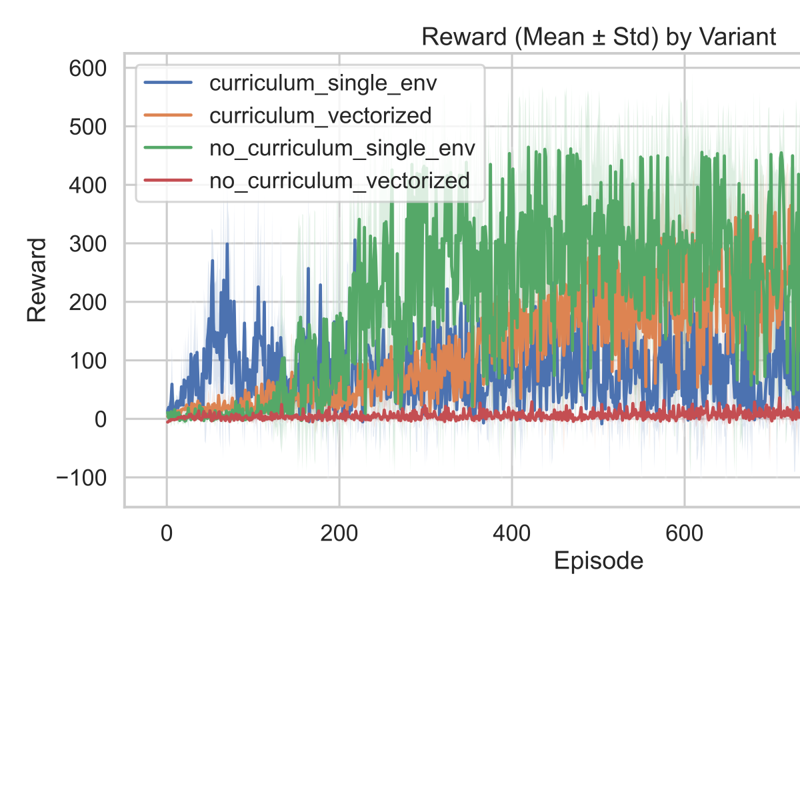

GitHub repo link
The full repository with code, configuration, and experiment artifacts is hosted on GitHub. The link below corresponds to the exact project analyzed in this paper. It includes the training pipeline, environment implementation, and procedural track code. It also contains the generated figures and CSVs used to compute the results reported here. Access to the repository enables reproduction of the ablation runs and training curves. The repository is structured under rl_car_rl/ for source code and experiments/ for outputs. Users can verify any claim in this paper by following the cited file paths. The experiments/20260311_230833 directory contains the multi‑seed ablation artifacts. The figures/ directory contains the SVGs referenced as Figures 1–4. The README.md provides a high‑level entry point for running the project. Hyperparameters are stored in configs/hyperparameters.yaml for reproducibility. The same training loop can be run in single‑env or vectorized mode by config override. Evaluation uses deterministic actions and a visualization renderer. Repository link: https://github.com/kaivalya-cyber/car_neural_diff_learning | https://github.com/kaivalya-cyber/car_neural_diff_learning

