Hierarchy of Input, Processing, and Output

This is a description of how our photo browser will work. It’s organized using the “HIPO” system so that larger tasks are broken down into smaller tasks.

After we know what our program needs to do, we can create a header file which declares classes and function types/names/input. Then once we have a header file we can all start programming our individual sections of the project.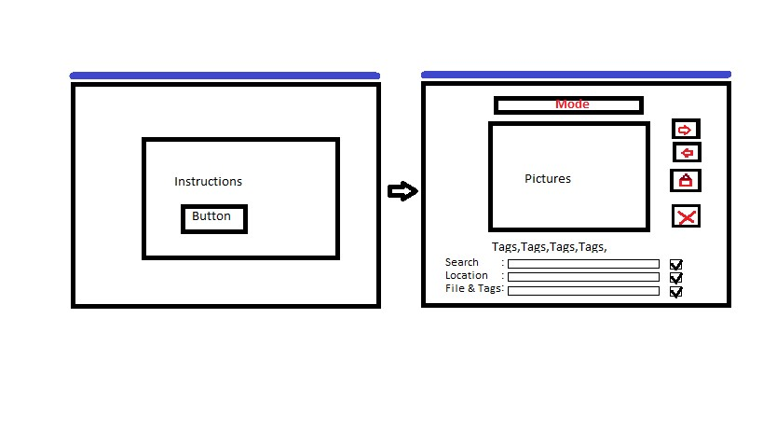

**Create a “Photo Browser Program”**

* Store Photos and Information (Class)
  + Take input (function)
    - Check format of file/url
      * Decide if we are looking for a file or url(http)
        + Errors:

Allow recovery if incorrect file/url format

Recover: URL cannot be downloaded / opened from disk

* + - * + Check allowed file extensions (.jpg, .png etc)
      * Take in text or button input
    - Add no more than 5 tags
      * Errors:
        + Recover from too many tags entered
* Database (Class)
  + Save input to the disk
    - Download file/url
    - Save tag information
    - Create database
      * Check if database is present
      * Tag formatting
        + Photo_name.extension, tag1, tag2 etc
    - Create tag data object data_obj to store tags and filename
* Display Photos and text (Class)
  + Show an instructions screen
    - Include examples/pictures
  + Retrieve Photos and Information
    - Open files and read tags from index
  + Navigate Photos
    - Next and previous buttons
    - Search Tags
      * Take input
      * Save tags to disk
      * Indicate that a search for tags has been made
  + Display picture on a screen
    - Open pictures
      * Find picture on disk
        + Check that file exists