**F**or **t**he **P**eople

# PROBLEM SUMMARY(ABSTRACT)

People’s feedback is an important aspect of democracy and this often gets overlooked in India. In this project, we aim to get feedback of willing people by making certain online platforms that are open to all. We plan to closely analyze these inputs from the people and extract important parameters, like the problem, location, which department/ministry it is falling under, frequency of submission. This data would be then submitted to the authority of city/state and hence they can be notified about the persisting issues under their locality. Hence by getting such feedbacks, analyzing them closely and solving problems, we aim to help people resolve their problems and work as a stepping stone towards perfect democracy.

The services which are provided by the government with an assurance “For the People” are built and never looked upon unless there is wreckage in their daily functioning. Since we live in a democracy, it becomes our right to enjoy every service in its best possible way. Hence, we aim to solve this problem by creating online platforms immersed with data analytics.

# INTRODUCTION

* The central intuition behind the working of this system is to let people enjoy real democracy. We observed that a lot of recent movements and bills targeted the citizen's privacy or were against the will of citizens.
* And lots of influential voices and opinions were left unheard. And this continues and keeps getting deep-rooted with every passing day.
* Other than that, the genal grievances of the people remain unheard by the intuitions that were established to solved them
* The major reason behind all the above being lack of a system that can meaning fully collect, organise and represent to the above-mentioned authorities

# SCOPE/APPLICATION

# BLOCK DIAGRAM

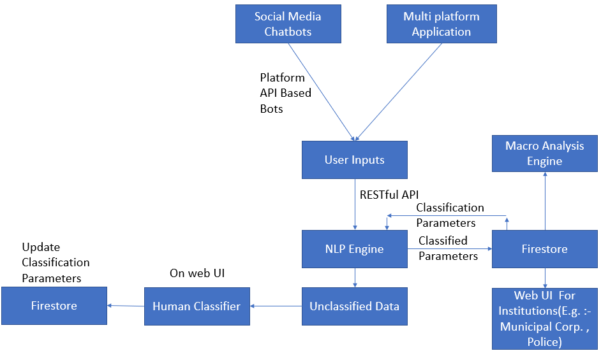

Overall Block Diagram of system

FLOW CHART

Flowchart part 1:

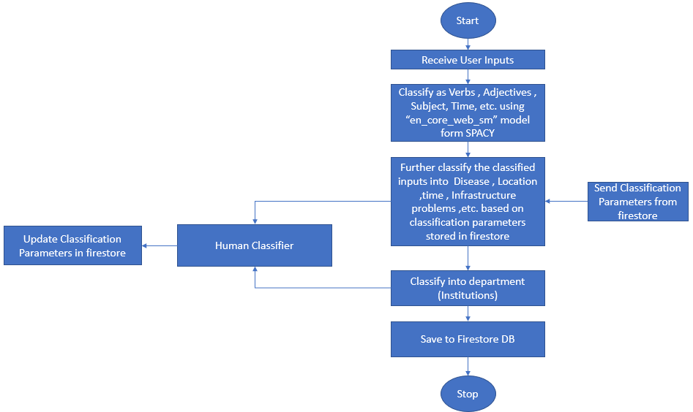

NLP Engine Flowchart

Flowchart part 2:

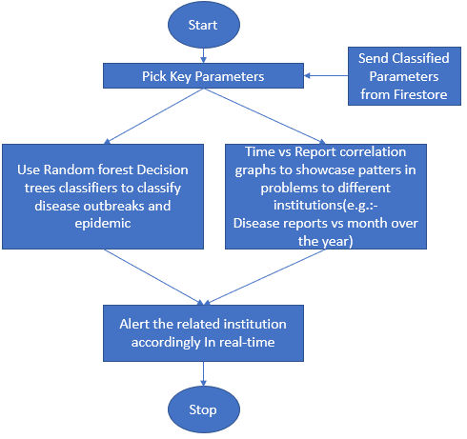

Macro Analysis Engine Flowchart

Flowchart part 3:

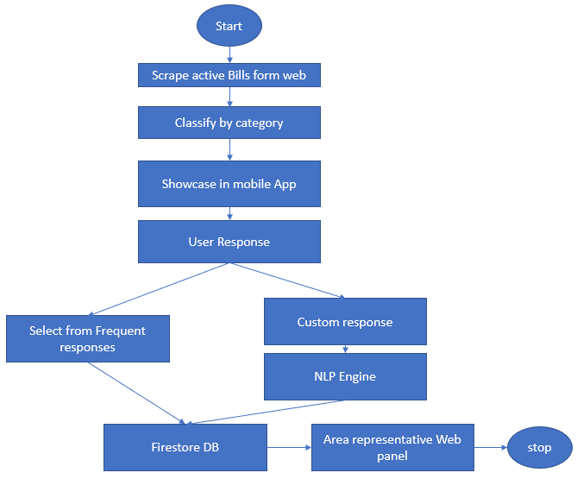

E-Governance Flowchart

|  |  |
| --- | --- |
| Work | Weeks |
| NLP engine | 3 Weeks |
| NLP Feedback System | 1 Week |
| Web Panels | 2 Weeks |
| Mobile Applications | 2 Weeks |
| Social Media bots | 2 Weeks |
| Macro Analysis Engine | 1.5 Weeks |
| E-Governance | 2 Weeks |

# Work Flow

# REFERENCES

References as on date (25/02/2020):

* Fix-my-Street, Brazil
* Zubair Bhatti’s work using [pro-active citizen feedback](https://apolitical.co/the-anti-viral-app/)
* UK’s ‘nudge unit’ used in organ donation