**For the People**

By

**16ET415: Shikhar Maheshwari**

**16ET430: Kaiwalya Patil**

Guided by

**Prof. Amit H. Choksi**

**(Assistant Professor)**

A Project Submitted to

Birla Vishvakarma Mahavidyalaya (Engineering College), An Autonomous Institution affiliated to Gujarat Technological University in Partial Fulfillment of the Requirements for

the Bachelor of Technology with Specialization in ***Electronics and Communication Engineering***

**July, 2020**



BIRLA VISHVAKARMA MAHAVIDYALAYA (ENGINEERING COLLEGE)

AN AUTONOMOUS INSTITUTION

Vallabh Vidyanagar – 388120

GUJARAT, INDIA

**COMPLIANCE CERTIFICATE**

This is to certify that the research work embodied in this Project entitled **“For the People”** was carried out at Birla Vishvakarma Mahavidyalaya (Engineering College) An Autonomous Institution for partial fulfillment of Bachelor of Technology with Specialization in Electronics and Communication Engineering degree to be awarded by Gujarat Technological University. He / She has complied with the comments given by the Mid Semester Project Reviewer.

Date :

Place :

|  |  |  |
| --- | --- | --- |
| *Name of the Students* | *ID No. of the Students* |  |
| **1.Shikhar Maheshwari**  **2.Kaiwalya Patil** | **1. 16ET415**  **2. 16ET430** |  |
| **Prof. Amit H. Choksi** | Project Coordinator  Dr. Darshan C. Dalwadi  Prof. Anish A. Vahora | Head, *(EC Dept.)*  *Dr. Bhargav C. Goradiya* |



BIRLA VISHVAKARMA MAHAVIDYALAYA (ENGINEERING COLLEGE)

AN AUTONOMOUS INSTITUTION

Vallabh Vidyanagar – 388120

GUJARAT, INDIA

**DECLARATION OF ORIGINALITY**

I hereby certify that I am the sole author of this Project and that neither any part of this Project nor the whole of the Project has been submitted for a degree to any other University or Institution.

I certify that, to the best of my knowledge, my Project does not infringe upon anyone’s copyright nor violate any proprietary rights and that any ideas, techniques, quotations or any other material from the work of other people included in my Project, published or otherwise, are fully acknowledged in accordance with the standard referencing practices. Furthermore, to the extent that I have included copyrighted material that surpasses the bounds of fair dealing within the meaning of the Indian Copyright Act, I certify that I have obtained a written permission from the copyright owner(s) to include such material(s) in my Project and have included copies of such copyright clearances to our appendix.

I declare that this is a true copy of Project, including any final revisions, as approved by my Project review committee.

**Date:**

|  |
| --- |
| 16ET415: Shikhar Maheshwari  16ET430: Kaiwalya Patil |



BIRLA VISHVAKARMA MAHAVIDYALAYA (ENGINEERING COLLEGE)

AN AUTONOMOUS INSTITUTION

Vallabh Vidyanagar – 388120

GUJARAT, INDIA

**Abstract**

People’s feedback is an important aspect of democracy and this often gets overlooked in India. In this project, we aim to get feedback of willing people by making certain online platforms that are open to all. We plan to closely analyze these inputs from the people and extract important parameters, like the problem, location, which department/ministry it is falling under, frequency of submission. This data would be then submitted to the authority of city/state and hence they can be notified about the persisting issues under their locality. Hence by getting such feedbacks, analyzing them closely and solving problems, we aim to help people resolve their problems and work as a stepping stone towards perfect democracy.

The services which are provided by the government with an assurance “For the People” are built and never looked upon unless there is wreckage in their daily functioning. Since we live in a democracy, it becomes our right to enjoy every service in its best possible way. Hence, we aim to solve this problem by creating online platforms immersed with data analytics.

**Acknowledgement**

First, we would like to thank our Project guides, **Prof. Amit H. Choksi** and **Prof. Ronak R. Vashi** for their guidance, help and support. And also for encouraging, motivating us to design and build this Project. We would like to thank all the other faculties of our EC Department for their support and guidance. We also thank **Dr. Bhargav C. Goradiya,** Head of EC department for his support.

Finally, we would like to thank our college, “**Birla Vishvakarma Mahavidyalaya”** Engineering college for this opportunity to work on this project.

**Table of contents**

Chapter 1: Introduction1

Chapter 2: Machine Learning Tools4

2.1 spaCy15

2.2 en_core_web_sm16

2.3 NLTK18

Chapter 3: Scope and Application 5

Chapter 4: System Software 14

4.1 Python15

4.2 Spacy16

4.3 Flask18

4.4 Selenium Webdriver15

4.5 Flutter16

4.6 Firebase18

Chapter 5: Proposed System Block Diagram15

Chapter 6: Flowcharts on System Working 20

6.1 Natural Language Processing Engine20

6.2 Macro Analysis Engine20

6.3 E-Governance System20

Chapter 7: Work Done 21

Chapter 8: Project Outcomes 22

Chapter 8: Conclusion 22

Chapter 9: References 22

**Appendices**

Progress Report1PAGEREF _Toc26299970 \h91

Plagiarism Report

Poster

**List of Figures**

1. Python Logo 91
2. spaCy Logo 10
3. Flask Logo 10
4. Selenium Webdriver Logo111
5. 1Flutter Logo 12
6. Firebase logo 13
7. Android App: Main page14
8. Android App: Grievance reporting18
9. Android App: Voting page18
10. Android App: Sign in page18
11. Website: Home page18
12. Website: Classified reports page18
13. Website: Vote analysis page18
14. Website: Entity adder page18

# **Chapter 1: Introduction**

* The central intuition behind the working of this system is to let people enjoy real democracy. We observed that a lot of recent movements and bills targeted the citizen's privacy or were against the will of citizens.
* And lots of influential voices and opinions were left unheard. And this continues and keeps getting deep-rooted with every passing day.
* Other than that, the genal grievances of the people remain unheard by the intuitions that were established to solved them
* The major reason behind all the above being lack of a system that can meaning fully collect, organise and represent to the above-mentioned authorities

**Chapter 2: Machine Learning tools**

**2.1 spaCy**:

It is a NLP framework designed upon industry standards to make using NLP easier and more efficient .It also provides many pretrained models to help with the Natural Language processing. spaCy is used my almost all the tech giants like Microsoft , Amazon and Google.

**2.2 en_core_web_sm:**

It is a English multi-task CNN trained on OntoNotes. Assigns context-specific token vectors, POS tags, dependency parse and named entities.

**2.3 NLTK:**

Natural language tool kit is a leading platform for building Python programs to work with human language data. It is easy to use and has a corpora of 50 and lexical resources such as WordNet, along with a suite of text processing libraries for classification, tokenization, stemming, tagging, parsing, and semantic reasoning, wrappers for industrial-strength NLP libraries.

**Chapter 3: Scope and Application**

**Chapter 4: System Software**

**4.1 Python**



Fig 1. Python

**Python** is used successfully in thousands of real-world business applications around the world, including many large and mission critical systems. Python is an interpreter based high level programming language Created byGuido van Rossumand first released in 1991, Python has recently gained popularity to become the most widely used language in the world. And it as one of the best community support which is a contributing factor to this meteoric rise.

**4.2 spaCy**



Fig 2. Spacy

**spaCy** is a NLP framework designed upon industry standards to make using NLP easier and more efficient .It also provides many pretrained models to help with the Natural Language processing. spaCy is used my almost all the tech giants like Microsoft , Amazon and Google.

**4.3 Flask**



Fig 3. Flask

**Flask** is a micro web framework written in  Python. It is classified as a microframework because it does not require particular tools or libraries. It has no database abstraction layer, form validation, or any other components where pre-existing third-party libraries provide common functions. However, Flask supports extensions that can add application features as if they were implemented in Flask itself. Extensions exist for object-relational mappers, form validation, upload handling, various open authentication technologies and several common framework related tools. Extensions are updated far more frequently than the core Flask program. Applications that use the Flask framework include Pinterest and LinkedIn.

**4.4 Selenium Webdriver**



Fig 4. Selenium

**Selenium** is a framework for testing applications and scraping the web using scripting languages like python, ruby, Perl and groovy. It runs on windows , Linux and mac os and is distributed under an open source software license

**4.5 Flutter**



Fig 5. Flutter

Flutter is Google’s UI toolkit for building beautiful, natively compiled applications for mobile, web, and desktop from a single codebase.

**4.5 Firebase**



Fig 6. Firebase

Firebase is a mobile and web application development platform developed by Firebase, Inc. in 2011, then acquired by Google in 2014. Firebase is an example of backend as a service and provides the fastest NO-SQL Database in the world.

**Chapter 5: Block Diagram**

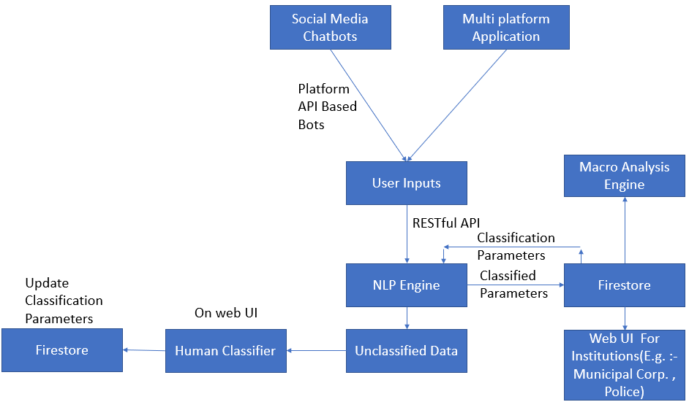

**Chapter 6: Flowcharts**

**6.1 Natural Language Processing engine**

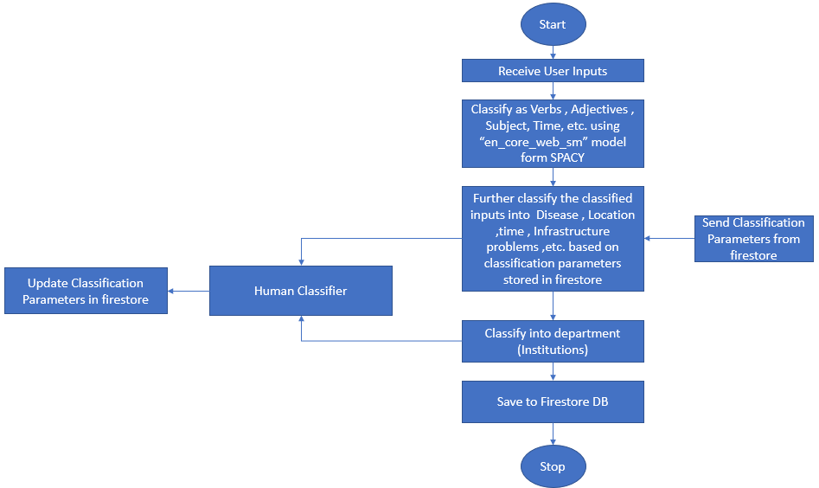

**6.2 Macro analysis engine**

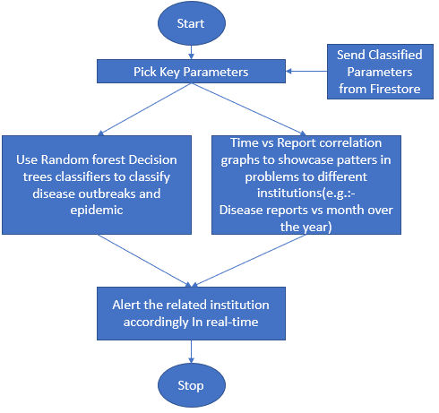

**6.3 E-Governance Engine**

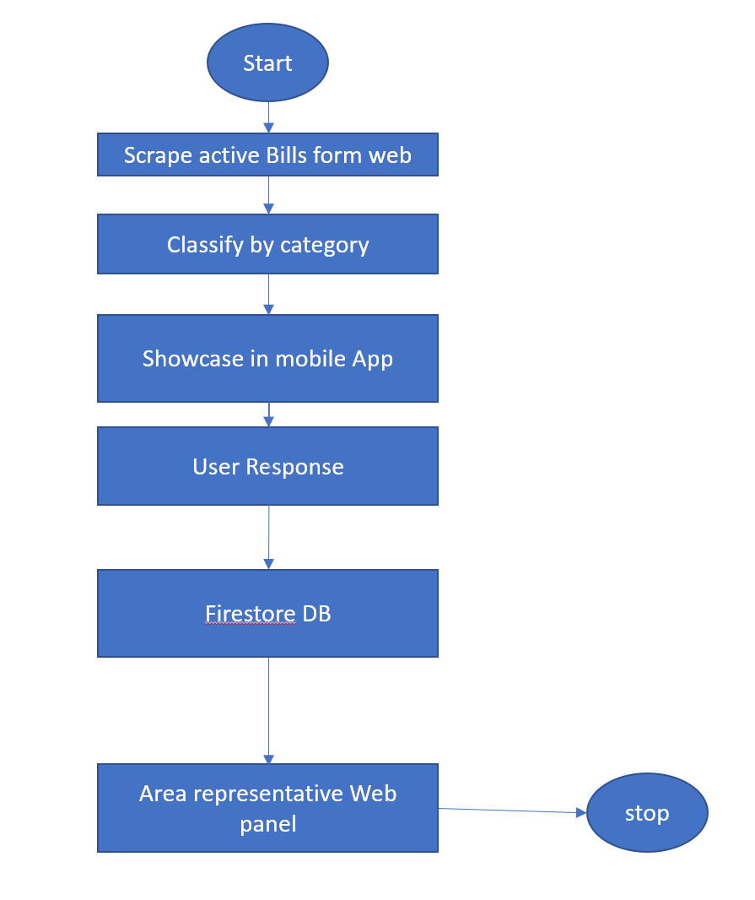

**Chapter 7: Work done**

|  |  |
| --- | --- |
| Work | Status |
| NLP engine | ✔ |
| NLP Feedback System | ✔ |
| Web Panels | ✔ |
| Mobile Applications | ✔ |
| Social Media bots | ✔ |
| Macro Analysis Engine | ✔ |
| E-Governance | ✔ |

**Chapter 8: Project outcomes**

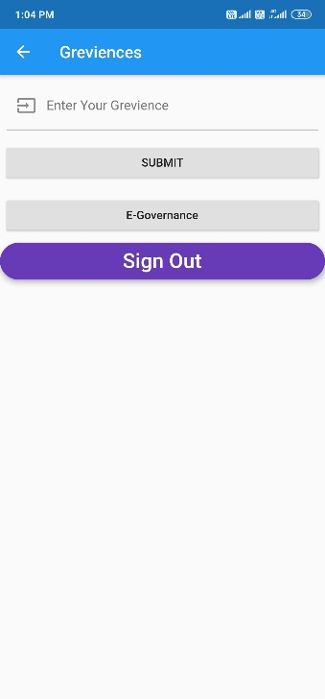 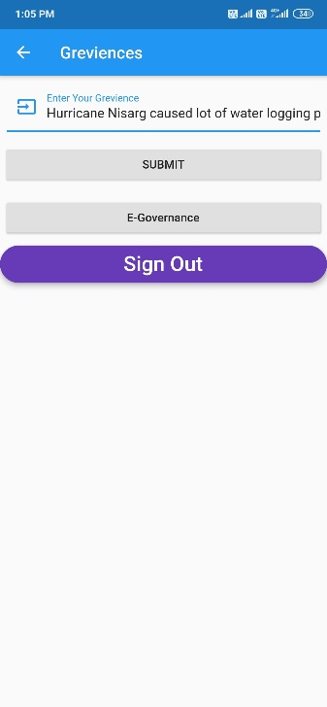

Fig 7. Main page Fig 8. Grievance reporting

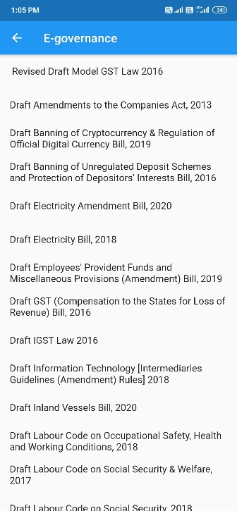 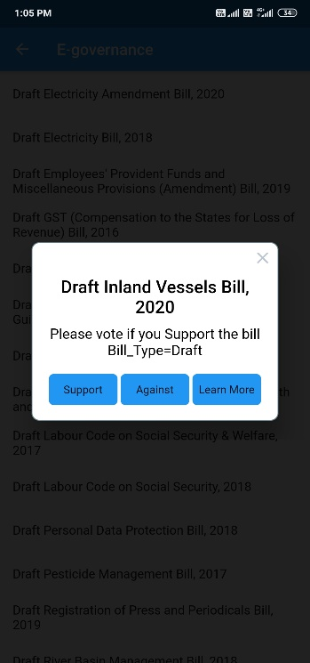 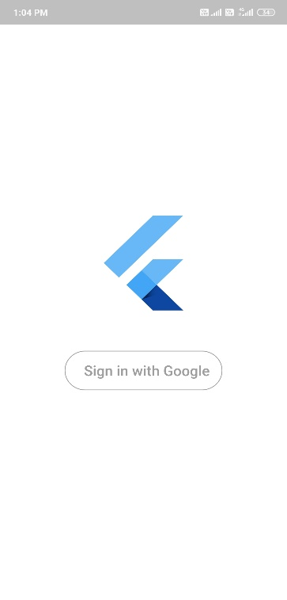

Fig 9. Bills to view and votes Fig 10. Voting: support or against Fig 11. Sign in page

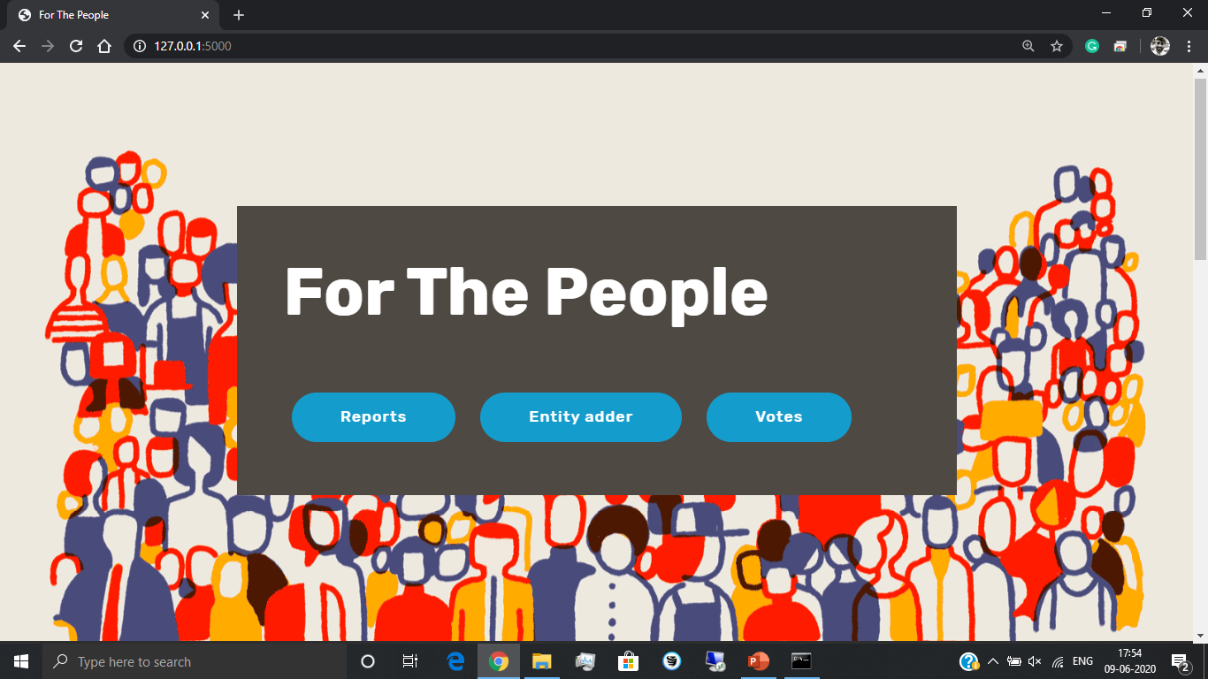

Fig 12. Website: Home Page

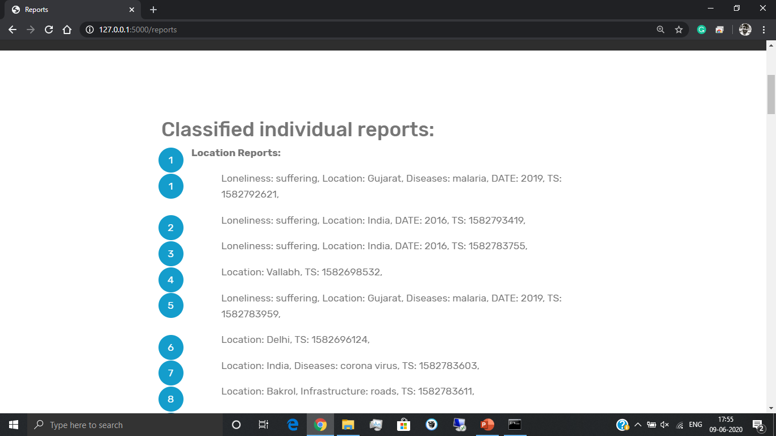Fig 13. Website: Classified reports page

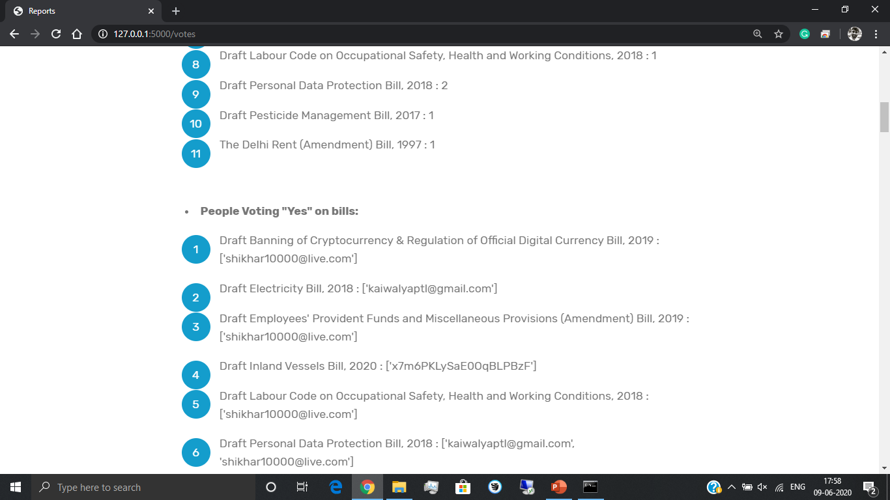Fig 14. Website: Votes analysis page

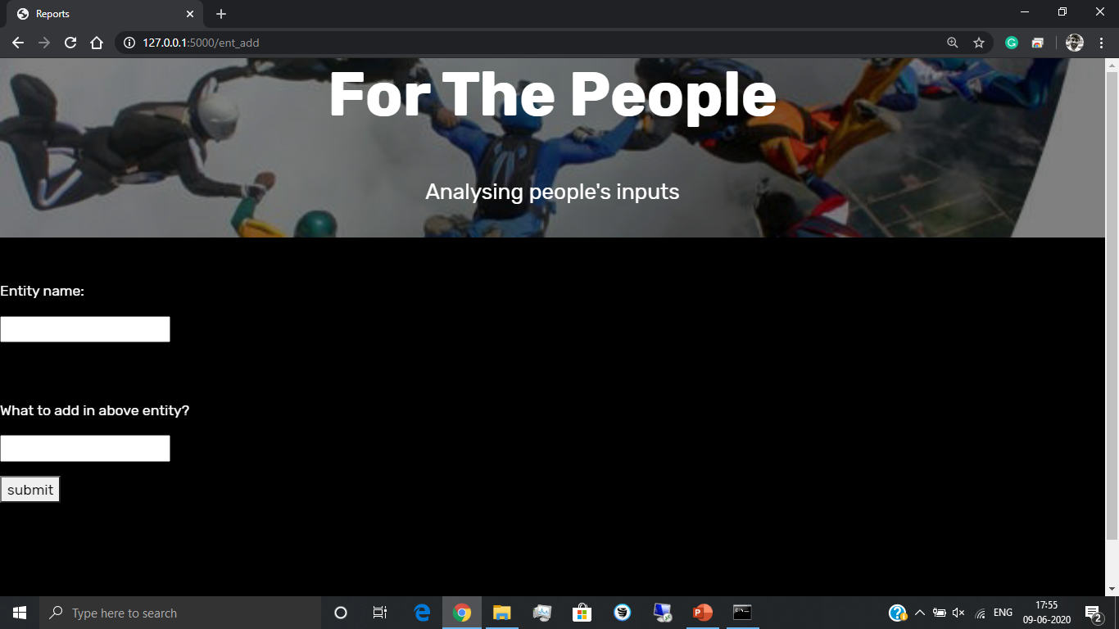Fig 15. Website: Entity adder page

**Chapter 8: Conclusion**

**Chapter 9: References**

* Fix-my-Street, Brazil
* Zubair Bhatti’s work using pro-active citizen feedback
* UK’s ‘nudge unit’ used in organ donation