Database Concepts and Design

project report.

03/16/2012

Author: Shumin Guo

UID: U00617724

Project Introduction and background.
Personal financial management is a practical and useful database application, in the sense that we can use it to manage our incomes, expenses and bank accounts etc. In this project, I try to implement such a prototype database system. Although, currently, this is not a full fledged application, I have the plan to migrate it to web-based application system and there is also plan to migrate to mobile systems, such as android based systems to make it even more handy to use and applicable to more users.

This project was implemented with MySQL as the database server. MySQL is a good choice, because it is a full-fledged open source database system that is very popular. It has been used in many critical environments. And many company, e.g. Facebook, use MySQL exclusively as their database server. MySQL has almost all the features that commercial database software (Such as Oracle) have. But MySQL is light weight, easy and flexible to use. Besides, MySQL has application interfaces implemented with a lot of popular programming languages, such as C++, java etc., in this project I have used C++ as the application implementation language due to its high performance in time-critical applications.

One important task of this project is to implement and understand the transaction mechanism of a database system. Transaction management of database systems is one major functionality to make sure the system can satisfy the ACID requirements. But in reality, it is very hard to see how this mechanism under normal operations, because system failure may not happen. MySQL database provides full support for transactions, so I have manually created some practical scenarios and/or used the MySQL system to handle transaction failures in case of exception during the database operations, and will show how the database can handle these exceptions.

This project report was organized as follows: in part two, a general description of project environment setup is given, including the setup of database servers, installation of related software development libraries; in part three, the database design is given, including the ER and EER diagrams and relation tables; part four describes the implementations of application functions, which includes modification of databases and records retrieval, and also the most important one is the design and implementation of database transactions.

Project Environment Setup
This project was designed and tested under linux environment (fedora 15, kernel 2.6.40), so the environment setup and other system related operation are all linux related, if your environment is other than linux, please consult related technical personnel.

Setting update the database server.
The MySQL database can be obtained on the official website, www.mysql.com. Or you can simply use the system package manager to install mysql, for example, under my fedora system, I installed mysql server with the following command:
sudo yum install mysqld mysqld-devel

And under ubuntu like systems, you need to use the apt-get package manager to perform the same task, you can consult to the system command manual for related issues during the installation process.
After installation, we can start up the MySQL database server, but before doing that, we need to determine the options to pass in. Although there are a lot of options provided during the start up process, we are only interested in the logging feature as far as this project is concerned, because we want to know what the database server is doing when we do some operations to the database, and how the server will handle system exceptions and failures during the database update process. Below is a list of logging operation for mysql start-up command line.

--log=/var/mysql.log # general query log.
--log-error=/var/log/mysql-error.log
--log-long-format # if you want to see details of database operation.
--log-short-format
--log-update=/var/log/mysql-update.log
--log-warnings=0 #log warning messages to the error log file.
--log-bin=/var/log/mysql-bin

Of all the logging options, --log-bin is the most important one for our project, what the binary logging does can be described as follows as described in the MySQL database documentation:

Binary logging is done immediately after a statement completes but before any locks are released or any commit is done. This ensures that the log is logged in execution order.
Updates to nontransactional tables are stored in the binary log immediately after execution. Within an uncommitted transaction, all updates (UPDATE, DELETE, or INSERT) that change transactional tables such as BDB or InnoDBtables are cached until a COMMIT statement is received by the server. At that point, mysqld writes the entire transaction to the binary log before the COMMIT is executed.
Modifications to nontransactional tables cannot be rolled back. If a transaction that is rolled back includes modifications to nontransactional tables, the entire transaction is logged with a ROLLBACK statement at the end to ensure that the modifications to those tables are replicated. This is true as of MySQL 4.0.15.
In the following sections, we are going to explore the application of the binary logging feature by doing transaction rollback.

Instead of using command line options, we can also use the configuration files/option file to tell mysql server the options to start with.
For example, mysql configuration file under fedora system is /etc/my.cnf, and I changed this file as follows:

[mysqld]
datadir=/var/lib/mysql
socket=/var/lib/mysql/mysql.sock
user=mysql
# Disabling symbolic-links is recommended to prevent assorted security risks
symbolic-links=0

[mysqld_safe]
log-long-format
log=/var/log/mysql.log
log-error=/var/log/mysql-error.log
log-update=/var/log/mysql-update.log
log-warnings=1
log-bin=/var/log/mysql-bin
pid-file=/var/run/mysqld/mysqld.pid

Creating users and grant privileges
After setting up the database server, we need to create user and grant privileges to the user to operate on the databases. We can follow the steps below:

ada ~@localhost$ mysqld_safe
ada ~@localhost$ mysql -u root -p
mysql > CREATE USER ‘ada’@’localhost’ IDENTIFIED BY ‘’;
mysql > GRANT SELECT, INSERT, CREATE, DROP, UPDATE, DELETE ON *.* TO ‘ada’@’localhost’ WITH GRANT OPTIONS;
mysql > SHOW GRANTS FOR ‘ada’@’localhost’;
mysql > FLUSH PRIVILEGES;
ada ~@localhost$ mysql -u ada -p

Installing the MySQL database connector software API
As we have described before, mysql provides a lot of connection APIs for application development using major programming languages, as for now, there are connectors for c/c++, java, python, ruby, php etc. And here I am going to use c++ connector for this project. Under the fedora system, the mysql c++ connector API library can be installed with the following command:

sudo yum install mysql-connector-c++, mysql-connector-c++-devel

Database design and Implementation.
Database relations for the Financial Manager Project. A full-fledged financial manager should have the ability to manage income, expense and bank accounts etc. In this proof-of-concept project, I assumed 3 entities: bank account, income and expense/spend, and 2 relations: one is between bank account and income and the other is between bank account and spend/expense. Also, according the relational dependency concept, I designed the relations such that they are in 2NF and / or 3NF. For example, in relation BankAccount, we have that all the other fields are functionally dependent on AcntId and AcntId is also the primary key of this relations, so, this relation is in 2NF.
Database Relations for this project are lists below, the primary key was written in underscored bold face.

BankAccount
AcntId | AcntName | AcntBlnc | AcntDate | Memo

Income
IcmId | IcmDate | IcmAmunt | Memo

Spend
SpdId | SpdDate | SpdLoc | Memo

Deposit
DpId | DpToAcnt | DpFrom | DpAmunt | DpDate | Memo

Withdrawal
WdId | WdFrom | WdFor | WdAmunt | WdDate | Memo

The Entity Relation Diagram.
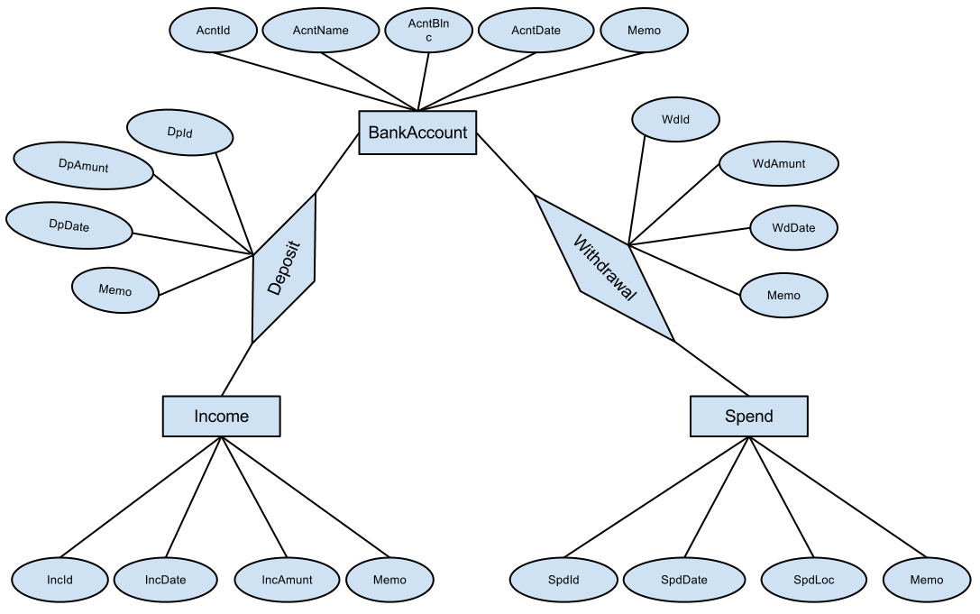

With the help of the MySQL workbench, we are able to create the EER diagram of the above ER diagram. Please see it in the following figure.
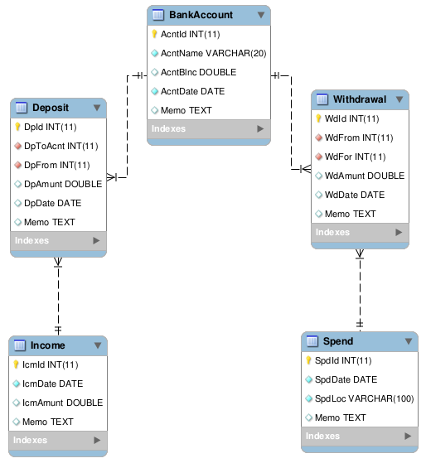

In this project, I propose to implement five application modules, bank account management, income management, spend management, deposit management and withdrawal management.

-- Database tables for CEG 701 Database principles project.
-- Author: Shumin Guo.

CREATE DATABASE IF NOT EXISTS CS701DB;

USE CS701DB;

CREATE TABLE IF NOT EXISTS BankAccount (
AcntId INT NOT NULL AUTO_INCREMENT,
AcntName VARCHAR(20) NOT NULL,
AcntBlnc DOUBLE DEFAULT 0,
AcntDate DATE NOT NULL,
Memo TEXT,
PRIMARY KEY (AcntId)
)ENGINE=INNODB;

CREATE TABLE IF NOT EXISTS Income (
IcmId INT NOT NULL AUTO_INCREMENT,
IcmDate DATE NOT NULL,
IcmAmunt DOUBLE DEFAULT 0,
Memo TEXT,
PRIMARY KEY (IcmId)
)ENGINE=INNODB;

CREATE TABLE IF NOT EXISTS Spend (
SpdId INT NOT NULL AUTO_INCREMENT,
SpdDate DATE NOT NULL,
SpdLoc VARCHAR(100) NOT NULL,
SpdAmunt INT DEFAULT 0,
Memo TEXT,
PRIMARY KEY (SpdId)
)ENGINE=INNODB;

CREATE TABLE IF NOT EXISTS Deposit (
DpId INT NOT NULL AUTO_INCREMENT,
DpToAcnt INT NOT NULL,
DpFrom INT NOT NULL,
DpAmunt DOUBLE DEFAULT 0,
DpDate DATE,
Memo TEXT,
PRIMARY KEY (DpId),
FOREIGN KEY (DpToAcnt) REFERENCES BankAccount(AcntId)
ON DELETE CASCADE ON UPDATE CASCADE,
FOREIGN KEY (DpFrom) REFERENCES Income(IcmId)
ON DELETE CASCADE ON UPDATE CASCADE
)ENGINE=INNODB;

CREATE TABLE IF NOT EXISTS Withdrawal (
WdId INT NOT NULL AUTO_INCREMENT,
WdFrom INT NOT NULL,
WdFor INT NOT NULL,
WdAmunt DOUBLE DEFAULT 0,
WdDate DATE NULL NULL,
Memo TEXT,
PRIMARY KEY (WdId),
FOREIGN KEY (WdFrom) REFERENCES BankAccount(AcntId)
ON DELETE CASCADE ON UPDATE CASCADE,
FOREIGN KEY (WdFor) REFERENCES Spend(SpdId)
ON DELETE CASCADE ON UPDATE CASCADE
)ENGINE=INNODB;

Creating database with MySQL script.
After creating the database script as shown above, we can use command line to import the database into MySQL server.

$ mysql -u root -p < DB.sql

After this, we can login to the MySQL server with a normal account to check if all the tables are created successfully. As shown in the following picture.
Login and show existing databases.
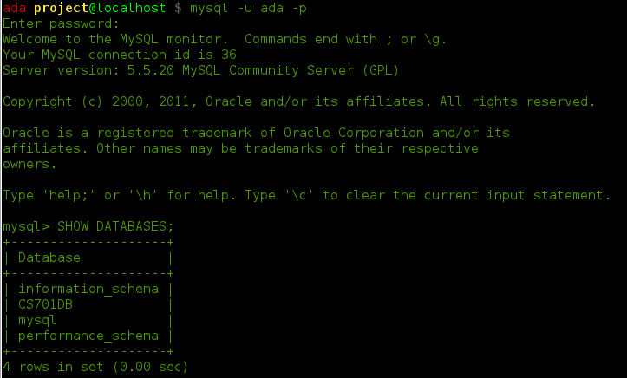

Show tables in the CS701 Database.
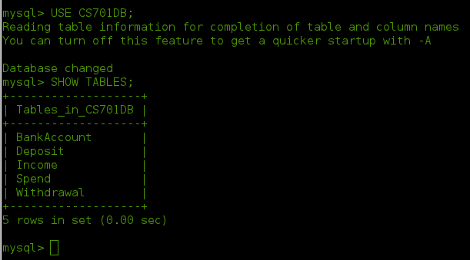

Description of tables BankAccount and Income.
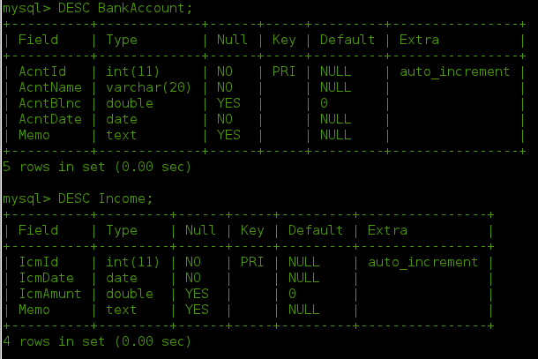
Description of tables Spend and Deposit.
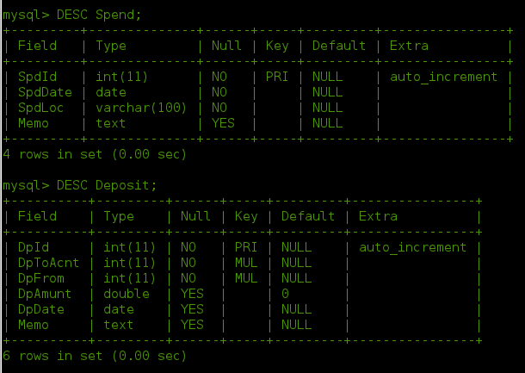
Description of table Withdrawal.
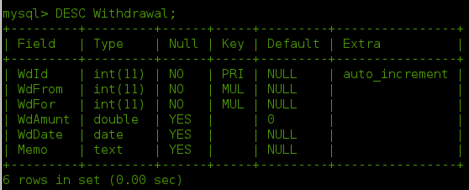

Test insert operations to the databases. I designed the following test cases for each table.

USE CS701DB;

INSERT INTO BankAccount (AcntName, AcntBlnc, AcntDate, Memo)
VALUES ("BoA", 1000, "2012-03-10", "Bank of america account.");
INSERT INTO BankAccount (AcntName, AcntBlnc, AcntDate, Memo)
VALUES ("BNC", 90, "2012-03-10", "BNC bank account.");
INSERT INTO BankAccount (AcntName, AcntBlnc, AcntDate, Memo)
VALUES ("WestCargo", 7800, "2005-12-10", "West Cargo account.");
INSERT INTO BankAccount (AcntName, AcntBlnc, AcntDate, Memo)
VALUES ("BOC", 350, "2010-10-09", "BOC account.");
INSERT INTO BankAccount (AcntName, AcntBlnc, AcntDate, Memo)
VALUES ("UNKNOWN", 100000, "2009-03-10", "UNKNOWN account.");

INSERT INTO Income (IcmDate, IcmAmunt, Memo)
VALUES ("2012-03-10", 1201.42, "March RA income.");
INSERT INTO Income (IcmDate, IcmAmunt, Memo)
VALUES ("2012-02-10", 1201.42, "Feb. RA income.");
INSERT INTO Income (IcmDate, IcmAmunt, Memo)
VALUES ("2012-01-10", 1201.42, "Jan. RA income.");
INSERT INTO Income (IcmDate, IcmAmunt, Memo)
VALUES ("2011-12-10", 1201.42, "Dec. RA income.");
INSERT INTO Income (IcmDate, IcmAmunt, Memo)
VALUES ("2011-11-10", 1201.42, "Nov. RA income.");

INSERT INTO Spend (SpdDate, SpdAmunt, SpdLoc, Memo)
VALUES ("2012-03-10", 15, "Texas grill", "Diner at Texas grill.");
INSERT INTO Spend (SpdDate, SpdAmunt, SpdLoc, Memo)
VALUES ("2012-03-06", 307, "XBOX", "For my wife.");
INSERT INTO Spend (SpdDate, SpdAmunt, SpdLoc, Memo)
VALUES ("2012-03-02", 15, "McDonolds", "Diner at McDonolds.");
INSERT INTO Spend (SpdDate, SpdAmunt, SpdLoc, Memo)
VALUES ("2012-02-10", 45, "Meijer", "Shopping at Meijer.");

INSERT INTO Deposit ( DpToAcnt, DpFrom, DpAmunt, DpDate, Memo)
VALUES (1, 1, 1000, "2012-03-10", "Save Income to BOA account.");
INSERT INTO Deposit ( DpToAcnt, DpFrom, DpAmunt, DpDate, Memo)
VALUES (1, 2, 1100, "2012-02-10", "Save Income to BOA account.");
INSERT INTO Deposit ( DpToAcnt, DpFrom, DpAmunt, DpDate, Memo)
VALUES (1, 3, 1100, "2012-01-10", "Save Income to BOA account.");
INSERT INTO Deposit ( DpToAcnt, DpFrom, DpAmunt, DpDate, Memo)
VALUES (1, 4, 1100, "2011-12-10", "Save Income to BOA account.");

INSERT INTO Withdrawal (WdFrom, WdFor, WdAmunt, WdDate, Memo )
VALUES (1, 1, 15, "2012-03-10", "exp.");
INSERT INTO Withdrawal (WdFrom, WdFor, WdAmunt, WdDate, Memo )
VALUES (1, 2, 307, "2012-03-06", "exp.");
INSERT INTO Withdrawal (WdFrom, WdFor, WdAmunt, WdDate, Memo )
VALUES (1, 3, 15, "2012-03-02", "exp.");
INSERT INTO Withdrawal (WdFrom, WdFor, WdAmunt, WdDate, Memo )
VALUES (1, 4, 45, "2012-02-10", "exp.");

Execute the about SQL script with the following command:

$ mysql -u ada -p < testdb.sql

And then in the database we can use SELECT command to check the contents for each tables as shown below:
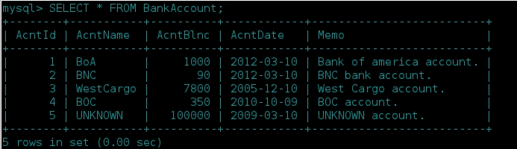
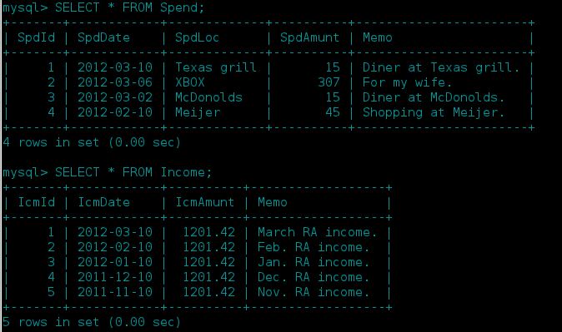
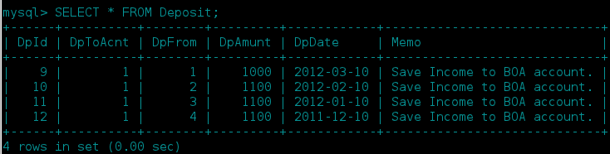
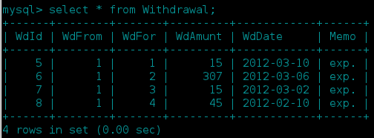

Database Application Implementation.
I selected C++ as the application development language, and with the help of mysql-connector-c++ library, I can easily connect to the MySQL database, and do SELECT, INSERT, ALTER and DELETE operations. In this part, I first will describe the code of the application implementations and then show some test cases of the implemented system.

General flow of application development with C++ and MySQL.
In a C++ based application, the steps we need to connect and interact with the MySQL database include the following steps:
1), make a connection to the known MySQL database server, in this step, we need to provide server location and user along with password;
2), if, as in this project we will show, we want to use manual transaction commit, we need to stop the auto-commit property of the MySQL database.
3), create SQL statements and execute the statement with the database connection handle.
4), in a SELECT operation we will get a result set, we can do any operations to the result set.
5), in case of database exception, we will catch the exception. For example, duplicate keys, foreign key does not exist etc., and also, in this case transaction will be rolled back;
6), after finishing all the desired operations, we need to close the database connection.

The following code snippets shows c++ code for the above descriptions.

driver = get_driver_instance();
conn = driver->connect("tcp://localhost:3306", "ada", "825123");

// Select database;
conn->setSchema("CS701DB");

// turn off the autocommit, and use commit statement explicitly.
conn->setAutoCommit(0);
cout << "\nDatabase connection\'s autocommit mode = "
<< conn->getAutoCommit() << endl;

// insert record into table Income.
stmt = con->createStatement();
stmtstr = "INSERT INTO Income(IncomeId, IncomeDate, amount, description, saveToAccnt) \ VALUES(\""+IncomeId+"\",\""+IncomeDate+"\",\""+amount+"\",\""+description+"\",\""+saveToAccnt+"\")";

// Select all records from
stmt = con->createStatement();
res = stmt->executeQuery("SELECT * FROM Spend WHERE Spd = \""+spdid+"\"");

// delete records with given Income id with explicit commit.
stmt = con->createStatement();
stmt->execute("DELETE FROM Income WHERE IncId = \""+incid+"\"");
con->commit();

// update account balance with explicite commit.
stmt = con->createStatement();
stmt->execute("UPDATE BankAccount SET AcntBlnc = " + amunt);
con->commit();

conn->close();

As for now, my database application has the following function implemented.
1) Inserting records into the database tables;
2) Delete record identified by Spend id from Spend table;
3) Modify record identified by income id in the Income table;
4) Retrieve the database table contents, as this will not change the content of the database, so it is not a transaction.

Application Demonstration.
Creating a new bank account :
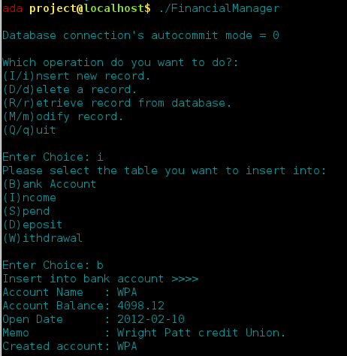

Modify the monthly income:
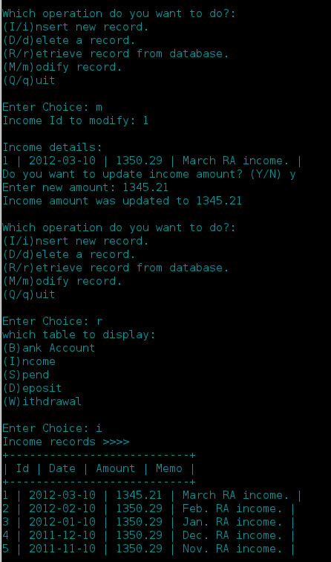

Delete A spend Record from database:
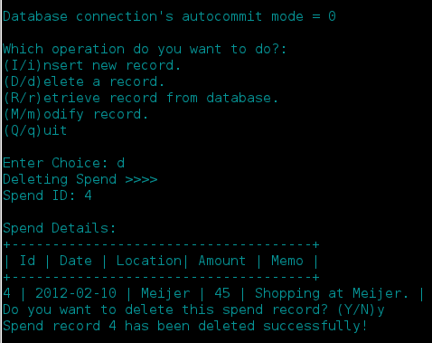
Retrieve and / or select records:
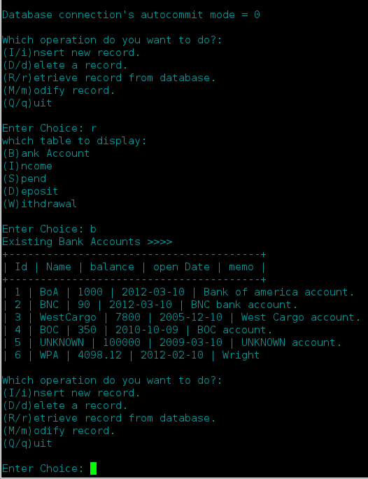

Transaction design and Implementation.
Transaction descriptions.
Before designing a database system, one important information we need to collect about the application is the functional characteristics of the database application, and also knowing relative importance of the various transactions and the expected rates of their invocation plays a crucial part in the process of database system design.

Database transactions can be grouped into three major categories, (1) retrieval transactions, which are used to retrieve data for display on the screen or for the production of a report; (2) update transactions, including inserting of new records into database tables and updating values of existing records; (3) Mixed transactions, which are used for more complex application that do some retrieval and some updates.

In this project, I tried to consider these three types of transactions and design an example for each of the category.

Transaction Demonstration.
In this part, I am going to demonstrate the running results of database transactions including the normal commit without exception, with exception and a cascade transaction operation.
Retrieval of BankAccount Records:

try {
cout << "Existing Bank Accounts >>>> " << endl;
cout << "+----------------------------------------+" << endl;
cout << "| Id | Name | balance | open Date | memo |" << endl;
cout << "+----------------------------------------+" << endl;
try {
res = stmt->executeQuery("SELECT * FROM BankAccount;");
con->commit();
while(res->next()) {
cout << "| "<< res->getUInt(1) << " | "
<< res->getString(2) << " | "
<< res->getDouble(3) << " | "
<< res->getString(4) << " | "
<< res->getString(5) << endl;
}
res->close();
stmt->close();
} catch(sql::SQLException &e) {
handleException(e);
}
The execution result of this transaction has been shown in the previous section.

Inserting/Adding a new BankAccount Record:
// use prepareStatement for record insert operation.
try {
stmt = con->createStatement();
pstmt = con->prepareStatement("INSERT INTO BankAccount(AcntName,AcntBlnc,AcntDate,Memo)VALUES(?,?,?,?)");
pstmt->setString(1, accntnm);
pstmt->setDouble(2, accntblnc);
pstmt->setString(3, accntdate);
pstmt->setString(4, accntmemo);
pstmt->execute();
con->commit();
cout << "Created account: " << accntnm << endl;
stmt->close();
} catch(sql::SQLException &e) {
handleException(e);
}

Updating balance of existing BankAccount Record:
After executing the MySQL statement, I intentionally throw an SQL exception, to make the system rollback.
try {
res = stmt->executeQuery("SELECT * FROM Income WHERE IcmId = \""+iid+"\"");
cout << "\nIncome details: " << endl;
if(!res->next()) {
cout << "" << endl;
return false;
}
cout << res->getInt(1) << " | "
<< res->getString(2) << " | "
<< res->getDouble(3) << " | "
<< res->getString(4) << " | " << endl;

char ans;
cout << "Do you want to update income amount? (Y/N) "; cin >> ans;
if((ans == 'Y') || (ans == 'y')) {
string amunt;
cout << "Enter new amount: "; cin >> amunt;
stmt = con->createStatement();
stmt->execute("UPDATE Income SET IcmAmunt = " + amunt + " WHERE IcmId = \"" + iid + "\"");
cout << "Updating income for record " << iid << " ... " << endl;
throw sql::SQLException();
con->commit();
cout << "Income amount was updated to " << amunt << endl;
}
} catch(sql::SQLException &e) {
cout << endl << "Exception happened ... !" << endl;
cout << "Rolling back ... " << endl;
con->rollback();
handleException(e);
}
The transaction was rolled back and no updated happened.
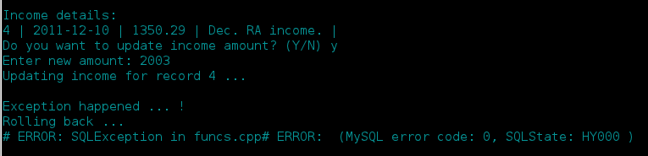

Adding a Spend record, which will trigger the insertion of withdrawal from BankAccount:
This is cascading transaction, in case of exceptions, cascading rollback may happened as shown in the figure below.
// Insert Spend record into database.
try {
stmt = con->createStatement();
stmtstr = "INSERT INTO Spend (SpdDate, SpdLoc, SpdAmunt, Memo) \
VALUES(\""+spenddate+"\",\""+location+"\",\""+itoa(amount)+"\",\""+memo+"\")";
cout << stmtstr << endl;
stmt->execute(stmtstr);
// this will trigger the insertion of a withdrawal operation.
goto WD;

con->commit();
cout << "Inserted spend record!" << endl;
stmt->close();
} catch(sql::SQLException &e) {
cout << "Exception happened spending ... withdrawal error. " << endl;
cout << "Rolling back ... " << endl;
con->rollback();
handleException(e);
}

WD: string wdfrom, wdfor, wddate, memo, amount;
cout << "Insert into Withdrawal table >>>> " << endl;
cout << "Withdrawal from Account :"; cin >> wdfrom;
cout << "Withdrawal for Expense :"; cin >> wdfor;
cout << "Withdrawal Date :"; cin >> wddate;
cout << "Withdrawal Amount :"; cin >> amount;
cout << "Memo :"; cin >> memo;
try {
stmt = con->createStatement();
stmtstr = "INSERT INTO Withdrawal (WdFrom, WdFor, WdAmunt, WdDate, Memo)" \
"VALUES(\""+wdfrom+"\",\""+wdfor+"\",\""+amount+"\",\""+wddate+"\",\""+memo+"\")";
cout << stmtstr << endl;
stmt->execute(stmtstr);
throw sql::SQLException();

con->commit();
cout << "Inserted Withdrawal record!" << endl;
stmt->close();
} catch(sql::SQLException &e) {
cout << "Exception happened withdrawaling ... no enough fund..." << endl;
cout << "Rolling back ... " << endl;
con->rollback();
handleException(e);
}
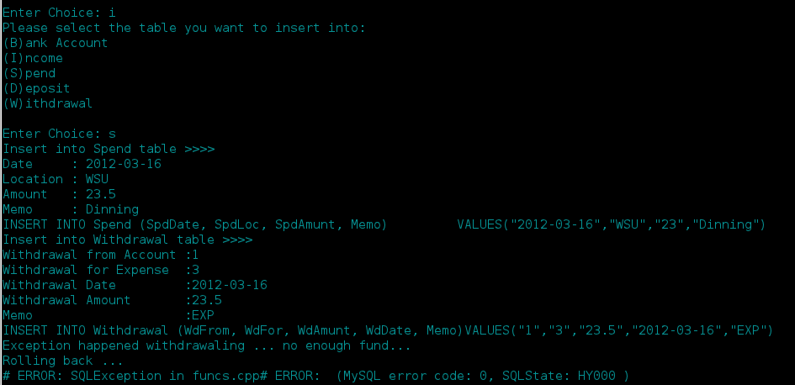
And the spend records are not changed either,
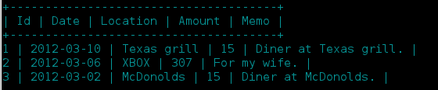
This transaction is for the scenario when a bank account does not have enough balance, in this case, a withdrawal with higher amount than existing balance will fail, the withdrawal transaction will be rolled back and the spend insertion transaction will also be rolled back.

Project Discussion.
In modern database systems, ACID (atomicity, consistency, isolation, durability) is a set of properties that guarantee that database transactions are processed reliably. And the purpose of this project is to show how this can be achieved by implementing a simple database application.

Atomicity requires that each transaction is "all or nothing": if one part of the transaction fails, the entire transaction fails, and the database state is left unchanged. An atomic system must guarantee atomicity in each and every situation, including power failures, errors, and crashes. This guarantees that a transaction cannot be left in an incomplete state.
The consistency property ensures that any transaction will bring the database from one valid state to another. Any data written to the database must be valid according to all defined rules, including but not limited to constraints, cascades, triggers, and any combination thereof. The design of database relations/tables follow the functional dependencies, relational algebra, and the decomposition of functional dependencies, and norms, so as to make the database update operations consistent, without any abnormalities.

Isolation refers to the requirement that no transaction should be able to interfere with another transaction. One way of achieving this is to ensure that no transactions that affect the same rows can run concurrently, since their sequence, and hence the outcome, might be unpredictable. This property of ACID is often partly relaxed due to the huge speed decrease this type of concurrency management entails.

Durability means that once a transaction has been committed, it will remain so, even in the event of power loss, crashes, or errors. In a relational database, for instance, once a group of SQL statements execute, the results need to be stored permanently. If the database crashes immediately thereafter, it should be possible to restore the database to the state after the last transaction committed.

Another major concern for database system design is related to backup and recover in case of catastrophic errors. This is also easy to implement using MySQL and tools along with MySQL, for example, we can setup a periodic job to backup our existing database by dumping all the records and metadata into a file that is on a separate system or disk. And then we can use the backup in case of system crash or catastrophic failures.

