Q1： P&L Attribution

Using the right order, the following figure is the PnL Attribution

Calculation methods:

Then the change carries on

Etc.

Then we try to reverse the order, using the same algorithm in the above:

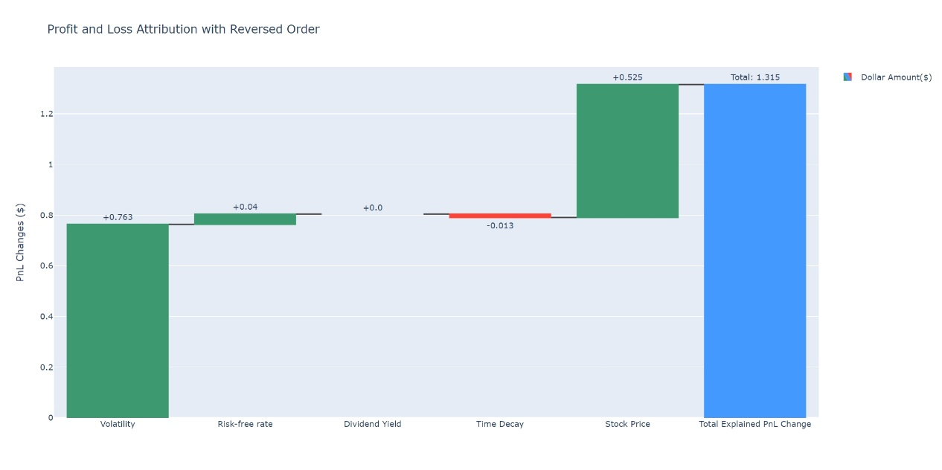

The difference in each section can be explained as follows: the sequential PnL attribution requires prioritize the time change. This is because when it comes to option pricing, factors such as risk-free rate, dividend yield, volatility all depend on the time change. If the PnL attribution does not account for time changes before calculating these factor, the attribution result for these factors will be biased. In addition, stock price is dependent on volatility. Therefore, if we calculate volatility pnl attribute before price, we will have a biased pnl attribute on stock price.

Q2: VaR and ES

For , Assume loss is distributed , given that by definition needs to satisfy

Then in distribution

For , by definition:

Evaluating at the limit:

Set , then the limit changes to

The last equal is in 0/0 form at the limit, so we Applying L'Hôpital's rule

The is in 0/0 form at the limit, we apply L'Hôpital's rule again

Hence

Suppose loss are pareto distributed, pdf:

cdf:

Hence:

Therefore,

Evaluate at the limit:

The ES/VaR ratio is larger for pareto compared to normal distribution. This indicates that if the loss has a pareto distribution, then it has a larger tail risk than a loss that has normal distribution, i.e. more fat tail distributed.

Q3: Hedging an equity portfolio

Similarly

Correlation:

VaR:

Weighting of three assets:

Variance of portfolio

Delta hedge:

Suppose at year end,

where is the return of the asset A

Similarly,

So portfolio delta

And given option have delta -0.25

We need 88 option to perfectly hedge

After neutralizing the delta of our portfolio wrt index, we no longer have the component related to the index to contribut to our portfolio variance, therefore our portfolio variance becomes:

Minimized 10-day VaR is

i.e. dollar amount of $65.58 is the updated portfolio var hedged by option

Q4: Netting for correlated Brownian Motion

Assume two contracts are not nettable：

Given the folded Normal distribution where

The expectation is given as

Suppose:

So:

If two contracts are nettable:

With variance and mean calculated, we can calculate the expected value. Because the equation is too tedious, we will denote such value as B

The analytical result given by using formula we derived, setting t=1, rounding to 4 decimal points:

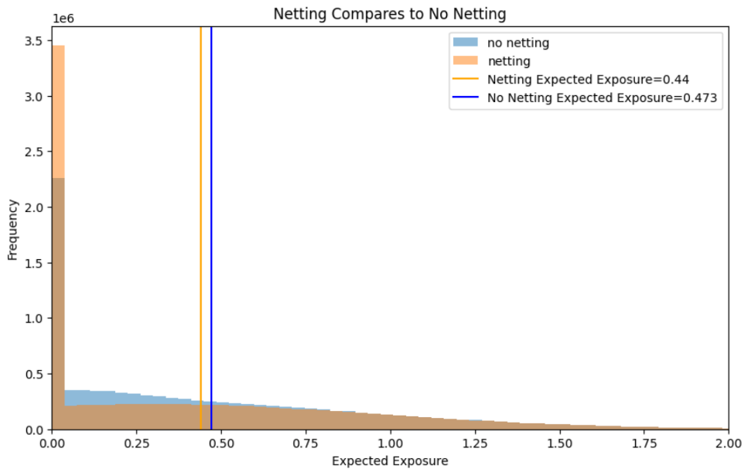And when we numerically simulate the Mark-to-Market, t=1 using 10,000,000 trials, rounding to 4 decimal points:

We can see that the expectation of netting is less than no netting, and they both agreed with the numerical calculation we derived previously.

Potential Future Exposure (PFE) profile:

Then for each t from 0 to 20, we did simulation of 10,000,000 , and plot at percentile of 90%, what is the expected exposure of our two contracts portfolio, then we calculate percentage of deviation from the expected value of our simulation

Although there is only marginal difference, but we do see for the picture on the right, the case of netting is always marginally better in terms of expected shortfall compares to the case of no netting.

Details see code attached.