DSA Explorer and Visualiser App
Project Report
(I completed the task alone, without any team members)
Student Name | Kaiwen Yang
Student ID | u3290623
Unit | Software Technology 2 (7170)
Teaching Period | Semester 1 2026
Assignment | ST2 Assignment 2 - Group Project
GitHub Repository | https://github.com/kaiwenyang895/DSA_Explorer_App.git
（）

Contents
1. Introduction
2. Project Requirements Mapping
3. Phase 1: Data Structures Playground
4. Phase 2: Algorithm Visualiser
5. Phase 3: Puzzle Challenges
6. Testing and Validation
7. Non-functional Requirements
8. Limitations and Future Improvements
9. Conclusion

1. Introduction
This report presents the DSA Explorer and Visualiser App developed for Software Technology 2 (7170), Semester 1 2026. The purpose of the project is to help users understand important data structures and algorithms through interactive visualisation.
The final application includes four working modules: Data Structures, Sorting Algorithms, Graph Algorithms, and Puzzle Challenges. The project therefore meets the requirement of implementing at least three fully working modules, with each module demonstrating at least two data structure or algorithm concepts.
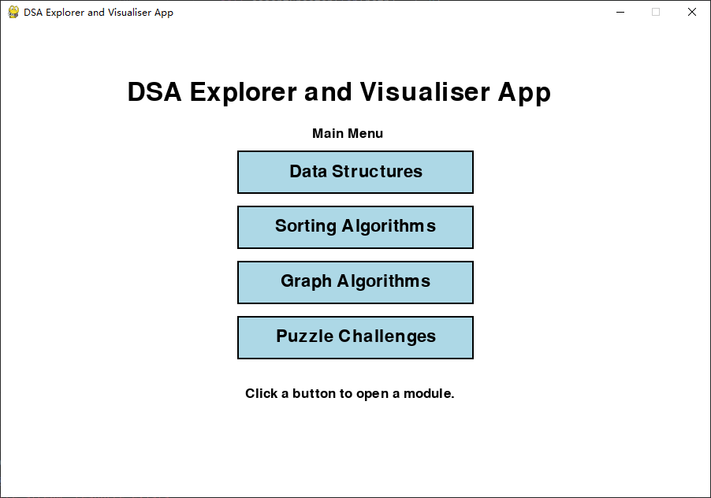
Figure 1. Main menu showing buttons for the different modules.

2. Project Requirements Mapping
Module | Implemented concepts
Data Structures | Stack (LIFO), Queue (FIFO), Linked List, insert, delete head, reverse, reset
Sorting Algorithms | Bubble Sort, Selection Sort, comparison highlighting, swap animation
Graph Algorithms | Breadth First Search (BFS), Depth First Search (DFS), adjacency list, user-selected start node
Puzzle Challenges | Dijkstra pathfinding, priority queue using heapq, Dynamic Programming grid path counting, path reconstruction

The visual design is kept consistent across the modules. Each module uses a title area, a Back button, operation buttons, and a message area to explain the current action.
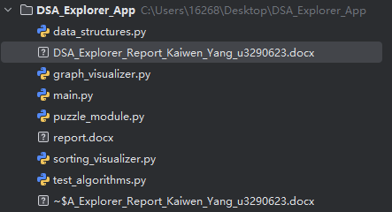
Figure 2. Screenshot of the project folder showing the modular file structure.

3. Phase 1: Data Structures Playground
The Data Structures module visualises Stack, Queue, and Linked List.

3.1 Stack Visualisation
The Stack section demonstrates the Last In, First Out (LIFO) principle. Users can click the button to add a value to the top of the stack and the Pop button to remove the most recently added value.
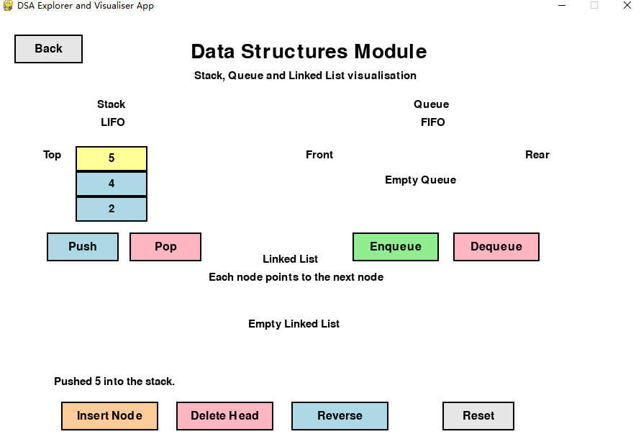
Figure 3. Stack visualisation after several Push and Pop operations.

3.2 Queue Visualisation
The Queue section demonstrates the First In, First Out (FIFO) principle. Users can click Enqueue to add a value to the rear of the queue and Dequeue to remove a value from the front.
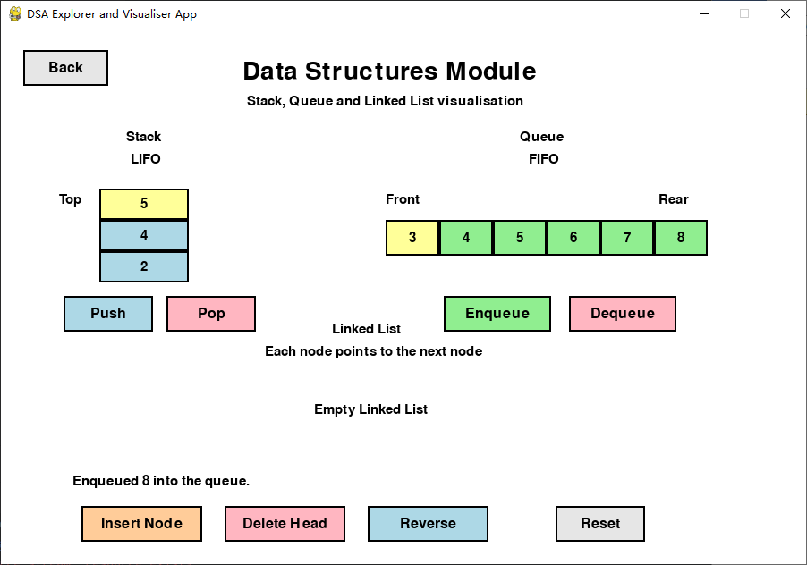
Figure 4. Queue visualisation showing front and rear positions.

3.3 Linked List Visualisation
In the Linked Lis, each node stores a value and a pointer to the next node.
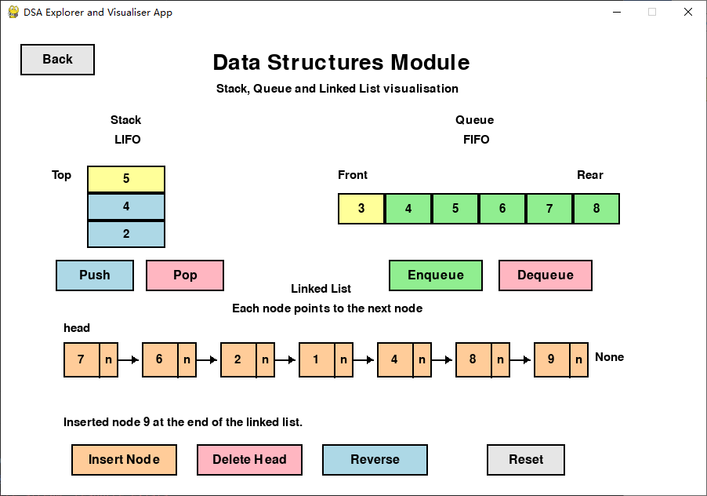
Figure 5. Linked List visualisation before using the Reverse operation.

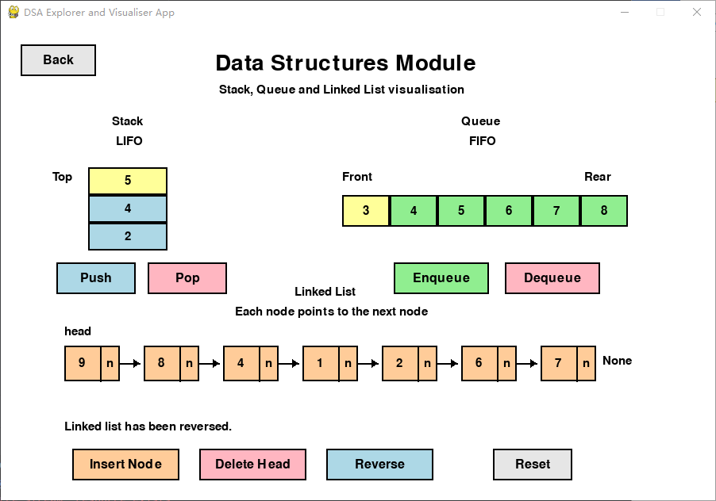
Figure 6. Linked List visualisation after using the Reverse operation.

4. Phase 2: Algorithm Visualiser
Phase 2 contains two main algorithm visualisation modules: Sorting Algorithms and Graph Algorithms.

4.1 Sorting Algorithms Module
The Sorting Algorithms module shows us how Bubble Sort and Selection Sort work. It does this by using bars to represent the array. Each bar is as tall as its value. When the algorithm is sorting it highlights the parts that are being looked at. This helps us see what is happening with the values at each step.

Bubble Sort looks at the values to each other and swaps them if they are not in the right order. It does this over and over. Selection Sort finds the value that has not been sorted yet and puts it where it belongs. The people who made this module wrote the sorting functions in a way. This allows the visualiser to stop after each comparison or swap. It can then show us the algorithm step, by step slowly so we can see what is happening with the Sorting Algorithms.
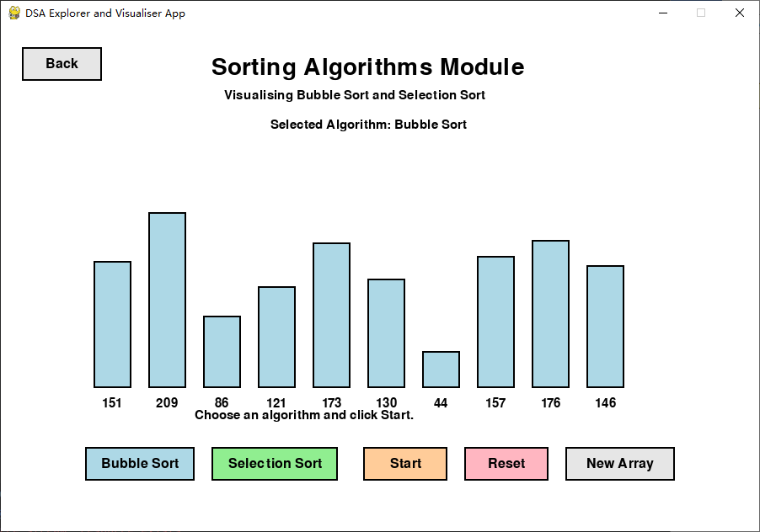
Figure 7. Sorting module before the algorithm starts.

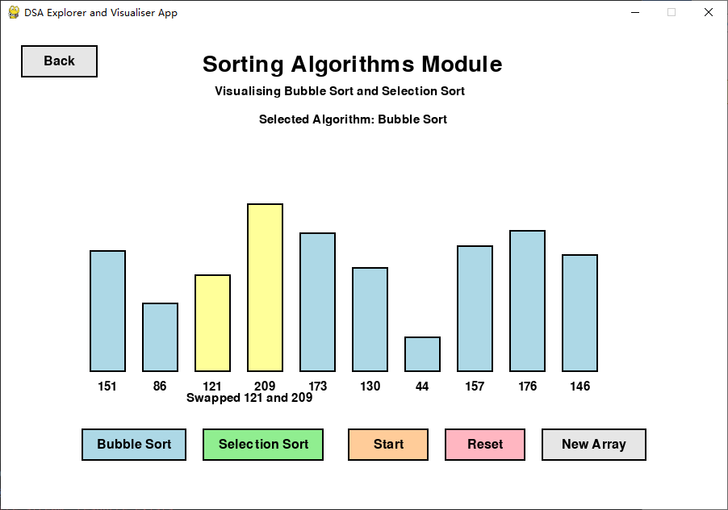
Figure 8. Bubble Sort visualisation with highlighted compared bars.

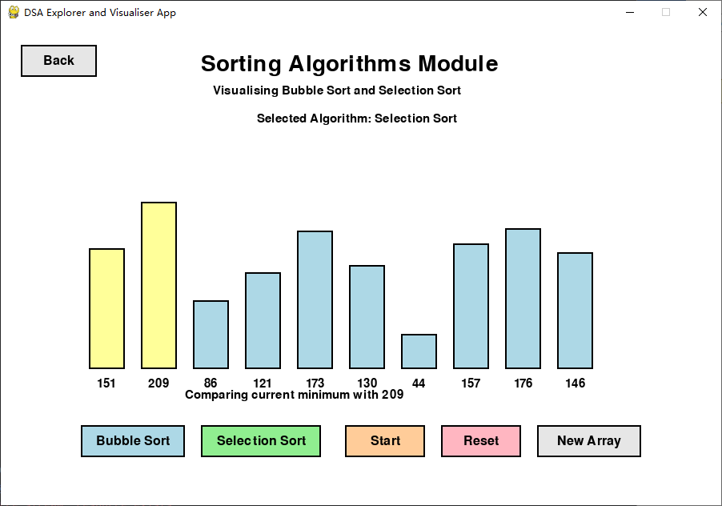
Figure 9. Selection Sort visualisation with highlighted current minimum and compared value.

4.2 Graph Algorithms Module
The Graph Algorithms module visualises Breadth First Search (BFS) and Depth First Search (DFS). T
BFS visits nodes level by level and is based on a queue-style traversal. DFS explores as deeply as possible before backtracking and is based on a stack-style traversal. You can pick a node to start with by clicking on it.Then you choose if you want to use Breadth First Search (BFS) or Depth First Search (DFS).After that you click Start to see the traversal animation.The order in which nodes are visited appears on the screen.

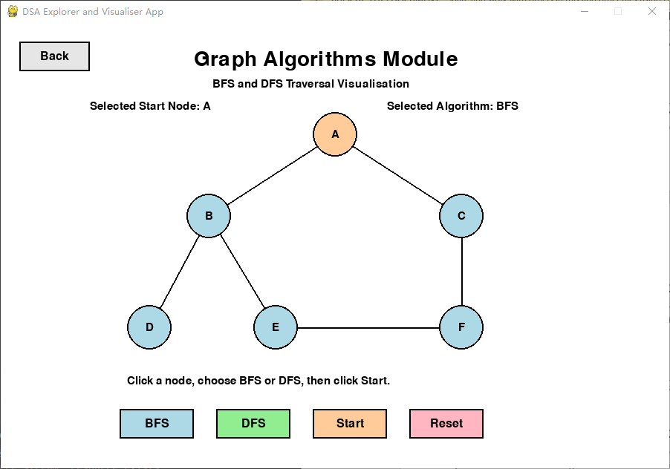
Figure 10. Graph module showing selectable nodes and algorithm buttons.

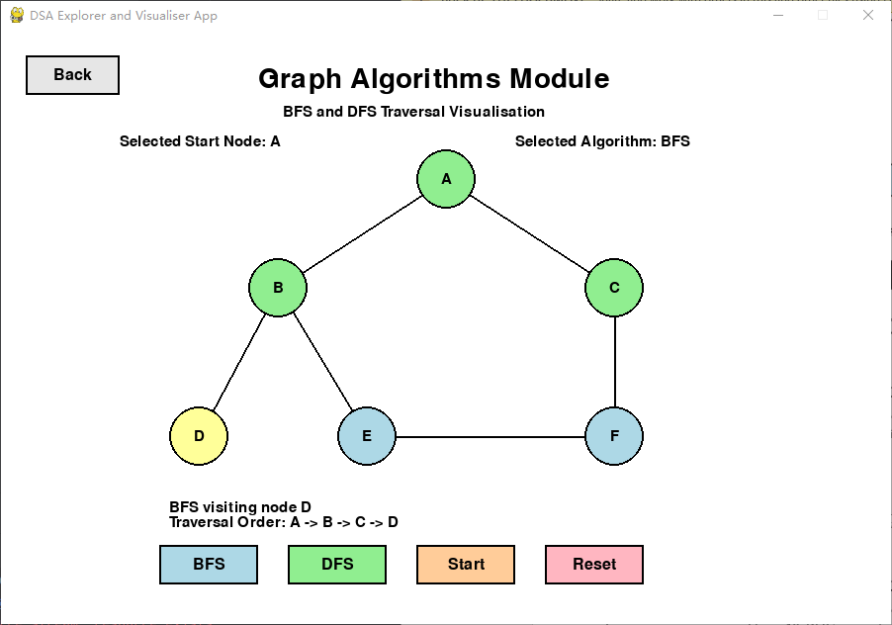
Figure 11. BFS traversal visualisation from the selected start node.

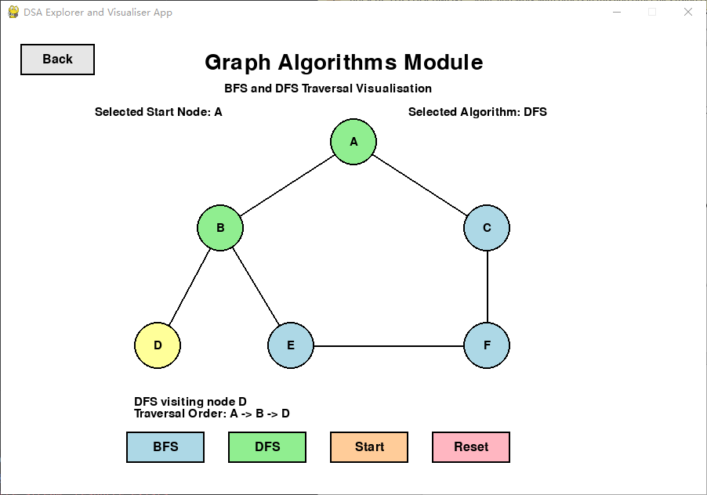
Figure 12. DFS traversal visualisation from the selected start node.

5. Phase 3: Puzzle Challenges
The Puzzle Challenges module combines algorithm knowledge with interactive problem solving.

5.1 Dijkstra Pathfinding Puzzle
The Pathfinding mode allows users to place a start point, an end point, and obstacles on an 8 by 8 grid. This algorithm implements a priority queue using Python's heapq module.
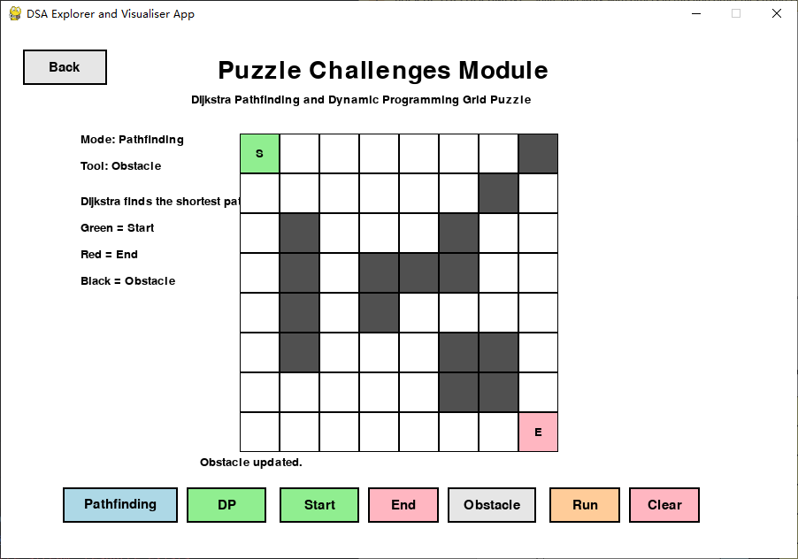
Figure 13. Pathfinding mode with start point, end point, and obstacles.

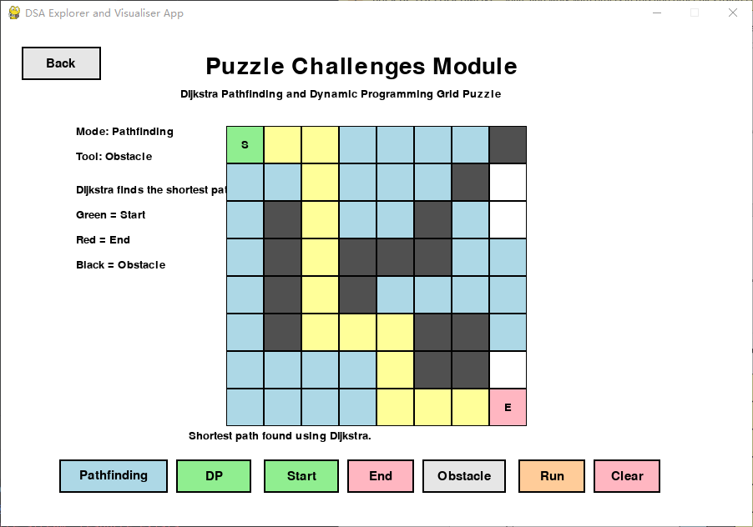
Figure 14. Dijkstra result showing visited cells and the shortest path.

5.2 Dynamic Programming Grid Puzzle
The Dynamic Programming mode calculates the number of possible paths from the top-left cell to the bottom-right cell while avoiding obstacles. The following image shows what happens when we do this and what we get. The screen will show us the DP values, in a grid. It will also show us the path that was made when there is a good path to take.
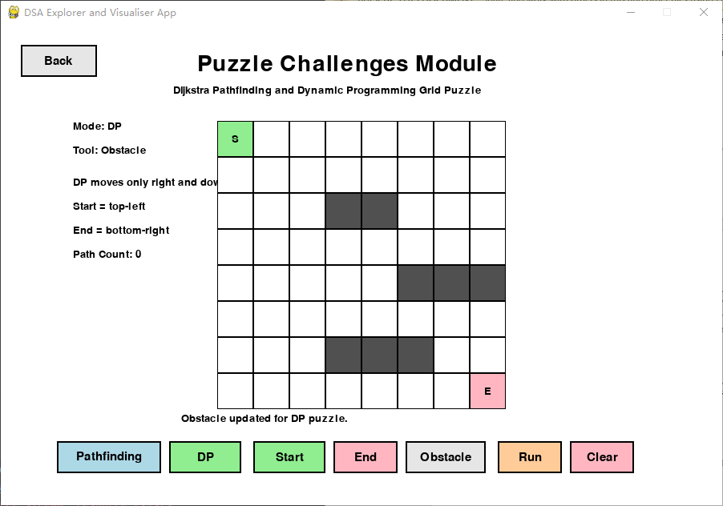
Figure 15. DP grid showing path count values in each cell.

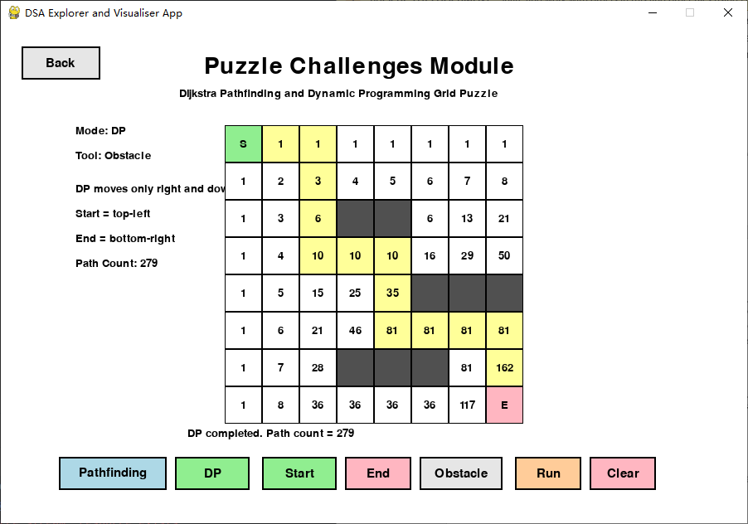
Figure 16. DP completed with total path count and reconstructed path.

6. Testing and Validation
The test suite checks Linked List operations, sorting correctness, graph traversal correctness, puzzle helper functions, Dijkstra pathfinding, Dynamic Programming path counting, and simple benchmarking.
Test Area | Validation Scenarios
Linked List | Insert at end, delete head, delete from empty list, reverse, reverse empty list, clear.
Sorting | Bubble Sort and Selection Sort with unsorted list, duplicate values, empty list, single element, already sorted list, and reverse order list.
Random Array | Checks that the generated array has 10 values and each value is within the visual range.
Graph Traversal | BFS and DFS from different start nodes, and checking that all reachable nodes are visited.
Puzzle Helpers | Mouse position to grid cell conversion and neighbour detection for corner and middle cells.
Dijkstra Pathfinding | Path exists, no path, start equals end, and path avoids obstacles.
Dynamic Programming | Correct path count on grids, with obstacle, blocked start, and blocked end.
Benchmarking | Basic runtime checks for Bubble Sort, Selection Sort, BFS, DFS, Dijkstra, and Dynamic Programming.

6.1 Automated Test Result
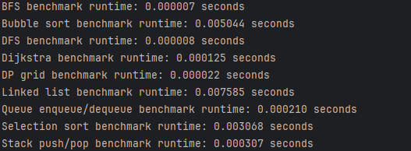
Figure 17. Automated testing screenshot showing all tests passed successfully.

7. Non-functional Requirements

7.1 User Interaction
The application has buttons that you can click on. It also gives you feedback and tells you what the algorithm is doing. You can control what you see of just watching something that does not change. For example you can. Remove values from a stack or add and remove values from a queue. You can also reverse a linked list. The application lets you choose between two ways to search for something, which are called BFS and DFS. You can pick where you want to start in a graph. You can even put obstacles in a grid. Then try to find a path around them using pathfinding or DP calculations. The application includes things, like these and you can use them to learn about the algorithm and how it works.

8. Limitations and Future Improvements

8.1

The application does what it is supposed to do with least three work modules.. There are still some things that can be made better. For example the user interface needs to be improved. This can be done by adding animations and making the transitions smoother. The instructions for the tutorials also need to be clearer. This will make the application better for the users. The entire application will be perfect.

9. Conclusion

In short, this project perfectly meets the required application functions, with each part demonstrating at least two concepts. At the same time, a very complete testing mechanism was implemented.

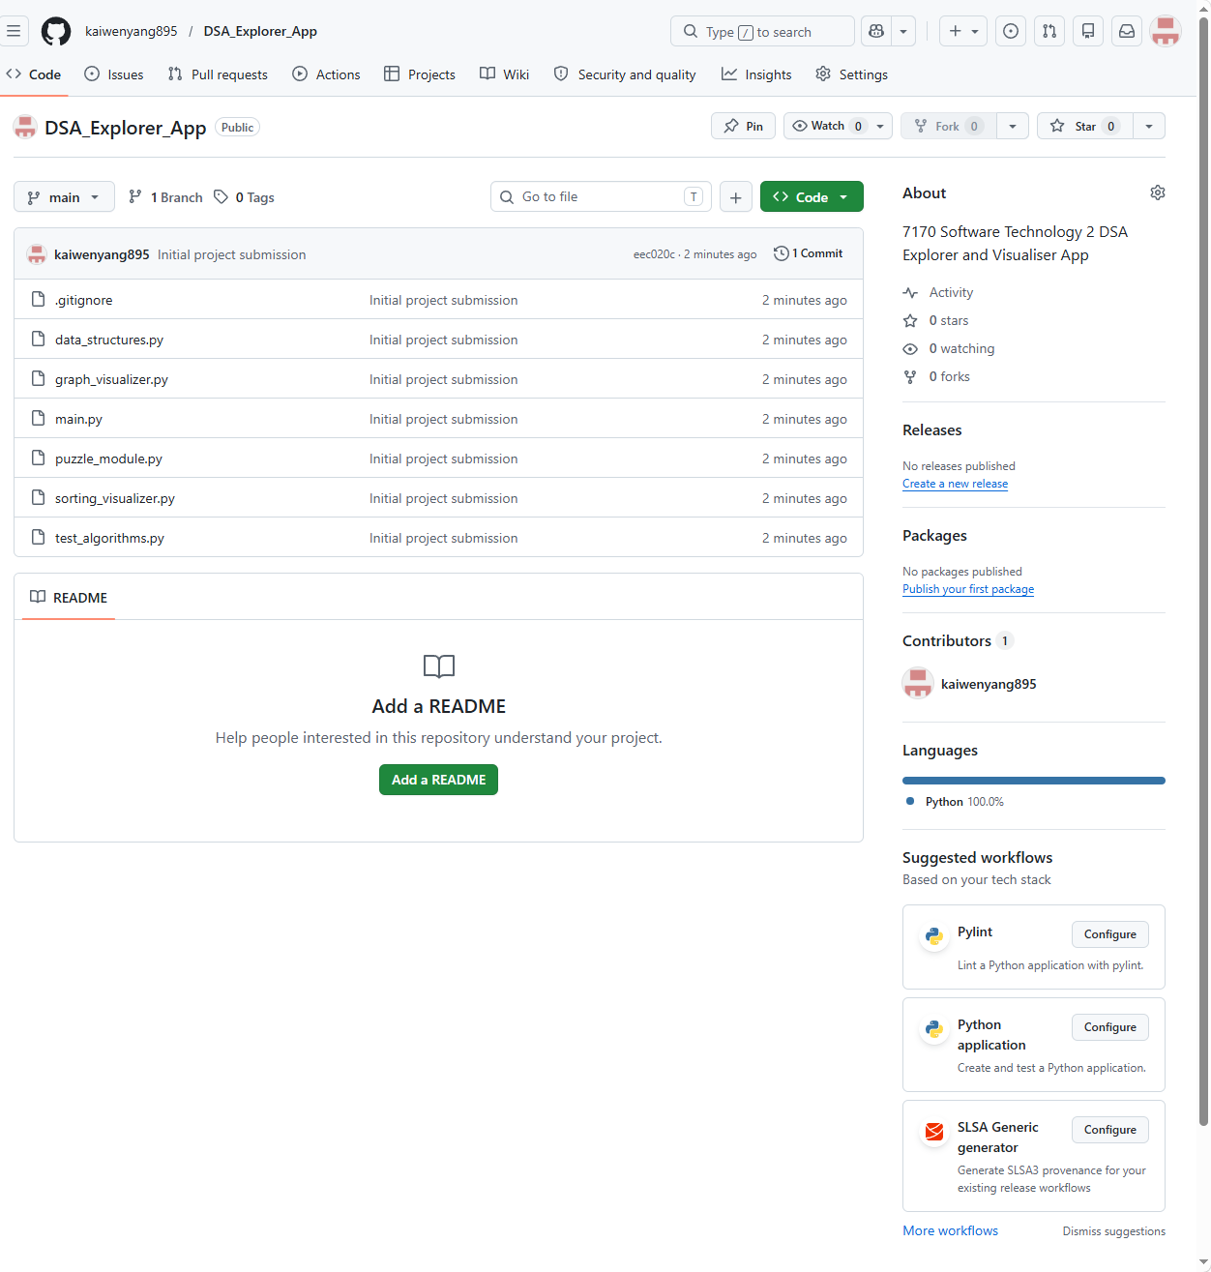
References
Pygame Community. (n.d.). Pygame documentation. https://www.pygame.org/docs/
Python Software Foundation. (n.d.). unittest — Unit testing framework. Python documentation. https://docs.python.org/3/library/unittest.html

