TECHNICAL PORTFOLIO

Scientific Software and Research Engineering
Kai Woodger
Medical physics Computational modelling Reproducible software Evidence led validation
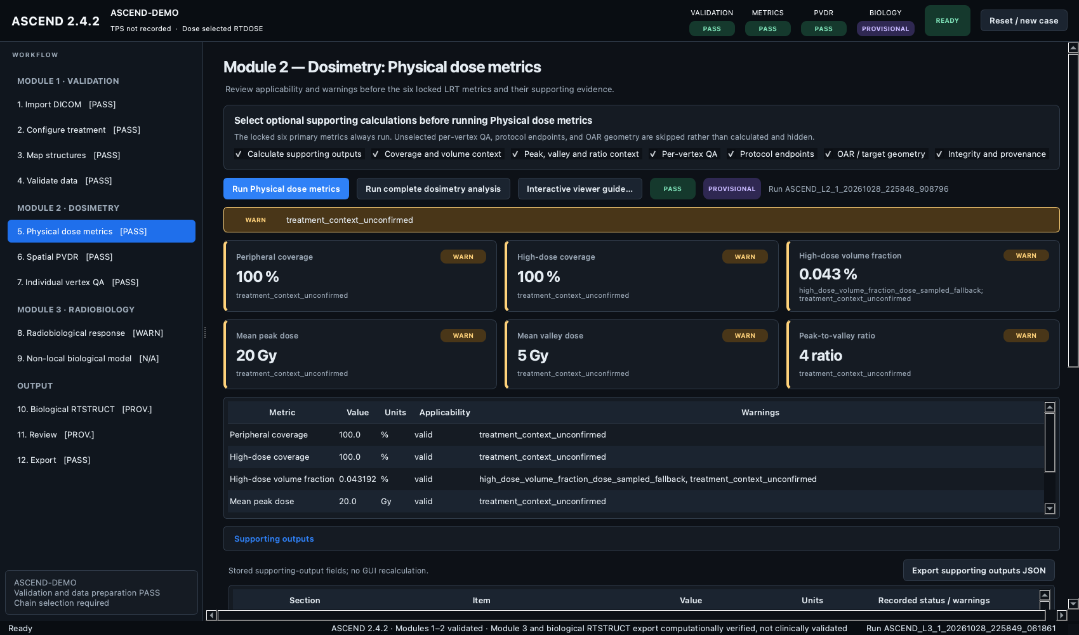
Figure 1 ASCEND 2.4.2 dosimetry workstation using a synthetic demonstration case
November 2026
Portfolio prepared from verified local repositories and 113 accessible development threads

PORTFOLIO SUMMARY

Portfolio Summary
Technical work verified against repository evidence
I develop research software that turns medical physics methods into auditable, reproducible tools. The work in this portfolio covers DICOM radiotherapy analysis, lattice radiotherapy metrics, computational digital twins, treatment planning automation, Monte Carlo beam modelling, biological audit systems, machine learning quality assurance, and API development.
The strongest example is ASCEND, a cross platform Qt workstation for DICOM RT validation, lattice radiotherapy dosimetry, and research radiobiology. I conceived the system, defined the scientific workflow, directed its implementation, integrated the modules, and built the validation and release evidence with AI assisted development.
Area | Evidence in this portfolio
Scientific software | ASCEND 2.4.2 desktop workstation and reproducible validation pipeline
Computational modelling | Deterministic multiscale radiotherapy digital twin with a watertight STL release
Treatment planning automation | C sharp ESAPI lattice sphere placement with geometry verification
Simulation and analysis | TOPAS VHEE beamline sweeps and transverse asymmetry analysis
Research platforms | BARAT biological audit framework and uncertainty aware contouring QA
Software services | FastAPI talent lead system with documented compliance boundaries

Evidence standard Each case study separates software implementation from scientific or clinical validation. Research tools retain explicit warnings when commissioned measurements, commercial treatment planning systems, licensed anatomy data, or clinical outcomes are still required.

DEVELOPMENT RECORD

Development Record
A concentrated record of scientific software development and verification
The accessible development history contains 113 threads. After excluding personal and administrative work, 103 development threads form the portfolio record. ASCEND and lattice radiotherapy account for the majority because the system was built iteratively across architecture, scientific algorithms, validation, GUI design, documentation, testing, release engineering, and publication support.
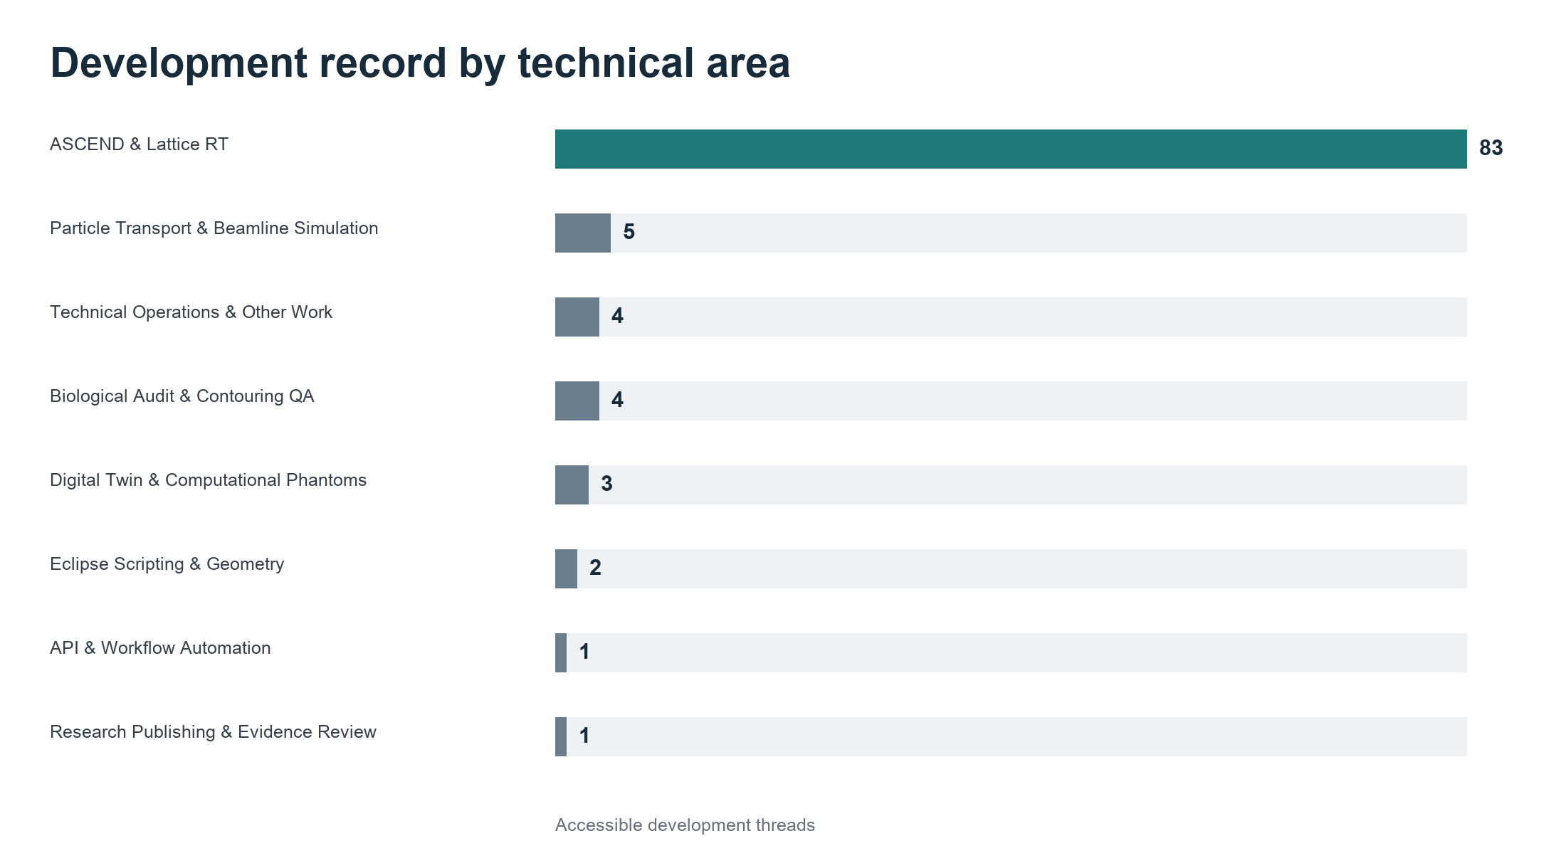
Figure 2 Distribution of accessible development threads by technical area
- Research methods were converted into executable workflows with named inputs, acceptance criteria, warnings, and provenance records.
- Scientific outputs were paired with regression tests, synthetic fixtures, documented validation boundaries, and reproducible release records.
- AI assistance accelerated implementation, review, documentation, and verification. Scientific direction, scope decisions, evidence interpretation, and release responsibility remained with me.

CASE STUDY 1

ASCEND Lattice Radiotherapy Workstation
Cross platform DICOM RT validation dosimetry and research radiobiology
Repository https://github.com/kaiwooodger/ASCEND
ASCEND is a Qt 6 desktop workstation that guides a case through three ordered modules. Module 1 validates the selected DICOM relationship chain and treatment context. Module 2 calculates locked physical lattice radiotherapy metrics, spatial PVDR, saddle evidence, and individual vertex QA. Module 3 contains computational research models whose outputs remain explicitly separate from clinically validated functions.
Current repository evidence | Value
Release | ASCEND 2.4.2
Python application files | 166
Automated test files | 44
Technical documentation files | 84
GitHub workflow files | 4
Supported runtime | Python 3.11 and newer

My contribution
- Defined the end to end scientific workflow and evidence boundaries for DICOM validation, dosimetry, spatial PVDR, radiobiology, and export.
- Integrated scientific services, GUI pages, state transitions, warnings, provenance, reporting, and synthetic fixtures into one workstation.
- Directed release engineering, cross platform testing, repository policy, documentation, and validation records.
- A prior Git audit attributed 99.68 percent of current code lines to Kai Woodger and 52 of 57 non merge commits, while recognising that repository attribution is not a measure of unaided manual typing.

ASCEND VISUAL EVIDENCE

ASCEND Interface and Scientific Method
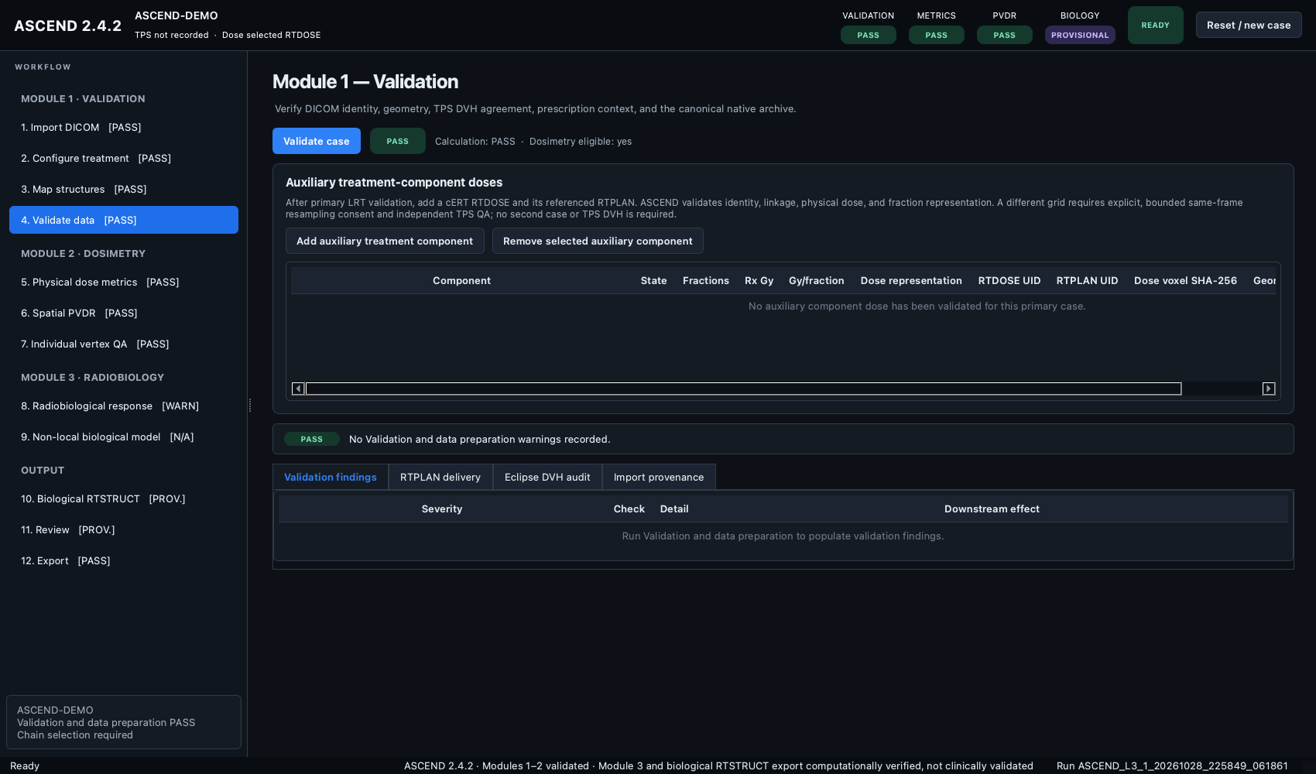  Figure 3 Module 1 validation interface | 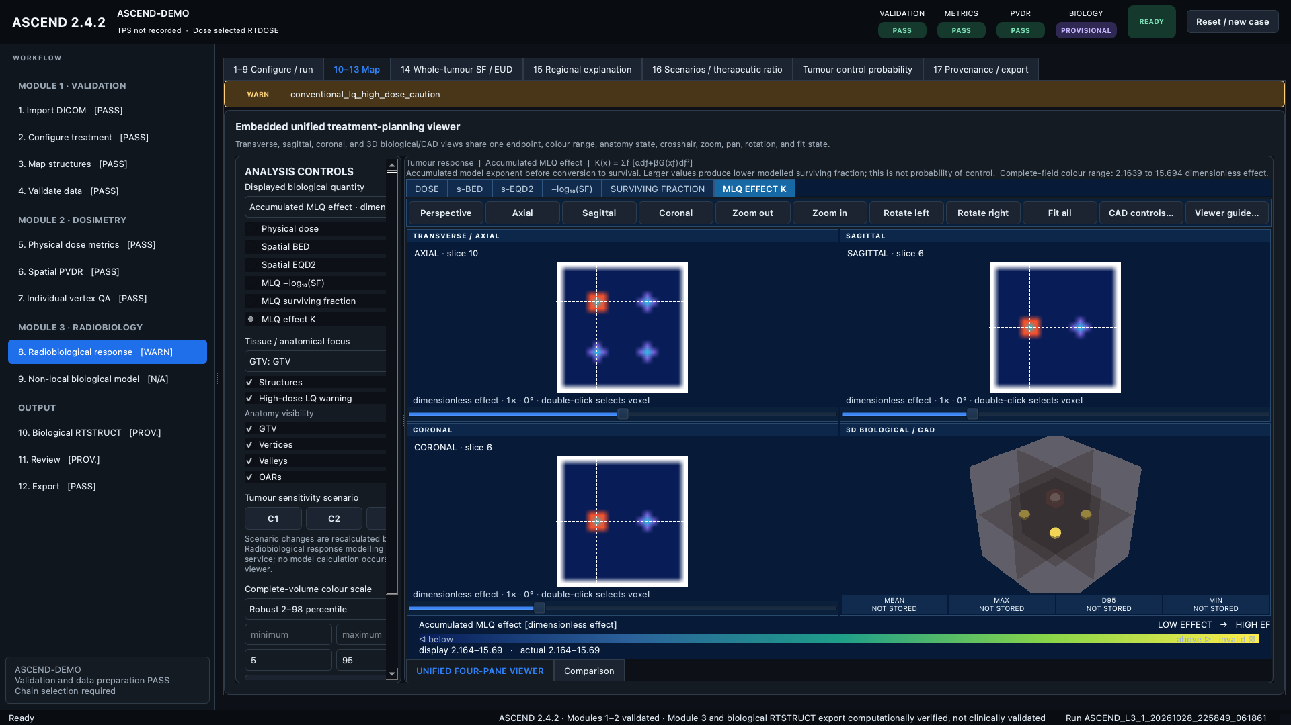  Figure 4 Module 3 research maps
The interface makes state and uncertainty visible. Disabled actions identify unmet prerequisites, warning panels name the required correction, and result exports retain version, commit, configuration hash, parameter identity, and source geometry evidence.
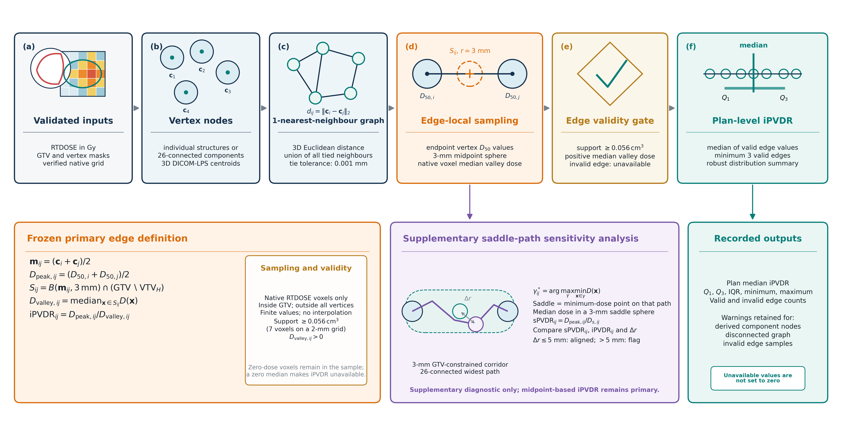
Figure 5 Publication figure for the edge local spatial iPVDR algorithm and supplementary saddle path analysis

ASCEND ENGINEERING

Verification Release and Research Boundaries
The 2.4.2 release adds ROI scoped auxiliary cERT coverage validation, preserves separate LRT and cERT fraction histories, and records incremental biological comparison evidence. It also separates Qt teardown from non GUI validation and shards Windows GUI tests for hosted runner limits.
Evidence class | What is established | Boundary retained
DICOM workflow | Relationship chain and source identity checks | No image registration or deformation
Physical dosimetry | Locked metrics and synthetic regression evidence | Case context and external TPS evidence remain visible
Spatial PVDR | Defined graph sampling validity gates and distribution summaries | Unavailable samples are not forced to zero
Radiobiology | Computational research functions and provenance | No clinical outcome validation claim
Release | Cross platform package checks and documented identity | Research software warning remains active

Portfolio value ASCEND demonstrates that I can combine medical physics, DICOM data structures, numerical methods, user interface design, software architecture, testing, documentation, and evidence based release management in one working system.
- DICOM RT identity and geometry handling
- Lattice radiotherapy plan quality and spatial dose analysis
- Qt desktop application design and workflow state management
- Scientific regression testing and synthetic fixtures
- Publication figures reports and thesis documentation
- GitHub Actions release contracts and cross platform portability

CASE STUDY 2

Dynamic Multiscale Radiotherapy Digital Twin
Deterministic engineering baseline for anatomy motion circulation radiation and biology
This project implements a reproducible whole body computational framework with explicit DICOM LPS coordinates, deformation, circulation, blood packet transport, lymph transport, radiation energy accumulation, oxygen fields, biological response interfaces, uncertainty propagation, checkpoints, and provenance manifests.
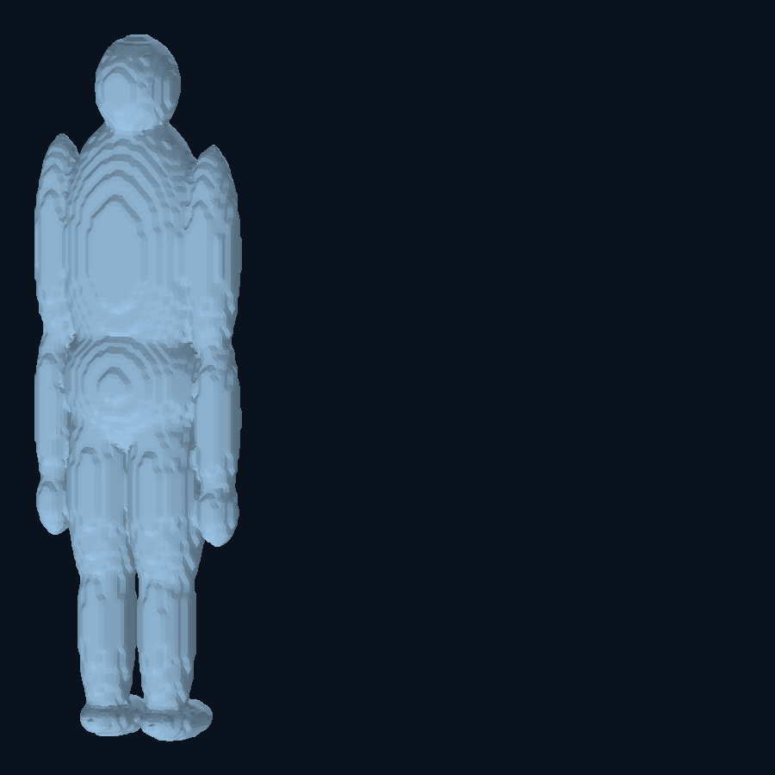  Figure 6 Watertight synthetic whole body mesh | 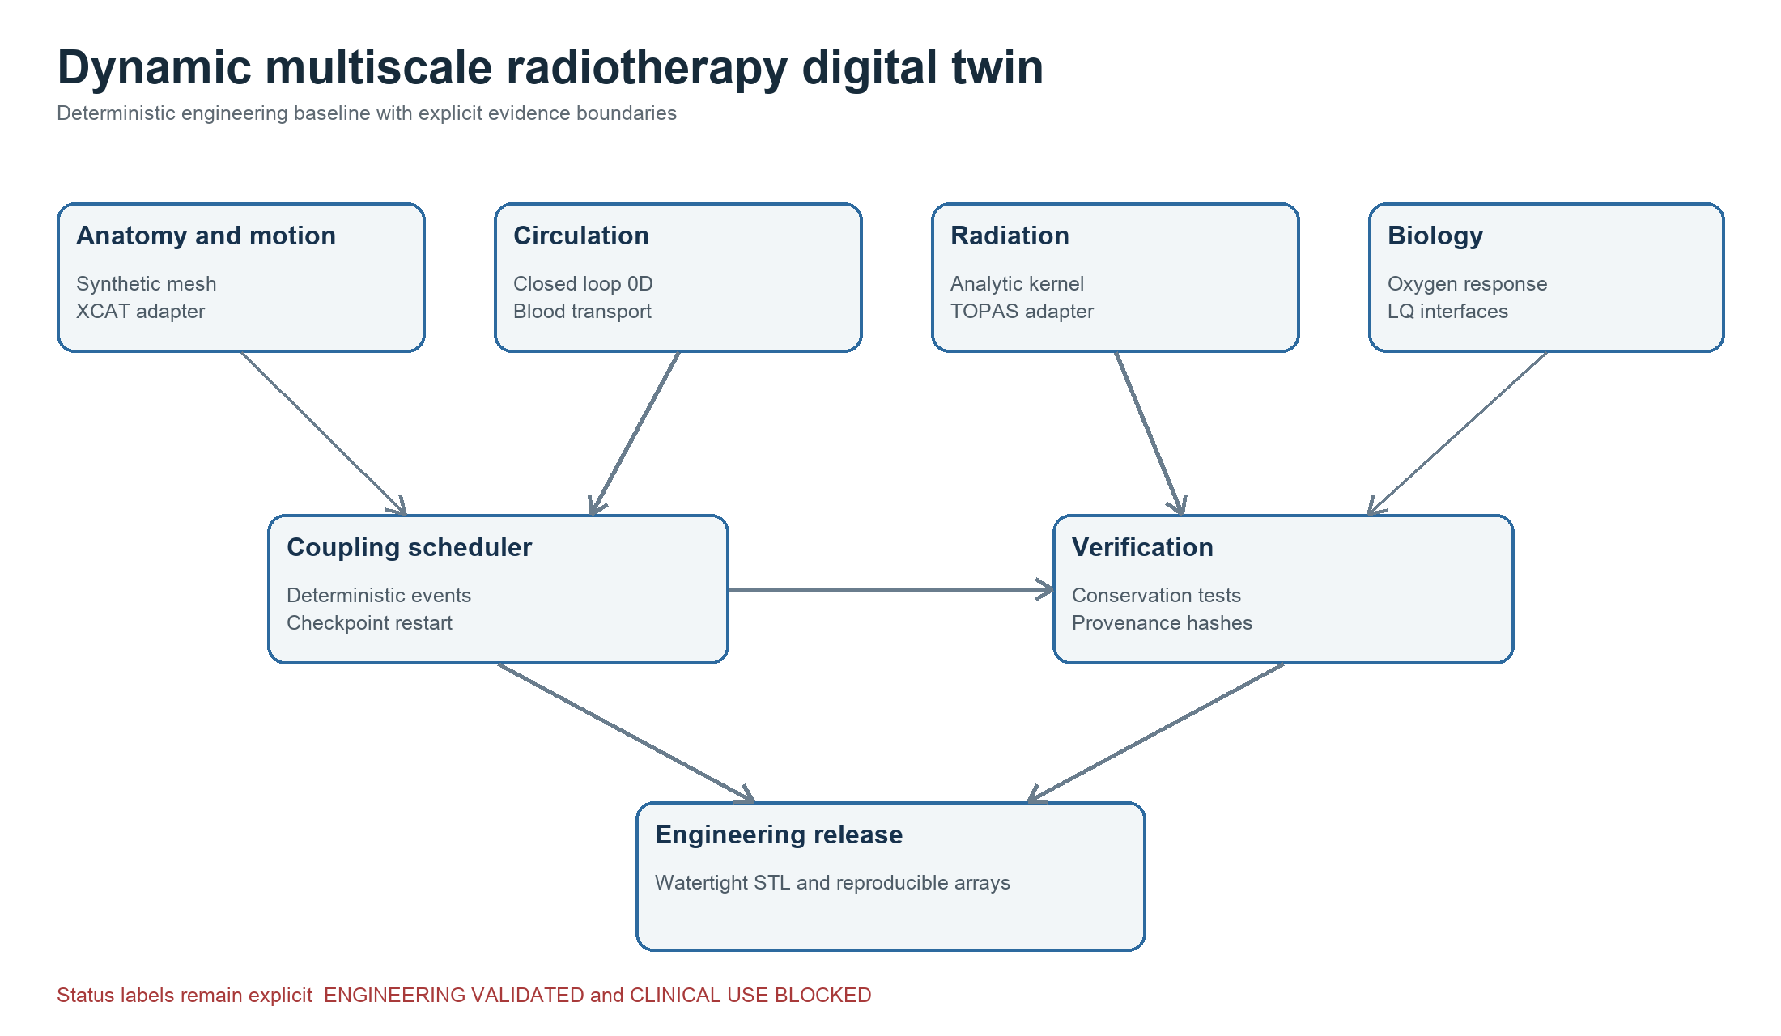  Figure 7 Implemented system architecture
Engineering release evidence | Result
Mesh | 39,664 triangles
Topology | Watertight with zero boundary nonmanifold or degenerate elements
Automated tests | 8 passed in the immutable v0.1.0 release
Clean rerun | Simulation arrays summaries and STL were byte identical
Status | ENGINEERING VALIDATED and CLINICAL USE BLOCKED

DIGITAL TWIN VALIDATION

External Reference Integration and Evidence Gates
The project treats external references as scoped validation layers. HEDOS tests blood transport and blood dose behaviour. XCAT tests anatomy and motion interfaces when a licensed executable and reference subject are available. TOPAS provides a boundary for commissioned radiation transport. Passing one layer never grants claims that belong to another.
Reference | Verified result | Remaining boundary
HEDOS | Twenty seeds and 100,000 particles per seed reproduced field and DVH based modes | Does not establish human physiology
XCAT | Adapter synthetic transforms and 24 of 24 authorised package intake criteria passed | Execution blocked by absent provider licence and Windows x86 64 requirement
TOPAS | Locked runtime smoke case and adapter evidence | Independent measurement and site commissioning still required
Coupling | Stationary moving dose conservation restart and refinement checks | Synthetic interface verification only

My contribution
- Converted a broad radiotherapy digital twin specification into versioned modules data contracts benchmarks and acceptance criteria.
- Built deterministic execution and reproducibility controls around geometry physiology transport radiation and biological interfaces.
- Preserved licensing computational platform and clinical evidence constraints rather than overstating readiness.
- Advanced the later repository to 65 passing tests during authorised XCAT intake while retaining the clinical block.

CASE STUDY 3

ESAPI Lattice Sphere Placement
C sharp treatment planning automation with independent geometry evidence
Repository https://github.com/kaiwooodger/ESAPI-Script
The script implements Gaudreault style three dimensional sphere lattice placement for an Eclipse structure set. It creates individual control structures and a union while preserving the original target, enforcing target contraction, image bounds, spacing, containment, output naming, and cleanup rules.
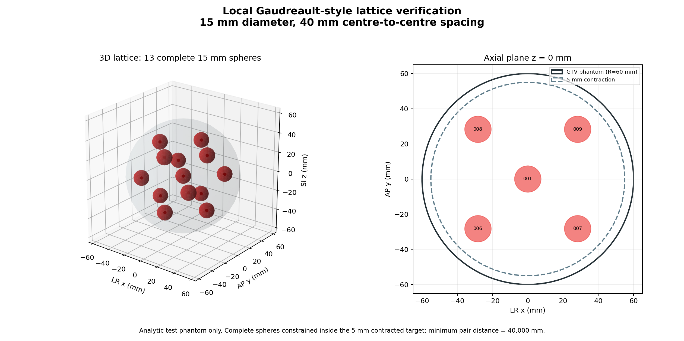
Figure 8 Local phantom verification for 15 mm spheres with 40 mm centre to centre spacing
- Shared geometry was compiled directly from the deployed C sharp source.
- A worked phantom produced 13 complete spheres with a 40.000000 mm minimum pair distance.
- The original GTV remains unchanged and existing output structure identifiers cause a pre modification failure.
- Actual Eclipse execution and compilation against installed Varian assemblies remain installation specific validation steps.

ESAPI VERIFICATION

Parameter Sweep and Robustness Evidence
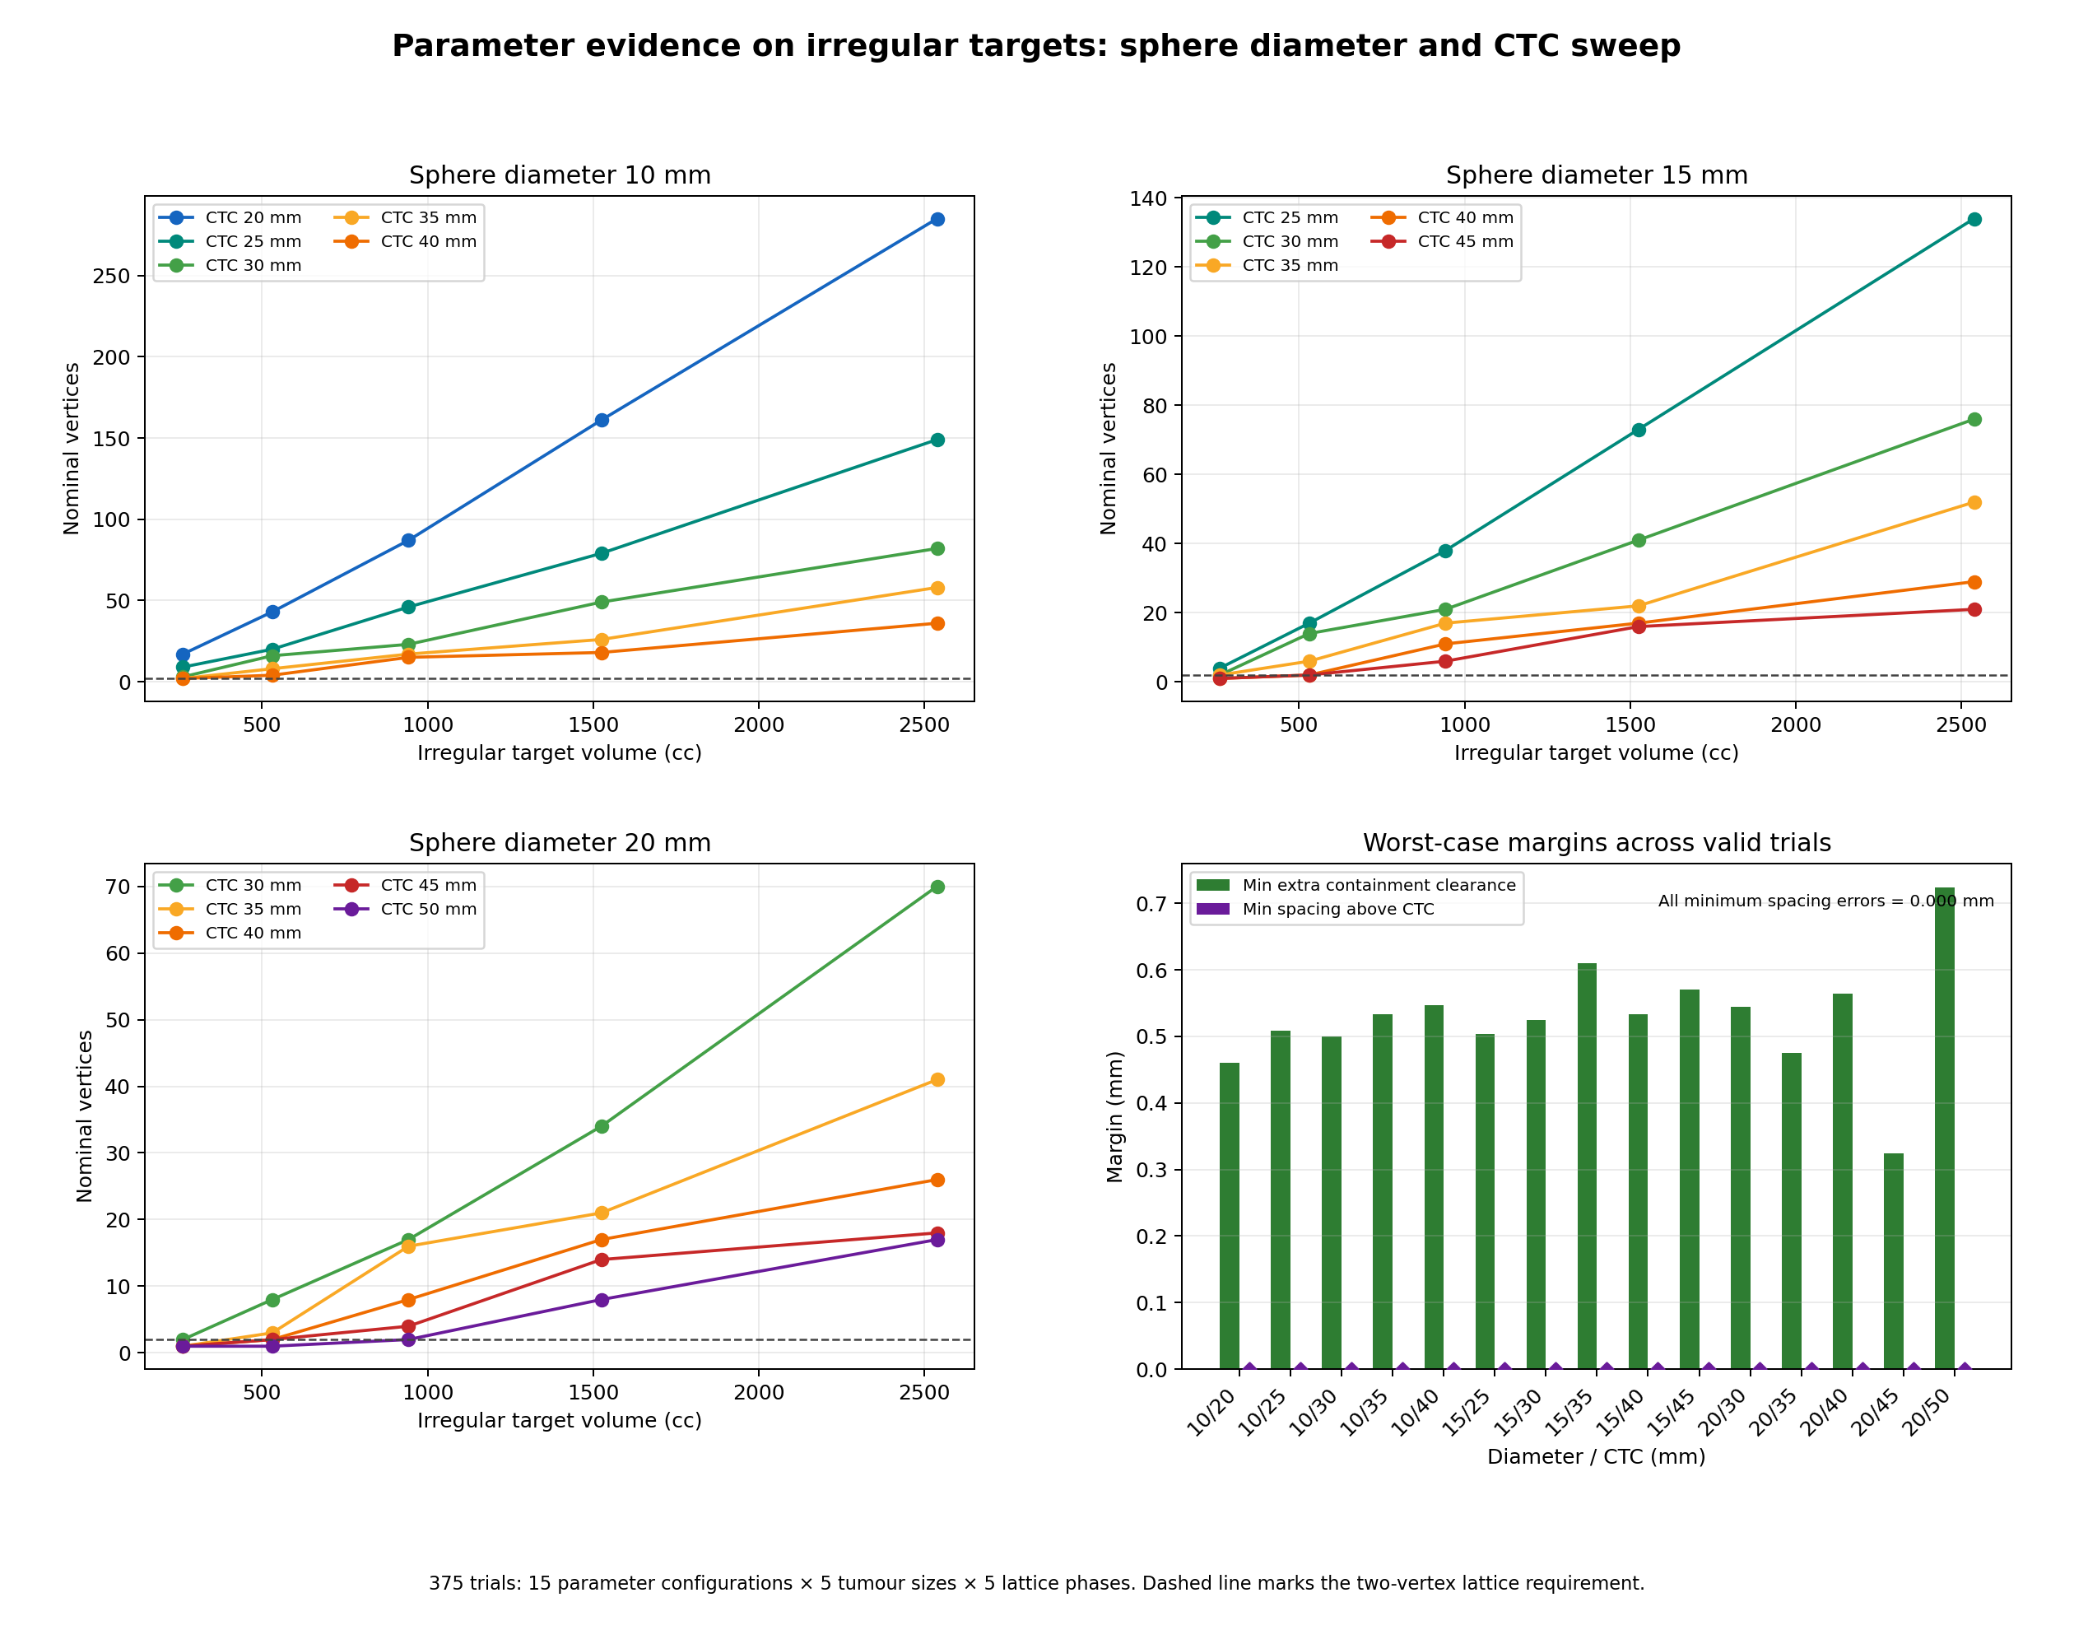
Figure 9 Sphere diameter and centre to centre spacing evidence across irregular target sizes
Verification measure | Recorded result
Total trials | 375
Valid lattices | 336
Correct no lattice outcomes | 39
Geometric failures | 0
Worst spacing error | 0.000000 mm
Minimum containment clearance | 0.324 mm
Maximum tested lattice | 292 vertices
Core regression suite | 19 passed

CASE STUDY 4

Talent Leads API
Compliant job signal ingestion ranking workflow and export
The FastAPI service ingests authorised job posting data, removes duplicates, scores hiring intent, generates editable outreach drafts, tracks pipeline state, exports CSV, and exposes an approved partner adapter for LinkedIn job publishing. It deliberately excludes scraping, member profile extraction, account automation, and unsupervised messaging.
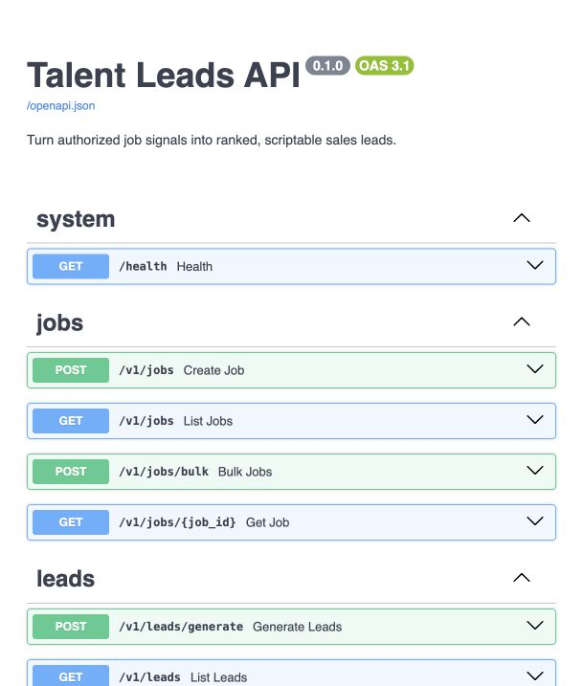  Figure 10 Generated OpenAPI interface | 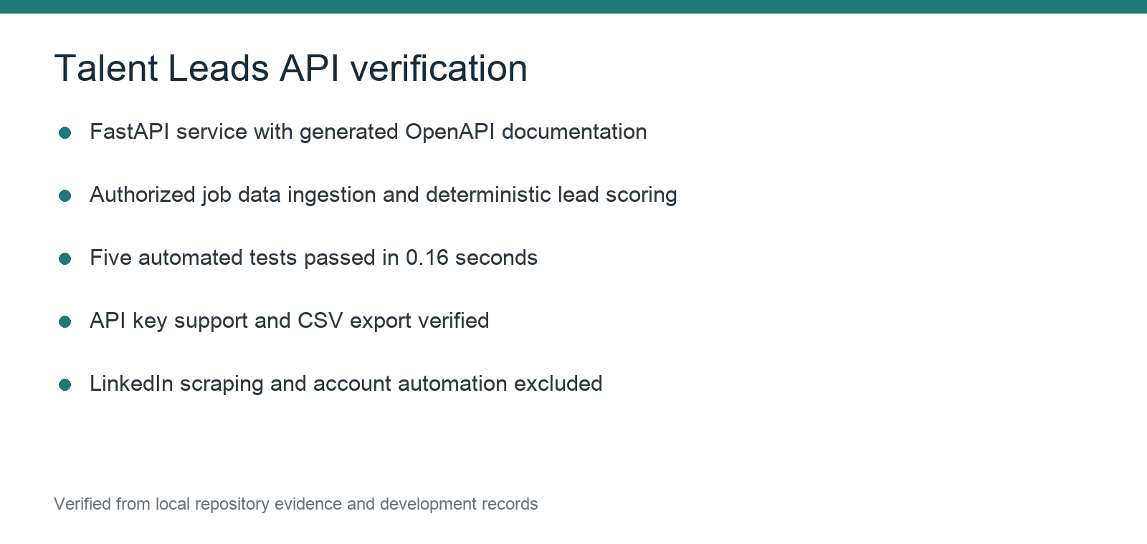  Figure 11 Verification record
Capability | Implementation
Ingestion | CSV JSON ATS feeds licensed providers and manually supplied URLs
Deduplication | Source identity URL and stable company title date fingerprint
Scoring | Freshness keywords location employment type remote status and contact routes
Review | Human editable outreach and verified contact fields
Security | Optional API key for all versioned endpoints
Verification | Five tests passed with previously recorded 85 percent coverage

ADDITIONAL PROJECTS

Biological Audit Contouring QA and VHEE Simulation
Archived development records and reproducible analysis outputs
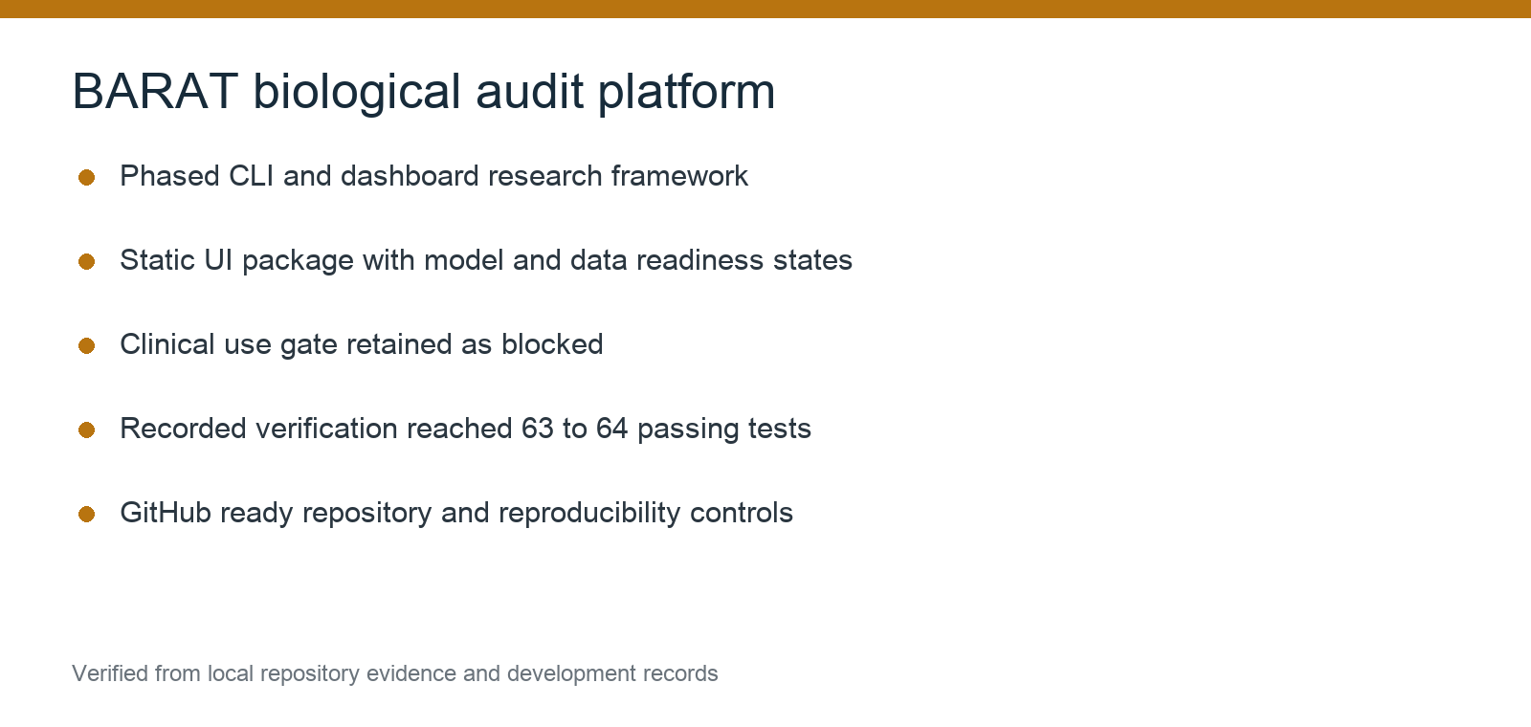  Figure 12 BARAT development record | 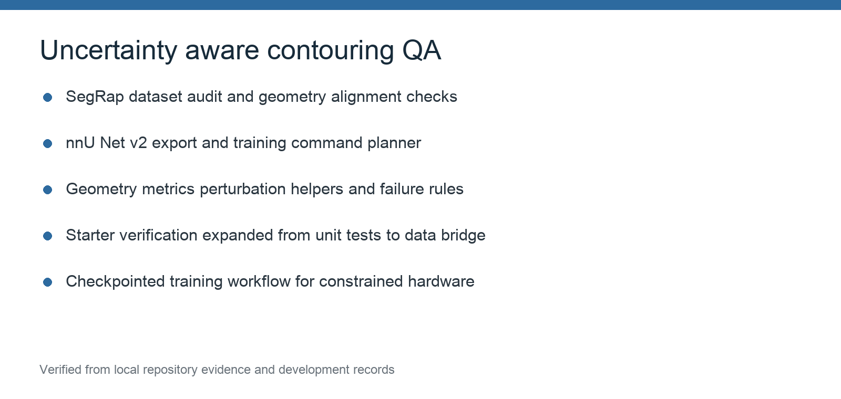  Figure 13 Contouring QA development record

BARAT Biological Audit and Risk Analysis Tool
BARAT was structured as a phased CLI and dashboard research platform for biological plan audit. The Phase 8 interface exposed data readiness, model trust, calibration lock, plan comparison, report exports, and an explicit clinical use gate. Recorded verification reached 63 to 64 passing tests, and the repository was prepared for GitHub with workflow checks, data handling rules, citation metadata, and release guidance.

Uncertainty Aware Contouring QA
The contouring QA project tests the claim that automatic contours should be judged by stability and plausibility as well as average overlap. The scaffold includes geometry metrics, perturbation helpers, failure rules, SegRap data auditing, an nnU Net v2 export bridge, training command planning, notebooks, and checkpointed workflows for constrained compute environments.

SIMULATION RECORD

TOPAS VHEE Beamline Modelling
The VHEE project built TOPAS scripts and Python analysis for a four quadrupole asymmetric beamline at 100 200 and 250 MeV. Development included Q4 sweeps, source phase space sensitivity, integrated depth metrics, Gaussian transverse width analysis, reproducible manifests, and plots that separate depth dose from lateral asymmetry.
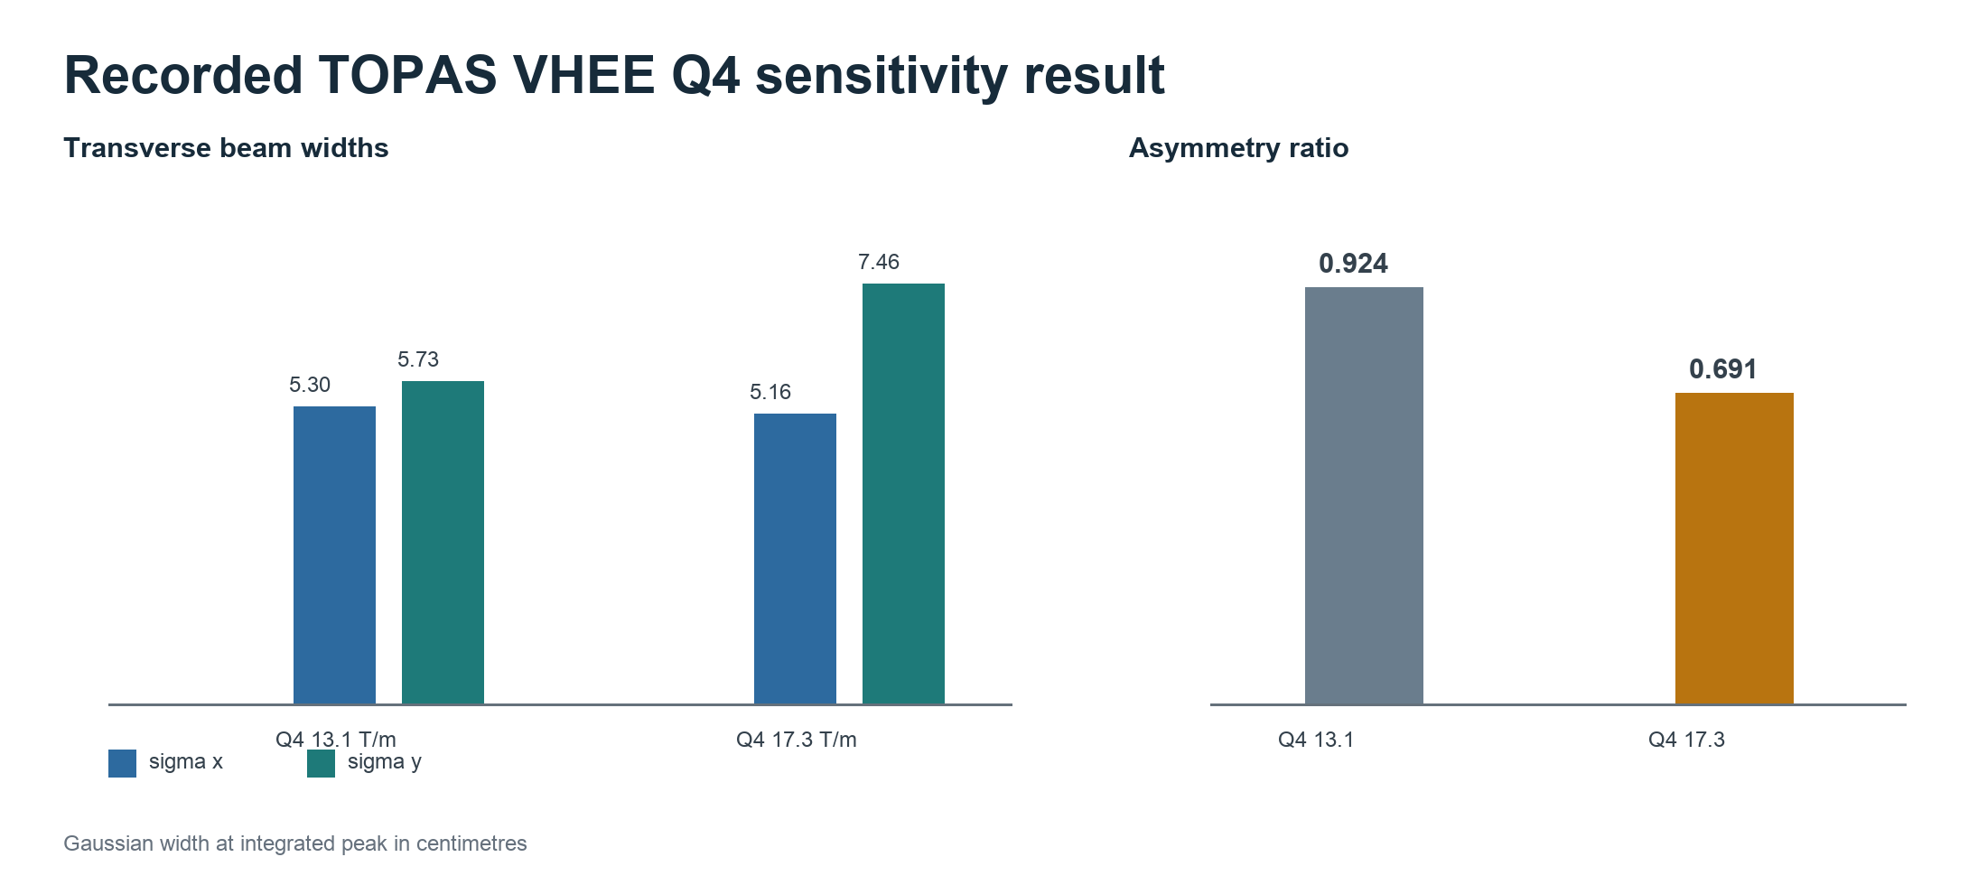
Figure 14 Recorded 250 MeV Q4 sensitivity result using the 4.0 mm source sigma baseline
The recorded analysis showed that Q4 equal to 17.3 T per m increased asymmetry compared with 13.1 T per m. At the integrated peak the Gaussian width ratio changed from 0.924 to 0.691. The work also established that a one dimensional percentage depth dose curve cannot demonstrate transverse asymmetry by itself.
Q4 T per m | Integrated peak cm | Sigma x cm | Sigma y cm | Ratio
13.1 | 23.9109 | 5.2958 | 5.7307 | 0.924
17.3 | 16.7822 | 5.1558 | 7.4577 | 0.691

PROFESSIONAL SUMMARY

Technical Capability Matrix
Evidence that can be used directly in a resume or application
Capability | Demonstrated evidence
Medical physics software | DICOM RT workflow validation lattice radiotherapy dosimetry spatial PVDR radiobiology and reporting
Scientific computing | Python NumPy SciPy PySide6 PyVista pydicom FastAPI R and reproducible numerical workflows
Treatment planning | Eclipse ESAPI C sharp automation DICOM RTSTRUCT logic and synthetic phantom verification
Computational modelling | Anatomy motion circulation blood and lymph transport radiation oxygen and biological response interfaces
Monte Carlo simulation | TOPAS beamline construction parameter sweeps manifest based execution and dose grid analysis
Machine learning QA | SegRap data audit nnU Net v2 bridge uncertainty metrics failure rules and checkpointed training
Software engineering | Modular architecture tests CI release records package checks provenance schemas and documentation
Research communication | Publication figures thesis material validation appendices abstracts and evidence led technical reporting

Resume ready project bullets
- Developed ASCEND 2.4.2, a cross platform Qt workstation for DICOM RT validation, lattice radiotherapy dosimetry, spatial PVDR, vertex QA, research radiobiology, and provenance controlled export.
- Designed a deterministic multiscale radiotherapy digital twin integrating synthetic anatomy, motion, closed loop circulation, transport, radiation, oxygen response, checkpoint restart, and evidence gated validation.
- Implemented and verified a C sharp ESAPI lattice sphere placement engine across 375 irregular target trials with zero geometry failures among 336 valid lattices.
- Built a TOPAS VHEE beamline and analysis pipeline for energy and quadrupole sweeps, quantifying transverse asymmetry and separating lateral beam behaviour from depth dose metrics.
- Created BARAT and uncertainty aware contouring QA research platforms with reproducible CLI workflows, model trust states, data readiness checks, nnU Net integration, and explicit clinical use gates.
- Built a tested FastAPI service for authorised job signal ingestion, deterministic lead scoring, human reviewed outreach, API key protection, and CSV export.
Development approach I use AI assisted engineering tools for implementation, debugging, validation, documentation, and release work. I retain responsibility for scientific scope, source selection, acceptance criteria, interpretation, risk boundaries, and final technical decisions.

APPENDIX

Development Thread Index
Portfolio relevant work grouped by technical area

ASCEND and Lattice Radiotherapy
- Revise ASCEND study diagram
- Choose a GitHub repo license
- Verify literature audit references
- Expand ASCEND test coverage details
- Clarify ASCEND validation comparison
- Find and draft a writing task
- Improve ASCEND thesis abstract
- Prepare .github for publication
- Resolve volume-convention mismatch
- Assess CT pitch correction
- Locate literature audit articles
- Assess ASCEND volume discrepancy
- Find LRT standardisation statistic
- Assess ASCEND slide show coverage
- Explain release assertion failure
- Assess ASCEND biological RTSTRUCT
- Test reconstruction volume agreement
- Add Ascend regression testing append
- Draft ASCEND thesis discussion
- Build patient validation report
- Audit literature review reporting
- Frame ASCEND thesis results
- Analyze GTV boundary vertex recon
- Assess vertex uncertainty at GTV
- Review thesis literature opening
- Refactor LRT into master pipeline
- Plan ASCEND presentation layout
- Calculate RT plan dose metrics
- Write ASCEND submission abstract
- Analyze ASCEND lattice radiotherapy
- Assess ASCED Layer 3.2 description
- Add ASCEND software validation
- Synthesize ASCEND results by layer
- Add RTDOSE summation script
- Find ASCEND validation metrics
- Analyze ASCEND layer sensitivity
- Prepare ASCEND 2.0.0 for release
- Define DICOM UID reference chain
- Complete framework with database
- Audit DICOM-RT Layer 3.1 flow
- GUI Building
- Update ASCEND to ICRU 91 GI
- Build LRT layer 1 script
- Review Layer 2.2B handover
- Create iPVDR ASCEND figure
- Create thesis architecture figure
- Clarify ASCEND V95 reference
- Create publishable workflow figure
- Assess ASCEND MLQ radiobiology
- Assess Ascend contribution
- Update ASCEN to 1.8.4
- Find ASCEND performance improvements
- Update ASCEND to 1.8.3
- Add standalone lattice export
- Fix ASCEND RTDOSE spacing error
- Restrict ROI to imported DVHs
- Push updated ASCEND version
- Fix OAR pathway in ASCEND 1.6.5
- Audit ASCEND DICOM-RT workflow
- Build ASCEND Layer 2.1
- Fix DVH import mapping failure
- Verify MLQ compartment terminology
- Run Ascend locally on Windows
- Review ASCEND physics capabilities
- Find ASCEND 1.5.0 metrics
- Find iPVDR validation tests
- Add vertex QA metrics tab
- Push ASCEND updates
- Summarize Layer 1 reconstruction
- Add RTPLAN metadata extraction
- Build unified four-pane viewer
- Create complete workflow diagram
- Push ASCEND updates to GitHub
- Audit ASCEND Layer 3.1D TCP
- Assess ASCEND against literature
- Build ASCEND biological rendering
- Refactor ASCEND architecture
- Implement ASCEND GitHub Actions
- Triage GitHub PRs and issues
- Create LRT project documentation
- Create SlicerRT synthetic test data
- Build Layer 2.1 metrics
- Audit Lattice radiotherapy papers

Digital Twin and Computational Phantoms
- Assess digital twin readiness
- Build reproducible Digital Twin
- Build realistic digital phantoms

Eclipse Scripting and Geometry
- Create Weavy sphere placement prompt
- Create ESAPI lattice script

Particle Transport and Beamline Simulation
- Generate TOPAS dose grid
- Process TOPAS SFRT dose grid
- Replicate TOPAS asymmetry results
- Monitor TOPAS run and run plots
- Recreate asymmetric VHEE beamline

Biological Audit and Contouring QA
- Find BARAT project archive
- Find BARAT project
- Make a new folder, in that new folder i want to start a new project, following the attached document. Name it BARAT (Biological Audit and Risk Analysis Tool) and make it CLI easy to use and full reproducbile like a dashboard build each part of the pipeline in phases, after each module has been built we can add RT clinical data to further verfiy model accuarcy.
- Create contouring QA project

API and Workflow Automation
- Build LinkedIn job postings API

Research Publishing and Evidence Review
- Locate PMB submission history

Technical Operations and Other Work
- Review RATING thesis coverage
- complete most recent task wating to finish given when usage…
- Locate Practice Eclipse dataset
- Fix unzip issue

