🏡 homies
Run a sharehouse without the drama.
Product & technical documentation
Bills · Bond · Chores · Parties · Marketplace · Move-out — one shared place.

Flutter mobile app · React web companion

Contents
- 1. Overview
- 2. Architecture
- 3. Feature map
- 4. Features — screen by screen
- 5. Data model
- 6. Getting started & demo accounts

1. Overview
Homies is a household-management app for rental sharehouses. It keeps bills, bond, chores, parties, complaints, the room marketplace, and the move-in / move-out paperwork in one shared place — with fair splits and a record everyone can trust.
Two apps, one model
App | Stack | Location
Mobile | Flutter (Dart) + Firebase Auth/Firestore | homies_mobile/
Web | React + Vite | src/
Roles
Role | Access
Leaseholder | Full access + leaseholder-only tools: Tenant performance and End of lease (termination).
Tenant | Everything except the leaseholder-only tools.

2. Architecture
All household state lives in one in-memory store that persists to the device. Firebase is used only for authentication and profile sync. Every write flows through mutate(), which applies the change, notifies listeners, and re-persists.
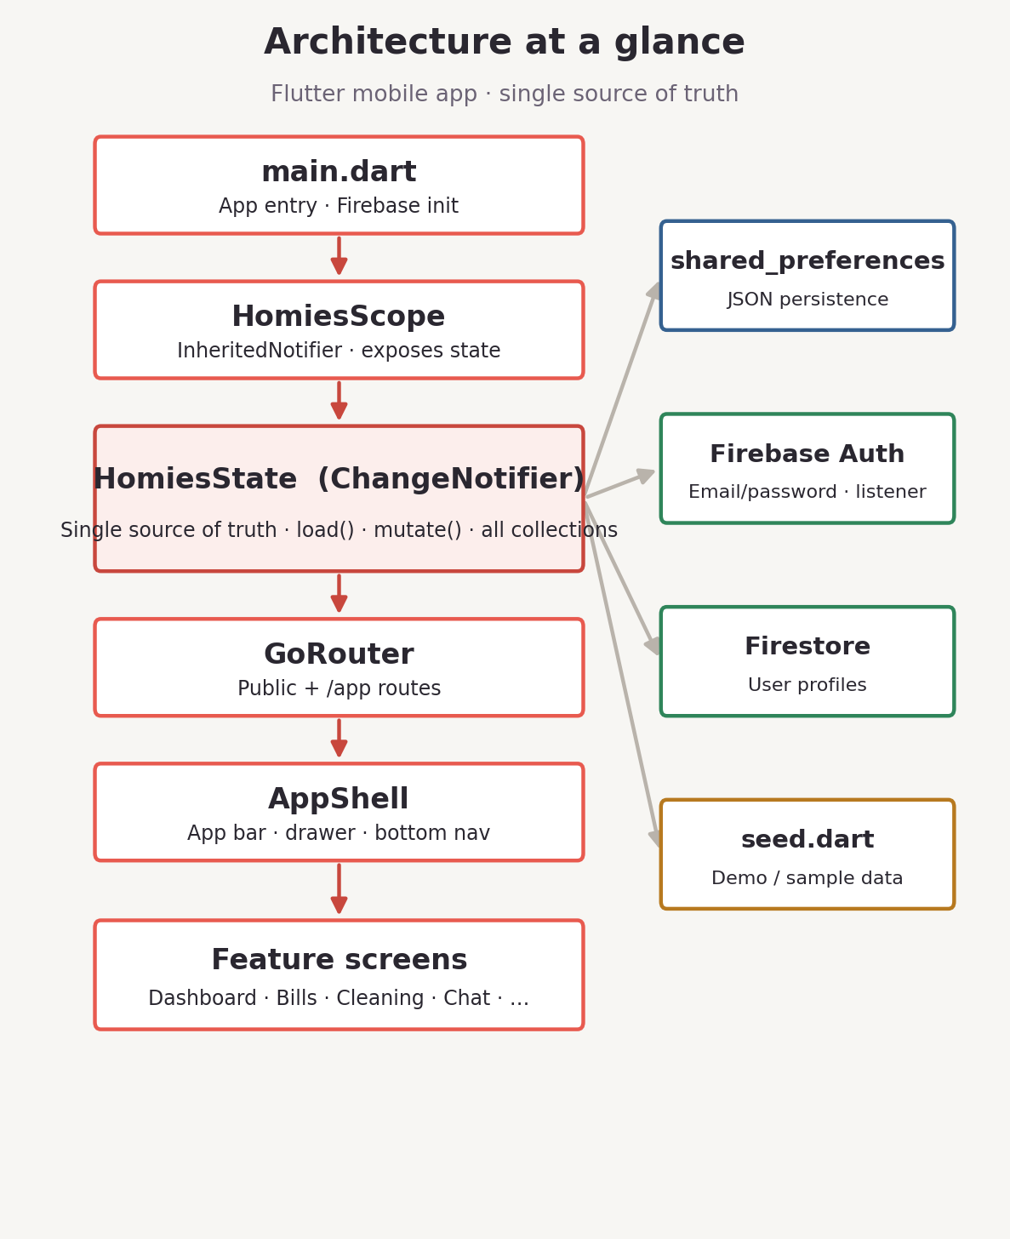
Key pieces
- HomiesState (ChangeNotifier) — the single source of truth for every collection plus the session.
- HomiesScope (InheritedNotifier) — screens read state via HomiesScope.of(context) and rebuild on change.
- Persistence — JSON in shared_preferences (key homies-mobile-v2); seed data is the fallback on a fresh install.
- Auth — Firebase email/password for real accounts; demo accounts bypass Firebase via signInAs().
- Routing — GoRouter; the authenticated app sits under /app wrapped by AppShell.

3. Feature map
The navigation is organised into Get started, Primary, Money, Living together, and Wrap up. Leaseholder-only screens are hidden from tenants.
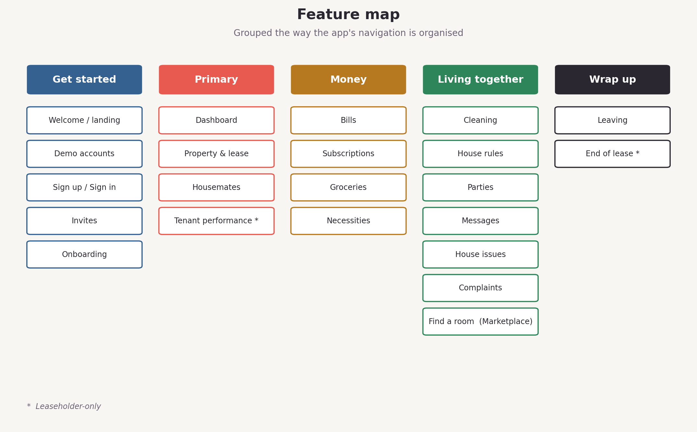

4. Features — screen by screen
ONBOARDING & ACCOUNTS
Welcome / landing — /
Marketing landing: gradient hero, feature grid, Marketplace highlight, and entry points to create an account, sign in, or explore a demo account.
Demo accounts — /demo
One-tap, credential-free sign-in as any pre-seeded housemate. No username or password needed.
Sign up / Sign in — /signup, /login
Email + password via Firebase; new users pick a role.
Invites — /invite/:code
Leaseholders invite housemates by email; invitees accept via a code.
Onboarding
Leaseholders configure property + lease; tenants submit ID/bond/advance proofs and accept house rules.
PRIMARY
Dashboard — /app
At-a-glance home: who's living here, what's owed, outstanding chores, recent activity.
Property & lease — /app/property
Address, type, beds/baths, features, agent, lease dates, rent, bond + advance weeks.
Housemates — /app/housemates
Everyone with role, contact, move-in date and verification status.
Tenant performance — /app/performance (leaseholder-only)
Per-tenant scorecard: chore rate, overdue/excused, bills paid vs owed, complaints, parties hosted, overall standing.
MONEY
Bills — /app/bills
One-off and recurring bills with category, amount, due date, equal/custom split, who-paid tracking, proof, and schedules.
Subscriptions — /app/subscriptions
Shared recurring services: amount, cadence, payer, participants, split.
Groceries — /app/groceries
Shared runs: total, payer, split, date, optional receipt.
Necessities — /app/necessities
Small shared items: item, payer, amount, date — shared or personal.
LIVING TOGETHER
Cleaning — /app/cleaning
Roster (day/area/assignee) + tasks with due dates, photo proof, or a logged excuse.
House rules — /app/rules
Shared rules with author + timestamp; accepted during onboarding.
Parties — /app/parties
Plan events with date, time, host, notes; housemates RSVP.
Messages — /app/messages
House group chat + DMs, with text posts and polls (single/multi, live tallies).
House issues — /app/issues
Maintenance log with category, description, optional photo, open/fixed status.
Complaints — /app/complaints
Formal complaints: against whom, reason, severity, open/resolved.
Find a room (Marketplace) — /app/listings
Two-sided marketplace: list a room or post what you're after, browse listings, and share only chosen details on a match.
WRAP UP (MOVING OUT)
Leaving — /app/leaving
Give notice: dates, reason, bond return, itemized deductions the tenant can agree to.
End of lease — /app/termination (leaseholder-only)
Plan termination: itemized expenses, split mode, notes.

5. Data model
Entities are plain classes with toJson / fromJson (state/models.dart). The web app mirrors the same shapes.
Core
Entity | Key fields
User | id, name, role (leaseholder|tenant), email, phone, moveIn/Out, bondPaid/Amount, advanceRentPaid, docVerified, acceptedRulesAt, pending, submissions
Property | address, type, beds, baths, features, agent, lease dates, rentAmount/cadence, bondWeeks, advanceWeeks, setupComplete
Session | userId, pendingSignup
Money
Entity | Key fields
Bill | title, category, amount, dueDate, issuedBy, split, shares, status, paidBy, scheduleId?, proof?
BillSchedule | cadence, customDays, cycleStart, nextDueDate, estimatedAmount, splitMethod, participants, active
Subscription | name, amount, cadence, payer, participants, split, shares
Grocery | title, total, payer, mode, split, shares, date, receipt?
Necessity | item, mode, payer, amount, date
Living together
Entity | Key fields
HouseRule | text, addedBy, addedAt
CleaningRosterEntry | day, area, assignee
CleaningTask | task, assignee, dueDate, done, photo?, excuse?, completedAt?
Party | title, date, time, host, notes, responses, status
Message / MessagePoll | from, text, at, type; poll: question, multi, closed, options, votes
Complaint | against, from, reason, severity, date, status
Issue | title, category, description, photo?, raisedBy, status, fixedAt/By
Marketplace & moving out
Entity | Key fields
Listing | type (tenant-wanted|room-wanted), by, title, suburb, rent|budget, availableFrom, description, status
ListingInterest | listingId, from, to, message, sharedFields, status (pending|accepted|declined)
Notice | userId, givenAt, leaveDate, reason, bondReturn, deductions[], deductionExplanation, tenantAgreed
TerminationPlan | expenses[], splitMode, customShares, notes

6. Getting started & demo accounts
Run the mobile app
cd homies_mobile
flutter pub get
flutter run
Explore instantly with demo accounts
- Launch the app → Welcome screen.
- Tap “Just looking? Explore with a demo account” (or open /demo).
- Pick any seeded housemate — leaseholder or tenant — to sign in with no username or password.
Seed / demo data
- 1 property — 12 Marrickville Road, Marrickville NSW 2204 (4-bed).
- 2 leaseholders — Maya Chen, Daniel Okafor.
- 3 tenants — Priya Sharma, Tom Becker, Aisha Rahman (onboarding).
- A handful of group-chat posts.
Note: persisted state overrides the seed; clear app storage or call HomiesState.reset() to restore it.
Run the web app
npm install
npm run dev

