ACADEMIC PERFORMANCE AND EQUITY
AMONG ENGINEERING STUDENTS
Case Study Report

Student: Kai Xing
Role: Analyst for the Department of Education
Data Source: Academic Performance Evolution for Engineering Students
Date of Submission: September 28, 2026

Executive Summary
This case study examines academic performance for 12,411 engineering students using linked records from the final year of high school and the final year of an engineering degree. The main outcome is the higher-education global assessment score (G_SC). The analysis focuses on parental education, socioeconomic stratum, gender, academic program, and selected resource indicators. The dataset was originally compiled from Colombian educational assessment records and is documented by De La Hoz (2020).
The strongest descriptive pattern is socioeconomic. Mean G_SC rises from 152.35 in Stratum 1 to 181.51 in Stratum 6, a gap of 29.16 points. A one-way analysis of variance indicates that stratum is associated with about 10.3 percent of observed variation in G_SC. Parental education also has a clear gradient. Students whose mothers have postgraduate education average 175.64, compared with 158.47 among students whose mothers completed secondary education. Maternal and paternal education are each associated with roughly 7.5 to 7.7 percent of G_SC variation in separate one-way comparisons.
Gender differences in the global score are much smaller. Male students average 163.69 and female students average 161.28, a 2.41-point difference. The standardized difference is small (Cohen's d = 0.105). Component scores show a more useful pattern: male students average higher on quantitative reasoning, while female students average higher on written communication. Other resource indicators show sizable gaps. Students with internet access average 164.92, compared with 154.62 among students without internet access. Students from private high schools average 168.22, compared with 156.53 for students from public high schools.
The preferred policy direction is a targeted equity and skill-specific support strategy. Resources should prioritize students from lower-resource backgrounds while academic support should respond to measured skill needs rather than broad demographic labels. Parental education should be used only as a group-level risk indicator. Program comparisons should be adjusted for prior achievement and student background before they are used to evaluate program quality.

Introduction
The Department of Education requested an analysis of engineering students' academic performance to identify meaningful differences across social and educational groups and to support recommendations for student programs. The data contain high-school assessment measures in mathematics, critical reading, citizenship competencies, biology, and English, together with higher-education assessment measures in quantitative reasoning, critical reading, citizenship competencies, written communication, English, engineering projects, and an overall global score. The file also contains demographic, family, socioeconomic, institutional, and program information (De La Hoz).
The central questions are whether parental education is related to outcomes, which socioeconomic strata perform best, how gender groups perform on the global assessment, and what policy recommendations follow from the observed patterns. This report treats G_SC as the primary outcome because it summarizes performance at the end of the professional engineering program. Descriptive statistics and group comparisons are supplemented by effect-size measures to distinguish statistically detectable differences from practically meaningful ones.
The report follows the supplied case study format. Summary findings appear in the body, while detailed descriptive statistics and selected Python code are included in the appendices. Because the data are observational, the analysis uses the language of association rather than causation.

Body

Key Issues, Goals, and Problems
The main policy problem is not simply whether groups have different average scores. The more important question is which differences are large enough, consistent enough, and actionable enough to guide education policy. A statistically significant gap can still be too small to justify a broad intervention, while a larger socioeconomic gradient may point to barriers that deserve more attention.
- Measure the size and direction of performance differences associated with parental education and socioeconomic stratum.
- Separate small global gender differences from larger differences in specific skill domains.
- Identify resource-related indicators, such as internet access and household revenue, that may help locate groups facing structural disadvantage.
- Avoid interpreting raw program averages as direct evidence of program quality when student composition differs across programs.

Decision Criteria
Recommendations are evaluated using five criteria. First, the size of the observed gap should be large enough to matter in practice. Second, the pattern should be consistent across ordered categories when an ordered relationship is expected. Third, the finding should be actionable through education policy or student support. Fourth, the recommendation should avoid labeling individuals on the basis of group averages. Fifth, the evidence should be interpreted within the limits of an observational dataset.

Assumptions
The analysis assumes that G_SC is the appropriate summary measure of higher-education academic performance and that the category labels in the source workbook are meaningful as documented. Records coded as 0 or “Not sure” are excluded from ordered parental-education and stratum comparisons where those values do not represent a usable educational or socioeconomic level. The analysis also assumes that individual rows represent distinct student records and that the source test scores are measured consistently across the sample. No claim is made that the observed group differences are causal.

Data Analysis

Overall Performance
The dataset contains 12,411 students. The mean global score is 162.71, the median is 163, and the standard deviation is 23.11. Scores range from 37 to 247. These values provide the benchmark for interpreting group differences.

Parental Education
Parental education is associated with student outcomes in a clear upward pattern. Students whose mothers have postgraduate education average 175.64 on G_SC. Students whose mothers completed secondary education average 158.47, and students whose mothers have incomplete primary education average 154.85. The postgraduate versus complete-secondary difference is 17.17 points. The corresponding paternal pattern is similar: students whose fathers have postgraduate education average 176.99 compared with 158.79 for complete secondary education, a difference of 18.20 points.
A one-way ANOVA across usable maternal-education categories produces an eta-squared of approximately 0.075, while the corresponding paternal-education value is approximately 0.077. In separate one-factor comparisons, parental education is therefore associated with roughly 7.5 to 7.7 percent of the observed variation in global scores. These figures indicate meaningful association, but they do not isolate parental education from household income, school type, prior achievement, or other correlated factors.
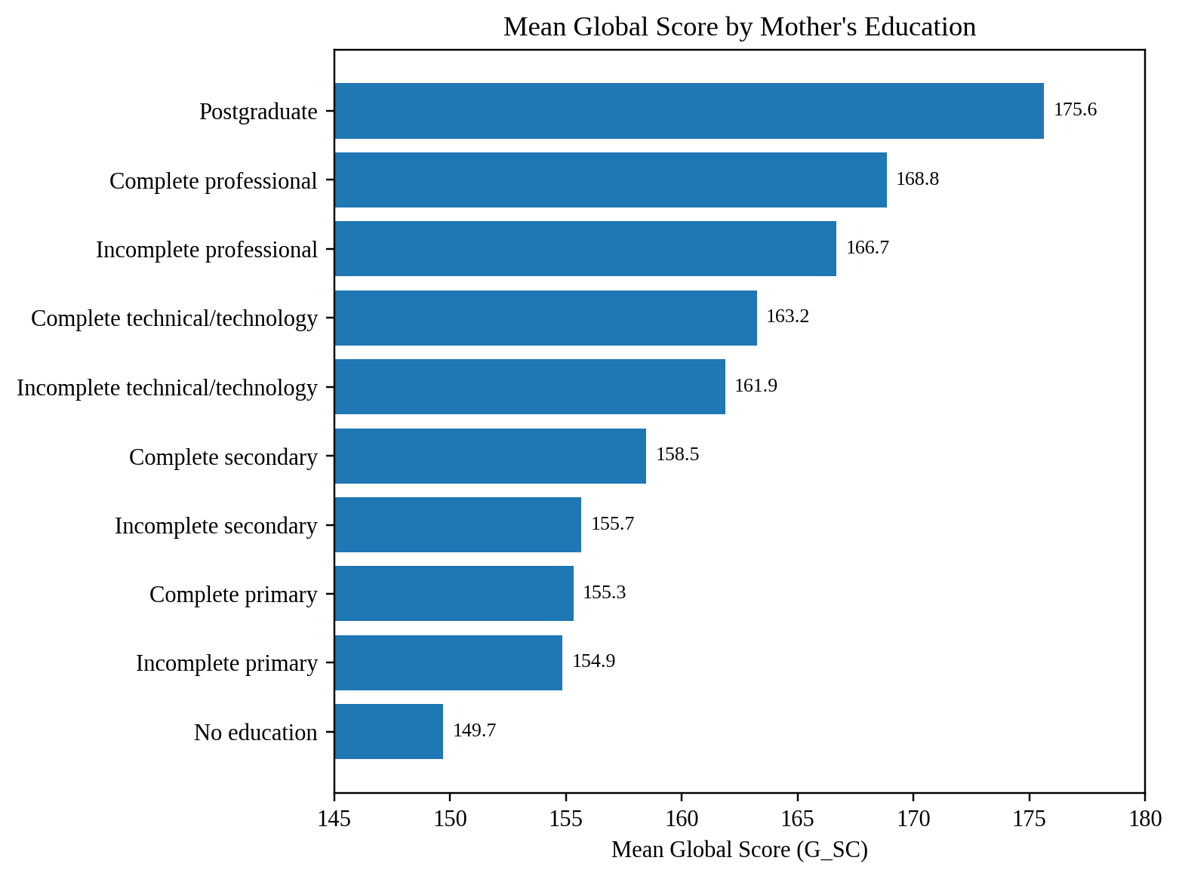
Figure 1. Mean global score by mother's education. Display labels are shortened for readability.
Source: Author's analysis of De La Hoz (2020) dataset.

Socioeconomic Stratum
Socioeconomic stratum shows the largest ordered group pattern among the required comparisons. Mean G_SC increases at every stratum level: 152.35 in Stratum 1, 158.20 in Stratum 2, 163.82 in Stratum 3, 172.00 in Stratum 4, 177.39 in Stratum 5, and 181.51 in Stratum 6. The difference between the highest and lowest strata is 29.16 points, which is more than one overall standard deviation of G_SC.
The one-way ANOVA is statistically significant (p < .001), with eta-squared approximately 0.103. Thus, stratum is associated with about 10.3 percent of the observed variation in global scores in this unadjusted comparison. Because the pattern rises steadily rather than being driven by one category, it supports the interpretation of a broad socioeconomic gradient.
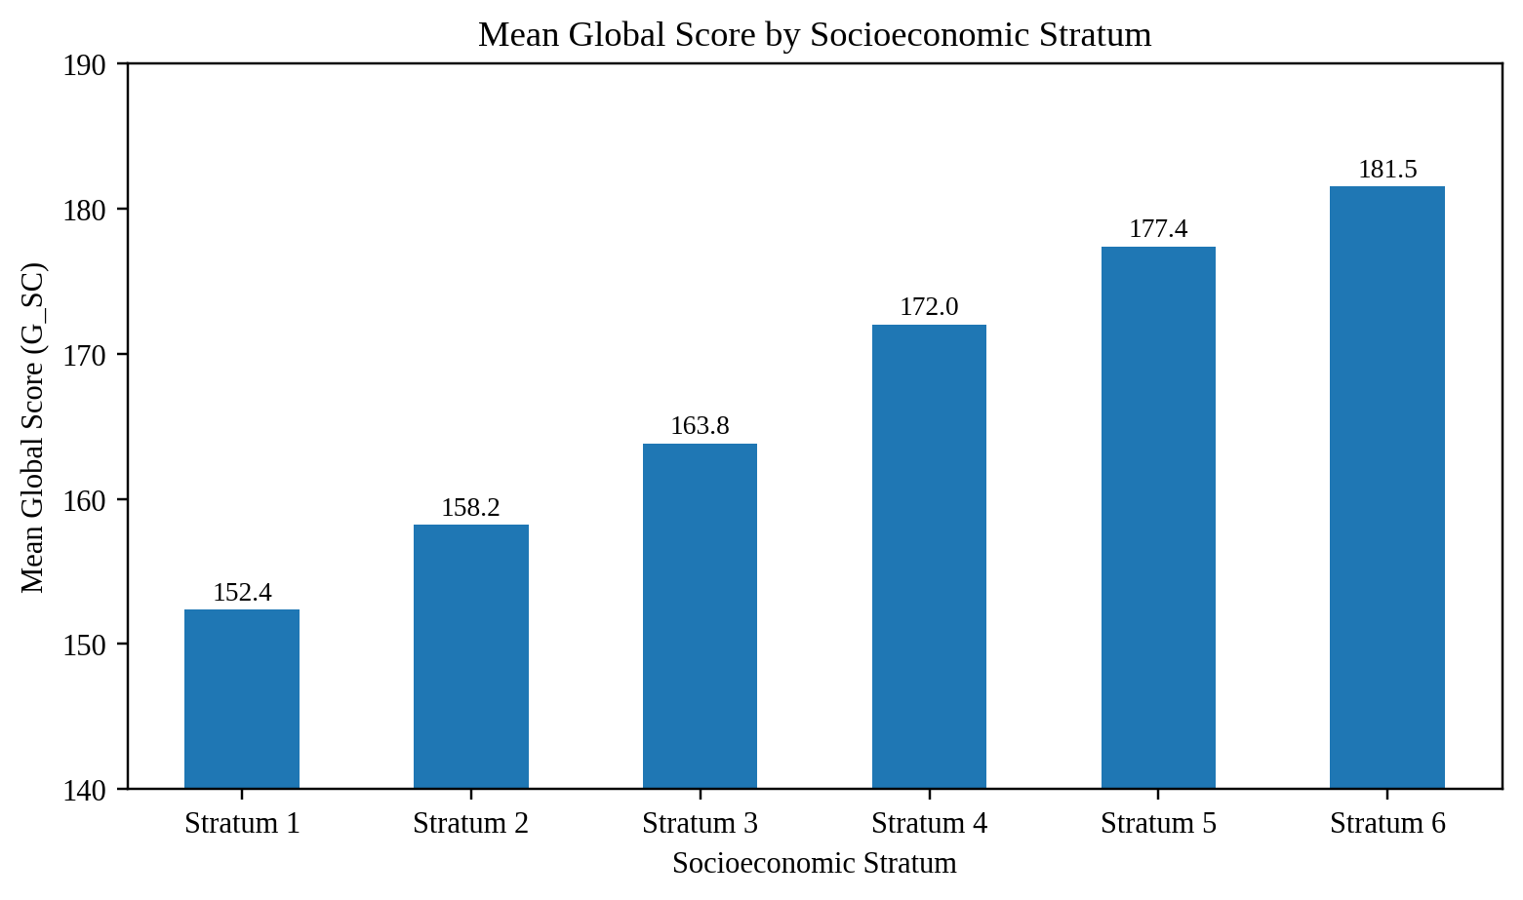
Figure 2. Mean global score by socioeconomic stratum.
Source: Author's analysis of De La Hoz (2020) dataset.

Gender
Male students average 163.69 on G_SC and female students average 161.28. The 2.41-point mean difference is statistically significant in a large sample (Welch t test, p < .001), but its standardized size is small (Cohen's d = 0.105). For policy purposes, the global gender gap is therefore less substantial than the socioeconomic differences described above.
The component scores show a more informative pattern. Male students average 81.20 in quantitative reasoning compared with 71.89 for female students. Female students average 56.62 in written communication compared with 51.71 for male students. Differences in critical reading, citizenship competencies, English, and engineering projects are smaller. This suggests that support should respond to specific skill areas rather than treat the global score as a complete description of gender differences.
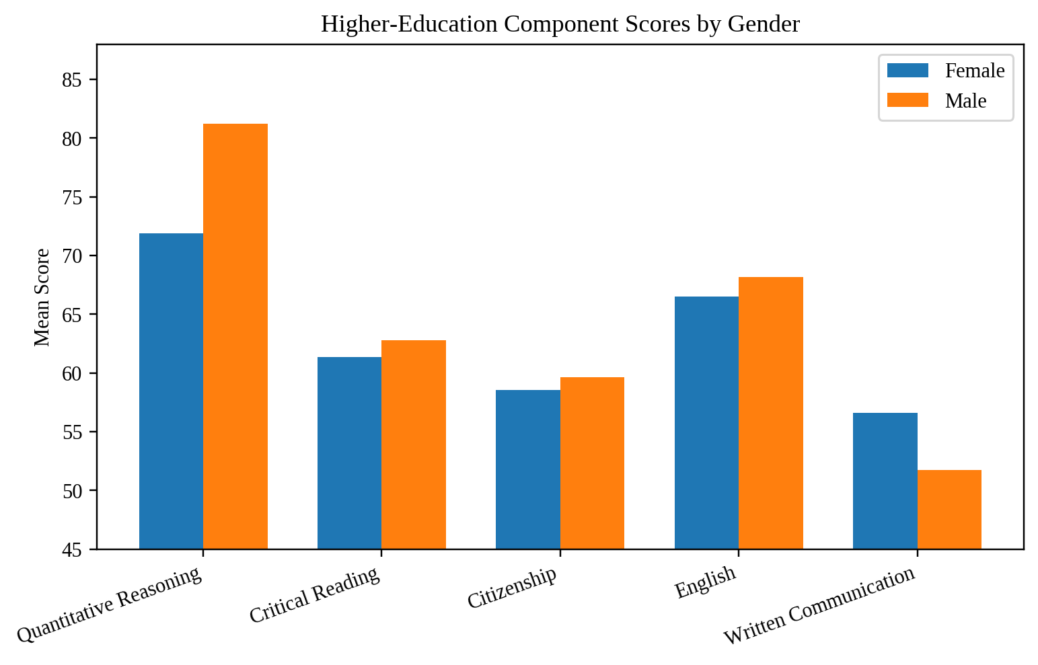
Figure 3. Higher-education component scores by gender. FEP_PRO and G_SC are omitted because they use different score scales.
Source: Author's analysis of De La Hoz (2020) dataset.

Other Socioeconomic and Program Patterns
Several additional indicators reinforce the socioeconomic interpretation. Students with internet access average 164.92 on G_SC, compared with 154.62 for students without internet access, a gap of 10.30 points. Students from private high schools average 168.22, compared with 156.53 among students from public high schools. Household revenue also shows a strong gradient, from 153.31 among students in households below one LMMW to 183.67 among students in households at 10 or more LMMW.
Raw program averages also differ. Among programs with at least 100 students, Chemical Engineering has the highest mean G_SC at 176.70, followed by Electric Engineering at 173.99. Electronic Engineering averages 166.87, Mechanical Engineering 166.05, Civil Engineering 161.11, and Industrial Engineering 159.04. These results should not be interpreted as direct measures of program quality because program entrants may differ in prior achievement, institution, socioeconomic background, and other characteristics.
Table 1. Selected group comparisons on global score (G_SC)
Group | N | Mean G_SC | Comparison
Overall sample | 12411 | 162.71 | Reference
Female | 5043 | 161.28 | Gender
Male | 7368 | 163.69 | Gender
Stratum 1 | 1709 | 152.35 | Stratum
Stratum 6 | 403 | 181.51 | Stratum
Internet: No | 2659 | 154.62 | Resources
Internet: Yes | 9752 | 164.92 | Resources
Public high school | 5846 | 156.53 | School type
Private high school | 6565 | 168.22 | School type
Source: Author's analysis of De La Hoz (2020) dataset.

Preferred Alternative with Rationale
The preferred alternative is a targeted equity and skill-specific support strategy rather than a uniform intervention for all students or a strategy based mainly on gender. This option best matches the evidence because the largest and most consistent gaps are associated with socioeconomic conditions, while the overall gender difference is small. Targeting does not mean excluding other students. It means using limited program resources first where the descriptive evidence indicates larger barriers, while preserving access to general academic services.
The strategy should combine three elements. First, institutions should prioritize academic advising, tutoring, digital access, and transition support for lower-resource students. Second, programs should use diagnostic skill information to direct support in quantitative reasoning, writing, and other areas where students show actual needs. Third, institutions should use parental education as a group-level indicator for mentoring and navigation support, not as a deterministic label for individual ability.

Justification, Predicted Outcome, and Recommendations
The economic rationale for targeted support is resource allocation. When program budgets are limited, concentrating intensive services on groups with larger observed gaps can direct staff time, tutoring capacity, and digital-access investments toward areas with greater potential need. The dataset does not provide intervention costs or causal treatment effects, so the report does not estimate a monetary return. Instead, the recommendation is to pilot targeted services and evaluate their outcomes before scaling.
- Prioritize lower-resource groups. Use stratum, household revenue, SISBEN status, internet access, and institutional socioeconomic indicators to identify populations that may benefit from additional support. Do not use any single variable as an automatic eligibility rule.
- Build early academic bridge support. High-school scores are strongly correlated with later G_SC in this dataset, with correlations of approximately 0.63 to 0.67 across the five S11 academic measures. Early preparation and first-year bridge services may address gaps before they compound.
- Use skill-specific diagnostics. The small overall gender gap hides larger differences in quantitative reasoning and written communication. Support should be based on measured skill needs rather than assumptions about gender.
- Expand mentoring and academic navigation. Lower parental education is associated with lower average scores. Mentoring can help students who may have less family experience with higher education navigate course selection, academic resources, and career planning.
- Evaluate programs with adjusted models. Before using raw program averages for accountability or resource decisions, estimate models that control for prior achievement, socioeconomic background, gender, institution, and parental education.
- Pilot and measure outcomes. Track participation, course performance, retention, and later assessment outcomes for students receiving targeted services. Compare changes over time and revise programs based on observed results.

Conclusion
The analysis shows that engineering students' academic outcomes are associated with social and educational background, but the size of the differences varies substantially across factors. Socioeconomic stratum has a strong ordered relationship with global performance, with a 29.16-point gap between Stratum 1 and Stratum 6 and an unadjusted eta-squared of about 0.103. Parental education also has a meaningful gradient, with postgraduate-parent groups scoring substantially above secondary-education groups. These patterns are reinforced by household revenue, internet access, SISBEN status, and school type.
The global gender difference is comparatively small, although specific skill areas show larger contrasts. This distinction matters for policy. Broad demographic averages can hide the skills that actually need support. A targeted equity and skill-specific strategy is therefore more consistent with the evidence than a uniform or gender-centered intervention. Future analysis should use multivariable models and program evaluation designs to separate correlated background factors and assess whether specific interventions improve outcomes.

References
De La Hoz, Enrique. “Data of Academic Performance Evolution for Engineering Students.” Mendeley Data, version 1, 2020, doi:10.17632/83tcx8psxv.1.

Appendices

Appendix A. Numerical Attribute Summary
Table A1 summarizes the main high-school and higher-education numerical assessment variables. All variables shown have 12,411 observations in the source dataset.
Variable | N | Mean | SD | Min | Median | Max
MAT_S11 | 12411 | 64.32 | 11.87 | 26.00 | 64.00 | 100.00
CR_S11 | 12411 | 60.78 | 10.03 | 24.00 | 61.00 | 100.00
CC_S11 | 12411 | 60.71 | 10.12 | 0.00 | 60.00 | 100.00
BIO_S11 | 12411 | 63.95 | 11.16 | 11.00 | 64.00 | 100.00
ENG_S11 | 12411 | 61.80 | 14.30 | 26.00 | 59.00 | 100.00
QR_PRO | 12411 | 77.42 | 22.67 | 1.00 | 85.00 | 100.00
CR_PRO | 12411 | 62.20 | 27.67 | 1.00 | 67.00 | 100.00
CC_PRO | 12411 | 59.19 | 28.99 | 1.00 | 65.00 | 100.00
ENG_PRO | 12411 | 67.50 | 25.50 | 1.00 | 74.00 | 100.00
WC_PRO | 12411 | 53.70 | 30.00 | 0.00 | 56.00 | 100.00
FEP_PRO | 12411 | 145.48 | 40.13 | 1.00 | 153.00 | 300.00
G_SC | 12411 | 162.71 | 23.11 | 37.00 | 163.00 | 247.00

Appendix B. Detailed Group Statistics
Table B1. Global score by socioeconomic stratum
Stratum | N | Mean | SD | Median
Stratum 1 | 1709 | 152.35 | 21.94 | 152.00
Stratum 2 | 4029 | 158.20 | 22.28 | 158.00
Stratum 3 | 4045 | 163.82 | 21.69 | 164.00
Stratum 4 | 1578 | 172.00 | 21.47 | 174.00
Stratum 5 | 633 | 177.39 | 21.54 | 179.00
Stratum 6 | 403 | 181.51 | 21.88 | 184.00
Table B2. Global score by mother's education
Mother's education | N | Mean | SD
No education (Ninguno) | 34 | 149.71 | 27.93
Incomplete primary | 541 | 154.85 | 21.64
Complete primary | 713 | 155.34 | 22.01
Incomplete secondary | 1056 | 155.67 | 21.93
Complete secondary | 3106 | 158.47 | 21.95
Incomplete technical/technology | 341 | 161.88 | 20.74
Complete technical/technology | 1495 | 163.24 | 21.94
Incomplete professional | 502 | 166.69 | 22.93
Complete professional | 3059 | 168.85 | 22.98
Postgraduate | 997 | 175.64 | 22.12
Table B3. Global score by father's education
Father's education | N | Mean | SD
No education (Ninguno) | 123 | 156.63 | 23.19
Incomplete primary | 735 | 155.73 | 20.94
Complete primary | 824 | 155.20 | 22.41
Incomplete secondary | 1091 | 156.54 | 21.74
Complete secondary | 2843 | 158.79 | 22.11
Incomplete technical/technology | 277 | 162.10 | 21.88
Complete technical/technology | 1194 | 164.03 | 22.17
Incomplete professional | 425 | 166.92 | 22.69
Complete professional | 3016 | 167.77 | 23.03
Postgraduate | 1085 | 176.99 | 21.73
Table B4. Higher-education component means by gender
Assessment | Female Mean | Male Mean
Quantitative Reasoning | 71.89 | 81.20
Critical Reading | 61.34 | 62.79
Citizenship Competencies | 58.57 | 59.61
English | 66.53 | 68.16
Written Communication | 56.62 | 51.71
Engineering Projects | 145.30 | 145.60
Global Score | 161.28 | 163.69
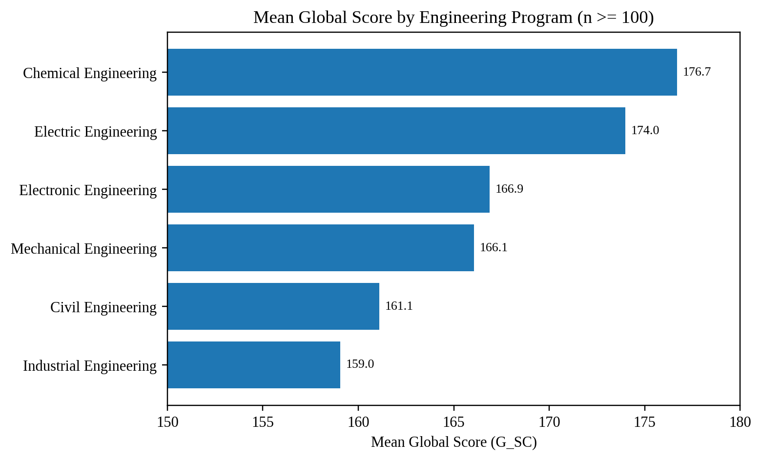
Figure B1. Mean global score by engineering program for programs with at least 100 students.
Source: Author's analysis of De La Hoz (2020) dataset.
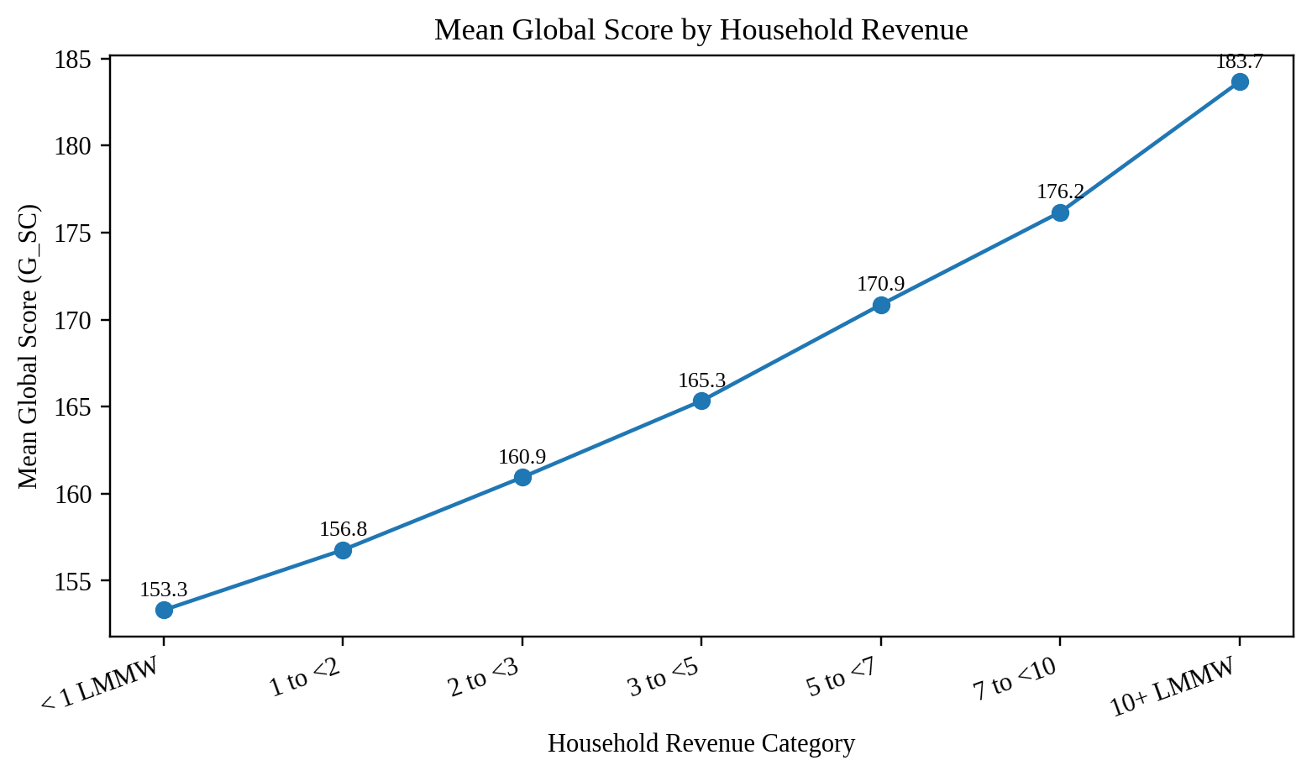
Figure B2. Mean global score by household revenue category.
Source: Author's analysis of De La Hoz (2020) dataset.

Appendix C. Selected Python Analysis Code
The full analysis was completed in Google Colab/Python. The following excerpts show the main workflow used for the required comparisons.
import pandas as pd
import numpy as np
from scipy import stats
df = pd.read_excel(
'data_academic_performance.xlsx',
sheet_name='SABER11_SABERPRO'
)
# Global score by socioeconomic stratum
stratum = df[df['STRATUM'] != 0]
stratum_summary = (
stratum.groupby('STRATUM')['G_SC']
.agg(['count', 'mean', 'std', 'median'])
)
# Global score by gender and Welch t test
gender_summary = df.groupby('GENDER')['G_SC'].agg(
['count', 'mean', 'std', 'median']
)
male = df.loc[df['GENDER'] == 'M', 'G_SC']
female = df.loc[df['GENDER'] == 'F', 'G_SC']
stats.ttest_ind(male, female, equal_var=False)
# Parental education
mother = df[~df['EDU_MOTHER'].isin([0, 'Not sure'])]
mother.groupby('EDU_MOTHER')['G_SC'].agg(
['count', 'mean', 'std']
).sort_values('mean')

