

**TUNKU ABDUL RAHMAN UNIVERSITY COLLEGE**

FACULTY OF COMPUTING AND INFORMATION TECHNOLOGY

BAIT2133 WEB ENGINEERING

PRACTICAL 10

1. Draft a pattern for web enquiry page. You are required to include the following fields :

* *Pattern name.*

*Enquiry form*

* *Intent.*

*To gather informational of user*

* *Also-known-as.*

*Contact form*

* *Motivation.*

Motivation, the template method defines an algorithm in a base class using abstract operations that subclasses override to provide concrete behavior?

* *Applicability*

Applicability is to implement the invariant parts of an algorithm once and leave it up to subclasses to implement the behavior that can vary. when refactoring is performed and common behavior is identified among classes. A abstract base class containing all the common code (in the template method) should be created to avoid code duplication.

* *Structure.*

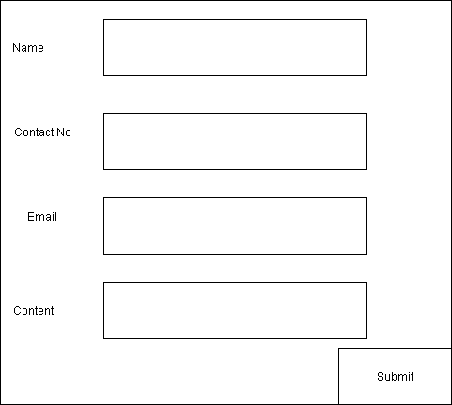

* *Participants.*

*User, visitor, newcomer*

* *Collaborations.*

Collaborations- By clicking enquiry form user can enquiry what they want to know, and also the web page company can know what customer requirement by giving enquiry form to user fill up

* *Consequences.*

*Web page company can gather informational of what user want to advice.*%3CmxGraphModel%3E%3Croot%3E%3CmxCell%20id%3D%220%22%2F%3E%3CmxCell%20id%3D%221%22%20parent%3D%220%22%2F%3E%3CmxCell%20id%3D%222%22%20value%3D%22Email%22%20style%3D%22text%3Bhtml%3D1%3BstrokeColor%3Dnone%3BfillColor%3Dnone%3Balign%3Dcenter%3BverticalAlign%3Dmiddle%3BwhiteSpace%3Dwrap%3Brounded%3D0%3B%22%20vertex%3D%221%22%20parent%3D%221%22%3E%3CmxGeometry%20x%3D%22110%22%20y%3D%22270%22%20width%3D%2270%22%20height%3D%2220%22%20as%3D%22geometry%22%2F%3E%3C%2FmxCell%3E%3C%2Froot%3E%3C%2FmxGraphModel%3E

* *Related patterns*

related patterns- Live Support Chatbot, the chatbot will show some message when user click the web page to assist user question.

related patterns- HOW CAN WE HELP? below have something to click such as I Need Help then will show the contact number to user.