

**TUNKU ABDUL RAHMAN UNIVERSITY COLLEGE**

FACULTY OF COMPUTING AND INFORMATION TECHNOLOGY

BAIT2133 WEB ENGINEERING

PRACTICAL 3

Read the case study:

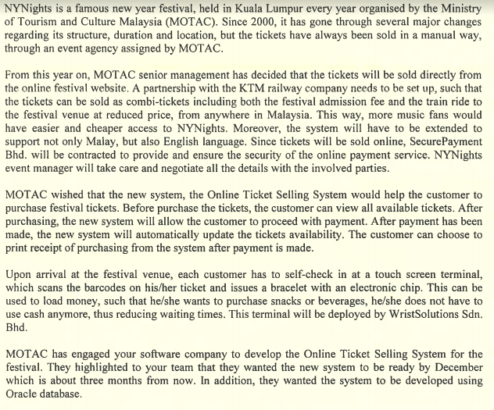

1. Draw the use case diagram for MOTAC system.

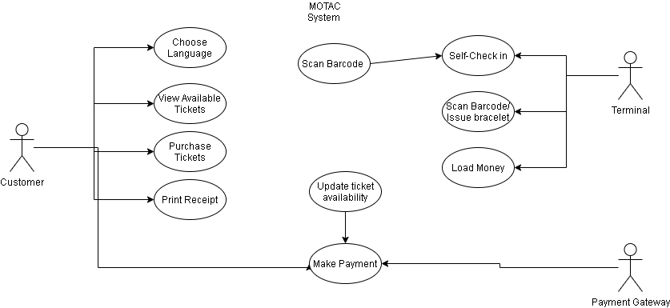

1. Provide description for the use cases.

|  |  |
| --- | --- |
| 1. Use case name: Purchase festival ticket 2. Brief Description: Step of customer purchase the festival ticket 3. Actor: customer 4. Pre-condition: They have use the system 5. Main flow: | |
| Actor Action | System Response |
| Enter Online Ticket Selling System | • Show the interface for selecting language (Malay or English) |
| • Choose language | 3.   Show the interface for ticketing system |
| 4. View all available tickets | • Show all available tickets. |
| • Choose the ticket and enter the amount | • Calculate the final price and proceed to payment |
| • Purchase the ticket |  |
|  | 9.Update the tickets availability |
| • Print Receipt | 10.Generate receipt |

|  |  |
| --- | --- |
| 1.Use case name: Self-check In  2.Brief Description:load money  3.Actor: customer  4.Pre-condition: they want to load money  5.Main flow: | |
| Actor Action | System Response |
| 1.Scan the barcode/ issues a bracelet | • Verify the barcode |
|  | 3.show  success self-check |
| 4.Enter the amount to load money | 5.Comfimation the amount |
|  | 6.confirmation of load money |
|  | 7.print the receipt |
| 8.Check amount | 9. Display the amount successful message |

Firstly, customer can choose language for system which have English and Malay. Secondly, the customer can view all available tickets before purchase the tickers. After purchase will proceed with payment. Lastly customer can choose to print receipt. Besides that, Customer and Motac will link to scan a barcodes or issues a bracelet. After that this can used to load money

1. Identify the functional requirements from the scenario.

Select Language, view available tickets, purchase the tickets, proceed with payment, print receipt, scans the barcodes or issues a bracelet.

1. Identify the possible non-functional requirements.

Security of the online payment service, Load money.