

**TUNKU ABDUL RAHMAN UNIVERSITY COLLEGE**

FACULTY OF COMPUTING AND INFORMATION TECHNOLOGY

BAIT2133 WEB ENGINEERING

PRACTICAL 4

**Assignment progress:**

1. Draw Use Case diagram for your system.

You may use any tool that you are comfortable with to draw use case diagram.

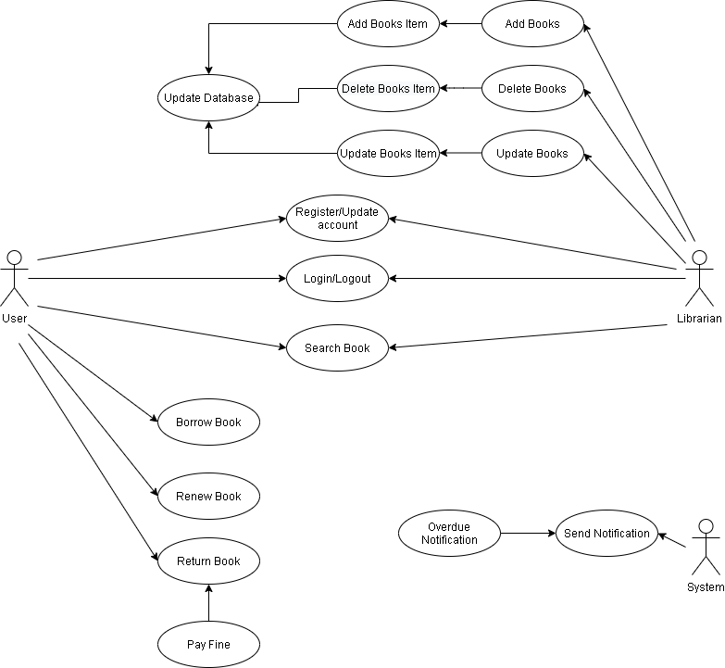

1. Describe every steps / process in your use case.

|  |  |  |
| --- | --- | --- |
| Use Case Name: Return Book | | |
| Use Case Description: User want to return book | | |
| Actors: User | | |
| Pre-Condition: The Actor must login to user account | | |
| Post-Condition: A notification will send to user after return books | | |
| Main Scenarios | Serial No | Steps |
| Actors/ User | 1 | Select return book button on menu |
|  | 2 | Actor select a book in the return list |
|  | 3 | Check return date of the book |
|  | 4 | The status of the book will update to available |
| Extensions | 3a | The book is not returned on time  System send a fine slip to user |
|  | 3b | User account cannot use the function of library management system after user pay fine  System will send a notification to user |

Describe in-detail the steps used in your use case.

1. Firstly, User and Librarian can register for using Library Management System.
2. After register the library account, user and librarian can login to their account to use library management system. Librarian and user have different roles and function.
3. After librarian login their account, Add books, Delete Books, and Update Books are available for librarian account.
4. After select Add books, Delete Books, and Update Books, librarian can fill the item they selected. Finally Add books, Delete Books, and Update Books items will update to library database.
5. User and librarian can use search function to search books.
6. After user login to their account, Borrow book, Renew book, Return book function are available for user account.
7. User after borrow a book must return before due date, if return due date user will pay fines. User also can renew a book, and it will get a new due date.
8. System will send notification to all user if no return books in due date.
9. List the requirements (both functional and no-functional).

Funtional Requirement:-

1. Add Books

-System must able to save new book in database.

-System must able to not allow two books having same book id.

1. Update Books

-System must able to update any changes in book.

1. Delete Books

-System must able to delete any book in database.

1. Register New Account

-System must able to register new account.

-Every account must have an unique ID.

1. Login/Logout

-User and librarian must login before accessing system.

-System must allow only user with valid id and password to access the system.

-System must able to recognize to decide which user level can access to.

-User and librarian must logout after using system.

1. Search Book

-All user level can search any books.

-System must able to filter books based on keyword entered.

1. Update Account

-All user must able to update their account information.

-Any changes must able to save in database.

1. Borrow Book

-System must allow user to borrow any book.

-System must able to verify books status before user borrow the book.

-System must able to generate due date of book to user.

1. Renew Book

-System must allow user to renew existing book the user have.

-System must able to generate a new due date of book to user.

1. Return Book

-System must allow user to return any book.

-System must able to send notification to user to remind them about due date of books.

-System must able to change status of book after user return the book.

-System must able to send notification of pay fine to user if no return within due date.

NonFuntional Requirement:-

1.Safety Requirements

-The database must have a backup to in case information safety if get crashed at any certain time due to virus or operating system failure.

2.Performance Requirements

-The system must very fast and accurate while user and librarian search book and making book transaction.

- The system must handle large amount of data.

3.Usability Requirements

-The system design must ease of use to all user so that they can perform various tasks effectively.

4.Security Requirements

-Different user level have different access right.

-Only librarian administrator can access to database to perform various tasks.

-Only librarian administrator can view and manage user account.

-Security authentication will use in user login.