

**TUNKU ABDUL RAHMAN UNIVERSITY COLLEGE**

FACULTY OF COMPUTING AND INFORMATION TECHNOLOGY

BAIT2133 WEB ENGINEERING

PRACTICAL 6

Assignment Progress:

1. Review the content model and interaction model.

A content model describes all content types, its association with one another (relationship) with a product/a service/a brand. It helps to define the relationship between content types. Content model can:

* enable content reuse
* allows efficient content management.
* Allows creation, management of content on accepted authoring standards like DITA, Dublin Core
* Makes content responsive, adaptive and flexible
* Enables translation and multi-channel delivery

The interaction model is a design model that binds an application together in a way that supports the conceptual models of its target users. It is the glue that holds an application together. It defines how all of the objects and actions that are part of an application interrelate, in ways that mirror and support real-life user interactions. It ensures that users always stay oriented and understand how to move from place to place to find information or perform tasks. This can help us to:

* Clear Discovery
* The Overlap with User Experience (UX) Design
* Save Money and Time
* Influence Emotional Responses

1. Perform interaction design.

Interactive design is to promote interaction between users and products. In the library management system, 5 aspects of interactive design fit together become web application interface.

* Word – In the library management system, we will use the simpler and easier to understand word to convey information to users. Reducing the words in the app is reducing user boredom and use can easier to use.
* Visual representations - Some illustrations and images will be used to decorate the application to make the library management system more interesting. We also will use some icon and word to make a functions button to improve user experience.
* Physical objects or space – User can use computer to access the library management system.
* Time - library management system will record the status user using when user logout. when user login again, if will open the last pages user open.
* Behavior - In order to reduce the workload of staff, we’ll make library management system more automated. library management system already improves auto record and the searching bar.

1. Identify the goals of design.

Design a system is to meet the user needs and provide a user-friendly experience. Goals of design is to make sure the system are:

* Visibility of system status - The design should always keep users informed about what is going on, through appropriate feedback within a reasonable amount of time.
* Match between system and the real world - The design should speak the users' language. Use words, phrases, and concepts familiar to the user, rather than internal jargon. Follow real-world conventions, making information appear in a natural and logical order.
* User control and freedom - Users often perform actions by mistake. They need a clearly marked "emergency exit" to leave the unwanted action without having to go through an extended process.
* Consistency and standards - Users should not have to wonder whether different words, situations, or actions mean the same thing. Follow platform and industry conventions.
* Error prevention - Good error messages are important, but the best designs carefully prevent problems from occurring in the first place.
* Recognition rather than recall - Minimize the user's memory load by making elements, actions, and options visible.
* Flexibility and efficiency of use - Allow users to tailor frequent actions.
* Aesthetic and minimalist design - Interfaces should not contain information which is irrelevant or rarely needed. Every extra unit of information in an interface competes with the relevant units of information and diminishes their relative visibility.
* Help users recognize, diagnose, and recover from errors - Error messages should be expressed in plain language, precisely indicate the problem, and constructively suggest a solution.
* Help and documentation - Help and documentation content should be easy to search and focused on the user's task. Keep it concise, and list concrete steps that need to be carried out.

1. Identify how each controls do (link, button, menu reacts).

In order to improve the user experience, we make sure each control in library system was:

* Specific - A link’s primary purpose is to communicate to users what they’ll find on the other side of a click. Vague or repetitive language fails that purpose.
* Sincere - A controls is a promise. To function properly, it must set expectations that are not only specific, but also accurate.
* Succinct - When composing links, don’t waste words. Get to the point as quickly as possible, to increase the likelihood that users will quickly understand the link as they scan and process the page.
* Consistency - being consistent not only helps a beautiful design, but also provides users with a more familiar experience.
* Label buttons with what they do for users - Label buttons with what they do for users and label buttons with what they do for users.

1. Draft the TEN (10) web page interface. You may use any software to design the interfaces.

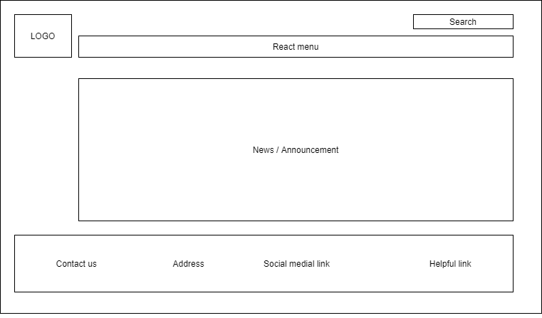

Home Page

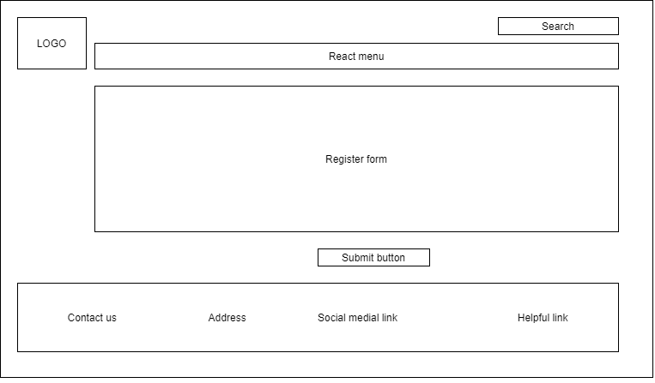

Register Page

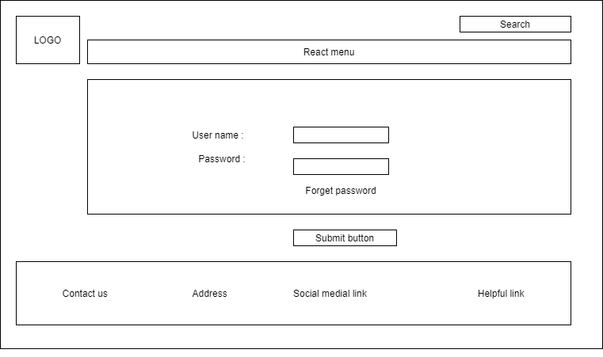

Login Page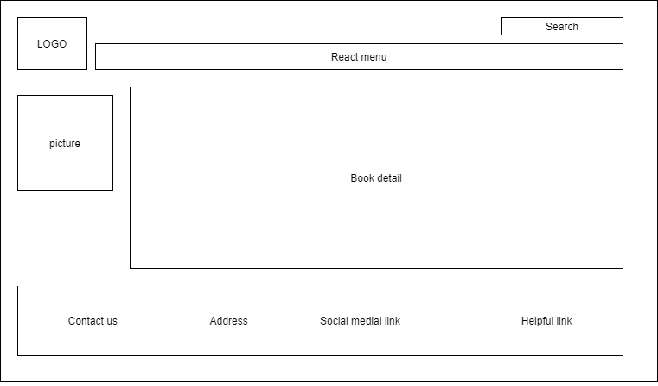

Add Book Page

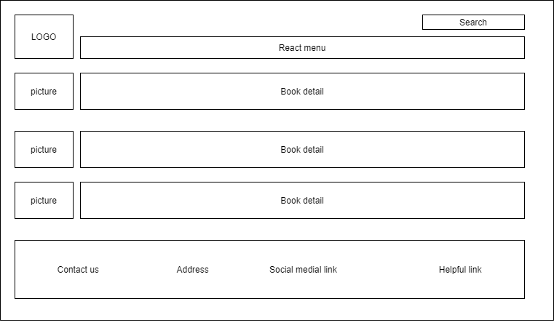

Book detail Page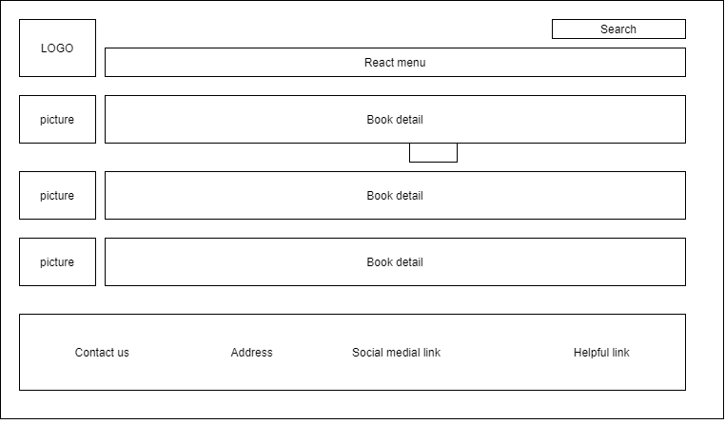

Search Result Page

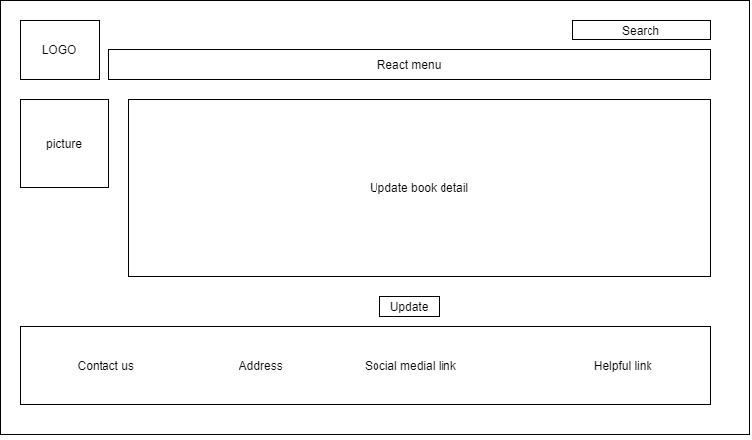

Delete book Page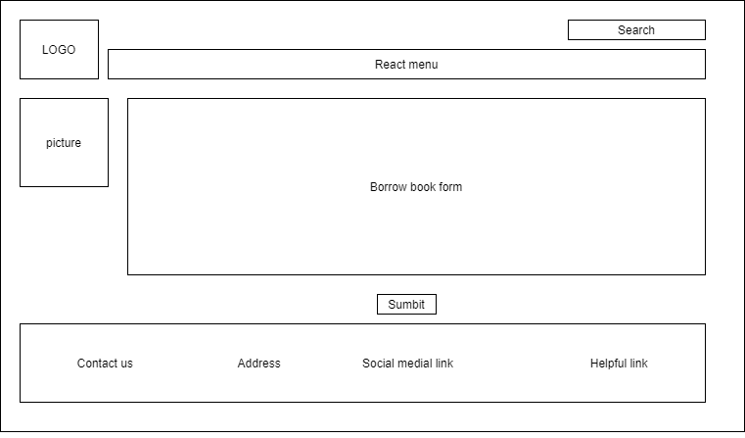

Update Book Page

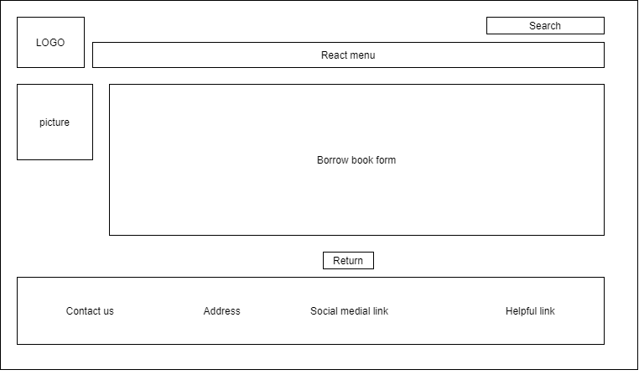

Borrow Book Page

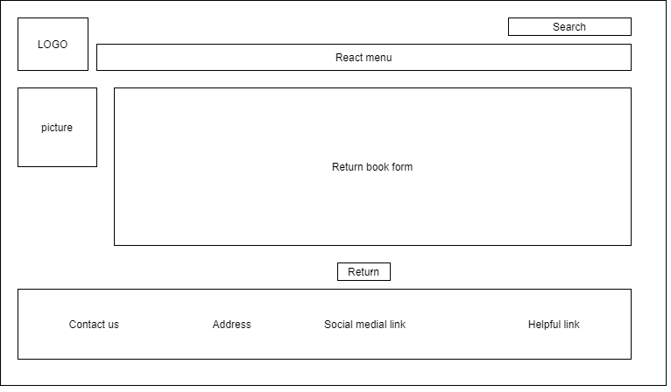

Return Book Page