

**TUNKU ABDUL RAHMAN UNIVERSITY COLLEGE**

FACULTY OF COMPUTING AND INFORMATION TECHNOLOGY

BAIT2133 WEB ENGINEERING

PRACTICAL 7

Please access the link <http://uwe.pst.ifi.lmu.de/teachingTutorial.html> for UWE (UML Based Web Engineering).

**State Diagram Exercise (Content Structure Model)**

1. A firmware update wizard can be in three states as follows:

a. Displaying the firmware update window when updates is available.

b. Searching will proceed to find for sources of update.

c. Display new source found. The wizard displaying update progress window.

d. While displaying the update progress window, the user can press a "Install" button to cause the installation of for new update, or the user can press a "Cancel" button to leave the wizard. If the user press Cancel button, the wizard will displays the firmware update window again. If the user press Cancel in this windows, the wizard will be terminated. When the wizard has completed installing new updates, it displays update completed. Draw a state machine diagram that represents the function of the firmware update wizard.

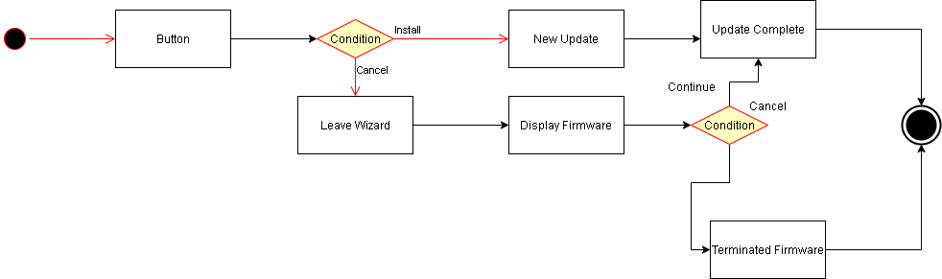

2. A motion speed sensor has two buttons START and STOP. Pressing button START will starts measuring the speed on an object’s motion and displaying the speed. Pressing START button once more will halt the measurement process and the measurement continue when user press START again. Pressing STOP button will stop the measurement process but pressing STOP in the initial state of the speed sensor has no effect. Pressing STOP button once more will reset the motion sensor to its idle state. Draw a state diagram for the scenario.

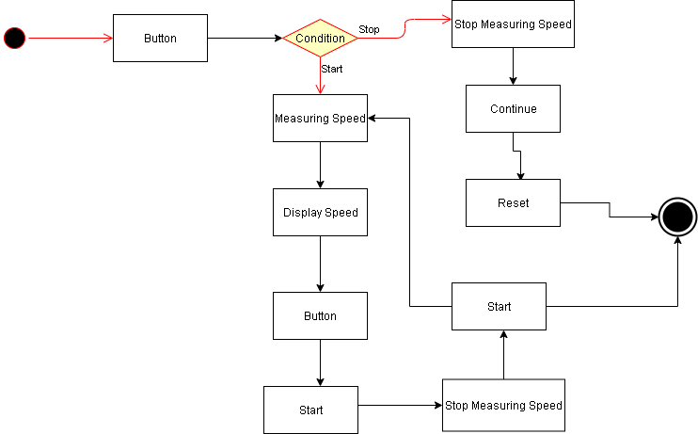

**Hypertext Model Exercise**

1. A simple e-commerce system is developed for a small souvenir shop. Form a group of three members to draft the Hypertext Structure Model for the Item Catalogue and Item. This part allows users to perform CRUD and search items. The Content Model for this part is shown in the following:

Catalogue

Item

p7 (6)

1. From the Hypertext Structure Model derived from 1, draft the Hypertext Access Model.

