

**TUNKU ABDUL RAHMAN UNIVERSITY COLLEGE**

FACULTY OF COMPUTING AND INFORMATION TECHNOLOGY

BAIT2133 WEB ENGINEERING

PRACTICAL 9

1. Design the Presentation Model for the Homepage of a Car Trading Company. You are required to use the UWE for the design. You may refer to the given link <http://uwe.pst.ifi.lmu.de/teachingTutorialPresentation.html> for examples.

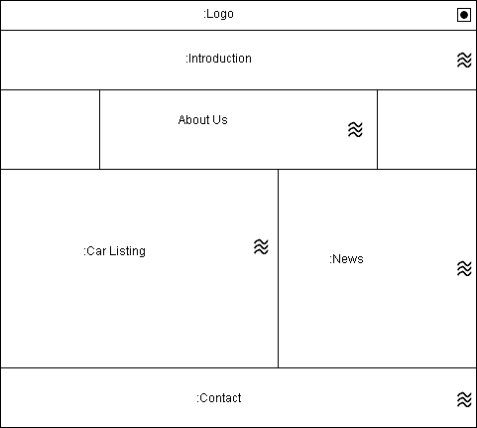

1. Deign the presentation model for your assignment.

