

**TUNKU ABDUL RAHMAN UNIVERSITY COLLEGE**

FACULTY OF COMPUTING AND INFORMATION TECHNOLOGY

BAIT2133 WEB ENGINEERING

TUTORIAL 5

**Answer all the questions:**

1. Explain in details on Relational Navigation Analysis.

Relationship-navigation analysis (RNA) provides a series of analysis steps that strive to identify relationships among the elements uncovered as part of the creation of the analysis model

1. Discuss Interaction Model, Information Model, Functional Model and Configuration Model.

Interaction Model-the function of input required by the learner while responding to the computer, the analysis of those responses by the computer, and the nature of the action by the computer.

Information Model-An information model in software engineering is a representation of concepts and the relationships, constraints, rules, and operations to specify data semantics for a chosen domain of discourse. Typically it specifies relations between kinds of things, but may also include relations with individual things.

Functional Model-In systems engineering, software engineering, and computer science, a function model or functional model is a structured representation of the functions (activities, actions, processes, operations) within the modeled system or subject area.

Configuration model-In network science, the configuration model is a method for generating random networks from given degree sequence. It is widely used as a reference model for real-life social networks, because it allows the user to incorporate arbitrary degree distributions.

1. Identify and explain the items in content model.

Content connects the business with its customers. It is the message that gets delivered as part of those right-time experiences at every touchpoint in the customer journey. A content model documents all content types associated with a brand, and defines the relationship between those content types. With a content model, strategists can visualize the purpose of each piece of content enabling the organization of a website’s content ecosystem.

1. Describe Activity Diagram, Sequence Diagram.

Illustrates the processing flow and logical decisions within the flow.The construction details indicate how these operations are invoked, and the interface details for each operation are not considered until webapp design commences.

Activity diagram describe how activities are coordinated and logical decisions flow. Usually an activity need to achieved by some operations. Activity diagram construction details in a number of different things coordination together. For example a process details about registration Co-Curricular Course Registration, first student must filled out the form, select the course they want to choose, confirmation of selecting the course, student pay for the fee, Lastly the student name will store in database

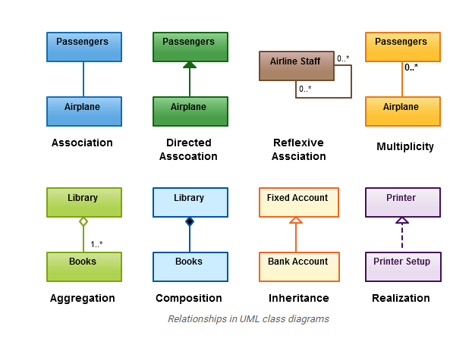

1. Perform a finding on the types of relationship for class diagram from <https://creately.com/blog/diagrams/class-diagram-relationships/>

Association is a broad term that encompasses just about any logical connection or relationship between classes.

Directed Association refers to a directional relationship represented by a line with an arrowhead. The arrowhead depicts a container-contained directional flow.

Reflexive Association. This occurs when a class may have multiple functions or responsibilities. For example, a staff member working in an airport may be a pilot, aviation engineer, a ticket dispatcher, a guard, or a maintenance crew member. If the maintenance crew member is managed by the aviation engineer there could be a managed by relationship in two instances of the same class.

Multiplicity is the active logical association when the cardinality of a class in relation to another is being depicted. For example, one fleet may include multiple airplanes, while one commercial airplane may contain zero to many passengers. The notation 0..* in the diagram means “zero to many”.

Aggregation. refers to the formation of a particular class as a result of one class being aggregated or built as a collection.

Composition. The composition relationship is very similar to the aggregation relationship. with the only difference being its key purpose of emphasizing the dependence of the contained class to the life cycle of the container class

Inheritance / Generalization refers to a type of relationship wherein one associated class is a child of another by virtue of assuming the same functionalities of the parent class.

Realization denotes the implementation of the functionality defined in one class by another class.