

**TUNKU ABDUL RAHMAN UNIVERSITY COLLEGE**

FACULTY OF COMPUTING AND INFORMATION TECHNOLOGY

BAIT2133 WEB ENGINEERING

TUTORIAL 7

**Answer all the questions:**

1. Discuss **FIVE (5)** principles of interaction design for an online banking system.

Consistency We are wired to be sensitive to change. Changes to a layout attract our attention. As long as persistent elements remain in the same place, retain the same appearance, and adhere to the same grid layout and proportions, we do not direct attention toward them until we need them. But when elements move and change appearance without purpose across pages or screens, it becomes immediately noticeable.

Perceivability invites interaction. Hidden interactions decrease usability and efficiency. People should not need to search for opportunities to interact. They should not guess when interacting, due to confusion or desperation. We should be able to review an interface, and identify where we can interact. Interaction should not depend on luck or random discovery.

Learnability Interactions should be easy to learn, and easy to remember. Ideally, people should be able use an interface once, learn it, and remember it forever. Practically, people often need to use an interface at least a few times before they learn it, and then we hope that they will remember what they have learned.

Predictability Good interaction design should set accurate expectations about what will happen before the interaction has occurred. We should be able to show people an interface and ask, before they interact, what can you do here? Where can you interact with this? What will happen if you do that? What will be the result, or outcome?

Feedback Feedback provides acknowledgment of our interactions and information about their outcomes. We use feedback to understand where we are, our current condition or status, what we can do next, and even to know when we are finished.

1. Discuss the guidelines in interface design.

-visually apparent and forgiving, instilling in their users a sense of

control. Users quickly see the breadth of their options, grasp how to

achieve their goals, and do their work.

-do not concern the user with the inner workings of the system. Work is

carefully and continuously saved, with full option for the user to undo

any activity at any time.

- Effective applications and services perform a maximum of work, while

requiring a minimum of information from users.

1. Explain why response time, error handling is important in web application design.

error handling is an important part of the application design process. For that reason we should analyze different aspects of our project and choose wisely between various approaches. The more precisely we do it, the easier it will be to achieve a satisfying communication level between frontend and backend, subsequently leading to a greater application user experience.

1. Identify any **THREE** *(3)* items encompassed in design model.

-poor response time, especially if done repeatedly, it will result in loss of customer and revenue. They key to generating loyal customers is to provide them with efficient service by the required time frame. Error handling -It helps maintain the normal, desired flow of the program even when unexpected events occurred. If exceptions are not handled, programs may crash or requests may fail.

5.ENP is a newly established media company. The company has decided to build a website for different types of news. The web site allows readers to read news articles, searching for interest topics and to comment on the news article they have read. In addition, the website contains small e-commerce systems that sell the company’s souvenir. Based on the scenario:

1. Analyze THREE (3) design principles for interface design that can be applied for the design of ENP’s website.

Flexibility. The interface should be flexible enough to enable some users to accomplish tasks directly and others to explore the WebApp in a somewhat random fashion.

Consistency. The use of navigation controls, menus, icons, and aesthetics (e.g., color, shape, layout) should be consistent throughout the WebApp. Communication.

The interface should communicate the status of any activity initiated by the user.

1. What are the factors from developers that will affect the architecture of a web system? Suggest THREE (3) factors from developers and justify your answer.

Developers own experience with systems he has successfully/ unsuccessfully designed.

Use of Pattern, may lead to same architecture with existing system.

Project management, might be concerned about adhering to the development schedule, maintaining product quality.

1. The web architect has decided to use two-tier architecture for the website, draft a diagram to shows the architecture of the website. Your diagram shall show the static page, dynamic page, database, client, server and services.

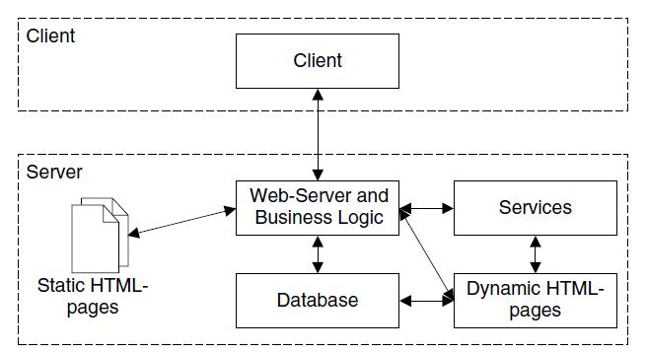

6. Safe Home is a web site that provides information regarding home safety and security. It contains the information regarding different possible risks at home and its prevention methods. The websites also provide information on the cases of home safety around the globe. The website belongs to a non-profit organization where the main objective of the organization is to create awareness of home safety to the public. In addition, the websites also sell some security tools such as door alarm, hidden video camera, door locks etcetera. This is the minor part in the website. You are appointed as the web designer for Safe Home.

1. Analyze the importance of navigation design for Safe Home.

Navigation design allows visitors to explore Safe Home site and learn about their services, products and home safety information. In addition, easily direct visitors to various pages and information on their site.

1. Suggest and justify your answer for TWO (2) quality attributes that are necessary for Safe Home’s interface design.

Clarity and Familiar, Easy for customers or viewers to understand the website and creating a interface design that is more similar to other websites so that users will know how it may behave like other websites

1. Do you agree that the focus of the design should concentrate more on the content of website than the functions provided in the e-commerce part of the website? Justify your point of view.

I disagree on the point where design should be concentrate more than the content. The reason of why disagree is because the function is the soul of the website. Even a fanciest website but having a broken function will not get popular in the society as the function is what make the website work. Besides, the client make money by having the function of an website but not the design of the website.