

**TUNKU ABDUL RAHMAN UNIVERSITY COLLEGE**

FACULTY OF COMPUTING AND INFORMATION TECHNOLOGY

BAIT2133 WEB ENGINEERING

TUTORIAL 8

1. Discuss what information design is.

Information design is the practice of presenting information in a way that makes it most accessible and easily understood by users. Information design is targeted to specific audiences in specific situations to meet defined objectives. In its most sophisticated forms, it helps users understand complex data by organizing and simplifying data and information in ways they can quickly grasp.

1. Discuss **FIVE** characteristics of IA.

Composition with multiple, dynamic data. The model must support the ability to group different

information items into a presentation and the expression of constraints among these items.

Higher-level presentation specification. The model should be able to specify constraints across

multiple information items.

Temporal relations. Certain information items may have time-based relationships, which can be

important to their presentation (e.g., a link to information about an event might only be relevant up until that event is held).

Context for links and link semantics. The ability to control the presentation depending upon which

links are followed.

Separation of content and information. Content is the collection of data sources that are available for use. Information is what is useful to the users of the WebApp.

1. Compare the classifications of information structure.

A hierarchical navigation structure is like tree map. The home page is at the top. Underneath it breaks into categories which can be further broken into different sub-categories.

1. Perform a finding on the pros and cons of each structure.

Pros: Step by step, present information in a specific order. Cons: Only to able to trace back step by step, does not provide shortcut.

1. Why blueprint is important? Justify your point.

Blueprints shows how the various content objects map into a specific information Structure for example, it captures additional information to a sitemap. A blueprint also discussed about whether content is dynamic or static, the content is personalized for individual users and in what ways, what are the content objects are mapped to which Web pages, and what navigational paths will address given tasks.

6.Compare **THREE** navigational mechanism.

Global links. Shortcuts. These are ways of bypassing the normal navigational route and jumping over intermediate steps straight to a particular location within the information space

Shortcuts, Breadcrumbs and trails

7.What are the approaches in Navigation Design?

A more recently developed, and richer, notation than RMM is the Web

Modeling Language (WebML)

incorporates robust support for aspects such as workflow modeling,

presentation and content adaptation, personalization, and design patterns

Web Application Extension for UML (WAE) is a design approach that

links the informational perspective with functional WebApp

components.

indicates how functional components generate and/or provide information and

how the information (through aspects such as link activation or form

submission) triggers functional components.

models the connection between client-side content and behavior, and

server-side functionality.

8.Compare *Web Modeling Language* (*WebML*) with *Web Application Extension for UML* (*WAE)*.

WebML (Web Modeling Language) is a visual notation and a methodology for designing complex data-intensive Web applications. It provides graphical, yet formal, specifications, embodied in a complete design process, which can be assisted by visual design tools. An extension to UML is expressed in terms of stereotypes, tagged values, and constraints. Combined, these mechanisms enable us to extend the notation of UML, enabling us to create new types of building blocks that we can use in the model.

9.Illustrate each of the *Information Structure* with diagrams.

ArchiMate is a popular open standard from the Open Group related to enterprise architecture modeling which includes simply and yet powerful visual notation to support descriptions, analysis and visualization of architecture within and across the enterprise architecture domains. With this integrated representation convention, ArchiMate helps evaluate the impact of changes within multiple architecture domains and enables different stakeholders to communicate the enterprise architecture being developed effectively and with ease.

10.A membership account of a supermarket is used to store the points of purchase for those customers who had registered as a member. For new member, there is no point accumulated in the account, points will only be added when customer’s purchase is successfully completed. The points in the account will be deducted for prize redemption. Draw a State Diagram to show the state changes of the account.

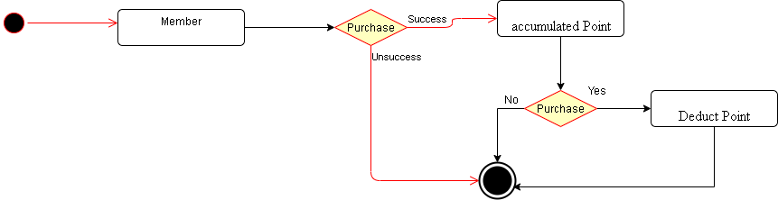

11.

When designing the *Information Architecture* of a web application, what content- related characteristics of a web application should has? Explain *THREE (3)* of them.

Separation of information and application. A WebApp IA should differentiate between the information that a user would find meaningful, and the structural ways in which this information might be arranged and accessed.

12.Analyze the relationship between *State*, *State Model* and *State Diagram*.

A state is an externally observable mode of behavior. External stimuli cause transitions between states. A state model represents the behavior of a WebApp by depicting its states and the events that cause the WebApp to change state. A state model indicates what actions (e.g., process activation) are taken as a consequence of a particular event. State models are created using state diagrams

13.A flowchart illustrates processes that are executed in the system that change the state of objects. A state diagram shows the actual changes in state, not the processes or commands that created those changes.

