GNN Experiments-

1. Pruning on Adjacency Matrix

|  |  |  |  |  |
| --- | --- | --- | --- | --- |
|  | Cora | Citeseer | Pubmed | Wiki |
| Top-k (k=1) (Singleshot) | **DONE** | **DONE** |  |  |
| Top-k (k=1) (Multishot Levels- 3) | **DONE** | **DONE** |  |  |
| Synflow (Single) | **DONE** | **DONE** |  |  |
| Synflow  (Multiple Levels- 3 ) | **DONE** | **DONE** |  |  |
| UGS | **DONE** | **DONE** |  |  |
| Random | **DONE** | **DONE** |  |  |

1. Cora (Total 1 fig)

1. Citeseer (Total 1 fig)

1. Pubmed (Total 1 fig)
2. Wiki (Total 1 fig)
3. Pruning on Weights

|  |  |  |  |  |
| --- | --- | --- | --- | --- |
|  | Cora | Citeseer | Pubmed | Wiki |
| Top-k (k=1)(Singleshot) | **DONE** | **DONE** |  |  |
| Top-k(k=1)( (Multishot Levels- 3 ) | **DONE** | **DONE** |  |  |
| Synflow (Singleshot) | **DONE** | **DONE** |  |  |
| Synflow  (Multishot Levels- 3 ) | **DONE** | **DONE** |  |  |
| UGS | **DONE** | **DONE** |  |  |
| Random | **DONE** | **DONE** |  |  |

1. Cora (Total 1 fig)

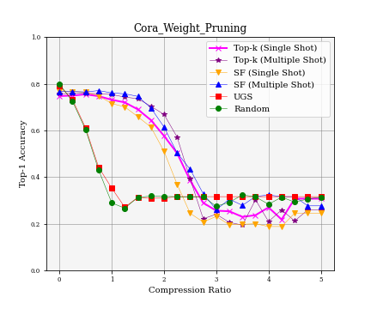

(2)Citeseer (Total 1 fig)

1. Pubmed (Total 1 fig)
2. Wiki (Total 1 fig)
3. Adj-Weight Separate Compression
4. 0.2 scale: Weight Compression: [0.2,0.4,0.6,0.8,1.0] Adj Compression: [0.2,0.4,0.6,0.8,1.0] (Total 5 figures for each dataset)

|  |  |  |  |  |
| --- | --- | --- | --- | --- |
|  | Cora | Citeseer | Pubmed | Wiki |
| Top-k (k=1)(Singleshot) | **DONE** | **DONE** |  |  |
| Top-k(k=1) (Multishot Levels- 3) | **DONE** | **DONE** |  |  |
| Synflow (Singleshot) | **DONE** | **DONE** |  |  |
| Synflow  (Multishot Levels- 3) | **DONE** | **DONE** |  |  |
| UGS | **DONE** | **DONE** |  |  |
| Random | **DONE** | **DONE** |  |  |

* Cora

* Citeseer

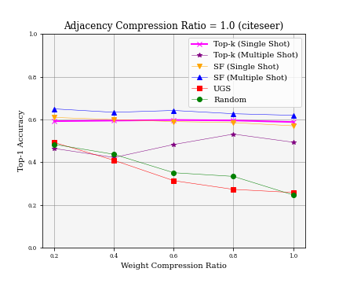

* Pubmed
* Wiki

1. 0.4 scale: Weight: [0.4,0.8,1.2,1.6,2.0] Adj: 0.4,0.8,1.2,1.6,2.0] (Total 5 figures for each dataset)

|  |  |  |  |  |
| --- | --- | --- | --- | --- |
|  | Cora | Citeseer | Pubmed | Wiki |
| Top-k (k=1) (Singleshot) | **DONE** | **DONE** |  |  |
| Top-k (k=1) (Multishot Levels- 3) | **DONE** | **DONE** |  |  |
| Synflow (Singleshot) | **DONE** | **DONE** |  |  |
| Synflow  (Multishot Levels- 3) | **DONE** | **DONE** |  |  |
| UGS | **DONE** | **DONE** |  |  |
| Random | **DONE** | **DONE** |  |  |

* Cora

* Citeseer

* Pubmed
* Wiki

1. Multi Shot Iterations
2. On Adj: Level 1 to Level 5

|  |  |  |  |  |
| --- | --- | --- | --- | --- |
|  | Cora | Citeseer | Pubmed | Wiki |
| Top-k (k=1) (Multishot) | **DONE** | **DONE** |  |  |
| Synflow  (Multishot) | **DONE** | **DONE** |  |  |

* Cora (Total 1 fig)

* Citeseer (Total 1 fig)

* Pubmed (Total 1 fig)
* Wiki (Total 1 fig)

1. On Weights: Level 1 to Level 5

|  |  |  |  |  |
| --- | --- | --- | --- | --- |
|  | Cora | Citeseer | Pubmed | Wiki |
| Top-k (k=1) (Multishot) | **DONE** | **DONE** |  |  |
| Synflow  (Multishot) | **DONE** | **DONE** |  |  |

* Cora (Total 1 fig)

* Citeseer (Total 1 fig)

* Pubmed (Total 1 fig)
* Wiki (Total 1 fig)

1. Top-k Selection (Compression Ratio set to 1.0)
2. From k to [1,2,3,4,5] on Weights and Adjacency Matrix (Total 2 figures for each dataset)
3. From k to [1,2,3,4,5] on Weights:

|  |  |  |  |  |
| --- | --- | --- | --- | --- |
|  | Cora | Citeseer | Pubmed | Wiki |
| Top-k (Multishot Levels-5) | **DONE** | **DONE** |  |  |
| Top-k  (Singleshot) | **DONE** | **DONE** |  |  |

* Cora

* Citeseer

* Pubmed
* Wiki

1. From k to [1,2,3,4,5] on Adj:

|  |  |  |  |  |
| --- | --- | --- | --- | --- |
|  | Cora | Citeseer | Pubmed | Wiki |
| Top-k (Multishot Levels-5) | **DONE** | **DONE** |  |  |
| Top-k  (Singleshot) | **DONE** | **DONE** |  |  |

* Cora

* Citeseer

* Pubmed
* Wiki

1. From k to [5,10,15,20] on Weights and Adjacency Matrix (Total 2 figures for each dataset)
2. From k to [5,10,15,20] on Weights:

|  |  |  |  |  |
| --- | --- | --- | --- | --- |
|  | Cora | Citeseer | Pubmed | Wiki |
| Top-k (Multishot Levels-5) | **DONE** | **DONE** |  |  |
| Top-k  (Singleshot) | **DONE** | **DONE** |  |  |

* Cora

* Citeseer

* Pubmed
* Wiki

1. From k to [5,10,15,20] on Adj:

|  |  |  |  |  |
| --- | --- | --- | --- | --- |
|  | Cora | Citeseer | Pubmed | Wiki |
| Top-k (Multishot Levels-5) | **DONE** | **DONE** |  |  |
| Top-k  (Singleshot) | **DONE** | **DONE** |  |  |

* Cora

* Citeseer

* Pubmed
* Wiki