streams

### base cations

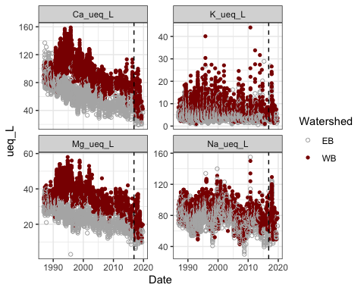

### acid anions

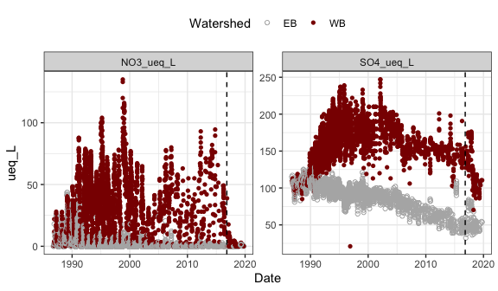

### DOC

**check units and conversions**

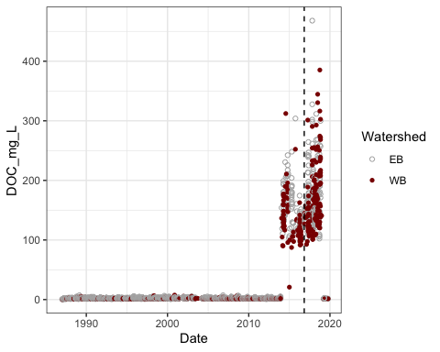

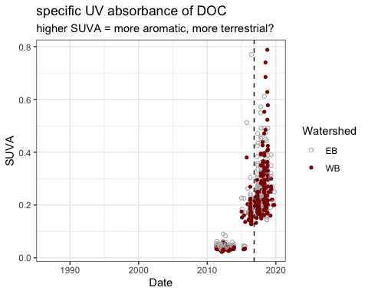

### aluminum

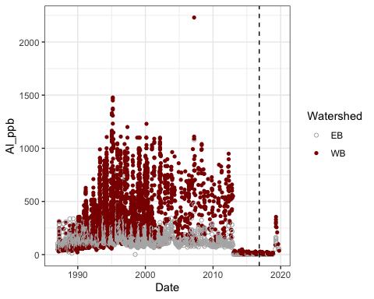

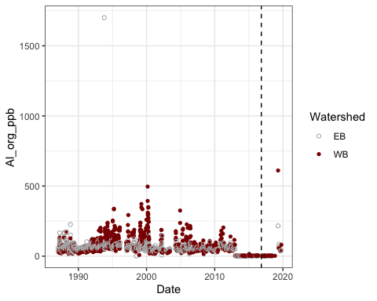

### pH – so many pHs!

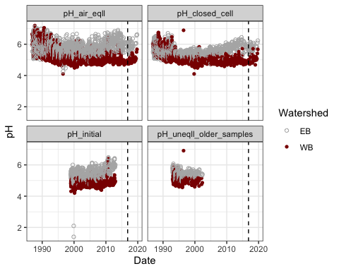

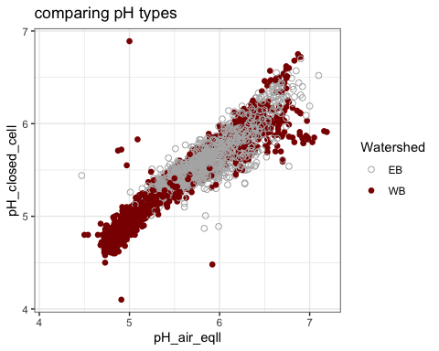

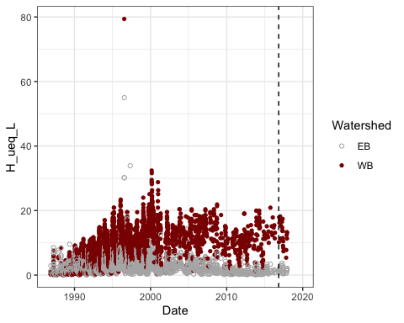

### others

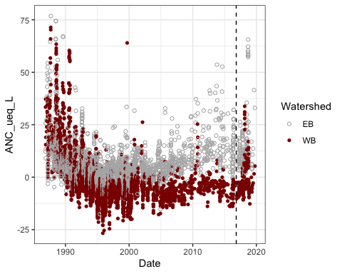

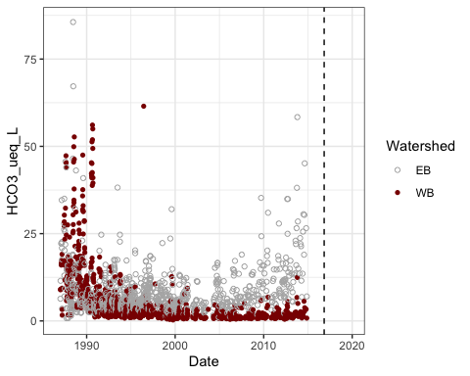

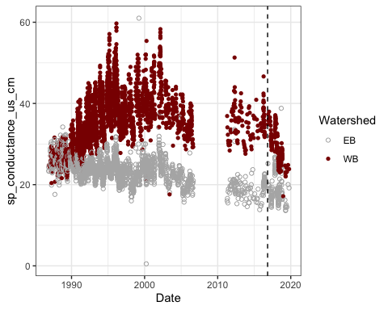

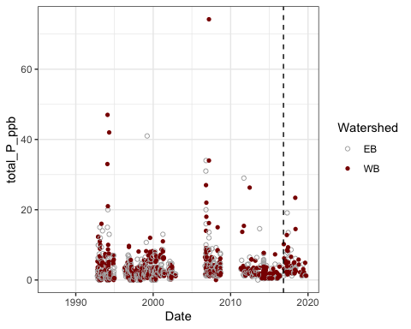

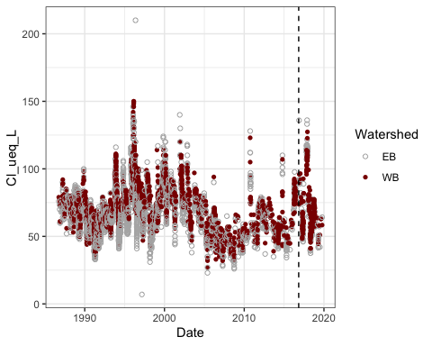

**Session Info**  
Date run: 2020-06-20

#> R version 3.6.0 (2019-04-26)  
#> Platform: x86_64-apple-darwin15.6.0 (64-bit)  
#> Running under: macOS Mojave 10.14.6  
#>   
#> Matrix products: default  
#> BLAS: /Library/Frameworks/R.framework/Versions/3.6/Resources/lib/libRblas.0.dylib  
#> LAPACK: /Library/Frameworks/R.framework/Versions/3.6/Resources/lib/libRlapack.dylib  
#>   
#> locale:  
#> [1] en_US.UTF-8/en_US.UTF-8/en_US.UTF-8/C/en_US.UTF-8/en_US.UTF-8  
#>   
#> attached base packages:  
#> [1] stats graphics grDevices utils datasets methods base   
#>   
#> other attached packages:  
#> [1] soilpalettes_0.1.0 lubridate_1.7.8 forcats_0.5.0   
#> [4] stringr_1.4.0 dplyr_1.0.0 purrr_0.3.4   
#> [7] readr_1.3.1 tidyr_1.1.0 tibble_3.0.1   
#> [10] ggplot2_3.3.0 tidyverse_1.3.0   
#>   
#> loaded via a namespace (and not attached):  
#> [1] tidyselect_1.1.0 xfun_0.10 haven_2.2.0 lattice_0.20-38   
#> [5] colorspace_1.4-1 vctrs_0.3.0 generics_0.0.2 htmltools_0.4.0   
#> [9] yaml_2.2.0 blob_1.2.1 rlang_0.4.6 pillar_1.4.4   
#> [13] glue_1.4.0 withr_2.1.2 DBI_1.0.0 dbplyr_1.4.4   
#> [17] modelr_0.1.5 readxl_1.3.1 lifecycle_0.2.0 munsell_0.5.0   
#> [21] gtable_0.3.0 cellranger_1.1.0 rvest_0.3.5 evaluate_0.14   
#> [25] labeling_0.3 knitr_1.25 fansi_0.4.0 broom_0.5.6   
#> [29] Rcpp_1.0.2 scales_1.0.0 backports_1.1.5 jsonlite_1.6.1   
#> [33] fs_1.3.1 hms_0.5.3 digest_0.6.25 stringi_1.4.3   
#> [37] grid_3.6.0 cli_2.0.2 tools_3.6.0 magrittr_1.5   
#> [41] crayon_1.3.4 pkgconfig_2.0.3 ellipsis_0.3.0 xml2_1.2.2   
#> [45] reprex_0.3.0 assertthat_0.2.1 rmarkdown_2.1 httr_1.4.1   
#> [49] rstudioapi_0.11 R6_2.4.0 nlme_3.1-141 compiler_3.6.0