BBWM initial recovery
Kaizad Patel
2019-11-19

nitrate
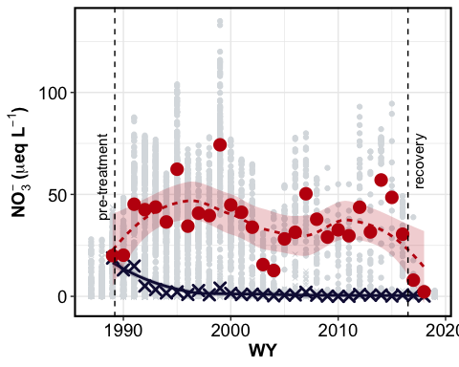

sulfate
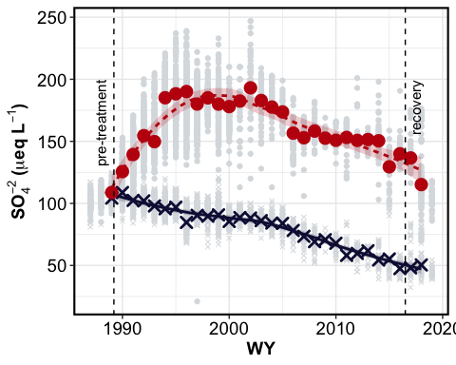

DOC
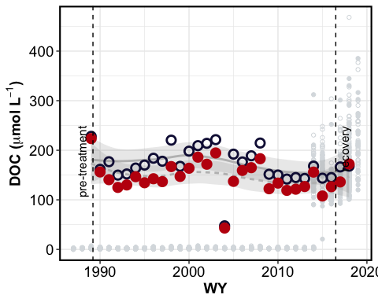

ANC
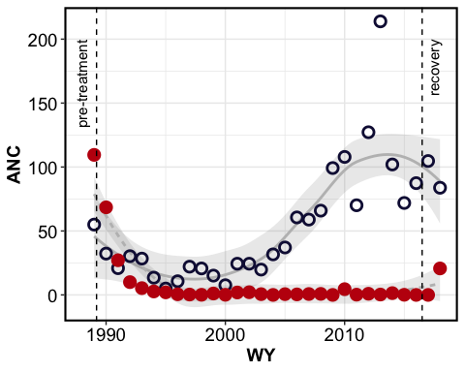

pH
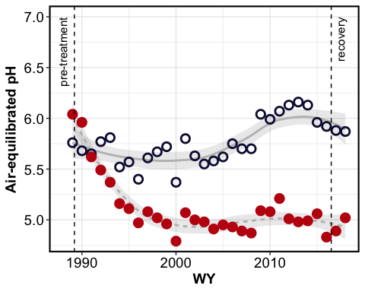

summary table – fluxes
species | Watershed | pre-treatment | first decade | second decade | third decade | recovery
NO3 | EB | 182.8 ± NA | 43.38 ± 14.61 | 8.04 ± 1.76 | 4.89 ± 1.6 | 2.85 ± 0.95
NO3 | WB | 216 ± NA | 423.6 ± 41.96 | 345.7 ± 50.03 | 420.43 ± 30.24 | 59.5 ± 33.5
SO4 | EB | 1014 ± NA | 870.7 ± 51.51 | 807.8 ± 58.6 | 642.14 ± 57.05 | 553.5 ± 15.5
SO4 | WB | 1177 ± NA | 1655.9 ± 134.09 | 1801.7 ± 143.94 | 1620.14 ± 118.98 | 1472.5 ± 125.5
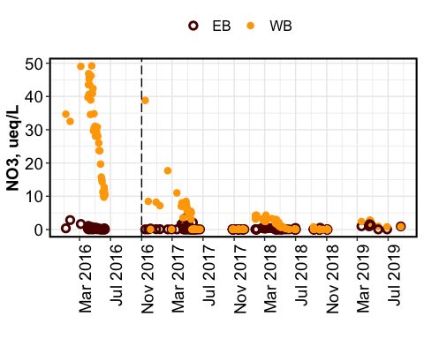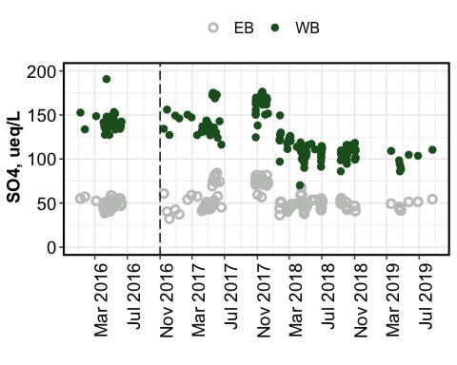

fluxes

nitrate
