adsorption_markdown

Kaizad Patel

Run: 2019-12-08

# Native SOM and the Fenton reaction

## summary tables

|  |  |  |  |  |
| --- | --- | --- | --- | --- |
| element | HW PreFenton | HW PostFenton | SW PreFenton | SW PostFenton |
| C | 20 | 20 | 21 | 19 |
| H | 26 | 27 | 27 | 27 |
| N | 3 | 2 | 3 | 2 |
| O | 10 | 12 | 10 | 12 |
| P | 1 | 1 | 1 | 1 |
| S | 1 | 1 | 1 | 1 |

|  |  |  |  |  |
| --- | --- | --- | --- | --- |
| Class | HW PreFenton | HW PostFenton | SW PreFenton | SW PostFenton |
| Condensed Ar | 2.5 | 0.3 | 1.87 | 0.29 |
| Aromatic | 10.12 | 3.52 | 8.87 | 1.73 |
| Lignin-like | 54.8 | 55.94 | 53.56 | 51.55 |
| Carbohydrate-like | 7.3 | 24 | 8.63 | 27.44 |
| Aliphatic-noN | 14.85 | 9.73 | 18.26 | 14.3 |
| Aliphatic+N | 10.44 | 6.51 | 8.81 | 4.69 |

## van krevelen: native SOM

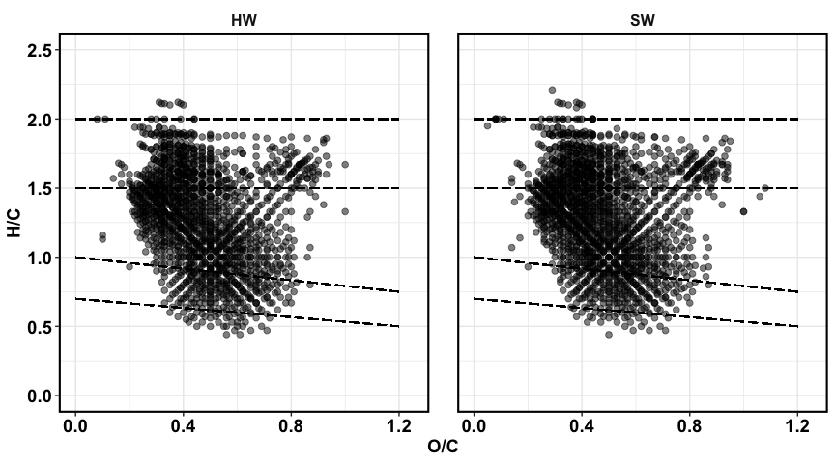

native SOM

## van krevelen: Fenton

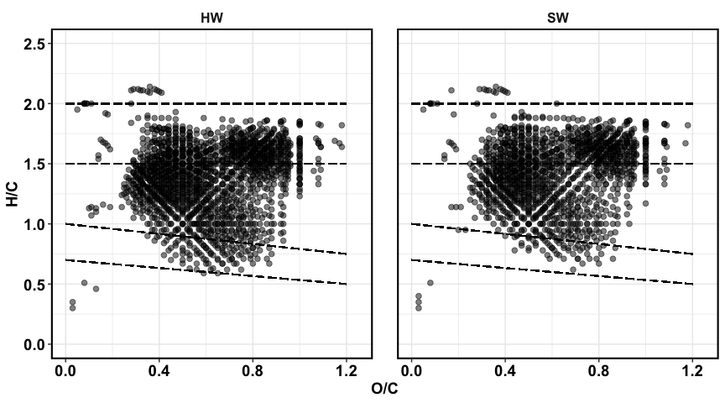

fenton SOM

## fenton

1. fenton loss/gained 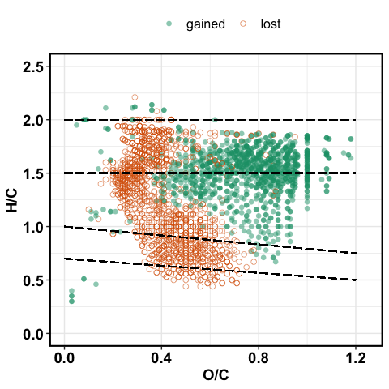
2. fenton vs. oxygens

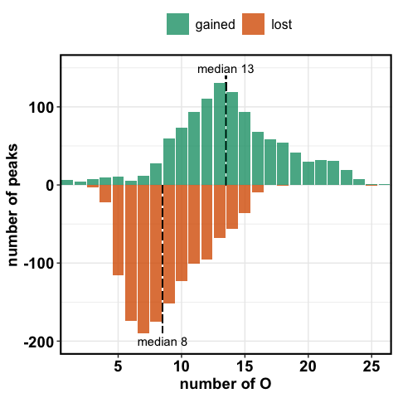

fenton vs. no. of oxygens

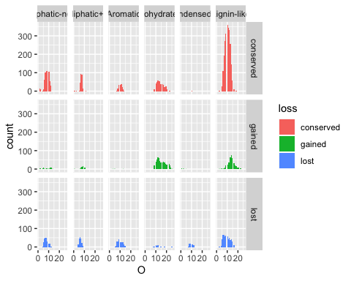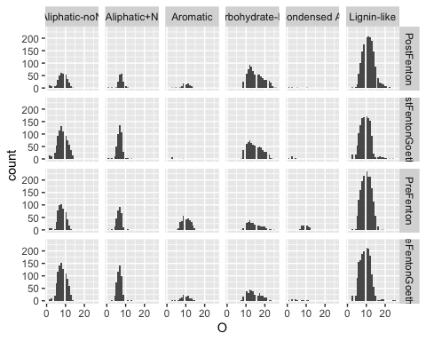

# goethite

1. sorption fractionation

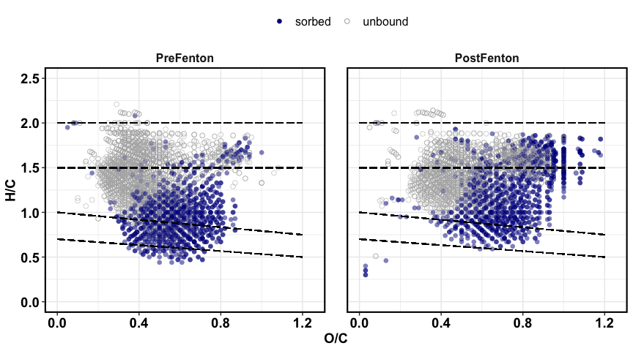

native SOM

1. contribution of groups 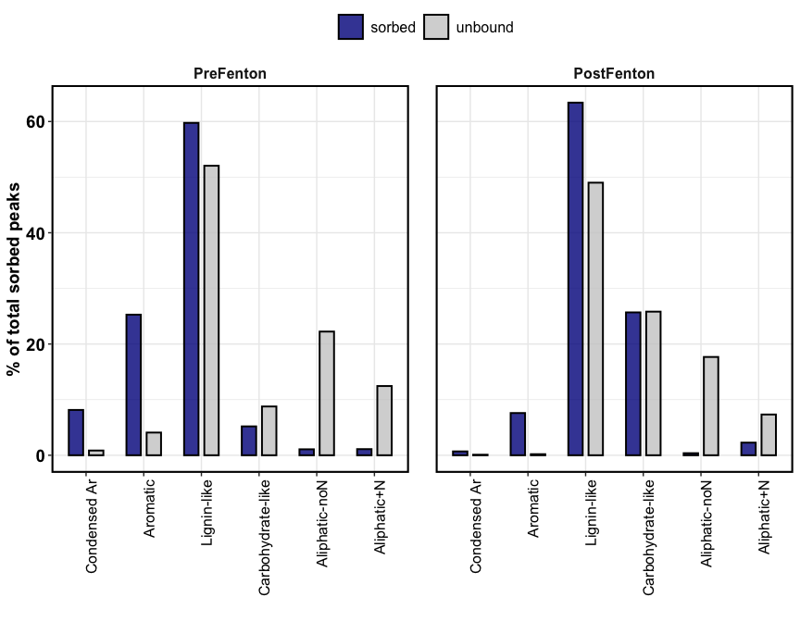
2. sorbed peaks only

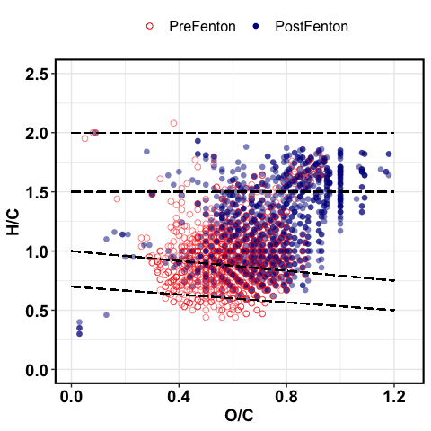

native SOM

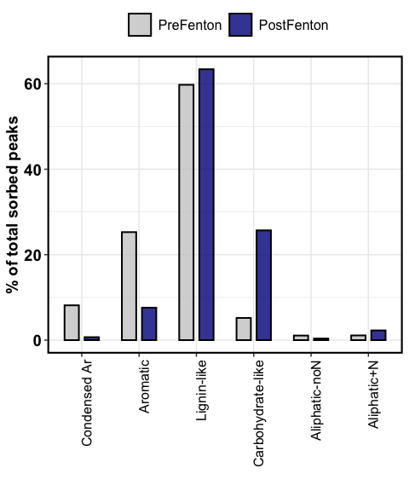

native SOM