**Hydroxyl Radical Effects on the Chemical Composition of Soil-Derived Water Extractable Organic Matter and Its Adsorptive Fractionation with Iron (oxy)hydroxide**

Kaizad F. Patel, †⍑* Václav Tejnecký, ⅂ Tsutomu Ohno,*, † Thomas B. Parr, ‡ M. Susan Erich, ‡ Rachel L. Sleighter,§ and Patrick G. Hatcher§

† School of Food and Agriculture, University of Maine, Orono, ME, 00469-5722, U.S.A.

⍑Pacific Northwest National Laboratory, Biological Sciences Division, Richland, WA 99352, U.S.A.

⅂ Department of Soil and Soil Protection, Czech University of Life Sciences Prague, Prague, Czech Republic.

‡ Department of Biology, University of Oklahoma, Norman, OK, 73019, U.S.A.

§ Department of Chemistry and Biochemistry, Old Dominion University, Norfolk, VA 23529, U.S.A.

*Corresponding authors:

kaizad.patel@pnnl.gov; ohno@maine.edu

**ABSTRACT**

1. **INTRODUCTION**

The fate of soil organic carbon (SOC) depends on its potential biotic and abiotic interactions with soil components. Recent research has found that SOC adsorbed to metal (oxy)hydroxide surfaces has reduced bioavailability3-5, and that the organic matter-mineral interaction is the dominant factor in the stabilization of SOC.6-8 This finding has driven researchers to obtain a better understanding of the chemical process driving the interaction of DOM with mineral surfaces. The ultrahigh resolution capabilities of Fourier transform ion cyclotron resonance mass spectrometry (FT-ICR-MS) have shown in numerous studies that aromatic and aliphatic molecules with high O/C atomic ratios have high affinity for FeOOH and Al2O3 mineral surfaces.9-13 Studies that combined the use of atomic force microscopy (AFM) and FT-ICR-MS showed that higher molecular weight carboxyl-rich aromatic and N-containing aliphatic DOM molecules were correlated with high binding forces between DOM and iron (oxy)hydroxide functionalized AFM tips.14,15 These studies clearly show that adsorptive fractionation of DOM is occurring on the mineral surfaces with in the enrichment of DOM components with higher affinity on the metal (oxy)hydroxide surface and those with lower affinity towards the mineral surfaces remaining in solution. The AFM studies provide strong support for the layer-by-layer “onion” model of DOM structuring where carboxylic-rich aromatic and N-containing aliphatic molecules are initially involved in the DOM adsorption process. (REF)

With adsorption to the mineral surface being a critical step in the stabilization process of soil C, soil processes that affect the chemical composition of SOC are likely to affect the persistence of soil C. FT-ICR-MS studies have consistently shown that lignin-like class of DOM molecules make up the dominant fraction DOM.16-20 Further, lignin-derived organic matter has recently been shown to undergo aerobic abiotic oxidation by reactive oxygen species through a series of reaction steps. The steps include: 1) the loss of methoxy groups, 2) the oxygenation of aromatic rings, 3) ring opening to form carboxylated olefins, 4) condensation to cyclic structures, and 5) radical-induced proton scavenging to form either carboxylated aromatic observed in soils or carboxylated alicyclic molecules. 21-23 Recently, Whendee Silver’s group has published a series of elegant papers on the role of iron in the decomposition of lignin and soil organic matter based on soils from a humid tropical forest in Puerto Rico, which experiences warm temperatures and frequent precipitation leading to repeated fluctuations in soil redox potential. They demonstrated the production of reactive oxygen species from the oxidation of Fe(II) in soils.24 They showed that fluctuating levels of soil O2 drove soil Fe redox reactions generating reactive oxygen species that led to increased lignin biodegradation.25 A laboratory soil incubation study with Fe(II) addition showed that Fe(II) addition disproportionately reduced the mineralization of lignin, independent of O2 availability.26 In addition, drier upland soils from diverse ecosystems also have high iron reduction potential that could affect iron-coupled processes such as lignin decomposition in non-tropical ecosystems.27

The hydroxyl radical (·OH) is a powerful oxidant that can be generated in soils through the Fenton reaction28: H2O2 + Fe2+ ⟶ ·OH + OH- + Fe3+. In soils, the H2O2 can come from rainwater which average 2~40 µmol L-1 H2O2 29 or through *in situ* oxidation of Fe2+ and reduced DOC by O2.30 Climate-induced increases in both frequency and intensity of precipitation events31 is likely to affect the frequency of soil redox cycling as soils undergo more rapid and intense wet-dry cycles. Understanding these dynamic soil processes will be increasingly important for understanding ecosystem services such as the decomposition of soil organic matter and stabilization of soil C associated with redox-active soil processes. The effects of reactive oxygen species (ROS) on lignin-derived DOM and aquatic DOM have been extensively investigated,21-23, 32,33 however studies ROS effects on soil-derived DOM have been limited.

To address this knowledge gap, we studied the effects of ·OH on the chemical composition of SOM extracted from the O horizon of hardwood (HW) and softwood (SW) forest stands in Maine. We mixed SOC water extracts with __ to initiate the Fenton oxidation reaction. Additionally, we conducted an adsorption experiment using FeOOH to determine how the Fenton oxidation of DOM impacts its interaction with FeOOH.

1. **EXPERIMENTAL SECTION**
   1. **Dissolved Organic Matter and Reaction with ·OH Radical.**

The organic O-horizon soils were collected from hardwood (HW) and softwood (SW) stands in the reference watershed of the Bear Brook Watershed in Maine (44°52'′ N, 68°06′ W), U. S. A.34 The two soils were extracted in triplicate with deionized distilled water (DI-H2O) at a 1:10 w:v ratio for 16 h at 4 °C, centrifuged, and vacuum filtered through 0.4 µm Nuclepore polycarbonate filters. The dissolved organic carbon (DOC) concentration of the extract was measured using a Shimadzu TOC-V analyzer. A portion of each was retained to serve as the reference DOM prior to the oxidation and adsorption to FeOOH treatments. The DOM oxidation treatment used OH· radicals produced from the Fenton reaction (Waggoner et al., 2015). Briefly, the DOM solution of ~300 ppm dissolved organic carbon (DOC) was adjusted to pH 3 and 4 mg of FeSO4**·**7H2O were added to the solution. The OH· species formation was initiated by adding 2 mL of 30% H2O2 and allowed to react for 1 h prior to characterization by NMR and mass spectrometry.

* 1. **Solid State 13C NMR Analysis.**

The extracts were frozen and then freeze-dried for the NMR analysis. Solid-state 13C NMR experiments were performed by a double resonance technique on a Bruker Advance II spectrometer with 1H resonating at 400 MHz and 13C resonating at 100 MHz. The NMR was equipped with a 4mm H-X magic angle spinning probe head. The 13C chemical shifts were calibrated to a glycine external standard (176.03 ppm). Quantitative 13C NMR spectra with a multi-CP (cross polarization) pulse program have been shown to be comparable to direct polarization NMR experiments but with greater S/N (Johnson and Schmidt-Rohr, 2014). Samples of approximately 80 mg were packed into zirconium rotors and sealed with Kel-F caps for analysis. Acquisition parameters were optimized per sample using the multi-CP approach, acquiring 5008 scans and a magic-angle spinning rate of 14 kHz.

* 1. **ESI-FT-ICR-MS Analysis.**

The extracts were processed through Agilent PPL solid-phase extraction cartridges to desalt the extract for subsequent electrospray ionization (ESI) FT-ICR-MS analysis.35 The DOM was characterized using negative ion mode ESI with a 12 T Bruker Daltonics Apex Qe FT-ICR-MS instrument at the COSMIC facility at Old Dominion University. To increase the ionization efficiency, ammonium hydroxide was added immediately prior to ESI to raise the pH to 8. Samples were introduced by a syringe pump at an infusion rate of 120 µL h-1 and analyzed in negative ion mode with electrospray voltages optimized for each sample. Ions (in the range of 200-2000 m/z) were accumulated in a hexapole for 1.0 sec before being transferred to the ICR cell. Exactly 300 transients, collected with a 4 MWord time domain, were added for a total run time of ~ 30 min. The summed free induction decay signal was zero-filled once and Sine-Bell apodized prior to fast Fourier transformation and magnitude calculation using the Bruker Daltonics Data Analysis software. Prior to data analysis, all samples were externally calibrated with a polyethylene glycol standard and internally calibrated with naturally present fatty acids within the sample.

* 1. **Mass Spectra Data Post-Processing.**

For assignments of molecular formulas, peaks with a signal to noise ratio above 5 were assigned using the formula extension approach.36 A MATLAB script was used to parse the assigned formulas into the appropriate van Krevelen space, which consisted of six discrete regions 37: 1) condensed aromatic molecules (AImod > 0.66); 2) aromatic molecules (0.66 ≥ AImod > 0.50); 3) highly unsaturated molecules (AImod ≤ 0.50 and H/C < 1.5); 4) saturated molecules (Sat, H/C ≥ 2.0 and O/C ≥ 0.9.); 5) non-N containing aliphatic molecules (2.0 > H/C ≥ 1.5); and 6) N containing aliphatic molecules (2.0 > H/C ≥ 1.5). To avoid biases of the electro-spray ionization (see REF), we report all FT-ICR-MS data in terms of peak counts and not intensities.

The DBE value is the sum of double bonds and rings in a molecule that characterizes the degree of unsaturation in a molecule based on C-C double bonds and rings and is independent of the number of O and S in the formula. The DBE values were calculated as 1 + ½(2C-H+N+P).38 The modified aromaticity index (AImod) was calculated as (1+C-½O-S-½H)/(C-½O-S-N-P).39 The AImod value accounts for the capability of heteroatoms found in organic matter molecules to form double bonds, and this modified index assumes that all O atoms are present as carboxyl groups. The nominal oxidation state of carbon (NOSC) was calculated using the formula: NOSC = 4 – [(4c + h – 3n -2o -2s)/c], where c, h, n, o, s refer to the stoichiometric numbers of C, H, N, O, and S atoms per formula, respectively. Further post-processing details can be found elsewhere.40 To provide a rigorous evaluation of the oxidation and adsorption treatments, an R script was used to identify assigned formulas present in all three replicates of the treatment WEOM solutions to be included into the data analysis.

* 1. **Adsorption Experiments.**

Batch DOM adsorption studies were conducted in triplicate using catalysis-grade FeOOH purchased from Sigma-Aldrich (#371254) and used after repeated rinsing with DI-H2O. A suspension of 1.00 g FeOOH in 30 mL of DOM solution in glass Erlenmeyer flasks was shaken on an orbital shaker for 48 h at 4° C. Controls were established with DI-H2O plus the FeOOH. The solutions were then filtered and analyzed for their DOC concentrations as described above. The quantity adsorbed was calculated by difference from the initial DOC solution concentration.

Adsorbed molecules were determined using a presence/absence technique. Molecules present in the pre-goethite extracts but not in the post-goethite extracts were completely adsorbed, hereafter called “sorbed”. Molecules that were present in both, pre- and post-goethite extracts were theoretically, either completely unbound (not adsorbed) or partially adsorbed. Relative intensities of the different molecular groups were calculated using peak counts.



**3. RESULTS AND DISCUSSION**

* 1. **Chemical composition of native SOM**

The Van Krevelen diagrams in **Figure 1** show the distribution of molecules in the native SOM pools as defined by their H/C and O/C ratios. In general, SOM composition did not differ between forest types, with ~ 76 % of peaks (1416) shared by both hardwood and softwood soils. Both HW and SW soils were dominated by lignin-like molecules (**Table 1**).

**Figure 1.** Van Krevelen diagrams for initial (pre-Fenton) SOM molecules in hardwood (HW) and softwood (SW) soils. The intensity of color represents the relative abundance of the molecules.

**Table 1.** Relative abundance (percentage) of groups in HW and SW SOM, for initial (pre-Fenton) and post-Fenton soils.

|  |  |  |  |  |
| --- | --- | --- | --- | --- |
|  | **HW PreFenton** | **HW PostFenton** | **SW PreFenton** | **SW PostFenton** |
| DOC concentration, mg/L | 513 ± 12 | 599 ± 9 | 656 ± 13 | 640 ± 16 |
| No. of assigned formulas | 1562 | 1675 | 1714 | 1385 |
| **element** |  |  |  |  |
| C | 20 | 20 | 21 | 19 |
| H | 26 | 27 | 27 | 27 |
| N | 3 | 2 | 3 | 2 |
| O | 10 | 12 | 10 | 12 |
| P | 1 | 1 | 1 | 1 |
| S | 1 | 1 | 1 | 1 |
| **Class %** |  |  |  |  |
| Condensed Ar | 2.5 | 0.3 | 1.87 | 0.29 |
| Aromatic | 10.12 | 3.52 | 8.87 | 1.73 |
| Lignin-like | 54.8 | 55.94 | 53.56 | 51.55 |
| Carbohydrate-like | 7.3 | 24 | 8.63 | 27.44 |
| Aliphatic-noN | 14.85 | 9.73 | 18.26 | 14.3 |
| Aliphatic+N | 10.44 | 6.51 | 8.81 | 4.69 |

**Table 2.** Relative abundance (percentage) of groups in pre- and post-Fenton extracts using NMR analysis. The ppm shift range for each group is provided in parentheses.

|  |  |  |  |  |  |
| --- | --- | --- | --- | --- | --- |
| **Functional group  (ppm shift)** | **HW** | |  | **SW** | |
| **Initial** | **Post-Fenton** |  | **Initial** | **Post-Fenton** |
| carbonyl (190-220) | 1.0 | 1.0 |  | 1.1 | 1.2 |
| carboxyl (165-190) | 12.6 | 15.1 |  | 9.4 | 10.9 |
| aromatic (112-165) | 6.2 | 5.3 |  | 5.08 | 3.5 |
| anomeric (90-112) | 11.8 | 13.7 |  | 13 | 14.5 |
| Main carb (58-112) | 52 | 46.6 |  | 58.1 | 53 |
| methoxy (54-58) | 2.9 | 4.0 |  | 2.3 | 2.9 |
| aliphatic (5-54) | 15.1 | 14.9 |  | 11.7 | 16.3 |
| total sum | 101.6 | 100.6 |  | 100.68 | 102.3 |
| total | 100 | 100 |  | 100 | 100 |

**Figure 2.** Van Krevelen diagrams for post-Fenton SOM molecules in hardwood (HW) and softwood (SW) soils. The intensity of color represents the relative abundance of the molecules.

**Table 3. Fenton peaks**

|  |  |  |  |
| --- | --- | --- | --- |
| **Class** | **conserved** | **gained** | **lost** |
| Condensed Ar | 1 | 5 | 41 |
| Aromatic | 57 | 4 | 148 |
| Lignin-like | 680 | 316 | 405 |
| Carbohydrate-like | 141 | 347 | 21 |
| Aliphatic-noN | 175 | 49 | 171 |
| Aliphatic+N | 79 | 37 | 121 |
| Total | 1133 | 758 | 907 |

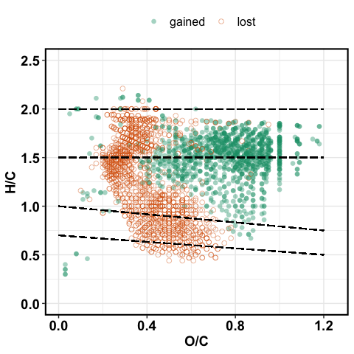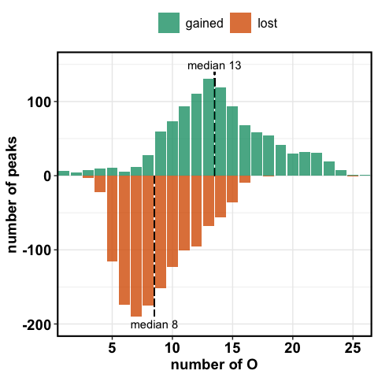

**Figure 3. (a) VK diagrams of molecules gained or lost following** **oxidation via Fenton reaction. (b) The percentage of total peaks for the lost and newly formed formulas binned by the number of oxygen atoms for the ·OH oxidation treatment.**

* 1. **·OH Oxidation Effects on Extract DOC Concentration and Composition.**

Although the overall DOC concentrations did not differ significantly between pre- and post-Fenton extracts (**Table 1, p = XXXX**), the chemical molecular composition of DOC extracts, analyzed using FT-ICR-MS, was substantially changed for both HW and SW soils (**Fig. 2, Table 1**), suggesting that our one-hour Fenton reaction resulted in partial oxidation of the DOM components, rather than complete oxidation to CO2.The van Krevelen diagrams in **Figure 2** also show a high degree of similarity for the HW and SW extracts, indicating that stand vegetation might not strongly affect SOM response to hydroxyl ion oxidation. Of the 907 peaks lost in the Fenton reaction, ~65 % were complex molecules – aromatic, condensed aromatic, and lignin-like. Post-Fenton extracts saw a 3-fold increase in detected carbohydrate-like peaks.

We used solid-state 13C NMR to quantify relative abundances of organic functional groups, reported in **Table 2.** Carbohydrates accounted for nearly 50 % of total abundance by NMR analysis, and showed no change in pre- vs. post-Fenton extracts (**Table 2**). This is an interesting contrast to the FT-ICR-MS results discussed above, suggesting that although the total relative carbohydrate content did not change, there may have been a shift in the *types* of carbohydrate molecules detected post-Fenton. In fact, **Figure X** shows that the carbohydrate-like fraction had a median molecular O content of **XX** pre-Fenton and **XX** post-Fenton.

Another difference between the two analyses is related to the sample preparation. The negative spray ESI technique used for FT-ICR-MS is biased toward more aromatic molecules like lignin, whereas aliphatic molecules like carbohydrates are typically underrepresented (Ohno et al. 2016). **Figure 3a** shows that many polyphenolic (lignin-like) peaks were lost due to the Fenton oxidation, allowing for more aliphatic (carbohydrate-like) peaks to be ionized and subsequently detected in the post-Fenton extracts. Relative intensity measurements by FT-ICR-MS are therefore biased by the ionization process and we avoid this issue by using only peak counts. We use NMR for a more quantitative understanding of the SOM composition, because this technique is unlikely to show such biases.

* + 1. **Fenton oxidation altered the SOM oxygen status**

Overall, molecules with lower O/C ratios, whereas the newly detected molecules generally had H/C > 1.0 and O/C > 0.5 **(Fig. 3a)**. Our data also suggest that the ·OH radical reaction was preferentially consuming DOM molecules with ≤ 8 O atoms and the newly detected molecules had ≥ 13 O atoms (median values, **Fig. 3b**). This effectively raised the median number of O atoms to 11, compared to 9 for pre-Fenton extracts. This shift to higher O-containing molecules suggests potential shifts in DOM reactivity in terms of lability and sorption onto mineral surfaces. In this experiment, we investigated the latter, by adsorbing these extracts onto goethite, discussed below in section 3.3.

* 1. **Adsorptive fractionation by goethite**

Sorbed molecules had a median O/C of 0.67 and median O of 12, whereas the unbound and partially sorbed molecules had a median O/C of 0.46 and median O of 9.

For the native pre-Fenton soil extracts, sorbed peaks consisted mostly of medium H/C and medium O/C values (**Figure 4a**). Approximately 90 % of the sorbed peaks were complex aromatic molecules (condensed aromatic, aromatic, lignin-like), with lignin-like peaks accounting for approximately 60 % of total sorbed peaks (**Figure 5**). Although lignin did contribute approximately 63 % of the total sorbed peaks even in post-Fenton extracts, the contribution of aromatic and condensed aromatic peaks was greatly reduced, driven by disappearance of those peaks after the Fenton oxidation. Instead, carbohydrate-like molecules contributed ~25 % of the sorbed peaks, a 5-fold increase from the pre-Fenton extracts (**Figure 5**).

Complexation with mineral surfaces offers protection to SOM from mineralization, with implications for C bioavailability and persistence. Aromatic and lignin-like molecules are typically adsorbed onto mineral surfaces, followed by aliphatic and carbohydrate-like molecules – the latter are therefore considered more labile to C-mineralization. Our study suggests that as SOM gets oxidized by ROS, the higher O content would likely drive the stabilization of simpler molecules.

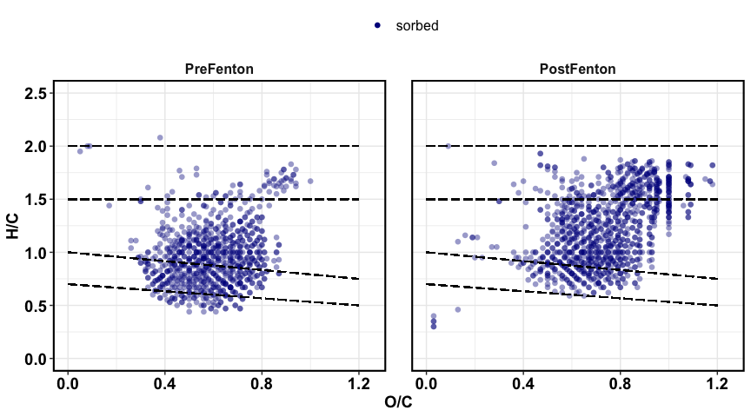**Figure 4. Van Krevelen plot showing sorbed peaks for pre- and post-Fenton extracts. Sorbed peaks had a median O/C of 0.61 for pre-Fenton and 0.75 for post-Fenton extracts. CHANGE COLOR FOR PRE-FENTON**

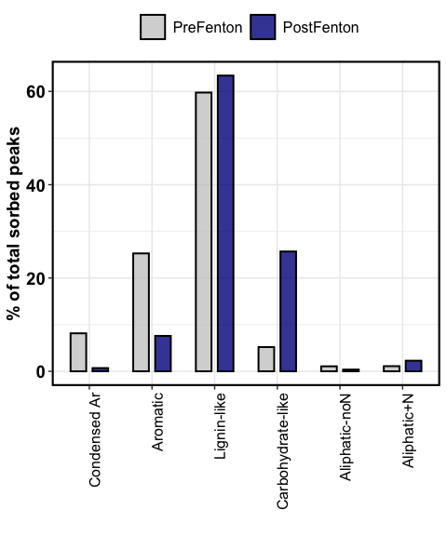

**Figure 5. Contribution of organic classes to the sorbed fraction.**

——————

**REFERENCES**

Dittmar, T.; Koch, B.; Hertkorn, N.; Kattner, G. A simple and efficient method for the solid-phase extraction of dissolved organic matter (SPE-DOM) from seawater. *Limnol. Oceanogr-Meth.* 2008, 6, 230-235.

Kujawinski, E. B.; Behn, M. D. Automated analysis of electrospray ionization fourier-transform ion cyclotron resonance mass spectra of natural organic matter. *Anal. Chem*. 2006, 78, 4363-4373.

Seidel, M.; Beck, M.; Riedel, T.; Waska, H.; Suryaputra, I. G. N. A.; Schnetger, B.; Niggemann, J.; Simon, M.; Dittmar, T. Biogeochemistry of dissolved organic matter in an anoxic intertidal creek bank. *Geochim. Cosmochim. Acta* 2014, 140:418-434.

Koch, B. P.; Dittmar, T. From mass to structure: An aromaticity index for high-resolution mass data of natural organic matter. *Rapid Commun. Mass Sp*. 2006, 20, 926-932.

Hertkorn, N.; Benner, R.; Frommberger, M.; Schmitt-Kopplin, P.; Witt, M.; Kaiser, K.; Kettrup, A.; Hedges, J.I. Characterization of a major refractory component of marine dissolved organic matter. *Geochim. Cosmochim. Acta* 2006, 70, 2990-3010.

Ohno, T.; Ohno, P. E. Influence of heteroatom pre-selection on the molecular formula assignment of soil organic matter components determined by ultrahigh resolution mass spectrometry. *Anal. Bioanal. Chem*. 2013, 405, 3299-3306.

Avneri-Katz, S., Young, R.B., McKenna, A.M., Chen, H., Corilo, Y.E., Polubesova, T., Borch, T., Chefetz, B., 2017. Adsorptive fractionation of dissolved organic matter (DOM) by mineral soil: Macroscale approach and molecular insight. Org. Geochem., 103, 113-124.

Norton, S.; Kahl, J.; Fernandez, I.; Haines, T.; Rustad, L.; Nodvin, S.; Scofield, J.; Strickland, T.; Erickson, H.; Wigington, P.; Lee, J. The Bear Brook Watershed, Maine (BBWM), U. S. A. Environ. Monit. Assess. 1999, 55, 7−51.