Hysteresis and Soil C

Kaizad Patel

11/14/2019

Run: 2019-11-14

# 1. PICARRO DATA

## initial plots, QA, QC

number of readings

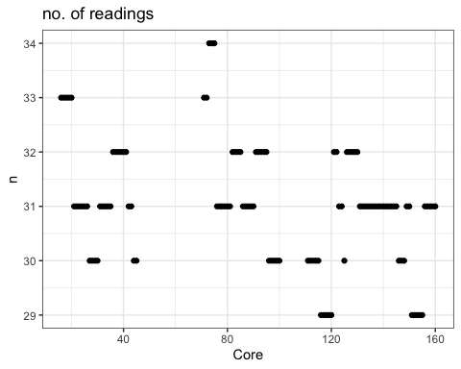

each core 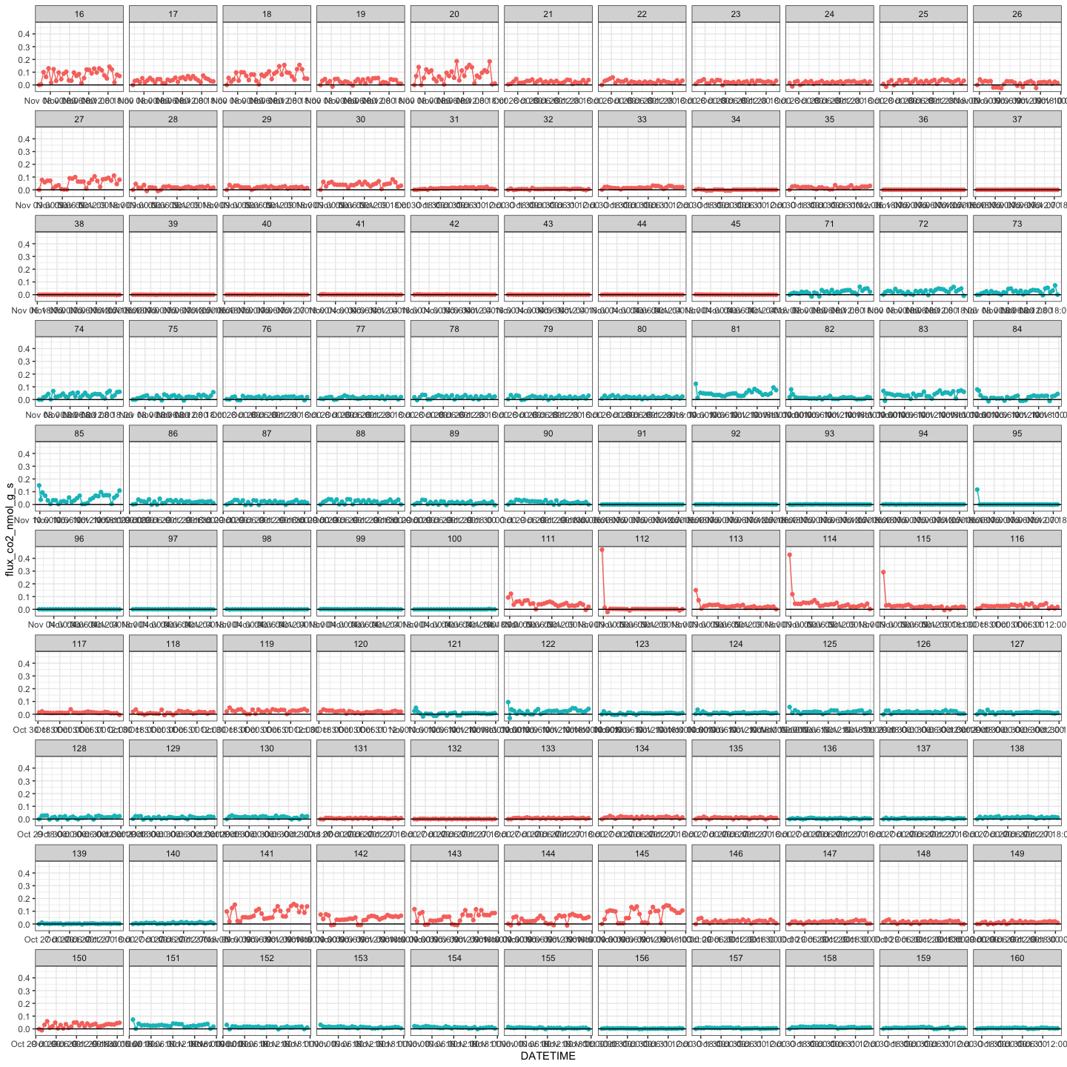

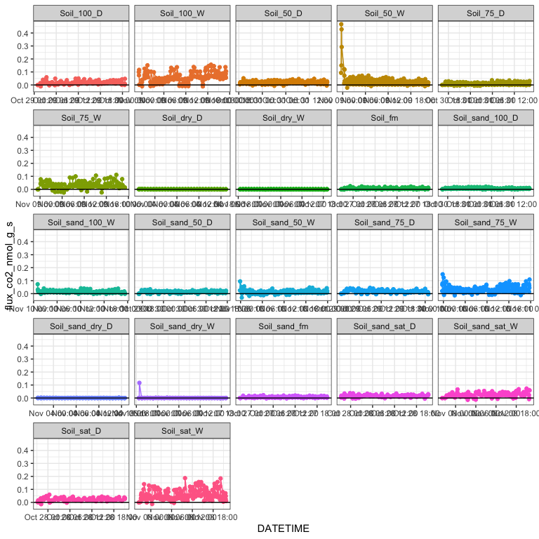

## normalized to soil

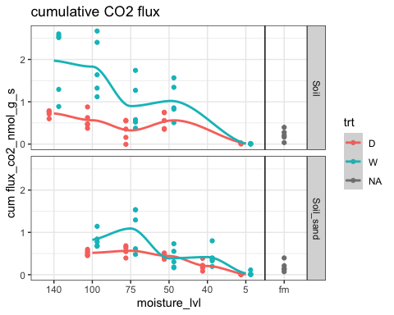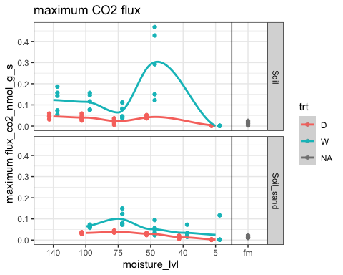

## normalized to TC content

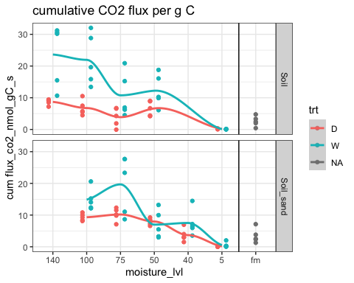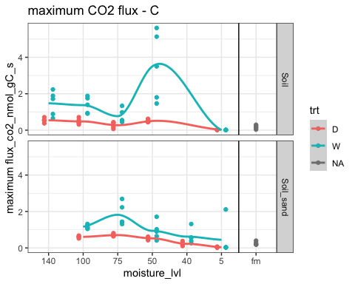

## using percent saturation

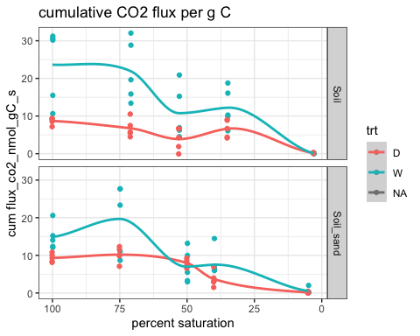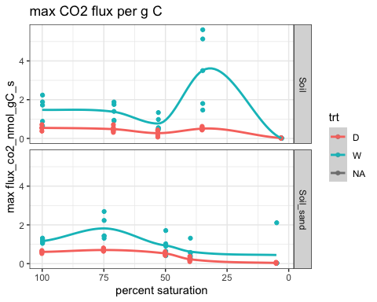

## questions

1. Do we delete flux values below zero?
2. Fluxes keep oscillating (Fig. 1). Do we know what’s causing that? It’s not day-night cycles, since each core was analyzed for only ~24 hours.
3. Soil_50_W (cores 111-115 in Fig. 2) had an initial spike. The samples were initially air-dry and then wetted, so it could be the Birch effect. But this was very short-lived, and this wasn’t seen in any of the other "_W" soils. So maybe trailing CO2 from previous samples?

* Do we delete the initial pulse?

1. Soil_sand_dry_W, FIg. 1 (core 95, Fig. 2) had an initial spike and then almost no respiration. Pretty sure that’s “wrong” data, since the samples were air-dry and no moisture added. Delete that high value?
2. There were unequal number of readings across cores (Fig. 4), as some ran a little longer than others, like 24 vs. 25 hours. That would influence the cumulative flux calculation. Do we (a) somehow filter data to keep it consistent; (b) leave as is; or (c) represent data a different way (e.g. max/mean flux)?