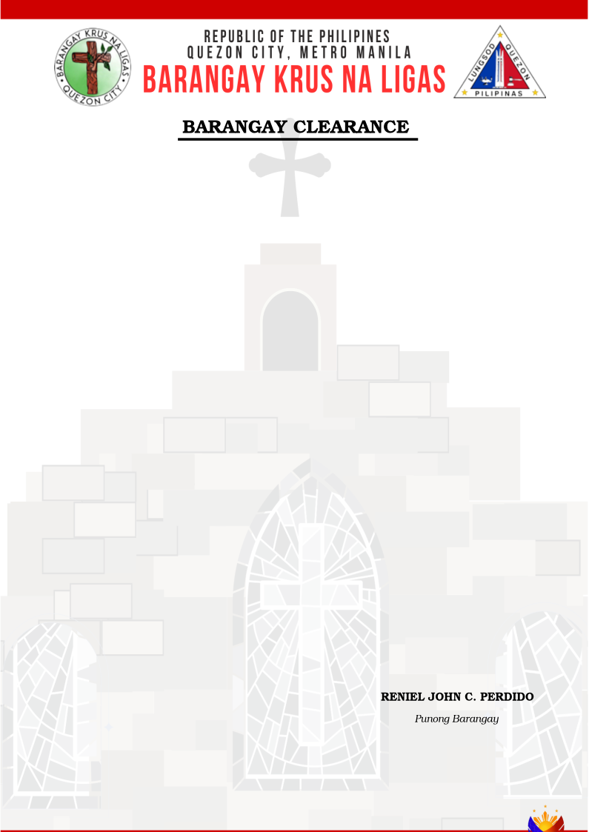
TO WHOM IT MAY CONCERN:

This is to certify that Mr./Ms./Mrs. {{ resident_name }}, born on {{ birth_date }}, {{ marital_status }}, is a resident of Barangay Krus Na Ligas residing at {{ address }} since {{ year_on_barangay }}.

The undersigned has certified that after a reasonable inquiry, I have verified the authenticity of barangay residency showing that the applicant has been residing in the barangay for at least six (6) months prior to the application of this Affidavit of Residency.

This certification is issued upon the request of the above-named person as a supporting
document for {{ purpose }}. This certify further that she/he has no derogatory record and a person of good moral character.

Issued this {{ issue_date }}, at Barangay Krus Na Ligas, District IV, Quezon City
Issued at: Barangay Krus Na Ligas
Issued on: {{ issue_date }}
Valid until: {{ validity }}
Prepared by: {{ author }}
Reference No: {{ document_id }}
APPLICANT PHOTO
APPLICANT THUMBMARK
APPLICANT SIGNATURE
{{ resident_photo }}
{{ qr_code }}

