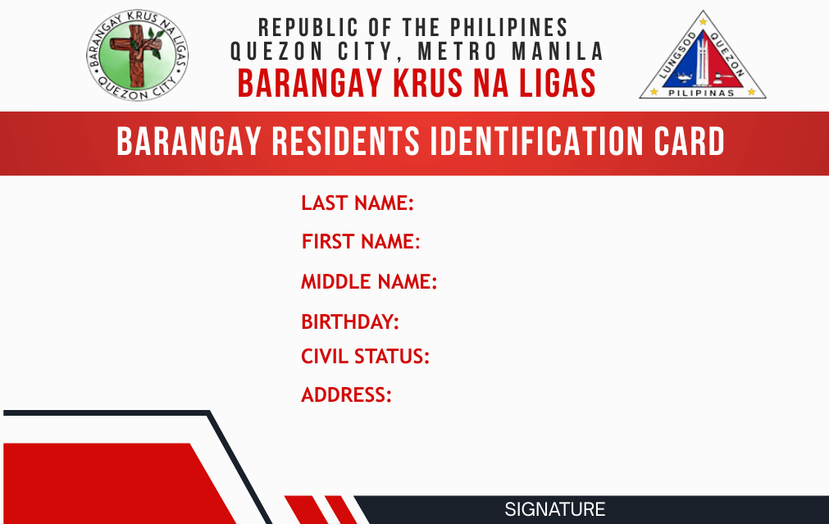
{{ last_name }}
{{ first_name }}
{{ middle_name }}
{{ birth_date }}
{{ marital_status }}
{{ resident_signature }}
{{ address }}
{{ resident_photo }}
{{ document_id }}
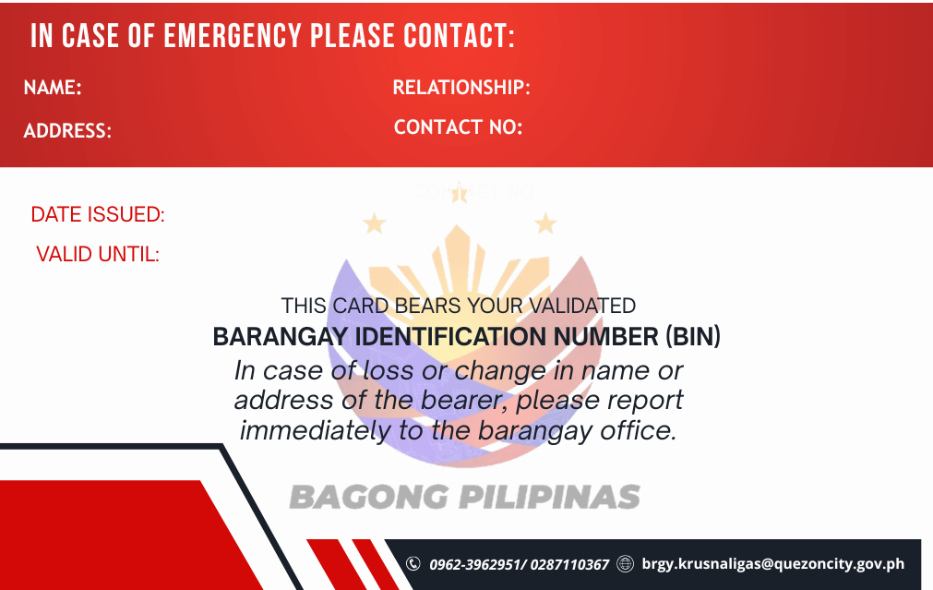
{{ emergency_contact_name }}
{{ emergency_contact_address}}
{{ emergency_contact_number }}
{{ emergency_contact_relationship }}
{{ issue_date }}
{{ expiration_date }}
{{ document_id }}

