**Functionality:**

This is a GUI created by MATLAB. It’s a demo to show how K-means algorithm applies on Image Segmentation. The image segmentation is based on RGB colors. Input any color image, a segmented image is returned, which will be saved in the current folder.

**How to use the GUI:**

1. Run “Kmeans.m” and the GUI will show up:

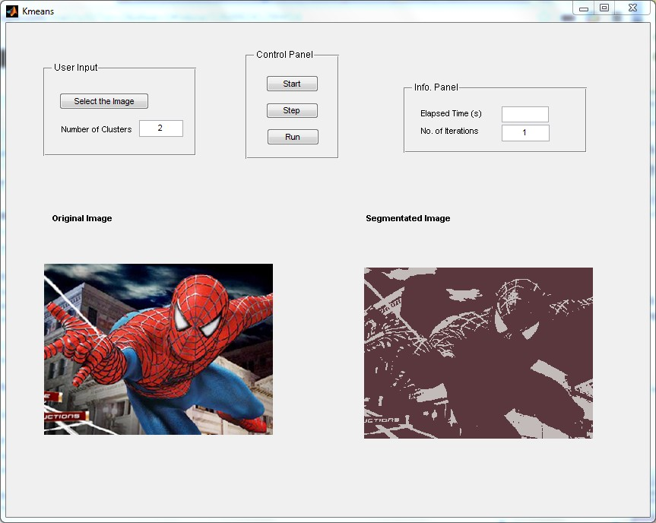

1. Press “Select the Image” to pick any image from local computer, and assign the number of clusters.
2. In the Control Panel, there are three buttons, “Start” prepares the running; “Step” runs the code step-by-step and you can check the result in the window of “Segmented Image”; “Run” makes one run and the result will show up once the algorithm finishes.
3. From the Info. Panel, you can check the time consumed and the total number of iterations of K-means.

**Software Requirement:**

MATLAB, Image Processing Toolbox

**Reference:**

This code belongs to Tiantian Zhang. Please cite <http://www.eecs.ucf.edu/~ttzhang/> for redistribution and use.

Author contact: Tiantian Zhang

Email: zhangtt@knights.ucf.edu