原料仓启用AGV冷热区功能

一：RCS冷热区区域同步
- RCS管理员划分区域储位
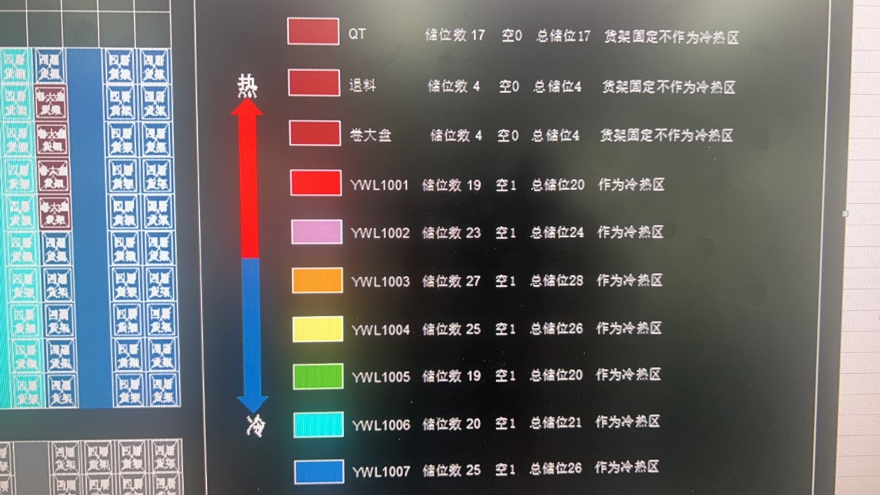
- 同步RCS地图位置所属区域
- 菜单：ProjectAGV/AGV_Location
- 点击页面上的【同步】按钮手动同步一次最新RCS地图位置
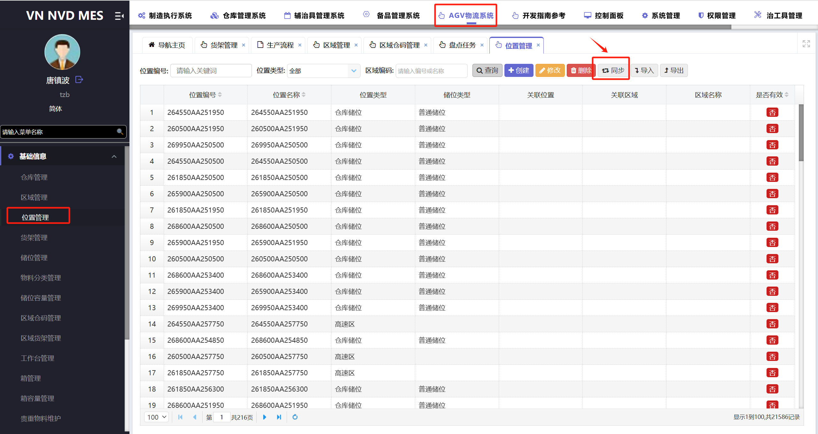

二：冷热区配置调整
- 设置AGV原料仓库
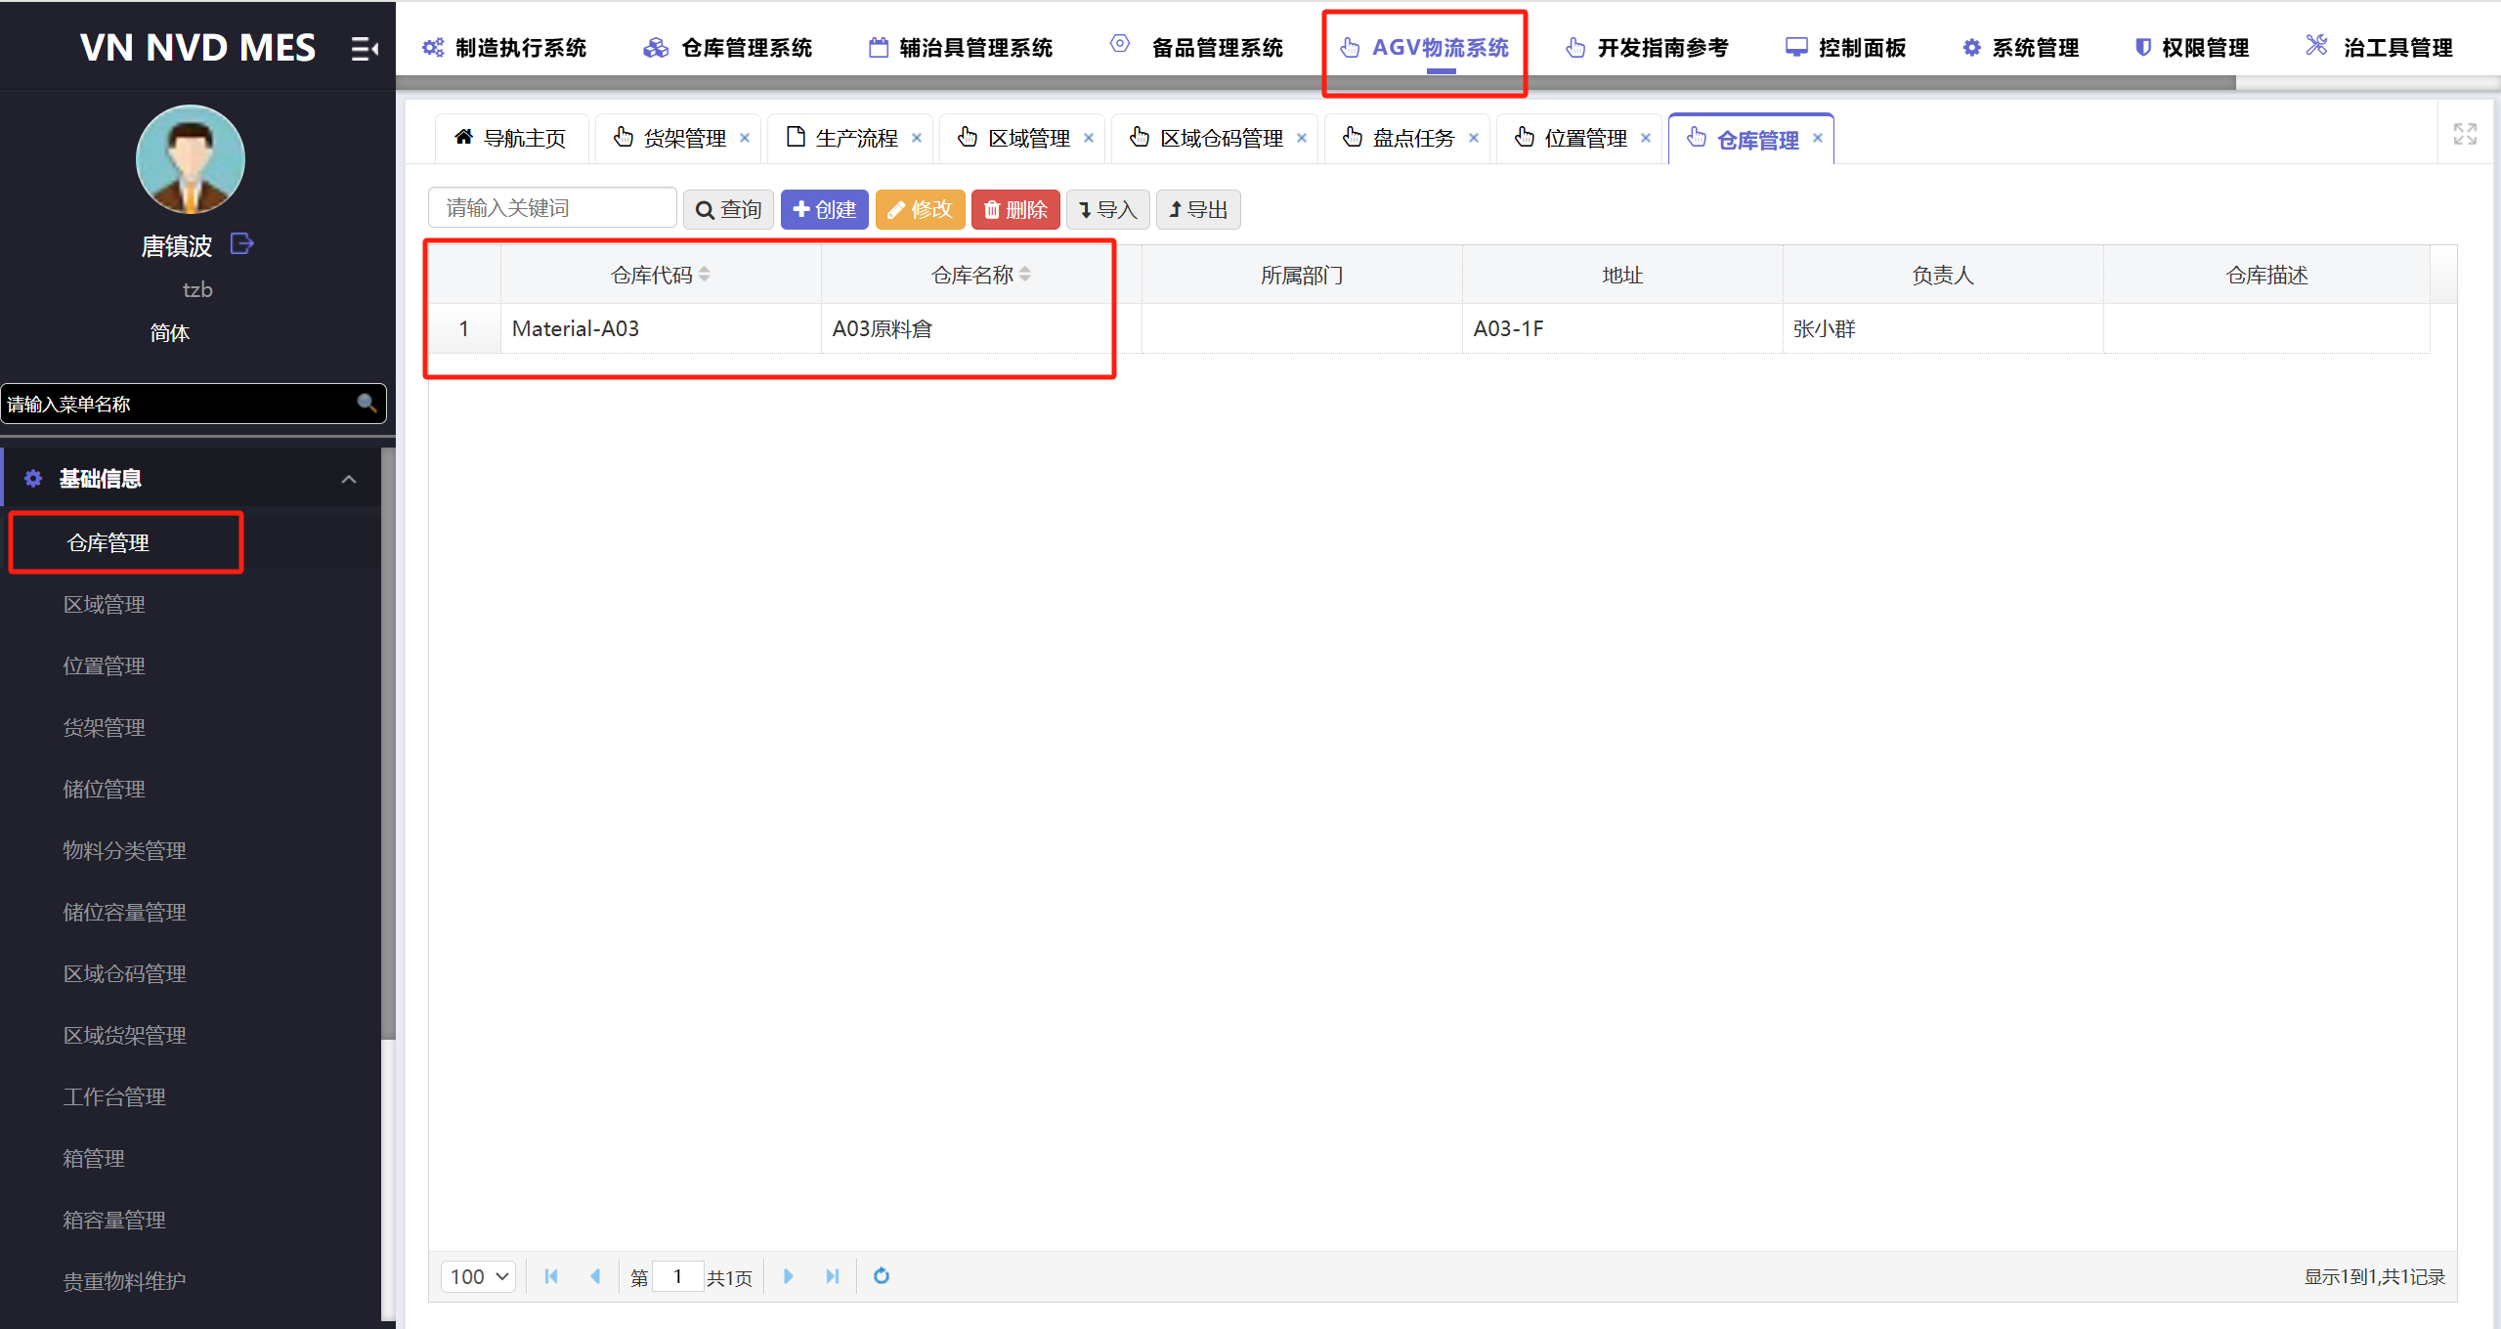
- 数据库更新区域数据，设置区域的冷热区属性，更改允许冷热区转入，设置优先级、锁定库位数，设置仓库编码为对应AGV原料仓库
UPDATE a SET a.aare_priority = RIGHT(a.aare_code, 1), a.aare_transferable = 1, a.aare_lock_loc_count =1, awhi_code = 'Material-A03'
FROM dbo.AGV_Area a
WHERE a.aare_code LIKE 'YWL10%'
AND a.isdelete = 0;
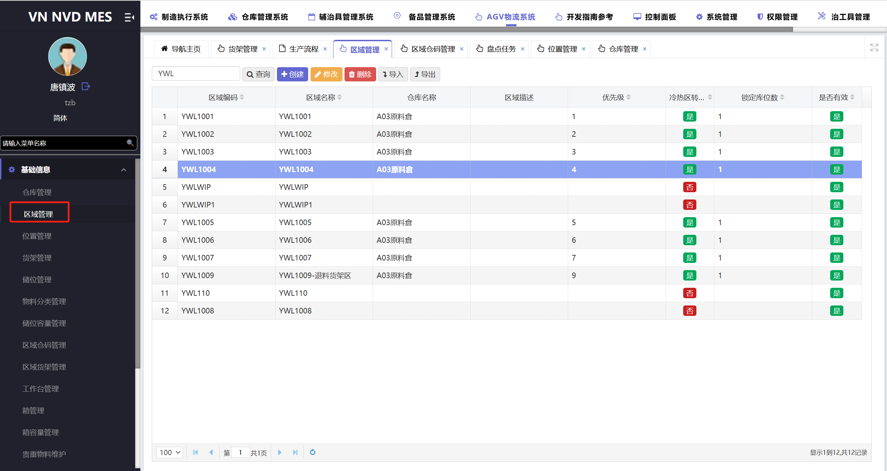
- 数据库更新货架数据，设置冷热区货架，更改允许冷热区转入，设置仓库编码为对应AGV仓库
UPDATE a SET a.ashl_transferable = 1, awhi_code = 'Material-A03'
FROM dbo.AGV_Shelves a
WHERE a.aare_stock_code LIKE 'YWL10%'
AND a.isdelete = 0;
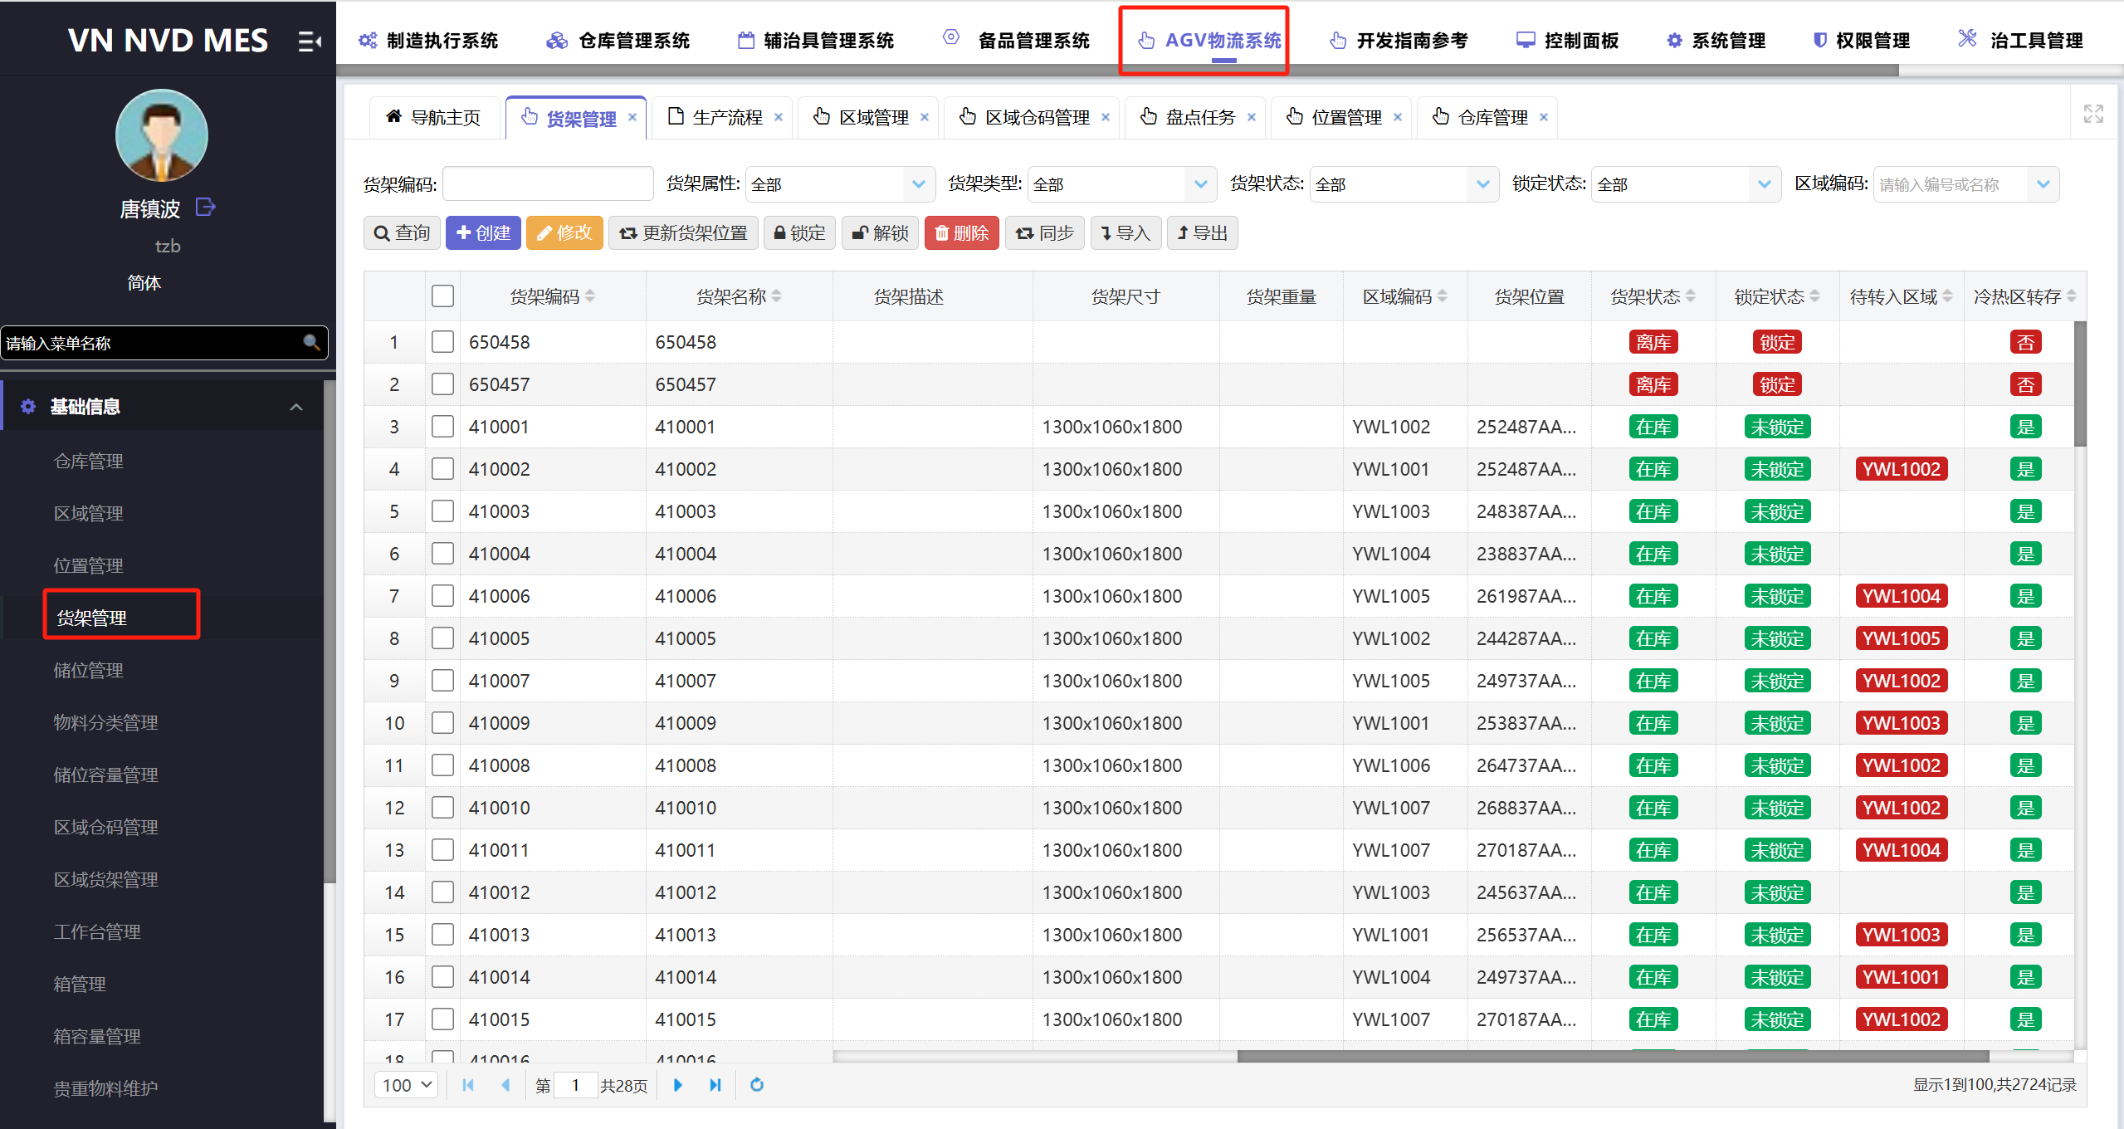
3.配置【区域货架】关系，允许指定类型的货架存放对应区域
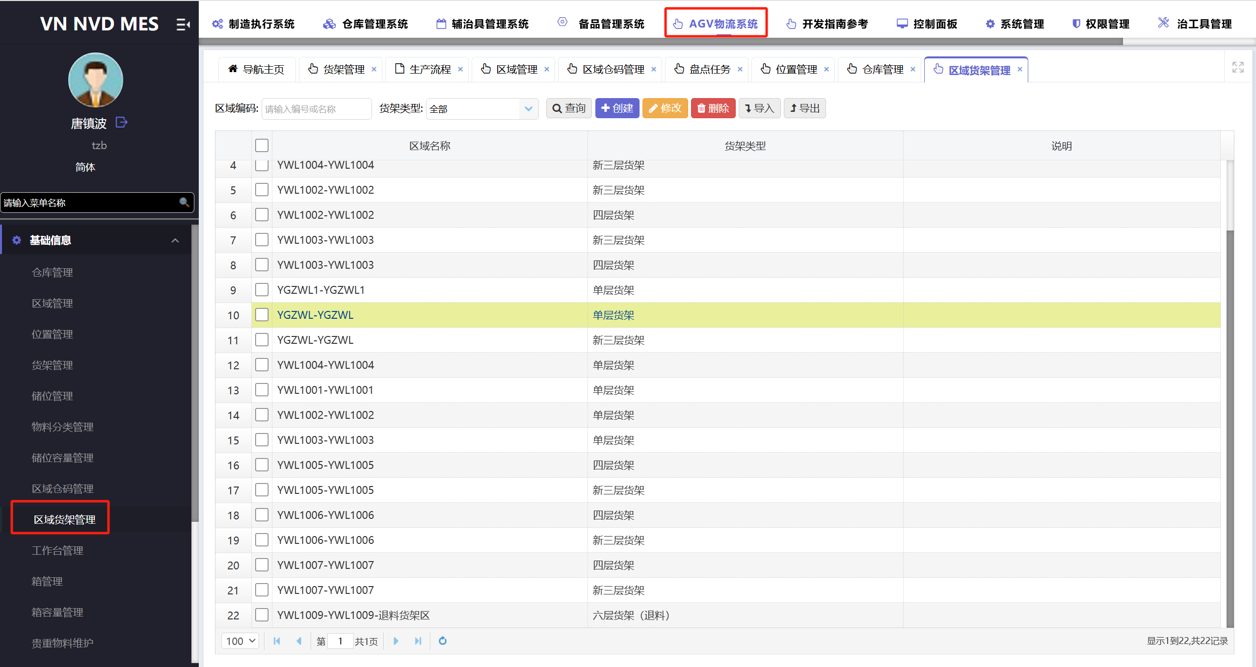
4.配置【区域仓码】关系，允许指定仓码的货架存放对应区域
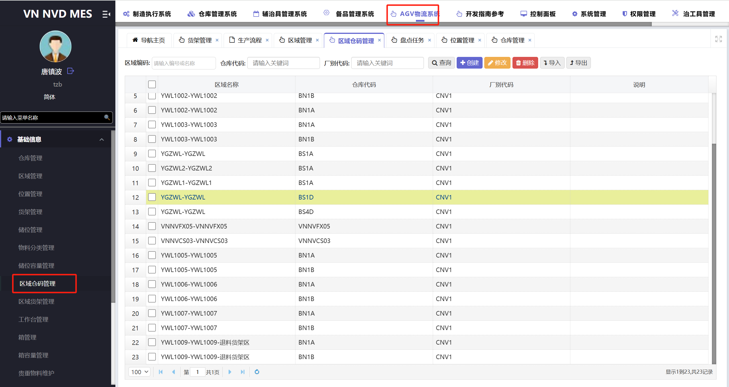
- 部署冷热区调度代理作业
定时作业：J_AGV_Shelf_TransferArea_AutoSync
执行计划：设置每天早上8点自动执行一次冷热区调整
注：部署完成，先手动执行一次，及时更新冷热区调度
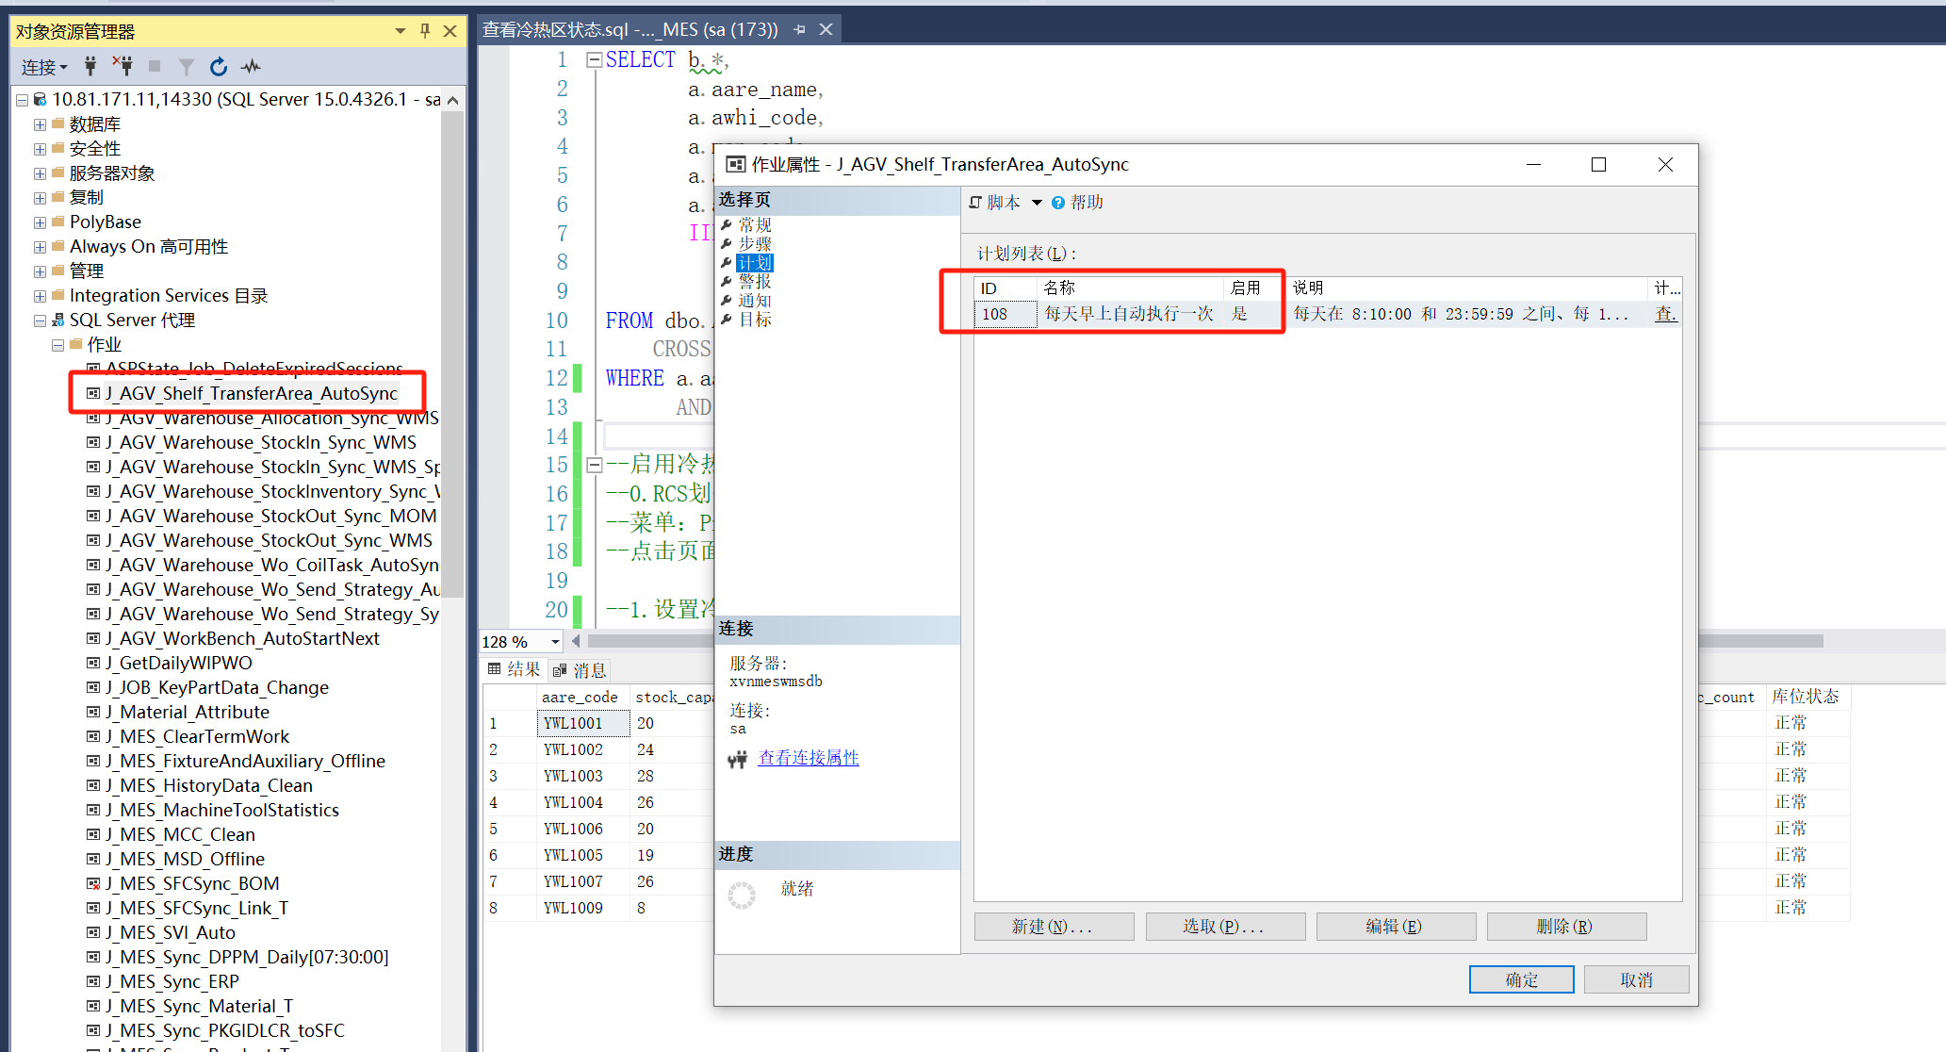

三：冷热区货架存放状态
- 查询脚本
SELECT b.aare_code AS [区域编码],
a.aare_name AS [区域名称],
b.stock_capacity AS [区域总库位数],
b.stock_used AS [已关联货架数],
b.stock_in AS [在库货架数],
b.stock_transfer AS [待转入货架数],
a.awhi_code AS [AGV仓库编码],
a.map_code AS [AGV地图编码],
a.aare_priority AS [优先级],
a.aare_lock_loc_count AS [锁定库位数],
IIF(b.stock_capacity >= b.stock_used + ISNULL(a.aare_lock_loc_count,0),
N'正常',
IIF(b.stock_capacity >= b.stock_used, N'满仓', N'爆仓')) AS [区域储位状态]
FROM dbo.AGV_Area a
CROSS APPLY dbo.FT_AGV_Area_GetStockInfo(a.aare_code) b
WHERE a.aare_transferable = '1'
AND a.isdelete = 0;
