Air Defense System using Ultrasonic Sensors

Abstract
This project is to design and construct automatic missile detection and destroying system. The system is designed to detect the target (missile) moving in multiple directions. The destroying system moves automatically in the direction of missile and fires it upon fixing the target. This system consists of a SONAR based object tracking system that continuously monitors the target. Upon detecting the target it sends the target's location to a Central Control System. The Central Control System takes the action of moving the firing mechanism in the direction of target missile . Upon fixing the direction, it sends the control command to firing system to attack the target.

Chapter 1: Introduction

War is an organized armed conflict that is carried out by states, nations, national and social groups.
This ultrasonic proximity detector comprising independent, battery or AC powered transmitter and receiver section make use of a pair of matched ultrasonic piezo ceramic transducers each operating at around 40 kHz. This circuit is used to get reflected signals of 40 KHz from the a missile to feed that to a program to the microcontroller to switch on appropriate load while the program is executed at the microcontroller end. When the AVR microcontroller receives the signal from ultrasonic receiver it activates the door gun by triggering the gate of MOSFET through a transistor. The power supply consists of a step down transformer 230/12V, which steps down the voltage to 12V AC. Then this is converted to DC using a Bridge rectifier. The ripples are then removed using a capacitive filter and it is then regulated to +5V using a voltage regulator 7805 which is required for the operation of the microcontroller and other components.The ultrasonic proximity detector comprising independent, battery or AC powered transmitter and receiver sections make use of a pair of matched ultrasonic piezo ceramic transducers each operating at around 40 kHz each. This circuit is used to get reflected signals of 40 KHz from the object (here a missile) to feed that to a program to the microcontroller. OpAmps are used for amplification of the weak signals received upon reflection from the obstacle, by the receiving ultrasonic transducer sent by the transmitting one, to switch on appropriate load while the program is executed at the microcontroller end. The project consist of the ultrasonic transmitter and receiver each of which works for the frequency of 40 kHz. At the receiver side the received signal is amplified and given to the microcontroller which is used as to operate the relay driver (ULN2003) for operating the relay to drive the loads. The power supply consists of a step down transformer 230/12V AC which is converted to DC using a Bridge rectifier. The ripples present are removed using a capacitive filter and it is then regulated to +5V using a voltage regulator 7805 which is required for the proper operation of the microcontroller and other components.
Target acquisition and tracking are frequent domains of active sensing methods such as RADAR, Ultra-sound, or LASER scanning. The ability to track targets at manipulation range can significantly reduce the cost and complexity of manipulator control. Ultrasonic sensors, in particular, provide an ideal platform for experimental development in range detection. They are cheap, readily available, and increasingly possessed of high-resolution sensors. Its various Applications range from robotic security systems to environments such as production lines where distance measurement and obstacle measurement and manipulation of objects are routine tasks with potential for wide-scale automation and defence. Here, a robotic platform along with a stepper motor fitted with ultrasonic sensor is used to automatically locate and aim at a stationary target, moving target at a pre-defined range and destroying it successfully. Let’s us, we summarize the project's main advances and indicate possible directions for future work, thus
1. The main objectives of this project are: Monitoring the moving target.
2. Real time monitoring of target
3. Works in any lighting conditions.
4. Automatic target attacking.
5. Controlling the robot using IOT.

Block Diagram

POWER SUPPLY 12V DC

MOTOR DRIVER L298D

NODE MCU 1.0

DC GEAR MOTOR FOR WHEEL
RELAY

MICRO CONTROLLER
ATmega328
ULTRA SONIC SENSOR

LCD 16X2
BUZZER

RELAY
POWER SUPPLY 12V DC
HEATER

PCB LAYOUT
1:-Motor driver and ultrasonic sensor PCB

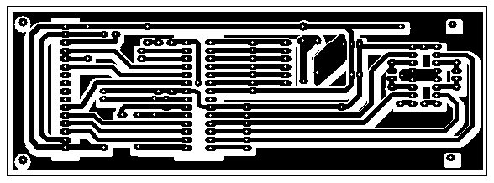

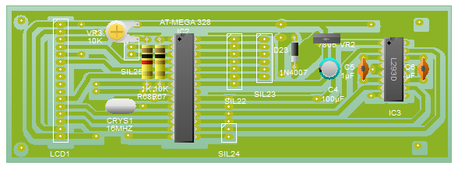

Chapter 2: PROGRAM CODE

#include<LiquidCrystal.h>
LiquidCrystal lcd(2, 3, 4, 5, 6, 7);
#include <Servo.h>

int temp = 0, i;
int fires = 0;
int ROP = 0;
// myservo.write(0);
// myservo2.write(0);
char str[15];
int duration, distance;
Servo myservo;
Servo myservo2;

int pos = 0;
int pos2 = 0;

int roun = 0;

# define sound A2
# define fire 9
# define trigger A0
# define echo A1
# define led 13

void setup()
{

myservo.attach(10);
myservo2.attach(11);

pinMode(sound, OUTPUT);
pinMode(fire, OUTPUT);

pinMode(trigger, OUTPUT);
pinMode(echo, INPUT);
pinMode(led, OUTPUT);

lcd.begin(16, 2);
Serial.begin(9600);

digitalWrite(sound, LOW);
digitalWrite(fire, LOW);
//digitalWrite(sel2,LOW);

lcd.clear();
lcd.print("WELCOME");
lcd.setCursor(0, 1);
lcd.print("SATI VIDISHA");
delay(3000);

gsm_init();

lcd.clear();
lcd.print("SYSTEM READY");
Serial.println("AT+CNMI=2,2,0,0,0");
delay(500);
Serial.println("AT+CMGF=1");
delay(1000);
myservo.write(0);
myservo2.write(0);
start();
}

void loop()
{ serialEvent();
ultra();

lcd.clear();
lcd.print("DISTANCE ");
lcd.setCursor(0, 1);
lcd.print(distance);
delay(3000);

lcd.clear();

// if (digitalRead(8))

{
for (pos = 0; pos <= 180; pos += 5)
{ myservo.write(pos);
delay(05);
{
for (pos2 = 0; pos2 <= 60; pos2 += 1)
{
myservo2.write(pos2);
delay(05);
serialEvent();
ultra();

}

for (pos2 = 60; pos2 >= 0; pos2 -= 1)
{
myservo2.write(pos2);
delay(05);
serialEvent();
ultra();

}
}
}

for (pos = 180; pos >= 0; pos -= 5)
{ myservo.write(pos);
delay(05);

{
for (pos2 = 0; pos2 <= 60; pos2 += 1)
{
myservo2.write(pos2);
delay(05);
serialEvent();
ultra();

}

for (pos2 = 60; pos2 >= 0; pos2 -= 1)
{
myservo2.write(pos2);
delay(05);
serialEvent();
ultra();

}
}
}
}

}

void serialEvent()
{
while (Serial.available())
{
if (Serial.find("#A.HIT ON"))
{
digitalWrite(sound, HIGH);
delay(100);
digitalWrite(sound, LOW);
delay(100);

{
lcd.clear();
lcd.print("MSG RECIEVE");
delay(1000);

digitalWrite(sound, HIGH);
delay(1000);

digitalWrite(sound, LOW);
fires = 1;

alertp();
}

}
}
}

void check()
{
if (!(strncmp(str, "HIT ON", 6))) // #A.light on*

{
lcd.clear();
lcd.print("MSG RECIEVE");
delay(1000);

digitalWrite(sound, HIGH);
delay(1000);

digitalWrite(sound, LOW);
fires = 1;
}

}

void gsm_init()
{
lcd.clear();
lcd.print("Finding Module..");
boolean at_flag = 1;
while (at_flag)
{
Serial.println("AT");
while (Serial.available() > 0)
{
if (Serial.find("OK"))
at_flag = 0;
}

delay(1000);
}
lcd.clear();
lcd.print("Module Connected..");
delay(1000);
lcd.clear();
lcd.print("Disabling ECHO");
boolean echo_flag = 1;
while (echo_flag)
{
Serial.println("ATE0");
while (Serial.available() > 0)
{
if (Serial.find("OK"))
echo_flag = 0;
}
delay(1000);
}

lcd.clear();
lcd.print("Echo OFF");
delay(1000);
lcd.clear();
lcd.print("Finding Network..");
boolean net_flag = 1;
while (net_flag)
{
Serial.println("AT+CPIN?");
while (Serial.available() > 0)
{
if (Serial.find("+CPIN: READY"))
net_flag = 0;
}
delay(1000);
}
lcd.clear();
lcd.print("Network Found..");
delay(1000);
lcd.clear();
}

void init_sms()
{
Serial.println("AT+CMGF=1");
delay(400);
Serial.println("AT+CMGS=\"+918517930065\""); // use your 10 digit cell no. here9770398127
delay(400);
}

void init_smsa()
{
Serial.println("AT+CMGF=1");
delay(400);
Serial.println("AT+CMGS=\"+917869752953\""); // use your 10 digit cell no. here
delay(400);
}

void send_data(String message)
{
Serial.println(message);
delay(200);
}
void send_sms()
{
Serial.write(26);
}
void lcd_status()
{ lcd.clear();
lcd.print("Message Sending");
delay(2000);
lcd.clear();
lcd.print("Message Sent");
delay(2000);
lcd.clear();
lcd.print("System Ready");
return;
}

void alert()
{
init_sms();
send_data("MISSILE LAUNCHER ALERT-");
send_data("Target loction Vertical: ");
Serial.println(pos);
send_data("Horizontal: ");
Serial.println(pos2);

send_data("Distance:");
Serial.println(distance);
send_data(" THANKU ");
send_sms();
delay(3000);
lcd_status();

init_smsa();
send_data("MISSILE LAUNCHER ALERT-");
send_data("Target loction -- Vertical: ");
Serial.println(pos);
send_data("Horizontal: ");
Serial.println(pos2);

send_data("Distance:");
Serial.println(distance);
send_data(" THANKU ");
send_sms();
delay(3000);
lcd_status();
}

send_sms();
delay(3000);
lcd_status();

init_smsa();
send_data("MISSILE LAUNCHER ALERT-");
send_data("Target finished at loction Vertical: ");
Serial.println(pos);
send_data("Horizontal: ");
Serial.println(pos2);

send_data("Distance:");
Serial.println(distance);

send_data(" THANKU ");
send_sms();
delay(3000);
lcd_status();
}

void alertp()
{
init_sms();
send_data("MISSILE LAUNCHER ALERT-");
send_data("AUTOMATED MODE ON ");
// Serial.println(pos);
// send_data("Horizontal: ");
// Serial.println(pos2);
// send_data(" THANKU ");
send_sms();
delay(3000);
lcd_status();

init_smsa();
send_data("MISSILE LAUNCHER ALERT-");
send_data("MISSILE LAUNCHER ALERT-");
send_data("AUTOMATED MODE ON ");
send_sms();
delay(3000);
lcd_status();
}

void start()
{
init_sms();
send_data("MISSILE LAUNCHER ALERT-");
send_data("SYSTEM ACTIVE ");
// Serial.println(pos);
// send_data("Horizontal: ");
// Serial.println(pos2);
// send_data(" THANKU ");
send_sms();
delay(3000);
lcd_status();

init_smsa();

send_data("MISSILE LAUNCHER ALERT-");
send_data("SYSTEM ACTIVE ");
send_sms();
delay(3000);
lcd_status();
}

void ultra()

{
//int duration, distance; // Output pulse with 1ms width on trigPin
digitalWrite(trigger, HIGH);
delay(1);
digitalWrite(trigger, LOW); // Measure the pulse input in echo pin
duration = pulseIn(echo, HIGH); // Distance is half the duration devided by 29.1 (from datasheet)
distance = (duration / 2) / 29.1;

lcd.clear();
lcd.print("DISTANCE:");
lcd.print(distance);
lcd.setCursor(0, 1);
lcd.print(pos);
lcd.print(" ");
lcd.print(pos2);

lcd.print(" PRMSN:");
lcd.print(fires);
delay(15);

lcd.clear();

if (distance <= 50 && distance >= 0)
{
if (fires == 1)
{ digitalWrite(sound, HIGH);
digitalWrite(fire, HIGH);
delay(8000);
digitalWrite(fire, LOW);
digitalWrite(sound, LOW);
delay(2000);
fires = 0;
ROP=1;
attack();
}

if (ROP == 0)

{ digitalWrite(sound, HIGH);
readd();
digitalWrite(sound, LOW);}
}
ROP=0;
}

void readd()
{

lcd.clear();
lcd.print("DISTANCE:");
lcd.print(distance);
lcd.setCursor(0, 1);
lcd.print(pos);
lcd.print(" ");
lcd.print(pos2);

lcd.print("PRMSN:");
lcd.print(fires);
delay(2000);
alert();
}

SOFTWARE USE IN PROJECT

SOFTWARE USE FOR CIRCUIT DESIGN
1:-PROTEUS
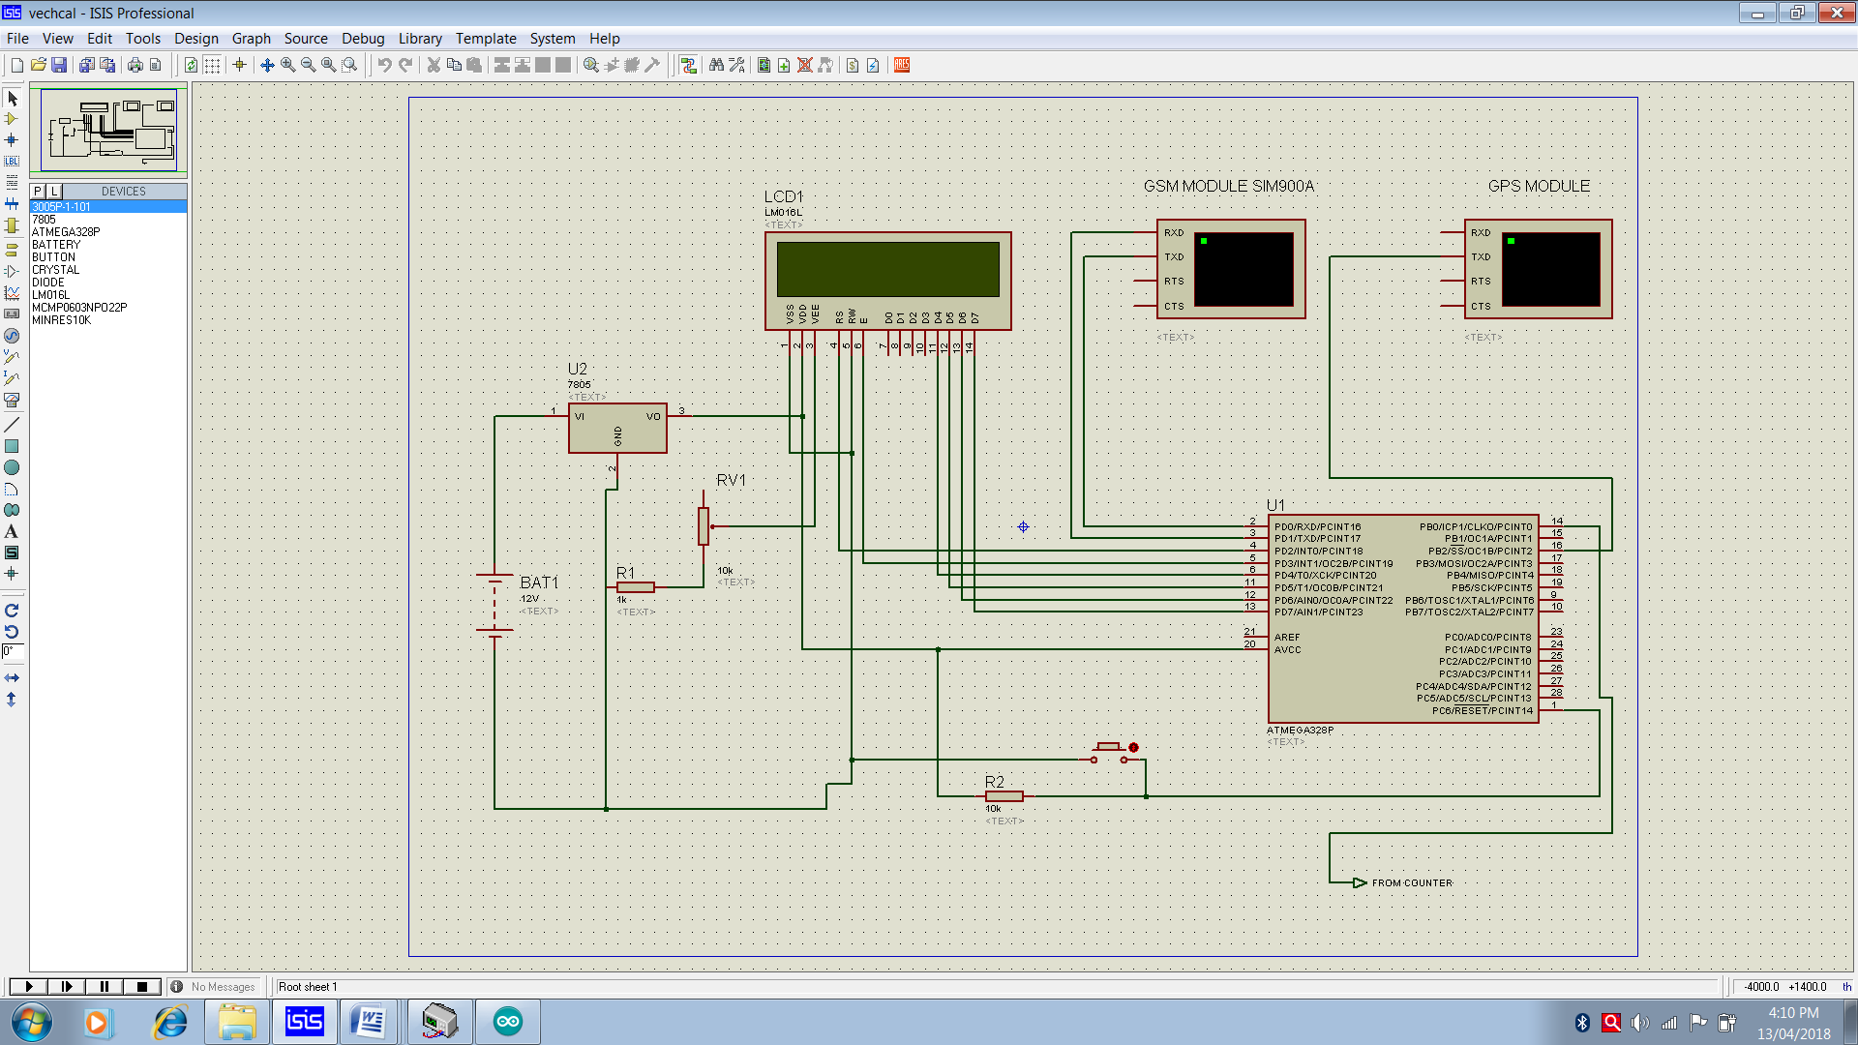

SOFTWARE USE FOR PCB LAYOUT DESIGN
1:-CIRCUIT WIZARD
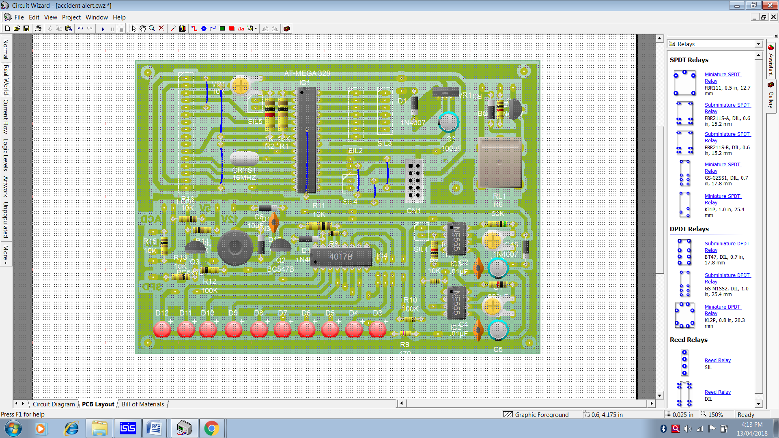
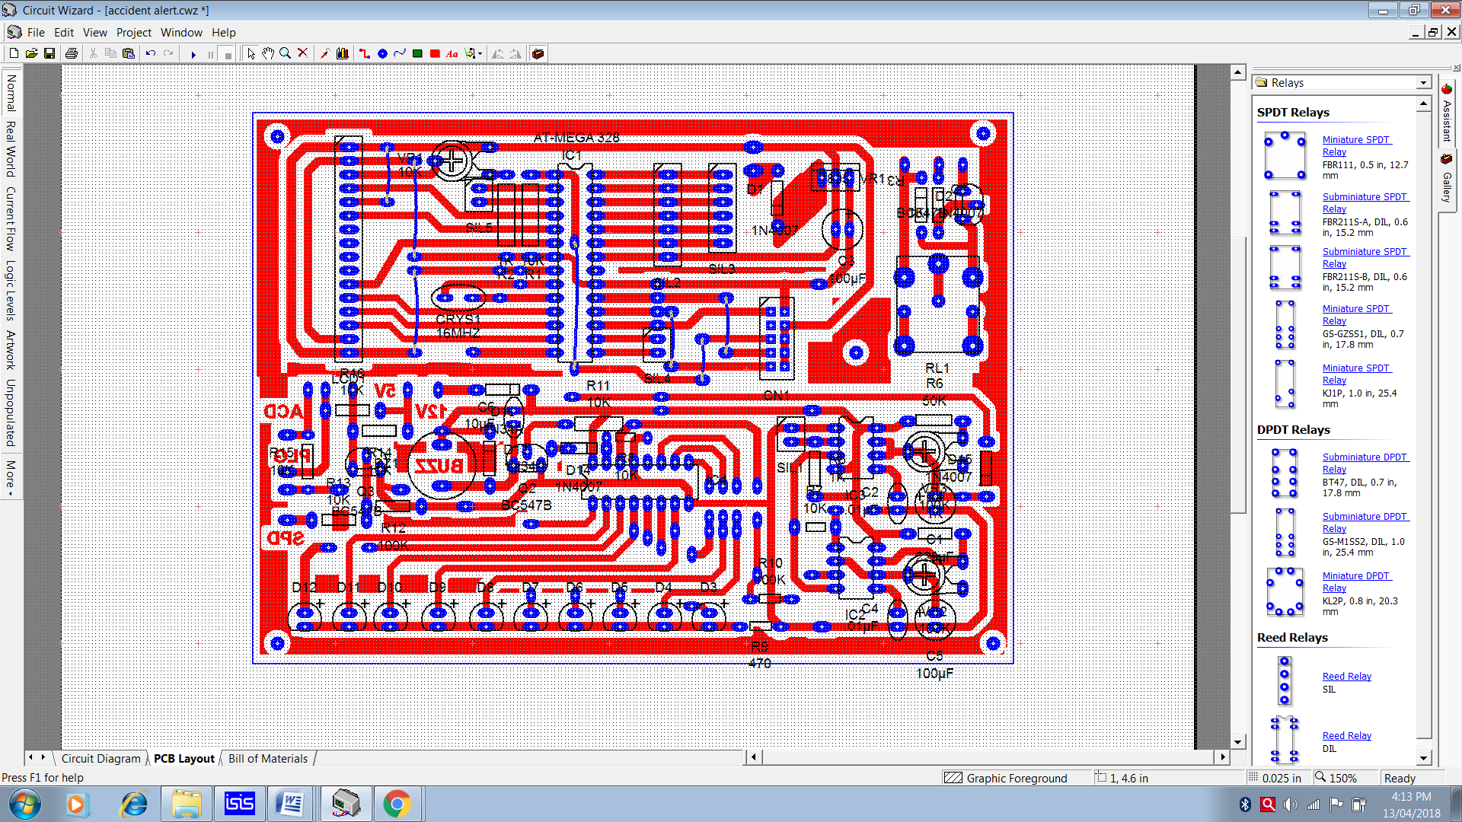

SOFTWARE USE FOR PROGRAMING
1:-Arduino Id
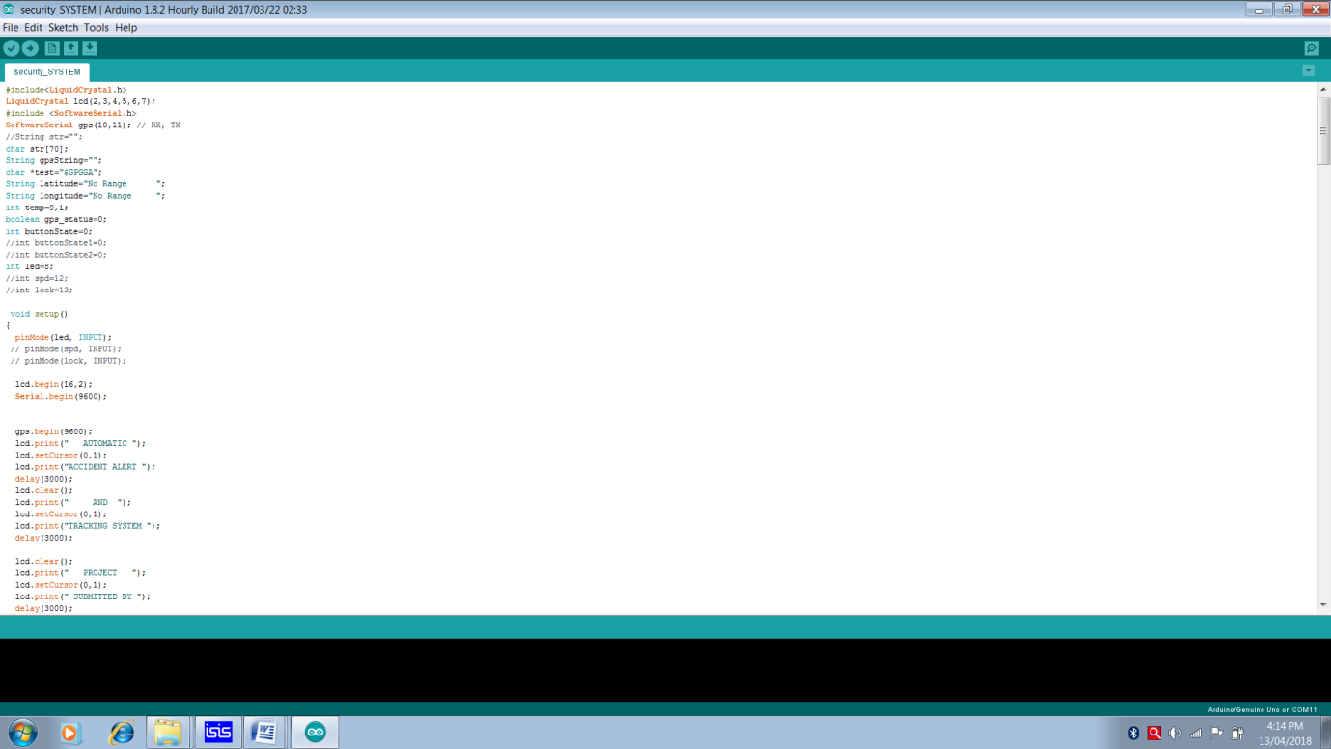
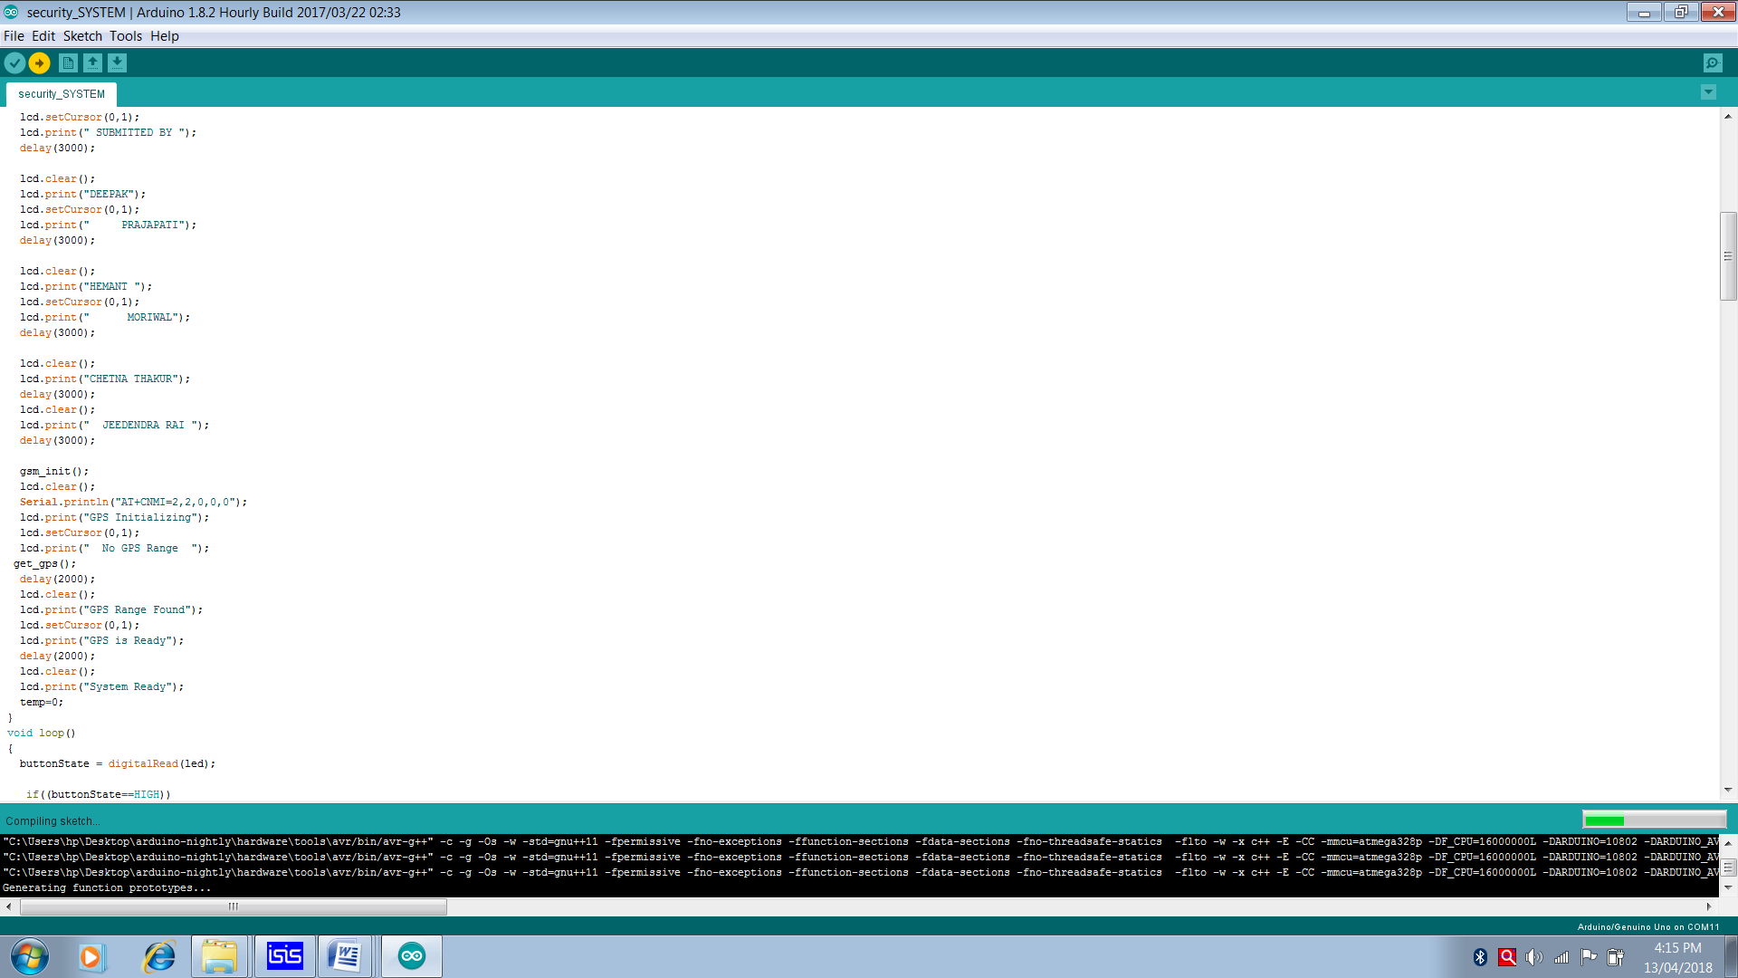

Chapter 3: PRINTED CIRCUIT BOARD DESIGN

A printed circuit board, or PCB, is used to mechanically support and electrically connect electronic components using conductive pathways, tracks or signal traces etched from copper sheets laminated onto a non-conductive substrate. It is also referred to as printed wiring board (PWB) or etched wiring board. A PCB populated with electronic components is a printed circuit assembly (PCA), also known as a printed circuit board assembly (PCBA). Printed circuit boards are used in virtually all but the simplest commercially-produced electronic devices. PCBs are inexpensive, and can be highly reliable. They require much more layout effort and higher initial cost than either wire wrap or point-to-point construction, but are much cheaper and faster for high-volume production; the production and soldering of PCBs can be done by totally automated equipment. Much of the electronics industry's PCB design, assembly, and quality control needs are set by standards that are published by the IPC organization.

Chemical etching
Chemical etching is done with ferric chloride, ammonium per sulfate, or sometimes hydrochloric acid. For PTH (plated-through holes), additional steps of electro less deposition are done after the holes are drilled, then copper is electroplated to build up the thickness, the boards are screened, and plated with tin/lead. The tin/lead becomes the resist leaving the bare copper to be etched away. The simplest method, used for small scale production and often by hobbyists, is immersion etching, in which the board is submerged in etching solution such as ferric chloride. Compared with methods used for mass production, the etching time is long. Heat and agitation can be applied to the bath to speed the etching rate. In bubble etching, air is passed through the etchant bath to agitate the solution and speed up etching. Splash etching uses a motor-driven paddle to splash boards with etchant; the process has become commercially obsolete since it is not as fast as spray etching. In spray etching, the etchant solution is distributed over the boards by nozzles, and recirculated by pumps. Adjustment of the nozzle pattern, flow rate, temperature, and etchant composition gives predictable control of etching rates and high production rates.
As more copper is consumed from the boards, the etchant becomes saturated and less effective; different etchants have different capacities for copper, with some as high as 150 grams of copper per litre of solution. In commercial use, etchants can be regenrated to restore their activity, and the dissolved copper recovered and sold. Small-scale etching requires attention to disposal of used etchant, which is corrosive and toxic due to its metal content.
The etchant removes copper on all surfaces exposed by the resist. "Undercut" occurs when etchant attacks the thin edge of copper under the resist; this can reduce conductor widths and cause open-circuits. Careful control of etch time is required to prevent undercut. Where metallic plating is used as a resist, it can "overhang" which can cause short-circuits between adjacent traces when closely spaced. Overhang can be removed by wire-brushing the board after etching.

Lamination
Some PCBs have trace layers inside the PCB and are called multi-layer PCBs. These are formed by bonding together separately etched thin boards.

Drilling
Holes through a PCB are typically drilled with small-diameter drill bits made of solid coated tungsten carbide. Coated tungsten carbide is recommended since many board materials are very abrasive and drilling must be high RPM and high feed to be cost effective. Drill bits must also remain sharp to not mar or tear the traces. Drilling with high-speed-steel is simply not feasible since the drill bits will dull quickly and thus tear the copper and ruin the boards. The drilling is performed by automated drilling machines with placement controlled by a drill tape or drill file. These computer-generated files are also called numerically controlled drill (NCD) files or "Excellon files". The drill file describes the location and size of each drilled hole. These holes are often filled with annular rings (hollow rivets) to create vias. Vias allow the electrical and thermal connection of conductors on opposite sides of the PCB. When very small vias are required, drilling with mechanical bits is costly because of high rates of wear and breakage. In this case, the vias may be evaporated by lasers. Laser-drilled vias typically have an inferior surface finish inside the hole. These holes are called micro vias. It is also possible with controlled-depth drilling, laser drilling, or by pre-drilling the individual sheets of the PCB before lamination, to produce holes that connect only some of the copper layers, rather than passing through the entire board. These holes are called blind vias when they connect an internal copper layer to an outer layer, or buried vias when they connect two or more internal copper layers and no outer layers.
The walls of the holes, for boards with 2 or more layers, are made conductive then plated with copper to form plated-through holes that electrically connect the conducting layers of the PCB. For multilayer boards, those with 4 layers or more, drilling typically produces a smearof the high temperature decomposition products of bonding agent in the laminate system. Before the holes can be plated through, this smear must be removed by a chemical de-smear process, or by plasma-etch. Removing (etching back) the smear also reveals the interior conductors as well.

Chapter 4: PARTS USE IN PROJECT

- Electrical resistance

The electrical resistance of an electrical conductor is the opposition to the passage of an electric current through that conductor. The inverse quantity is electrical conductance, the ease with which an electric current passes. Electrical resistance shares some conceptual parallels with the mechanical notion of friction. The SI unit of electrical resistance is the ohm (Ω), while electrical conductance is measured in Siemens (S).
An object of uniform cross section has a resistance proportional to its resistivity and length and inversely proportional to its cross-sectional area. All materials show some resistance, except for superconductors, which have a resistance of zero.
The resistance (R) of an object is defined as the ratio of voltage across it (V) to current through it (I), while the conductance (G) is the inverse:
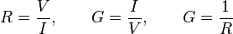
For a wide variety of materials and conditions, V and I are directly proportional to each other, and therefore R and G are constant (although they can depend on other factors like temperature or strain). This proportionality is called Ohm's law, and materials that satisfy it are called "Ohmic" materials.
In other cases, such as a diode or battery, V and I are not directly proportional, or in other words the I–V curve is not a straight line through the origin, and Ohm's law does not hold. In this case, resistance and conductance are less useful concepts, and more difficult to define. The ratio V/I is sometimes still useful, and is referred to as a "chordal resistance" or "static resistance",^{[1][2]} as it corresponds to the inverse slope of a chord between the origin and an I–V curve. In other situations, the derivative may be most useful; this is called the "differential resistance

- Capacitor

A capacitor (originally known as a condenser) is a passive two-terminal electrical component used to store energy electrostatically in an electric field. The forms of practical capacitors vary widely, but all contain at least two electrical conductors (plates) separated by a dielectric (i.e., insulator). The conductors can be thin films of metal, aluminum foil or disks, etc. The 'non conducting' dielectric acts to increase the capacitor's charge capacity. A dielectric can be glass, ceramic, plastic film, air, paper, mica, etc. Capacitors are widely used as parts of electrical circuits in many common electrical devices. Unlike a resistor, a capacitor does not dissipate energy. Instead, a capacitor stores energy in the form of an electrostatic field between its plates.
When there is a potential difference across the conductors (e.g., when a capacitor is attached across a battery), an electric field develops across the dielectric, causing positive charge (+Q) to collect on one plate and negative charge (-Q) to collect on the other plate. If a battery has been attached to a capacitor for a sufficient amount of time, no current can flow through the capacitor. However, if an accelerating or alternating voltage is applied across the leads of the capacitor, a displacement current can flow.
An ideal capacitor is characterized by a single constant value for its capacitance. Capacitance is expressed as the ratio of the electric charge (Q) on each conductor to the potential difference (V) between them. The SI unit of capacitance is the farad (F), which is equal to one coulomb per volt (1 C/V). Typical capacitance values range from about 1 pF (10⁻¹² F) to about 1 mF (10⁻³ F).
The capacitance is greater when there is a narrower separation between conductors and when the conductors have a larger surface area. In practice, the dielectric between the plates passes a small amount of leakage current and also has an electric field strength limit, known as the breakdown voltage. The conductors and leads introduce an undesired inductance and resistance.
Capacitors are widely used in electronic circuits for blocking direct current while allowing alternating current to pass. In analog filter networks, they smooth the output of power supplies. In resonant circuits they tune radios to particular frequencies. In electric power transmission systems they stabilize voltage and power flow.

- P–n junction diode
A p–n junction is a boundary or interface between two types of semiconductor material, p-type and n-type, inside a single crystal of semiconductor. It is created by doping, for example by ion implantation, diffusion of dopants, or by epitaxy (growing a layer of crystal doped with one type of dopant on top of a layer of crystal doped with another type of dopant). If two separate pieces of material were used, this would introduce a grain boundary between the semiconductors that severely inhibits its utility by scattering the electrons and holes. p–n junctions are elementary "building blocks" of most semiconductor electronic devices such as diodes, transistors, solar cells, LEDs, and integrated circuits; they are the active sites where the electronic action of the device takes place. For example, a common type of transistor, the bipolar junction transistor, consists of two p–n junctions in series, in the form n–p–n or p–n–p.
Properties of a p–n junction
The p–n junction possesses some interesting properties that have useful applications in modern electronics. A p-doped semiconductor is relatively conductive. The same is true of an n-doped semiconductor, but the junction between them can become depleted of charge carriers, and hence non-conductive, depending on the relative voltages of the two semiconductor regions. By manipulating this non-conductive layer, p–n junctions are commonly used as diodes: circuit elements that allow a flow of electricity in one direction but not in the other (opposite) direction. This property is explained in terms of forward bias and reverse bias, where the term bias refers to an application of electric voltage to the p–n junction.
PN junction operation in forward-bias mode, showing reducing depletion width. Both p and n junctions are doped at a 1e15/cm3 doping level, leading to built-in potential of ~0.59 V. Reducing depletion width can be inferred from the shrinking charge profile, as fewer dopants are exposed with increasing forward bias.With a battery connected this way, the holes in the P-type region and the electrons in the N-type region are pushed toward the junction. This reduces the width of the depletion zone. The positive potential applied to the P-type material repels the holes, while the negative potential applied to the N-type material repels the electrons. As electrons and holes are pushed toward the junction, the distance between them decreases. This lowers the barrier in potential. With increasing forward-bias voltage, the depletion zone eventually becomes thin enough that the zone's electric field cannot counteract charge carrier motion across the p–n junction, as a consequence reducing electrical resistance. The electrons that cross the p–n junction into the P-type material (or holes that cross into the N-type material) will diffuse in the near-neutral region. Therefore, the amount of minority diffusion in the near-neutral zones determines the amount of current that may flow through the diode.Only majority carriers (electrons in N-type material or holes in P-type) can flow through a semiconductor for a macroscopic length. With this in mind, consider the flow of electrons across the junction. The forward bias causes a force on the electrons pushing them from the N side toward the P side. With forward bias, the depletion region is narrow enough that electrons can cross the junction and inject into the P-type material. However, they do not continue to flow through the P-type material indefinitely, because it is energetically favorable for them to recombine with holes. The average length an electron travels through the P-type material before recombining is called the diffusion length, and it is typically on the order of micrometers.Although the electrons penetrate only a short distance into the P-type material, the electric current continues uninterrupted, because holes (the majority carriers) begin to flow in the opposite direction. The total current (the sum of the electron and hole currents) is constant in space, because any variation would cause charge buildup over time (this is Kirchhoff's current law). The flow of holes from the P-type region into the N-type region is exactly analogous to the flow of electrons from N to P (electrons and holes swap roles and the signs of all currents and voltages are reversed).Therefore, the macroscopic picture of the current flow through the diode involves electrons flowing through the N-type region toward the junction, holes flowing through the P-type region in the opposite direction toward the junction, and the two species of carriers constantly recombining in the vicinity of the junction. The electrons and holes travel in opposite directions, but they also have opposite charges, so the overall current is in the same direction on both sides of the diode, as required.The Shockley diode equation models the forward-bias operational characteristics of a p–n junction outside the avalanche (reverse-biased conducting) region.
Reverse bias mode

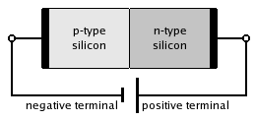
A silicon p–n junction in reverse bias.
Connecting the P-type region to the negative terminal of the battery and theN-type region to the positive terminal corresponds to reverse bias. If a
diode is reverse-biased, the voltage at the cathode is higher than that at the anode. Therefore, no current will flow until the diode breaks down. Reverse-bias usually refers to how a diode is used in a circuit. The connections are illustrated in the diagram to the right.
Because the p-type material is now connected to the negative terminal of the power supply, the 'holes' in the P-type material are pulled away from the junction, causing the width of the depletion zone to increase. Likewise, because the N-type region is connected to the positive terminal, the electrons will also be pulled away from the junction. Therefore, the depletion region widens, and does so increasingly with increasing reverse-bias voltage. This increases the voltage barrier causing a high resistance to the flow of charge carriers, thus allowing minimal electric current to cross the p–n junction. The increase in resistance of the p–n junction results in the junction behaving as an insulator.
The strength of the depletion zone electric field increases as the reverse-bias voltage increases. Once the electric field intensity increases beyond a critical level, the p–n junction depletion zone breaks down and current begins to flow, usually by either the Zener or the avalanche breakdown processes. Both of these breakdown processes are non-destructive and are reversible, as long as the amount of current flowing does not reach levels that cause the semiconductor material to overheat and cause thermal damage.
This effect is used to one's advantage in Zener diode regulator circuits. Zener diodes have a certain – low – breakdown voltage. A standard value for breakdown voltage is for instance 5.6 V. This means that the voltage at the cathode can never be more than 5.6 V higher than the voltage at the anode, because the diode will break down – and therefore conduct – if the voltage gets any higher. This in effect regulates the voltage over the diode.
Another application of reverse biasing is Varicap diodes, where the width of the depletion zone (controlled with the reverse bias voltage) changes the capacitance of the diode.

- Potentiometer
A potentiometer informally a pot, is a three-terminal resistor with a sliding contact that forms an adjustable voltage divider. If only two terminals are used, one end and the wiper, it acts as a variable resistor or rheostat. A potentiometer measuring instrument is essentially a voltage divider used for measuring electric potential (voltage); the component is an implementation of the same principle, hence its name. Potentiometers are commonly used to control electrical devices such as volume controls on audio equipment. Potentiometers operated by a mechanism can be used as position transducers, for example, in a joystick. Potentiometers are rarely used to directly control significant power (more than a watt), since the power dissipated in the potentiometer would be comparable to the power in the controlled load.
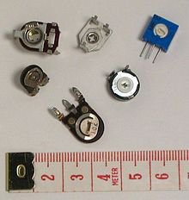

Potentiometer construction
Potentiometers comprise a resistive element, a sliding contact (wiper) that moves along the element, making good electrical contact with one part of it, electrical terminals at each end of the element, a mechanism that moves the wiper from one end to the other, and a housing containing the element and wiper.
Many inexpensive potentiometers are constructed with a resistive element formed into an arc of a circle usually a little less than a full turn and a wiper sliding on this element when rotated, making electrical contact. The resistive element, with a terminal at each end, is flat or angled. The wiper is connected to a third terminal, usually between the other two. On panel potentiometers, the wiper is usually the center terminal of three. For single-turn potentiometers, this wiper typically travels just under one revolution around the contact. The only point of ingress for contamination is the narrow space between the shaft and the housing it rotates in. Another type is the linear slider potentiometer, which has a wiper which slides along a linear element instead of rotating. Contamination can potentially enter anywhere along the slot the slider moves in, making effective sealing more difficult and compromising long-term reliability. An advantage of the slider potentiometer is that the slider position gives a visual indication of its setting. While the setting of a rotary potentiometer can be seen by the position of a marking on the knob, an array of sliders can give a visual impression of, for example, the effect of a multi-band equaliser.
The resistive element of inexpensive potentiometers is often made of graphite. Other materials used include resistance wire, carbon particles in plastic, and a ceramic/metal mixture called cermet. Conductive track potentiometers use conductive polymer resistor pastes that contain hard-wearing resins and polymers, solvents, and lubricant, in addition to the carbon that provides the conductive properties. Others are enclosed within the equipment and are intended to be adjusted to calibrate equipment during manufacture or repair, and not otherwise touched. They are usually physically much smaller than user-accessible potentiometers, and may need to be operated by a screwdriver rather than having a knob. They are usually called "preset potentiometers" or "trim[ming] pots". Some presets are accessible by a small screwdriver poked through a hole in the case to allow servicing without dismantling.
Multi turn potentiometers are also operated by rotating a shaft, but by several turns rather than less than a full turn. Some multi turn potentiometers have a linear resistive element with a sliding contact moved by a lead screw; others have a helical resistive element and a wiper that turns through 10, 20, or more complete revolutions, moving along the helix as it rotates. Multi turn potentiometers, both user-accessible and preset, allow finer adjustments; rotation through the same angle changes the setting by typically a tenth as much as for a simple rotary potentiometer. A string potentiometer is a multi-turn potentiometer operated by an attached reel of wire turning against a spring, enabling it to convert linear position to a variable resistance.User-accessible rotary potentiometers can be fitted with a switch which operates usually at the anti-clockwise extreme of rotation. Before digital electronics became the norm such a component was used to allow radio and television receivers and other equipment to be switched on at minimum volume with an audible click, then the volume increased, by turning a knob. Multiple resistance elements can be ganged together with their sliding contacts on the same shaft, for example, in stereo audio amplifiers for volume control.

- Voltage regulator ic
A voltage regulator is designed to automatically maintain a constant voltage level. A voltage regulator may be a simple "feed-forward" design or may include negative feedback control loops. It may use an electromechanical mechanism, or electronic components. Depending on the design, it may be used to regulate one or more AC or DC voltages. Electronic voltage regulators are found in devices such as computer power supplies where they stabilize the DC voltages used by the processor and other elements. In automobile alternators and central power station generator plants, voltage regulators control the output of the plant. In an electric power distribution system, voltage regulators may be installed at a substation or along distribution lines so that all customers receive steady voltage independent of how much power is drawn from the line.
.
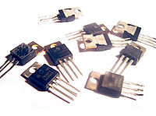
The 78xx (sometimes L78xx, LM78xx, MC78xx...) is a family of self-contained fixed linear voltage regulator integrated circuits. The 78xx family is commonly used in electronic circuits requiring a regulated power supply due to their ease-of-use and low cost. For ICs within the family, the xx is replaced with two digits, indicating the output voltage (for example, the 7805 has a 5 volt output, while the 7812 produces 12 volts). The 78xx line are positive voltage regulators: they produce a voltage that is positive relative to a common ground. There is a related line of 79xx devices which are complementary negative voltage regulators. 78xx and 79xx ICs can be used in combination to provide positive and negative supply voltages in the same circuit. 78xx ICs have three terminals and are commonly found in the TO220 form factor, although smaller surface-mount and larger TO3 packages are available. These devices support an input voltage anywhere from a couple of volts over the intended output voltage, up to a maximum of 35 to 40 volts depending on the make, and typically provide 1 or 1.5 amperes of current (though smaller or larger packages may have a lower or higher current rating).
Part Number | Output Voltage (V) | Minimum Input Voltage (V)
7805 | +5 | 7.3
7806 | +6 | 8.3
7808 | +8 | 10.5
7810 | +10 | 12.5
7812 | +12 | 14.6
7815 | +15 | 17.7
7818 | +18 | 21.0
7824 | +24 | 27.1

- Light-emitting diode
A light-emitting diode (LED) is a two-lead semiconductor light source that resembles a basic pn-junction diode, except that an LED also emits light. When an LED's anode lead has a voltage that is more positive than its cathode lead by at least the LED's forward voltage drop, current flows. Electrons are able to recombine with holes within the device, releasing energy in the form of photons. This effect is called electroluminescence, and the color of the light (corresponding to the energy of the photon) is determined by the energy band gap of the semiconductor. An LED is often small in area (less than 1 mm²), and integrated optical components may be used to shape its radiation pattern. Appearing as practical electronic components in 1962, the earliest LEDs emitted low-intensity infrared light. Infrared LEDs are still frequently used as transmitting elements in remote-control circuits, such as those in remote controls for a wide variety of consumer electronics. The first visible-light LEDs were also of low intensity, and limited to red. Modern LEDs are available across the visible, ultraviolet, and infrared wavelengths, with very high brightness. Early LEDs were often used as indicator lamps for electronic devices, replacing small incandescent bulbs. They were soon packaged into numeric readouts in the form of seven-segment displays, and were commonly seen in digital clocks. Recent developments in LEDs permit them to be used in environmental and task lighting. LEDs have many advantages over incandescent light sources including lower energy consumption, longer lifetime, improved physical robustness, smaller size, and faster switching. Light-emitting diodes are now used in applications as diverse as aviation lighting, automotive headlamps, advertising, general lighting,traffic signals, and camera flashes. However, LEDs powerful enough for room lighting are still relatively expensive, and require more precise current and heat management than compact fluorescent lamp sources of comparable output.
LEDs have allowed new text, video displays, and sensors to be developed, while their high switching rates are also useful in advanced communications technology.
Technology
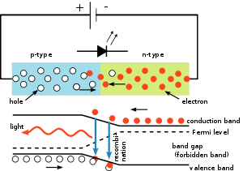
The inner workings of an LED, showing circuit (top) and band diagram (bottom)

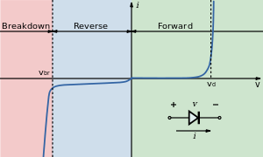

- Transistor
A transistor is a semi-conductor device used to amplify and switch electronic signals and electrical power. It is composed of semiconductor material with at least three terminals for connection to an external circuit. A voltage or current applied to one pair of the transistor's terminals changes the current through another pair of terminals. Because the controlled (output) power can be higher than the controlling (input) power, a transistor can amplify a signal. Today, some transistors are packaged individually, but many more are found embedded in integrated circuits.
The transistor is the fundamental building block of modern electronic devices, and is ubiquitous in modern electronic systems. Following its development in 1947 by John Bardeen, Walter Brattain, and William Shockley, the transistor revolutionized the field of electronics, and paved

Simplified operation
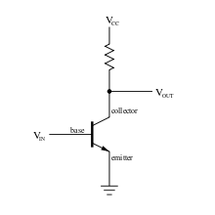
A simple circuit diagram to show the labels of a n–p–n bipolar transistor
The essential usefulness of a transistor comes from its ability to use a small signal applied between one pair of its terminals to control a much larger signal at another pair of terminals. This property is called gain. A transistor can control its output in proportion to the input signal; that is, it can act as an amplifier. Alternatively, the transistor can be used to turn current on or off in a circuit as an electrically controlled switch, where the amount of current is determined by other circuit elements.
There are two types of transistors, which have slight differences in how they are used in a circuit. A bipolar transistor has terminals labeled base, collector, and emitter. A small current at the base terminal (that is, flowing between the base and the emitter) can control or switch a much larger current between the collector and emitter terminals. For a field-effect transistor, the terminals are labeled gate, source, and drain, and a voltage at the gate can control a current between source and drain.
The image to the right represents a typical bipolar transistor in a circuit. Charge will flow between emitter and collector terminals depending on the current in the base. Because internally the base and emitter connections behave like a semiconductor diode, a voltage drop develops between base and emitter while the base current exists. The amount of this voltage depends on the material the transistor is made from, and is referred to as V_{BE}.

Transistor as a switch
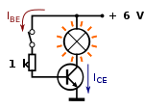
Transistors are commonly used as electronic switches, both for high-power applications such as switched-mode power supplies and for low-power applications such as logic gates.
In a grounded-emitter transistor circuit, such as the light-switch circuit shown, as the base voltage rises, the emitter and collector currents rise exponentially. The collector voltage drops because of reduced resistance from collector to emitter. If the voltage difference between the collector and emitter were zero (or near zero), the collector current would be limited only by the load resistance (light bulb) and the supply voltage. This is called saturation because current is flowing from collector to emitter freely. When saturated, the switch is said to be on. Providing sufficient base drive current is a key problem in the use of bipolar transistors as switches. The transistor provides current gain, allowing a relatively large current in the collector to be switched by a much smaller current into the base terminal. The ratio of these currents varies depending on the type of transistor, and even for a particular type, varies depending on the collector current. In the example light-switch circuit shown, the resistor is chosen to provide enough base current to ensure the transistor will be saturated.

ultrasonic module hc-sr04

The ultrasonic sensor works on the principle of SONAR and RADAR system which is used to determine the distance to an object. An ultrasonic sensor generates the high-frequency sound (ultrasound) waves. When this ultrasound hits the object, it reflects as echo which is sensed by the receiver as shown in below figure.
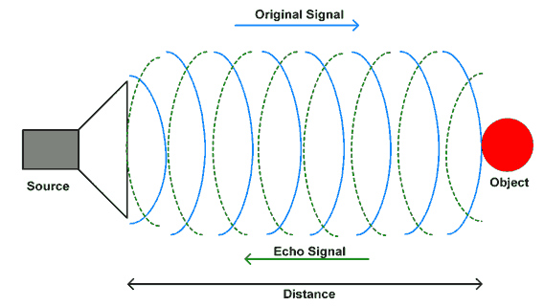
Ultrasonic Working Principle
By measuring the time required for the echo to reach to the receiver, we can calculate the distance. This is the basic working principle of Ultrasonic module to measure distance.
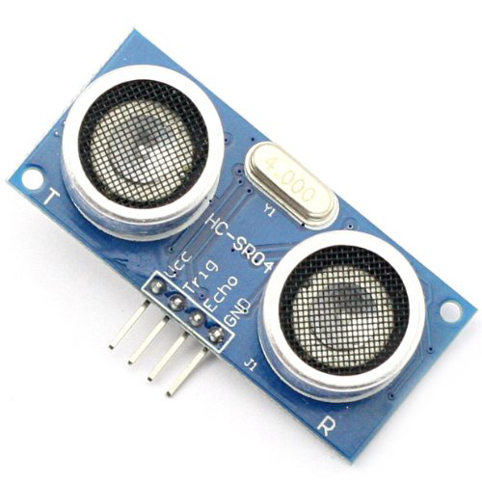
Ultrasonic Module
HC-SR-04 has an ultrasonic transmitter, receiver and control circuit. In ultrasonic module HCSR04, we have to give trigger pulse, so that it will generate ultrasound of frequency 40 kHz. After generating ultrasound i.e. 8 pulses of 40 kHz, it makes echo pin high. Echo pin remains high until it does not get the echo sound back. So the width of echo pin will be the time for sound to travel to the object and return back. Once we get the time we can calculate distance, as we know the speed of sound. HC-SR04 can measure up to range from 2 cm - 400 cm.

HC-SR04 Pin Description
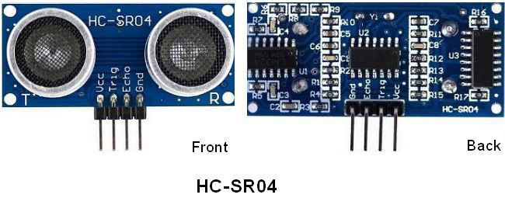
VCC - +5 V supply
TRIG – Trigger input of sensor. Microcontroller applies 10 us trigger pulse to the HC-SR04
ultrasonic module.
ECHO–Echo output of sensor. Microcontroller reads/monitors this pin to detect the obstacle
or to find the distance.
GND – Ground

HC-SR04 Working Principle
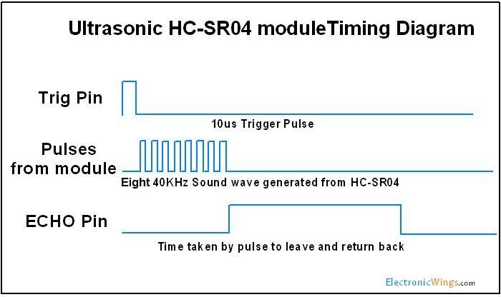
HC-SR04 Ultrasonic Module Timing Diagram
- We need to transmit trigger pulse of at least 10 us to the HC-SR04 Trig Pin.
- Then the HC-SR04 automatically sends Eight 40 kHz sound wave and wait for rising edge output at Echo pin.
- When the rising edge capture occurs at Echo pin, start the Timer and wait for falling edge on Echo pin.
- As soon as the falling edge is captured at the Echo pin, read the count of the Timer. This time count is the time required by the sensor to detect an object and return back from an object.
Now how to calculate distance?
We know that,
The speed of sound waves is 343 m/s.
So,
Total distance is divided by 2 because signal travels from HC-SR04 to object and returns to the module HC-SR-04.

- Relay
A relay is an electrically operated switch. Many relays use an electromagnet to mechanically operate a switch, but other operating principles are also used, such assolid-state relays. Relays are used where it is necessary to control a circuit by a low-power signal (with complete electrical isolation between control and controlled circuits), or where several circuits must be controlled by one signal. The first relays were used in long distance telegraph circuits as amplifiers: they repeated the signal coming in from one circuit and re-transmitted it on another circuit. Relays were used extensively in telephone exchanges and early computers to perform logical operations.
A type of relay that can handle the high power required to directly control an electric motor or other loads is called a contactor. Solid-state relays control power circuits with no moving parts, instead using a semiconductor device to perform switching. Relays with calibrated operating characteristics and sometimes multiple operating coils are used to protect electrical circuits from overload or faults; in modern electric power
Systems these functions are performed by digital instruments still called "protective relays".

Basic design and operation

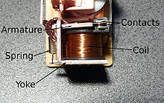

A simple electromagnetic relay consists of a coil of wire wrapped around a soft iron core, an iron yoke which provides a low reluctance path for magnetic flux, a movable iron armature, and one or more sets of contacts (there are two in the relay pictured). The armature is hinged to the yoke and mechanically linked to one or more sets of moving contacts. It is held in place by a spring so that when the relay is de-energized there is an air gap in the magnetic circuit. In this condition, one of the two sets of contacts in the relay pictured is closed, and the other set is open. Other relays may have more or fewer sets of contacts depending on their function. The relay in the picture also has a wire connecting the armature to the yoke. This ensures continuity of the circuit between the moving contacts on the armature, and the circuit track on the printed circuit board (PCB) via the yoke, which is soldered to the PCB.

When an electric current is passed through the coil it generates a magnetic field that activates the armature, and the consequent movement of the movable contact(s) either makes or breaks (depending upon construction) a connection with a fixed contact. If the set of contacts was closed when the relay was de-energized, then the movement opens the contacts and breaks the connection, and vice versa if the contacts were open. When the current to the coil is switched off, the armature is returned by a force, approximately half as strong as the magnetic force, to its relaxed position. Usually this force is provided by a spring, but gravity is also used commonly in industrial motor starters. Most relays are manufactured to operate quickly. In a low-voltage application this reduces noise; in a high voltage or current application it reduces arcing.
When the coil is energized with direct current, a diode is often placed across the coil to dissipate the energy from the collapsing magnetic field at deactivation, which would otherwise generate a voltage spike dangerous to semiconductor circuit components. Some automotive relays include a diode inside the relay case. Alternatively, a contact protection network consisting of a capacitor and resistor in series (snubber circuit) may absorb the surge. If the coil is designed to be energized with alternating current (AC), a small copper "shading ring" can be crimped to the end of the solenoid, creating a small out-of-phase current which increases the minimum pull on the armature during the AC cycle.^{[1]}
A solid-state relay uses a thyristor or other solid-state switching device, activated by the control signal, to switch the controlled load, instead of a solenoid. An opto coupler (a light-emitting diode (LED) coupled with a photo transistor) can be used to isolate control and controlled circuits
Pole and throw type:-
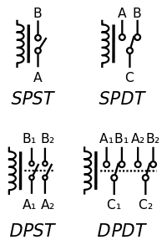
Circuit symbols of relays. (C denotes the common terminal in SPDT and DPDT types.)
Since relays are switches, the terminology applied to switches is also applied to relays; a relay switches one or more poles, each of whose contacts can be thrown by energizing the coil in one of three ways:
- Normally-open (NO) contacts connect the circuit when the relay is activated; the circuit is disconnected when the relay is inactive. It is also called a Form A contact or "make" contact. NO contacts may also be distinguished as "early-make" or NOEM, which means that the contacts close before the button or switch is fully engaged.
- Normally-closed (NC) contacts disconnect the circuit when the relay is activated; the circuit is connected when the relay is inactive. It is also called a Form B contact or "break" contact. NC contacts may also be distinguished as "late-break" or NCLB, which means that the contacts stay closed until the button or switch is fully disengaged.
- Change-over (CO), or double-throw (DT), contacts control two circuits: one normally-open contact and one normally-closed contact with a common terminal. It is also called a Form C contact or "transfer" contact ("break before make"). If this type of contact utilizes a "make before break" functionality, then it is called a Form D contact.

The following designations are commonly encountered:
- SPST – Single Pole Single Throw. These have two terminals which can be connected or disconnected. Including two for the coil, such a relay has four terminals in total. It is ambiguous whether the pole is normally open or normally closed. The terminology "SPNO" and "SPNC" is sometimes used to resolve the ambiguity.
- SPDT – Single Pole Double Throw. A common terminal connects to either of two others. Including two for the coil, such a relay has five terminals in total.
- DPST – Double Pole Single Throw. These have two pairs of terminals. Equivalent to two SPST switches or relays actuated by a single coil. Including two for the coil, such a relay has six terminals in total. The poles may be Form A or Form B (or one of each).
- DPDT – Double Pole Double Throw. These have two rows of change-over terminals. Equivalent to two SPDT switches or relays actuated by a single coil. Such a relay has eight terminals, including the coil.
The "S" or "D" may be replaced with a number, indicating multiple switches connected to a single actuator. For example 4PDT indicates a four pole double throw relay (with 12 terminals).
EN 50005 are among applicable standards for relay terminal numbering; a typical EN 50005-compliant SPDT relay's terminals would be numbered 11, 12, 14, A1 and A2 for the C, NC, NO, and coil connections, respectively.

- Atmega328

ATmega-328 is basically an Advanced Virtual RISC (AVR) micro-controller. It supports the data up to eight (8) bits. ATmega-328 has 32KB internal builtin memory. This micro-controller has a lot of other characteristics. You should also have a look at Introduction to PIC16F877a (it’s a PIC Microcontroller) and then compare functions of these two Microcontrollers.
ATmega 328 has 1KB Electrically Erasable Programmable Read Only Memory (EEPROM). This property shows if the electric supply supplied to the micro-controller is removed, even then it can store the data and can provide results after providing it with the electric supply. Moreover, ATmega-328 has 2KB Static Random Access Memory (SRAM). Other characteristics will be explained later. ATmega 328 has several different features which make it the most popular device in today’s market. These features consist of advanced RISC architecture, good performance, low power consumption, real timer counter having separate oscillator, 6 PWM pins, programmable Serial USART, programming lock for software security, throughput up to 20 MIPS etc. ATmega-328 is mostly used in Arduino. The further details about ATmega 328 will be given later in this section.

- ATmega328 is an 8-bit and 28 Pins AVR Microcontroller, manufactured by Microchip, follows RISC Architecure and has a flash type program memory of 32KB.
- It has an EEPROM memory of 1KB and its SRAM memory is of 2KB.
- It has 8 Pin for ADC operations, which all combines to form PortA ( PA0 – PA7 ).
- It also has 3 builtin Timers, two of them are 8 Bit timers while the third one is 16-Bit Timer.
- You must have heard of Arduino UNO, UNO is based on atmega328 Microcontroller. It’s UNO’s heart.
- It operates ranging from 3.3V to 5.5V but normally we use 5V as a standard.
- Its excellent features include the cost efficiency, low power dissipation, programming lock for security purposes, real timer counter with separate oscillator.
- It’s normally used in Embedded Systems applications. You should have a look at these Real Life Examples of Embedded Systems, we can design all of them using this Microcontroller.
- The following table shows the complete features of ATmega328:

ATmega328 Features
No. of Pins | 28
CPU | RISC 8-Bit AVR
Operating Voltage | 1.8 to 5.5 V
Program Memory | 32KB
Program Memory Type | Flash
SRAM | 2048 Bytes
EEPROM | 1024 Bytes
ADC | 10-Bit
Number of ADC Channels | 8
PWM Pins | 6
Comparator | 1
Packages (4) | 8-pin PDIP  32-lead TQFP  28-pad QFN/MLF  32-pad QFN/MLF
Oscillator | up to 20 MHz
Timer (3) | 8-Bit x 2 & 16-Bit x 1
Enhanced Power on Reset | Yes
Power Up Timer | Yes
I/O Pins | 23
Manufacturer | Microchip
SPI | Yes
I2C | Yes
Watchdog Timer | Yes
Brown out detect (BOD) | Yes
Reset | Yes
USI (Universal Serial Interface) | Yes
Minimum Operating Temperature | -40 C to +85 C

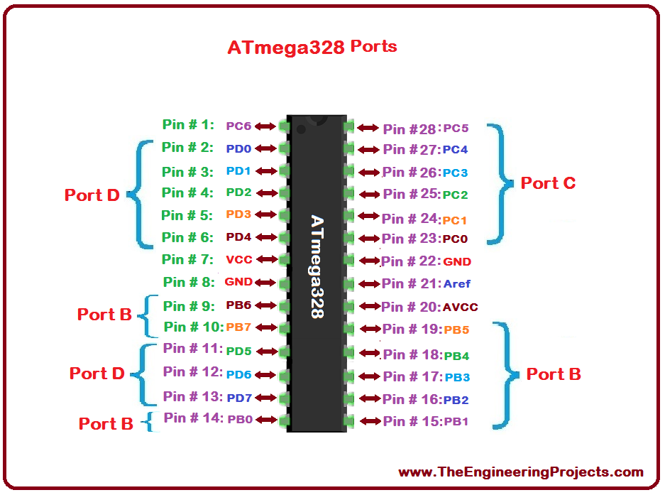

ATmega-328 architecture

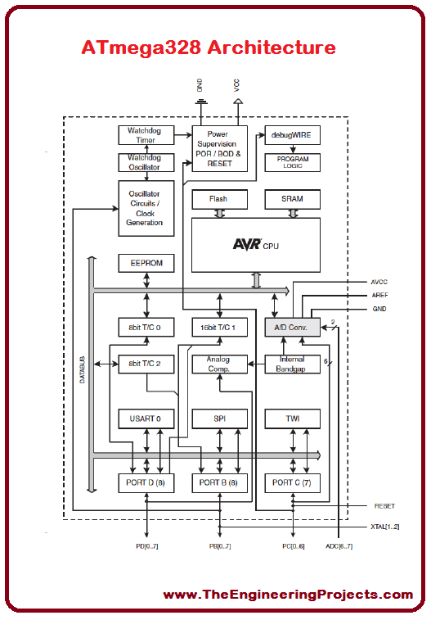

- Crystal Oscillators and Applications

A mechanical or electronic device that works on the principles of oscillation is an oscillator. In other words, oscillator can be defined as the periodic fluctuations between two things based on changes in energy. The practical applications of oscillators include Computers, clocks, watches, radios etc. An example for simple type of mechanical oscillator is a clock pendulum. According to the oscillation within atoms, the atomic clock keeps time. In order to generate signals in computers, wireless receivers and transmitters and audio-frequency equipments, electronic oscillators are mainly used. Particularly it is used in music synthesizers. Different types of electronic oscillators are available. All the electronic oscillators operate according to the same basic principle. An oscillator always employs a sensitive amplifier, whose output signal is fed back to the input signal in phase. Hence, the signal itself regenerates and sustains. This is called as a positive feedback. Thus the oscillator uses a positive feedback for working. This is almost same to the unwanted "howling" in public-address systems.
A quartz crystal determines the frequency at which an oscillator works. When a direct current is applied, these crystals vibrate at a frequency that depends on its thickness value and on the manner in which it is cut from the original mineral rock. To determine the frequency, some oscillators employ combinations of inductors, resistors, and capacitors. But, the use of quartz crystals gives the best stability (constancy of frequency) in oscillators.
In a computer the clock serves as a sort of pacemaker for the microprocessor. The clock is nothing but a specialized oscillator. The clock frequency (also called as clock speed) is usually specified in megahertz (MHz) frequency. The clock frequency is an important factor in determining the rate at which a computer can perform the execution of instructions.

Figure 1 shows the equivalent electronic circuit diagram of a crystal. The equivalent diagram of a crystal consists of a resistor, an inductor and two capacitors. The two capacitors are named as Cs and Cp

- Gsm Sim800L
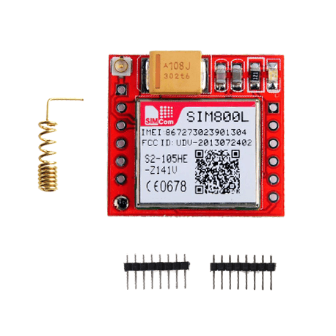

SIM800L Module is a small GSM/GPRS Module and ideal for small ideal projects. The module supports quad-band GSM/GPRS network, available for SMS and GPRS message data remote transmission. The SIM800L communicates with the microcontroller via UART port, supports command including 3GPP TS 27.007, 27.005 and SIMCOM enhanced AT Commands. Besides, the board also supports A-GPS technique which is called mobile positioning and gets the position by mobile network. This feature makes it can also be a tracker module.
The SIM800L can work up to 2Amps current at peak. It also has a low power consumption feature that consumes 1mA Current in sleep mode. You need to power the module from 3.7V to 4.2V as per the datasheet. More than that will damage the module. You can use a buck converter to achieve this voltage range.
Features:
- 2G Quad-band 850/900/1800/1900MHz
- Receive and make calls using the speaker and microphone outputs
- Receive and send SMS
- Listen to FM radio broadcasts
- GPRS multi-slot class12 connectivity: max. 85.6kbps(download/upload)
- GPRS mobile station class B
- Controlled by AT Command (3GPP TS 27.007, 27.005 and SIMCOM enhanced AT Commands)
- Supports Real Time Clock
- Operating Voltage range 3.4V ~ 4.4V
- Supports A-GPS
- Low power consumption, 1mA in sleep mode
- Micro SIM Card
LED Blinking status:
If the power to the SIM800L is enough, the onboard LED starts blinking. The frequency of the blinking denotes the following:
- Every second: searching for a network.
- Every three seconds: connected to a network.
- Twice per second: connected through GP

16×2 character LCD

An LCD is an electronic display module which uses liquid crystal to produce a visible image. The 16×2 LCD display is a very basic module commonly used in DIYs and circuits. The 16×2 translates o a display 16 characters per line in 2 such lines. In this LCD each character is displayed in a 5×7 pixel matrix.
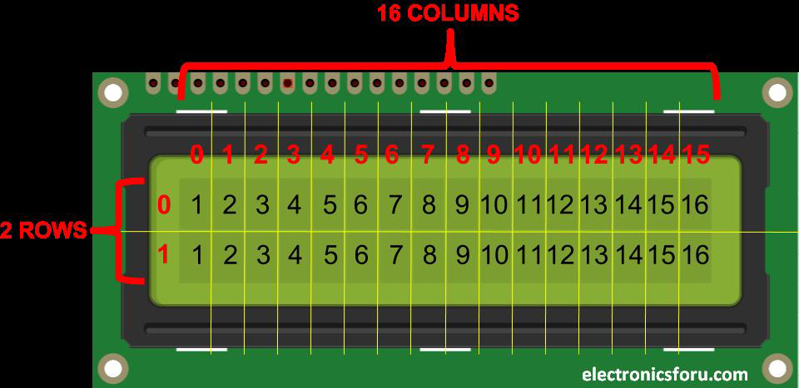

16X2 LCD pinout diagram
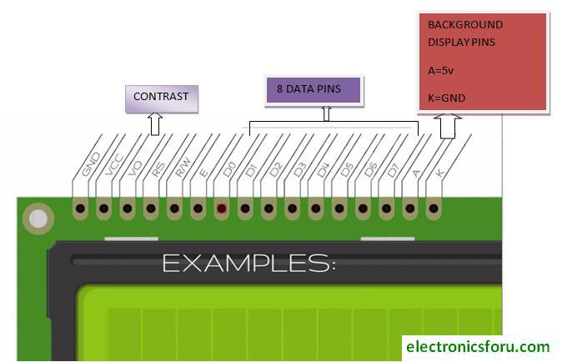

Pin No. | Function | Name
1 | Ground (0V) | Ground
2 | Supply voltage; 5V (4.7V – 5.3V) | Vcc
3 | Contrast adjustment; the best way is to use a variable resistor such as a potentiometer. The output of the potentiometer is connected to this pin. Rotate the potentiometer knob forward and backwards to adjust the LCD contrast. | Vo / VEE
4 | Selects command register when low, and data register when high | RS (Register Select )
5 | Low to write to the register; High to read from the register | Read/write
6 | Sends data to data pins when a high to low pulse is given; Extra voltage push is required to execute the instruction and EN(enable) signal is used for this purpose. Usually, we make it en=0 and when we want to execute the instruction we make it high en=1 for some milliseconds. After this we again make it ground that is, en=0. | Enable
7 | 8-bit data pins | DB0
8 | 8-bit data pins | DB1
9 | 8-bit data pins | DB2
10 | 8-bit data pins | DB3
11 | 8-bit data pins | DB4
12 | 8-bit data pins | DB5
13 | 8-bit data pins | DB6
14 | 8-bit data pins | DB7
15 | Backlight VCC (5V) | Led+
16 | Backlight Ground (0V) | Led-

RS (Register select)
A 16X2 LCD has two registers, namely, command and data. The register select is used to switch from one register to other. RS=0 for command register, whereas RS=1 for data register.
Command Register: The command register stores the command instructions given to the LCD. A command is an instruction given to LCD to do a predefined task. Examples like initializing it, clearing its screen, setting the cursor position, controlling display etc. Processing for commands happens in the command register.
Data Register: The data register stores the data to be displayed on the LCD. The data is the ASCII value of the character to be displayed on the LCD. When we send data to LCD it goes to the data register and is processed there. When RS=1, data register is selected.

Important command codes for LCD
Sr.No. | Hex Code | Command to LCD instruction Register
1 | 01 | Clear display screen
2 | 02 | Return home
3 | 04 | Decrement cursor (shift cursor to left)
4 | 06 | Increment cursor (shift cursor to right)
5 | 05 | Shift display right
6 | 07 | Shift display left
7 | 08 | Display off, cursor off
8 | 0A | Display off, cursor on
9 | 0C | Display on, cursor off
10 | 0E | Display on, cursor blinking
11 | 0F | Display on, cursor blinking
12 | 10 | Shift cursor position to left
13 | 14 | Shift cursor position to right
14 | 18 | Shift the entire display to the left
15 | 1C | Shift the entire display to the right
16 | 80 | Force cursor to beginning ( 1st line)
17 | C0 | Force cursor to beginning ( 2nd line)
18 | 38 | 2 lines and 5×7 matrix

Displaying Custom Characters on 16X2 LCD
Generating custom characters on LCD is not very hard. It requires the knowledge about custom generated random access memory (CG-RAM) of LCD and the LCD chip controller. Most LCDs contain Hitachi HD4478 controller.
CG-RAM is the main component in making custom characters. It stores the custom characters once declared in the code. CG-RAM size is 64 byte providing the option of creating eight characters at a time. Each character is eight byte in size.
CG-RAM address starts from 0x40 (Hexadecimal) or 64 in decimal. We can generate custom characters at these addresses. Once we generate our characters at these addresses, now we can print them on the LCD at any time by just sending simple commands to the LCD. Character addresses and printing commands are below
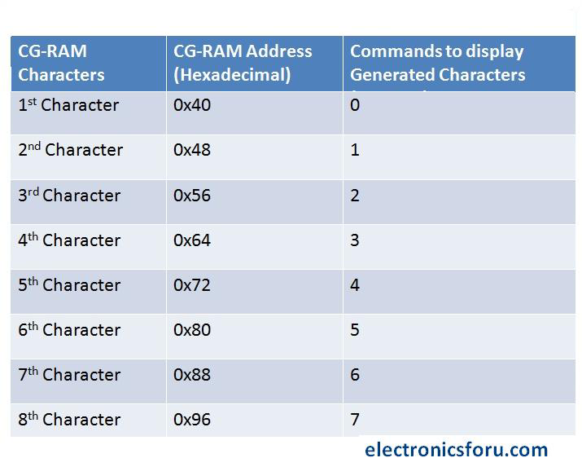
In the table above you can see starting addresses for each character with their printing commands. The first character is generated at address 0x40 to 0x47 and is printed on LCD by just sending simple command 0 to the LCD. The second character is generated at address 0x48 to 0x55 and is printed by sending 1 to LCD.

Chapter 5: RESULTS AND DISCUSSION

By using ultrasonic waves we can detect the missile then micro controller activate the destroyer. This can be applied in various defense fields to protect the Nation from foreign attacks. In case of global military conflict, the role of anti-missile defense becomes very important. Although anti-missile defense with a hundred percent reliability was not reached by any country, huge efforts are put into this area. For this purpose early attack detection systems, controllable rockets, high power lasers are used. We would like to believe that such technologies will never be used according to their direct destination, but will be applied by mankind for peaceful purposes.

Future Scope

1. By using controller microcontroller we can implement the intelligent system in future.

2. In Future it can be used as an advanced tracking system along with high intensity camera to track a
real target(say a Missile or Tank).

3. The advantage of this unit is that to run the system we can use video camera and other sensors to
see the live moving target from anywhere in the world.

Further developments could relax these restrictions by allowing range detection from the video image and implementing tracking and prediction of a moving target, but these features proved impossible to include within our timeframe. Target acquisition occurs via processing of an image stream from a single webcam, making use of foreground segmentation and SURF feature detection, together with a calibrated pinhole model to convert from pixel distances into real-world Cartesian coordinates. Because the missile launcher has no sensors to provide feedback on its pose, described in terms of the altitude and azimuth angles of its barrel, we also present results for a visual servicing system. This uses a camera mounted on the barrel to read a calibrated fan pattern printed behind the launcher base, providing pose feedback by detecting and recording movement from a denned origin. We also show results for ballistic light tests conducted on the foam missiles, swhich allow the calculation of the desired launcher pose given a target location.

REFERENCES

[1]. The AVR micro controller and embedded systems by Anand V Gadre.
[2]. Datasheets and the user manuals of Atmel AVR.
[3]. www.roboticsforum.com
[4]. www.engineergarrage.com
[5]. Alldatasheet.com
[6]. Wikipedia.com
[7]. 8051 and embedded system” by Mazidi and Mazidi
[8]. Programming and Customizing AVR microcontrollers by Aanad V Gadre
[9]. www.nex-robotics.com
[10]. www.datasheetcatalog.com
[11]. www.atmel.com And www.triindia.co.in
[12]. Ultrasonic READER MANUAL

