APPRISE

Web-app Application Documentation

Submitted by:

Clyde Jamir J Mapalo

James Florence Anticamara

Clarife Jasog

Submitted to:

Cliff Amadeus Evangelio

Our web-app application focuses on the information about local job around municipality of Manolo Fortich featuring Dynamic cards for the description for the job and we used Search Bar for searching the specific local job for the employee or freelancers also we use filtering system so that client can filter what he/she search for. We also add Find Jobs Navigation if the Employee see the available job opening and also to direct apply and for the job.

First days we collaborate on what will we do about our website to ensure the local jobs that give minimum wage or for the freelancers where they want to apply. We started to gather information about what is the most local job that are in around Manolo Fortich and we choose 6 jobs (Water Refilling, Carpentry, Plumber, Lechonero, Delivery Man, and Electrician).

*Home Page:*

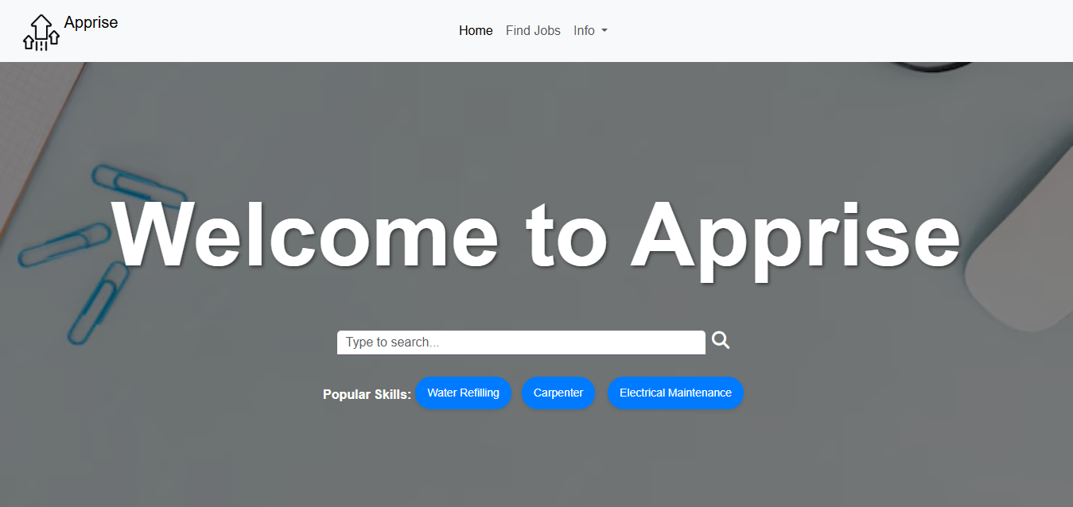

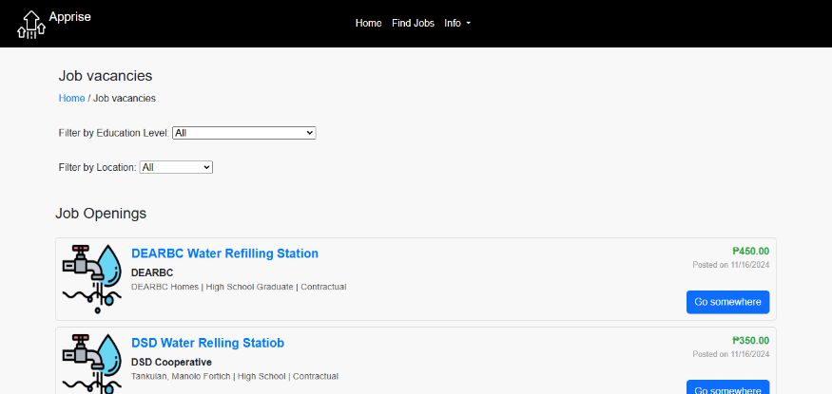*Available Jobs:*

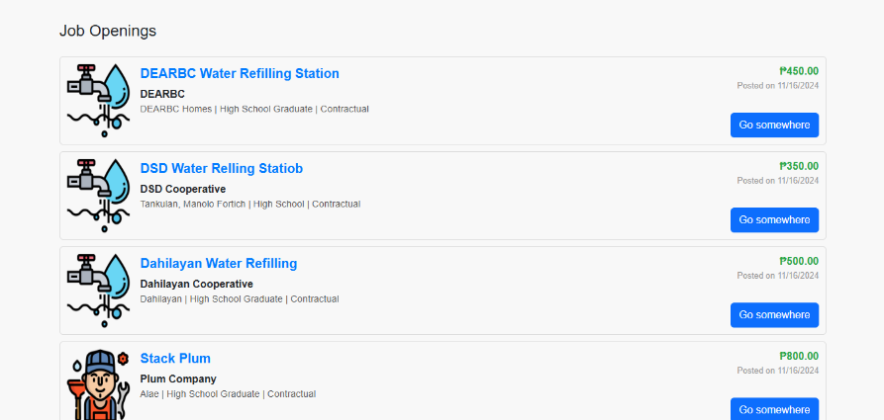

*Job Results:*

*For Water Refilling:*

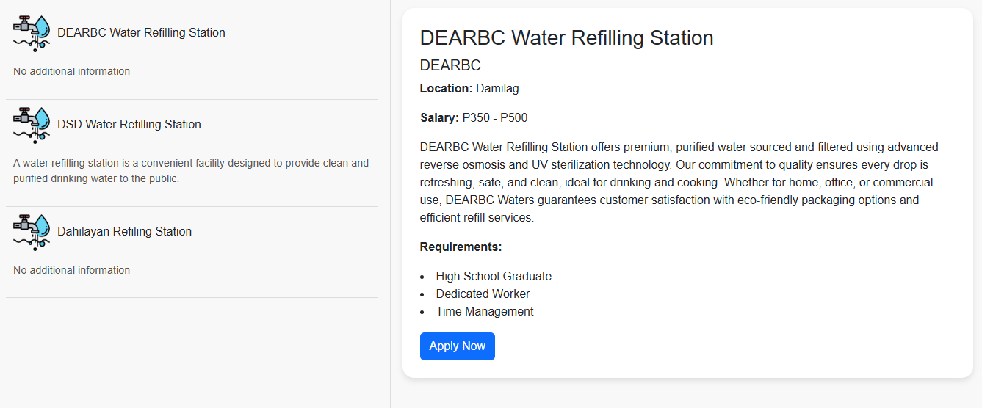

*For Carpentry:*

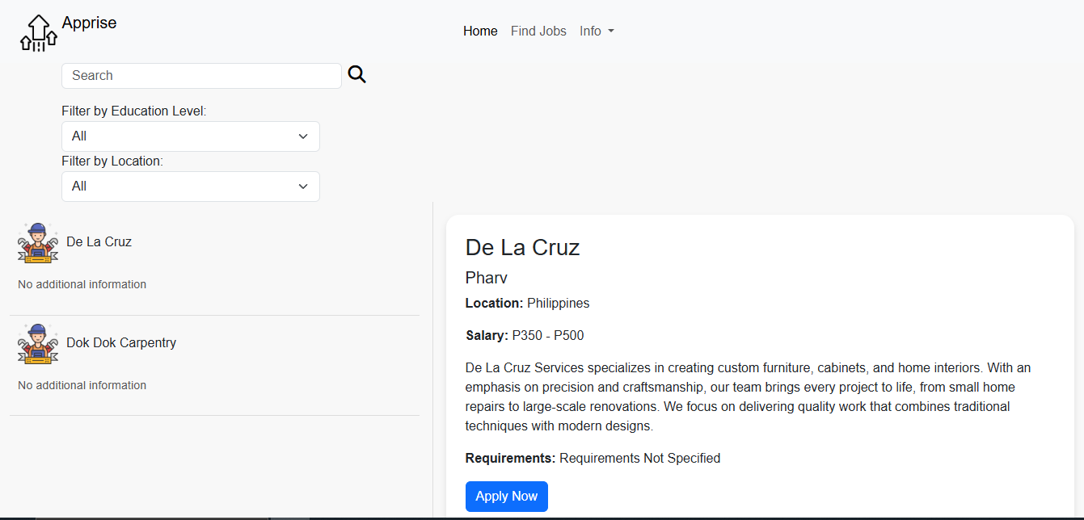

*Implementation of Filtering, Dynamic Cards, Search Bar and Modal for Message.*

Dynamic Cards: We use dynamic cards for neat and clean for the information or description at the left portion.



Search Bar: We use search bar code for searching the job you want and available jobs.

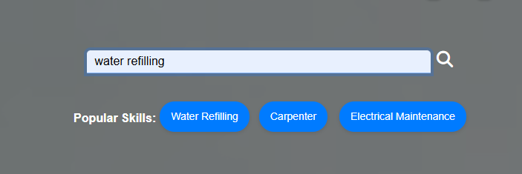

Modal: We use Modal to inform the client that their application for the job is submitted.

